4. Methodology
4.1 Modified Polar Pipeline
4.2 Steps In Depth Analysis
…Prompt Design and Response Structure
4.3 TBD

4.1 Modified Polar Pipeline
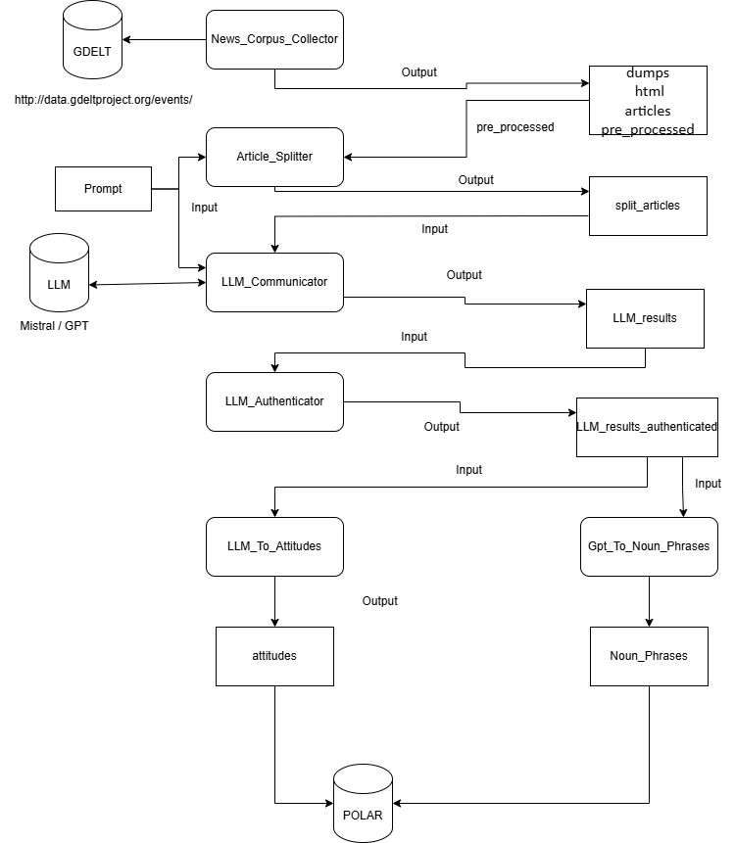
Figure 1: LLM Integrated Polar Pipeline

4.1.1 Overview and Explanation
The Process begins with Gathering Articles that fit a likely Polarizing topic using Polar’s News Corpus Collector, which based on a set of keywords gathers the articles that match the keywords from the GDELT Database and pre-processes them into Json files with their name matching their URL.
The Articles are then processed by a simple algorithm that attempts to cut the Articles so that they would all fit into the LLM’s Window Size without hitting it’s limit, thus they are split if necessary into Article Parts, so that the LLM Prompt + the Article Part do not exceed the window size.
The newly Split Articles are then processed into a Request for the LLM with the content being the Prompt which explains in detail to the LLM all of the instructions followed by the Article Part for the analysis. The request is processed and responds with a Json formatted file with all of the necessary data.
The files are then analyzed for any malformed files or non Json formatted requests and cleans them if possible.
The authenticated files are then reformatted into Noun_Phrases and into Attitudes, 2 outputs created by Polar and that are necessary for the implementation into the Polar Pipeline.

4.2 Steps in Depth Analysis
4.2.1 Article Gathering
Using Polar’s News Corpus Collector as a baseline, Articles of varying topics were gathered that fit the keywords and time restrictions placed. This Class allows for the use of keywords for gathering Articles like max number of articles per request, other variables like actor 1 and 2 country codes, being able to filter the articles by place of origin and most importantly the Start and End Date from which the Articles were published, as well as keywords for the article to contain, these were the noteworthy variables for the scope of this thesis, these fields have to be placed manually, preferably a topic high in Polarization.
Examples:
Topic: Brexit -> keywords: 'brexit'
Date: 2016/6 - 7/22 – 10
The Articles are saved as Raw String Json files with this format:
"{\"uid\": \" Filename ",
\"text\": “ Article content “ “}”

4.2.2 Article Splitting
This code processes a set of articles and splits them into Parts small enough to fit into a model’s maximum token limit, taking into account a fixed prompt that will be added onto it. It uses 2 types of models for tokenizing that depend on the model of the LLM, OpenAI models like GPT use tiktoken encoding while HuggingFace models like Mistral use AutoTokenizer.
These tokens are used to accurately count the maximum window size measured in Tokens using the built-in functions of tiktoken (tiktoken.encode()) and AutoTokenizer (tokenizer.tokenize())[ ALEX Probably Source these 2 ].
Once the maximum window size is reached, so once the available tokens + the prompt tokens reach the window size limit, the code uses LangChain to split the articles based on character count, so that it tries to preserve the sentences and words as much as possible in each part, prioritizing paragraph breaks and sentence breaks [ ALEX Source Langchain Here ]. As such the Part is split, assigning Part {i} into it’s filename and keeping the “uid” field and having the split article part in the “text” field.

4.2.3 LLM Communicator
This code takes as input the LLM to request, the Prompt for the LLM as well as the split articles. The prompt consists of detailed instructions and a set of rules for the LLM to follow for our particular case, which is gathering Polarization between Entities, as well as Polarization between Entities and Topics in articles.
4.2.3.1 Request Format
It also consists of a OneShot example for the LLM to be able to easily format its output and boost consistency in its replies, the OneShot example containing as follows:
{ 'topical_attitudes': [ {
'source' : { 'entity' : 'Donald Trump' , 'references' : ['Donald Trump']},
'target' : { 'topic' : 'mask mandate' , 'references' : ['usage of masks']},
'justifications' : [ 'constantly pushing against the usage of masks. '],
'attitude' : 'Negative' }],
'entity_attitudes': [ {
'entity1' : { 'entity' : 'Dr. Anthony Fauci' , 'references' : [ 'Fauci' ]},
'entity2' : { 'entity' : 'Donald Trump' , 'references' : [ 'Donald Trump' ]},
'justifications' : [ 'Donald Trump was in disagreement with Fauci' ],
'attitude' : 'Negative' } ]}

Where the entities and topics as well as the justifications are found in the Sentence / Article provided, it is left onto the LLM to find these pairs and assign onto them the attitude it thinks is accurate.
4.2.3.2 Code Structure

The newly Split Articles are then processed into a Request for the LLM with the content being the Prompt which explains in detail to the LLM all of the instructions followed by the Article Part for the analysis. The request is processed and responds with a Json formatted file with all of the necessary data.

