EDS Lab Assignments

Practical 1

Name: Amod Muley

Calculate Momentum
Problem Statement:
Write a programthataccepts the mass of an object (in kilograms) and its velocity (in meters per second), thencalculates and displays the momentum of the object. The momentum is calculated usingtheformula: p = m * v
where:
m is the mass oftheobject (in kilograms).
v is the velocityoftheobject (in meters per second).
PRN: 202501090003

Input Format:
- A singlefloating-point number representing the mass of the object in kilograms.
- A singlefloating-point number representing the velocity of the object in meters per second.
Output Format:
- Theoutputwilldisplay calculated momentum with appropriate units (kgm/s) (roundedupto2decimal places).
Code:
mass = ﬂoat(input()) velocity = ﬂoat(input()) momentum= mass * velocity
print(f"{momentum:.2f} kgm/s") Output:
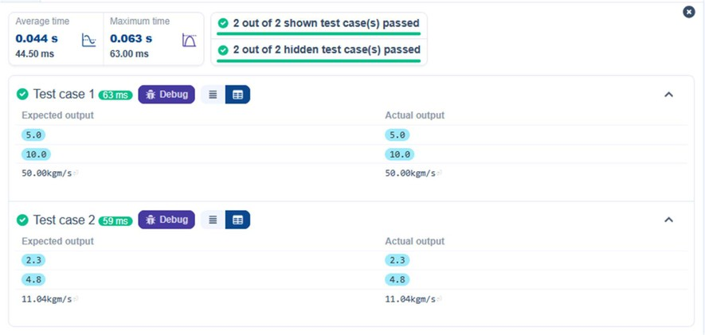

Conditional Calculation based on the Number of Digits
Problem Statement:
WriteaPythonprogram that accepts an integer as input. Depending on the number of digits in.
Constraints: 1≤n≤ 999

Input Format:

□ The inputconsists of a single integer.
Output Format:

□
□

Code:
If is a single-digit number, print its square.
If is a two-digit number, print its square root (rounded to two decimal places). If is a three-digit number, print its cube root (rounded to two decimal places). Else print "Invalid"

importmath n=int(input()) sq = n*n
sq_root = math.sqrt(n) cb_root = math.cbrt(n) if n>1 and n<=9:
print(f"{sq}") elif n>=10 and n<=99:
print(f"{sq_root:.2f}") elif n>=100 and n<=999:
print(f"{cb_root:.2f}")
else:
print("Invalid")

Output:
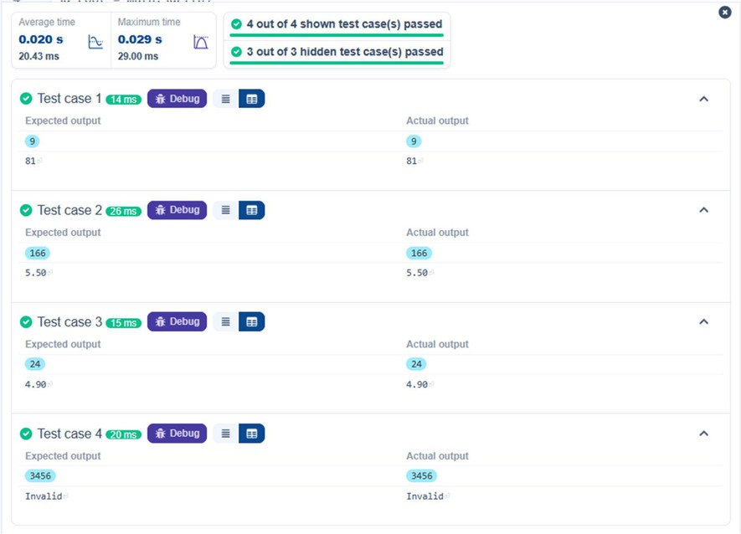

Days Between Two Dates
Problem Statement:
Write a Pythonprogram to calculate number of days between two dates.

Input Format:
- The firstline contains the first date in the format YYYY-MM-DD.
- The second line contains the second date in the format YYYY-MM-DD.

Output Format:
- Anintegerrepresenting the number of days between the given dates.

Code:
from datetime import date from datetime import datetime date1 = input().strip()
date2 = input().strip()
d1 = datetime.strptime(date1, "%Y-%m-
%d") d2 = datetime.strptime(date2, "%Y-
%m-%d")
di erence = d2-d1
print(di erence.days)

Output:
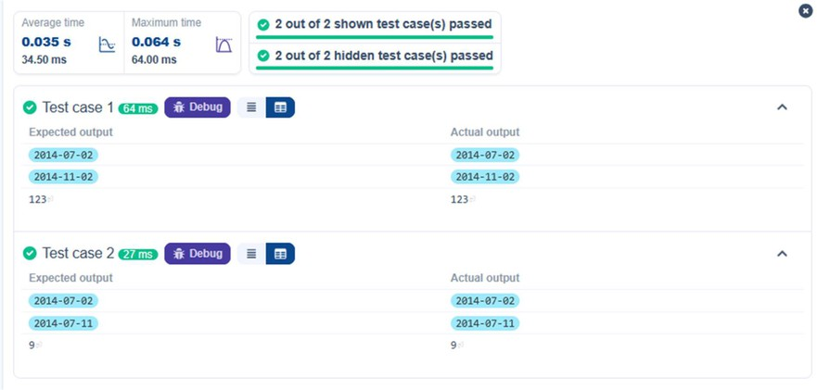

Reverse a Number
Problem Statement:
Write a Python program to reverse the digits of the number and print the reversed number.
Input Format:

- The input is a single integer.

Output Format:
- The output prints a single integer, which is the reversed number.

Code: n=int(input())
reverse=int(str(n)[::-1]) print(reverse)

Output:

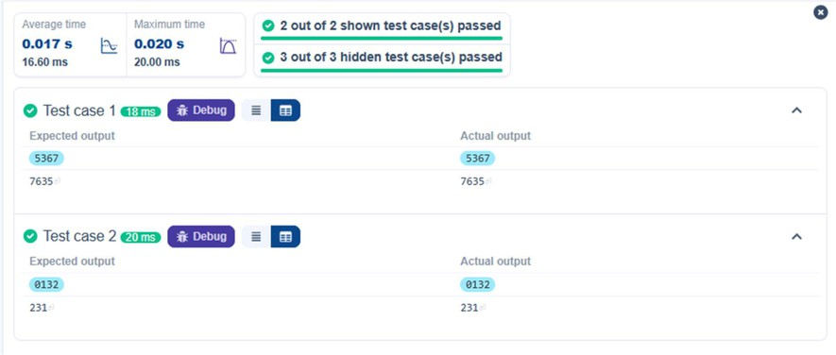

Multiplication Table
Problem Statement:
Write a Pythonprogram that takes an integer as input and prints the multiplication table
forthat integerfrom 1 to 10. Input Format:
- The firstline of input contains an integer that represents the number for which the multiplication table is to be printed.

Output Format:
- Printthemultiplication table for the given number in the format:
<number> x <multiplier> = <result>
Code:
n = int(input())
for i in range(1,11):
print(n, "x", i, "=", n*i) Output:
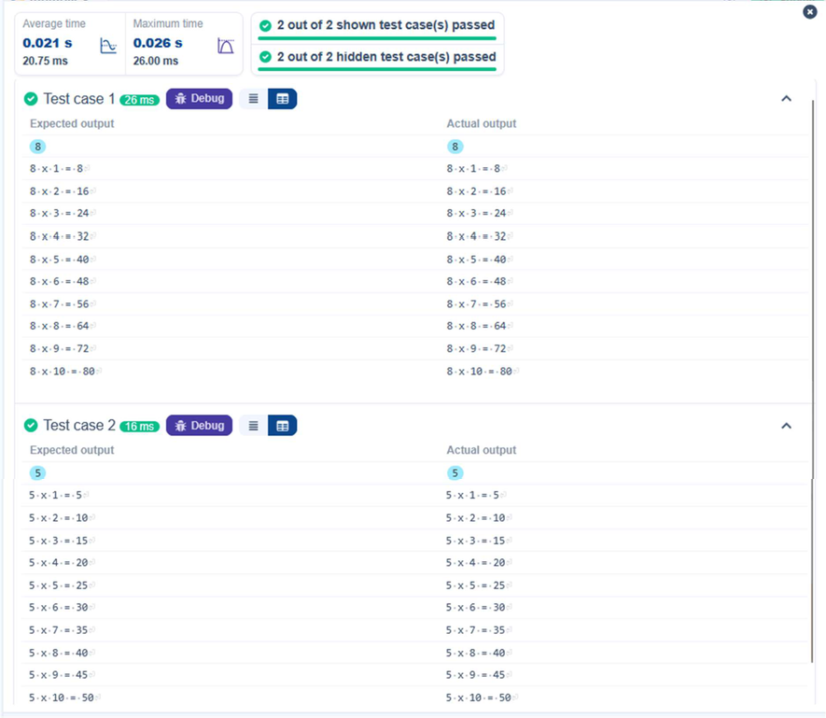

Pass or Fail
Problem Statement:.
Writea Pythonprogram that accepts the number of courses and the marks of a student in those courses.
The grade is determined based on the aggregate percentage:
- If the aggregate percentage is greater than 75, the grade is Distinction.
- If the aggregate percentage is greater than or equal to 60 but less than 75, the grade isFirst Division.
- If the aggregate percentage is greater than or equal to 50 but less than 60, the grade isSecond Division.
- If the aggregate percentage is greater than or equal to 40 but less than 50, the grade isThird Division.

Input Format:
- The firstinput will be an integer, the number of courses.
- The second input will be integers representing the marks of the student in each of the courses, separated by a space.

Output Format:
Ifthestudent passes all courses:
- Print theaggregate percentage (formatted to two decimal places).
- Print thegrade based on the aggregate percentage.
If the student fails any course (marks < 40 in any course), print:
- "Fail".

Code:
defcalculate(marks, total_courses):
if any(mark<40 for mark in marks): return "Fail"
total_marks = sum(marks)
aggregate_percentage = ((total_marks)/(total_courses*100))*100 if aggregate_percentage > 75:
grade = "Distinction"
elif aggregate_percentage >= 60: grade = "First Division"
elif aggregate_percentage >= 50: grade = "Second Division"
elif aggregate_percentage >= 40: grade = "Third Division"
return (aggregate_percentage, grade) num_courses = int(input())
marks = list(map(int,input().split())) result = calculate(marks, num_courses) if result == 'Fail':
print("Fail")
else:

aggregate_percentage, grade = result
print("Aggregate Percentage:",f"{aggregate_percentage:.2f}") print(f"Grade: {grade}")

Output:
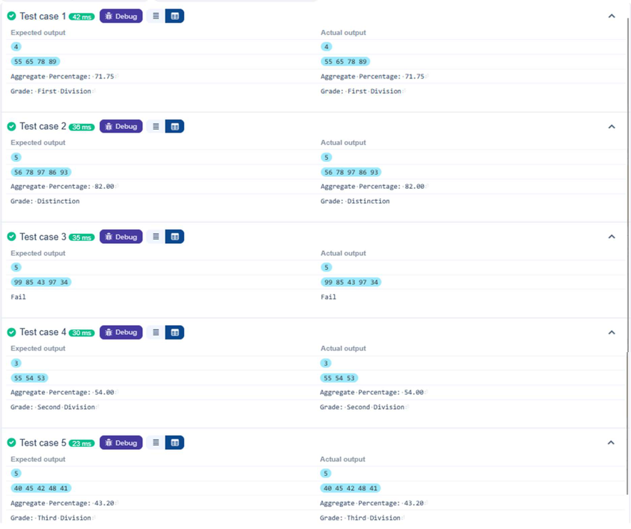

Fibonacci Series
Problem Statement:
Write a Python program that uses recursion to print the first terms of the Fibonacci series.

Input Format:

- Asingleinteger representing the number of terms to generate.

Output Format:
- Asingle line containing the first terms of the Fibonacci sequence, separated by spaces.

Code:
deffibonacci(n, a=0, b=1): if n==0:
return a

else:

n=int(input())

return fibonacci(n-1,b,a+b)

for i in range(n):
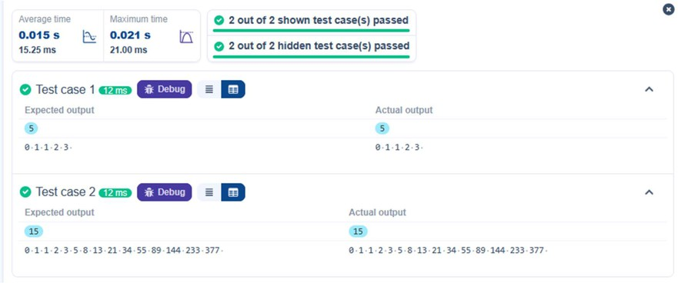
print(fibonacci(i) ,end=" ") Output:

Pattern-1
Problem Statement:
Writea Pythonprogram to print a pattern of asterisks in the form of a right-angled triangle.

Input Format:
- Theinputis an integer, representing the number of rows in the pattern.

Output Format
- The output should display the pattern of asterisks (*), with each row containing an increasing number of asterisks.

Code:
rows =int(input())
for i inrange(1, rows+1):
for j in range(i):
print("* ",end = "")
print() Output:
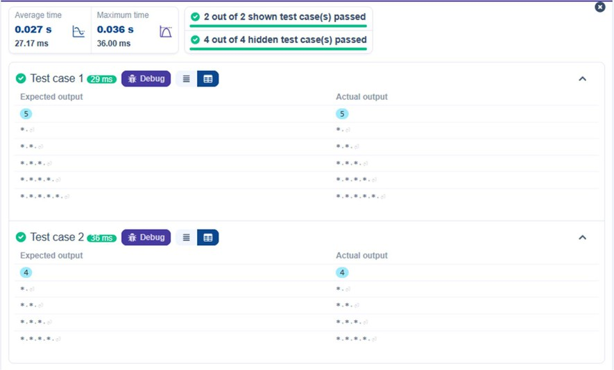

Pattern-2
Problem Statement:
Write a Pythonprogram to print a right-angled triangle pattern of numbers.

Input Format:
- The input is an integer, representing the number of rows in the pattern.

Output Format:
- The output should display the pattern of numbers separated by space, with each row containing increasing numbers starting from 1 up to the row number.

Code: n=int(input())
for i in range(1, n+1):
for j in range(1, i+1):
print(j,end=" ")
print()

Output:
