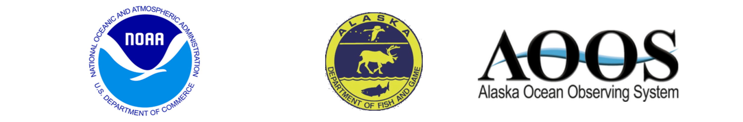

Tuesday, June 5, 2018

## Run Timing Prospects for 2018

The 2018 timing for Yukon River Chinook is expected to be slightly earlier than average. The first significant pulse (15% point) of Chinook in the lower river is expected on June 9, which is earlier than the long-term average of June 13 (1961 – 2017). The half-way point (50%) of the run is expected on June 17, which is also earlier than the long-term average of June 21 (1961 – 2017). The April mean air temperature at Nome this year of -3.2°C was warmer than the long-term average of -6.8°C (1961 – 2017). The May mean sea surface temperature as modeled just off the Yukon River delta (63.18°N 165.58°W) of -0.2°C was warmer than the long-term average of -0.4°C (1961 – 2017). In keeping with the early spring conditions in northwestern Alaska, the Spring (March 19 – May 31) sea ice coverage was 11.85%, which is very far outside the experience of the historical database (1970 – 2017), which has a long-term average of 56.27%, as measured in the waters between the Yukon River delta and St. Lawrence Island (Shpanberg Strait).

## Run Timing Forecast by Date 2018

Based on the relationship between the dates of the three percentiles (15%, 25%, and 50%) and the sea ice coverage and the air and sea surface temperatures, the predicted dates of the three percentiles are June 9 (15%), June 11 (25%), and June 17 (50%) in District Y-1 of the Lower Yukon River.

|  |  |
| --- | --- |
| Percentile (%) | Predicted Date |
| 15 | June 9 |
| 25 | June 11 |
| 50 | June 17 |

See [the project website](http://www.aoos.org/2018-run-timing-outlook-and-forecast-summary-chinook-salmon-yukon-river-delta/) for comparisons of the estimated daily percentages of the run to results of the 2018 Lower Yukon Test Fishery and past years’ test fisheries. If the current timing model doesn’t match reality, the forecast dates will be updated and posted on the web site.

## Credits

Prepared and reviewed by Bryce Mecum [brycemecum@gmail.com](mailto:brycemecum@gmail.com), Phil Mundy [proymundy@gmail.com](mailto:proymundy@gmail.com), and Jordan Watson [jordan.watson@noaa.gov](mailto:jordan.watson@noaa.gov). Data management and web page support by Will Koeppen [will@axiomalaska.com](mailto:will@axiomalaska.com). Web support also provided by Holly Kent [kent@aoos.org](mailto:%20kent@aoos.org). Yukon Chinook in-season salmon data and management agency coordination by Fred West [fred.west@alaska.gov](mailto:fred.west@alaska.gov), Sean Larson [sean.larson@alaska.gov](mailto:sean.larson@alaska.gov), and Holly Carroll [holly.carroll@alaska.gov](mailto:holly.carroll@alaska.gov). Financial and material supports were provided by the Alaska Ocean Observing System, NOAA National Marine Fisheries Service, and the Alaska Department of Fish and Game.