ICD Final Report
Please convert to PDF format after editing. (report_G_xx.pdf)

Group ID: G_02 (見公告表單)
Group Name: 不知道
Student ID: b09901005, b09901059, b09901067
Name: 韓家典, 彭亞綺, 陳少翔
RTL Report
Testbench | Pass (Pass/Fail)
Clock Cycle | 40 (ns)
Total Time | 56520 (ns)
Synthesis Report
Testbench | Pass (Pass/Fail)
No Latch | Pass (Pass/Fail)
Clock Cycle | 40 (ns)
Cell Area(A) | 211889.833082 (um²)
Total Time(T) | 56520 (ns)
Cell Area: Please report Total cell area
APR Report
Testbench | Pass (Pass/Fail)
No Error(x) | Pass (Pass/Fail)
Clock Cycle | 40 (ns)
Cell Area(A) | 264959.048 (um²)
Total Time(T) | 56520 (ns)
A*T² | 8.46E14 (ns²*um²)
Cell Area: Please report Total area of Core
Synthesis: No latch

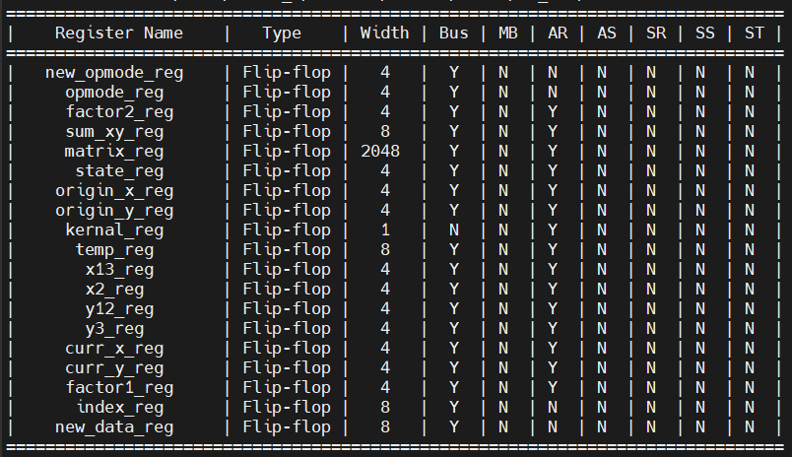

APR: NanoRoute Innovus Result
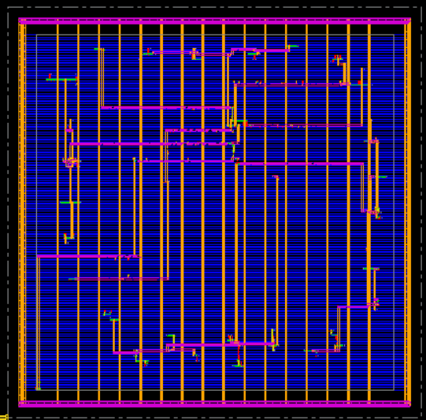
Report
If you didn’t pass APR, the score for your report will be determined based on its completeness.
You may include details on the innovation in your design, or the reasons why you may not have passed the APR.

