Sometimes you want to change the name of a Git repository in Stash. The reasons for wanting to do this can vary widely. For example, the repository may have been originally named poorly or the business project name has changed, etc.

If you have a Git repository in an existing Stash project and you wish to change its name follow these steps:

**In Stash:**

Navigate to the project, then the repository.

Click Settings (lower left navigation).

Change the name and save.

Note the message below the Name field:

Changing this repository's name will change its clone URL.

You can update a remote with the following command:

git remote set-url <name> <newurl>

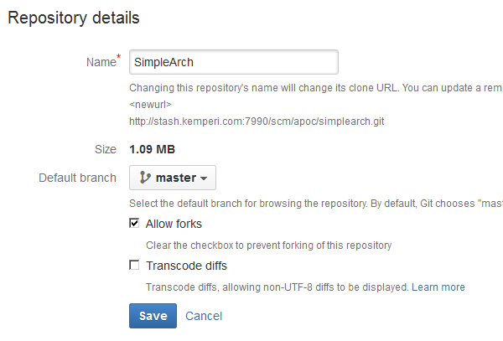

**In Eclipse/RAD:**

Make sure all files are close, servers stopped, etc.

From your Git Repository perspective:

* Right mouse on your Git Repository
* Select > Remove Repository from view

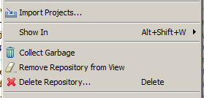

If there are associated eclipse projects in this repository the following dialog will be presented:

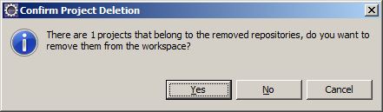

Click > Yes.

At this point, the Eclipse/RAD workspace and the Git Repository are disconnected.

You can now update the Git Repository with the new Stash location.

**In GitBash:**

Navigate to your repository.

$ git remote –v

Should show the old Stash url.

$ **git remote set-url origin <new-url>**

$ git remote –v

Should show the new Stash url.

$ git fetch origin

Verify the new url.

**In Eclipse/RAD:**

Make sure all files are close, servers stopped, etc.

From your Git Repository perspective:

* Add an existing local Git Repository to this view

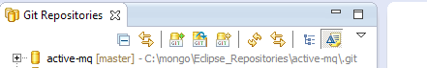

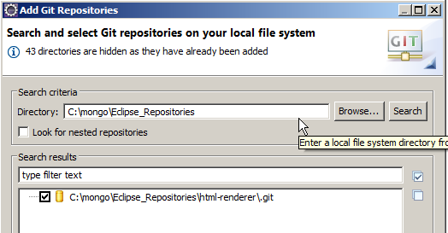

* Import your eclipse projects from the Git Repository.
* Now you should be back where you were before.