**Introduction:**

Currently, Harvest builds artifacts for the Systest, INT and the higher environments. With Git/Stash now handling source code versioning, Harvest no longer has the latest code and therefore is no longer required to build artifacts for those environments. That responsibility has moved over to Jenkins.

Jenkins will now build artifacts for the non-dev environments (Systest, INT and higher environments. This will be manually configured and triggered when required.

Jenkins will NOT be deploying those artifacts. Harvest is still responsible for the approval and deployment processes.

**Job Name Suffix:**

* **.artifact.build

**Jenkins Job Configuration:**

* The artifact build job should be modeled off a “dev” build job.
* Remove the “Build other projects” post-build action (downstream project).
* Additional post-build actions are required:
  + Artifact archiving
  + Fingerprinting

See below for example Jenkins configuration:

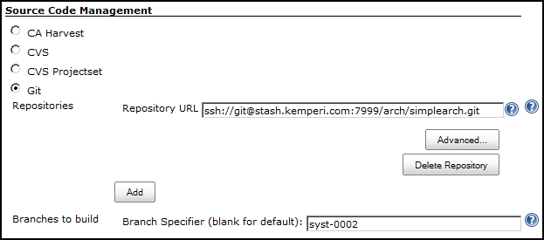

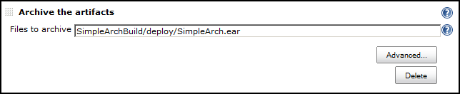

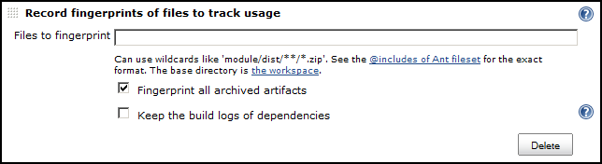

**Changing configuration for new Artifact creation:**

Git tags are generally used to specify a code base that you wish to use for the building of an artifact. In the example above, the tag (syst-0002) has been specified in the source code management section of the build.

Before building an artifact, ensure the job has been updated and saved with the correct tag.