**Prerequisites:**

* A Jenkin’s artifact has been successfully built.
* You have obtained the full 40 character SHA associated with the tag used to build the artifact. Ultimately, this artifact must will be copied from Jenkins and saved to a location where Harvest usually finds its build artifacts. Typically, this location is a /dist folder at the same level as the Build project.

**How to obtain the full 40 character SHA:**

* Locate the Jenkins artifact job.
* Click the required build from the build history.

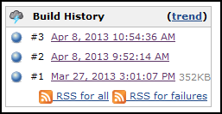

* Next to the Git section, you should see a revision and associated tag. In this case, 5ea3565728ae98f430c77b523cf27940149fd0c3. Tag: syst-0002.

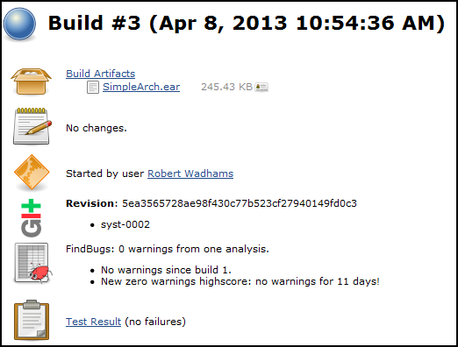

* When updating the build.bat file you will need to copy/paste this 40 character SHA.

**Configure Harvest Workbench: (one-time setup)**

* Configure the workbench to open (*.bat) files in a text editor rather than trying to execute the batch script. Tools > Preferences.

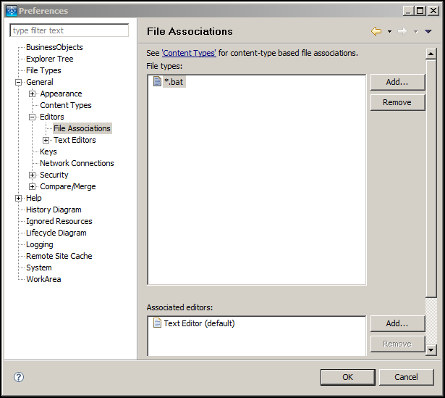

**System Test promotion workflow:**

* Create a Service Request Package:

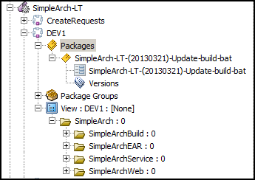

* In the build project, checkout for Update the build.bat using the appropriate package. To edit the file in place (i.e. within the workbench), make the “From:” and “To:” the same. See below:

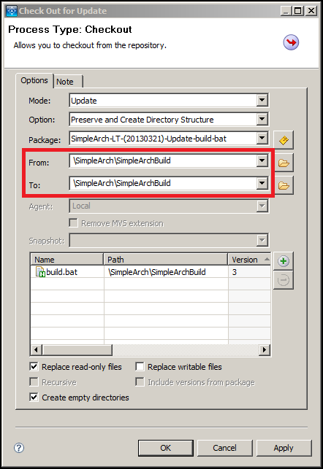

* Edit the build.bat by double-clicking. Replace existing content with something similar to below (2 lines):

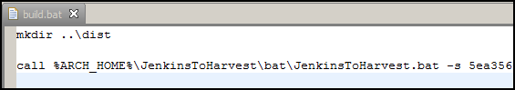

The call to JenkinsToHarvest.bat requires three(3) options. Options should be on one(1) line, space-separated.

1. –s (SHA)
2. –j (Jenkins job name)
3. –a (Artifact name)

Example: (shown on 4 lines for documentation purposes only, it has to be a single line in the file)

call %ARCH_HOME%\JenkinsToHarvest\bat\JenkinsToHarvest.bat

-s 5ea3565728ae98f430c77b523cf27940149fd0c3

-j usg.architecture.simplearch.git.artifact.build

-a SimpleArch.ear

* Save the build.bat
* Check-in the build.bat
* Trigger promote to System Test (Notify Environment Owners) in the normal fashion.

**INT promotion workflow:**

* Basically it’s the same process as System Test, with the exception that the artifact should have been built and verified ready for INT, UAT and eventually Production.

**UAT and Production promotion workflow:**

* Same process used today. Nothing changes.