**Published Documentation:**

* <http://wiki.eclipse.org/EGit/User_Guide>
* <http://wiki.eclipse.org/EGit/Git_For_Eclipse_Users>

The EGit User Guide is a comprehensive 130+ page manual. Please refer to it as questions come up about how to do something in EGit.

**EGit Perspectives:**

When it comes to doing version control related tasks, the Git Repository Exploring Perspective provides all possible views needed to complete that type of work. This perspective provides a number of useful views:

* Git Repositories view
* Git Staging view (use to stage files and commit)
* History view
* plus other views

**Git Repository View:**

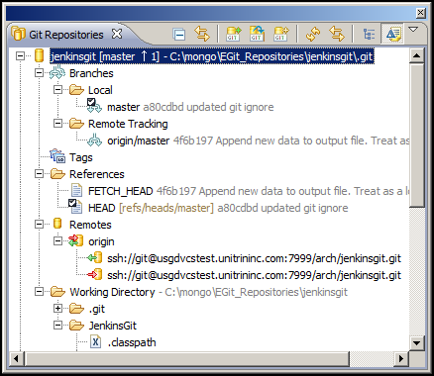

In this view:

* The top line reveals some useful information (what branch you are on, whether you are ahead of its remote tracking branch and where the repo is located on your local filesystem.
* Expanding Branches is useful for seeing your local and remote tracking branches.
* Tags are listed when present.
* Expanding Remotes is useful for seeing which remote repository manager is being used.

**Git Staging View:**

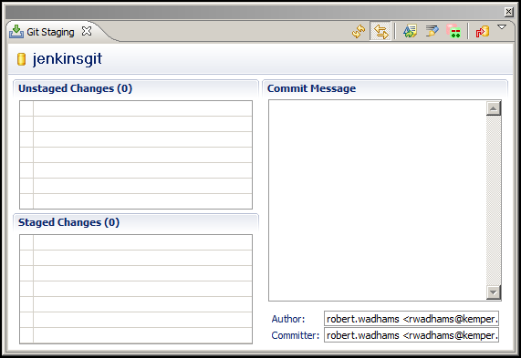

In this view:

* You can stage new changes and make commits.

**History View:**

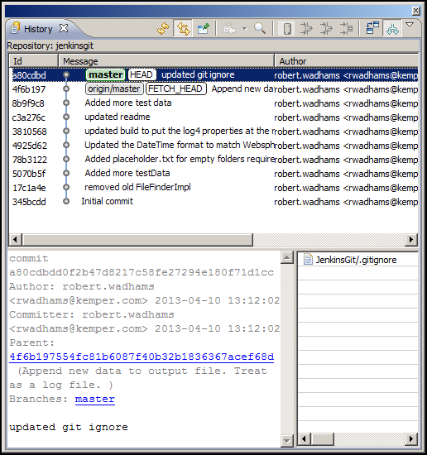

In this view:

* You can see a list of commits representing the repo’s history. Each commit shows revision details and a list of files that have changed.

**EGit Views:**

In your regular working perspectives (Java, JavaEE, Web, etc) you may want to add a Git view to help your workflow. Git Staging (set as a Fast View) is useful for quickly seeing what has changed and what may need to commit.

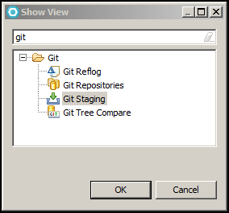

**How do I commit code?**

* bullet

**How do undo a change(s)?**

* bullet

**How do I see file versions?**

* bullet

**How do I Branch?**

* bullet

**How do I Merge?**

* bullet

**How do I Rebase?**

* bullet