**Minimum GIT Setup in RAD:**

Ensure you have followed the Developer Setup instructions on the Wiki. There are five (5) documents that you need to follow…

**Clone the Git Repository:**

* In stash, click in the SSH URL for your repo, then Ctrl-C to copy it to the clipboard.
* In the Git Repository view, click “Clone a Git Repository”. The dialog should look similar to the following:

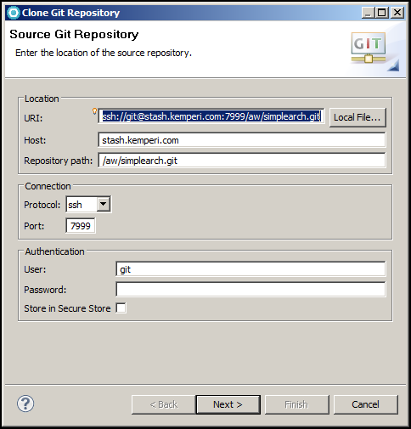

Next >

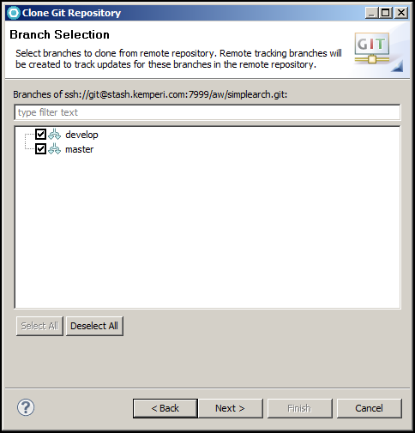

Next >

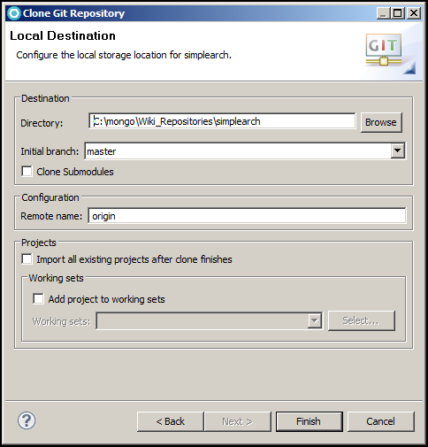

Click Finish

The following steps show you how to import the Eclipse projects into your workspace. In the future, a shortcut is available here by checking the “Import all existing projects after clones finishes”.

**Your Git Repository view and Package Explorer view:**

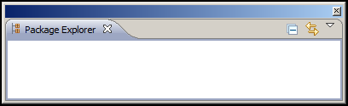

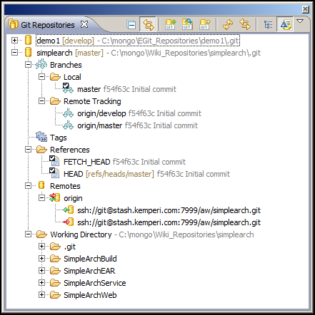

**Import Eclipse Projects:**

* In the Git Repository view, right-mouse on the repo, Import Projects…

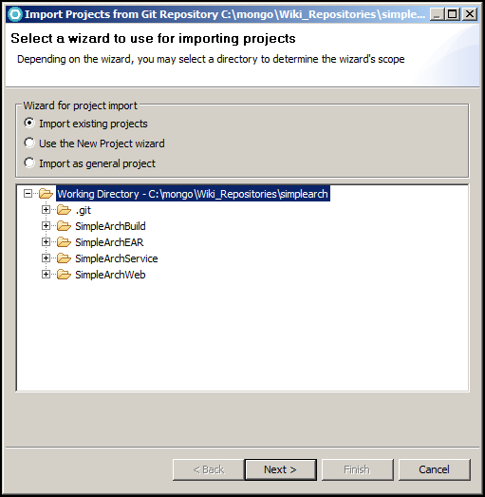

Click Next >

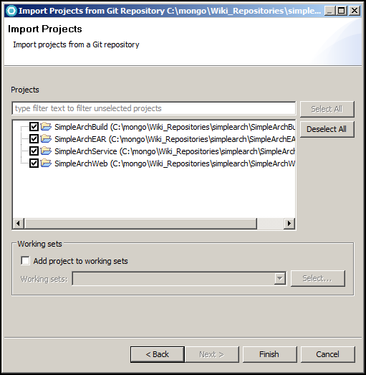

Click Finish

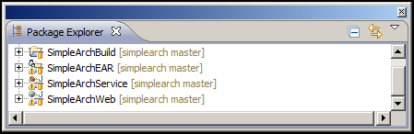

**Create your “develop” branch:**

* In the Git Repository view, right-mouse on Branches, Remote Tracking, origin/develop > Create Branch…
* Make your dialog look similar:

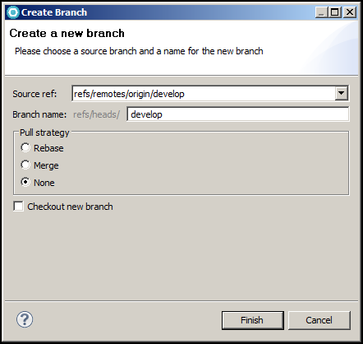

Click Finish.

Now you will see a local branch called develop.

**Configure Push:**

* In the Git Repository view, expand Remotes, Expand origin
* A red Push URL should exist. Right-mouse, Configure Push…

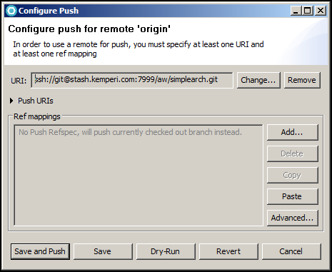

Click Advanced…

Use the “Add create/update specification” section and the “Add Spec” button to make your Push Ref Specifications like below:

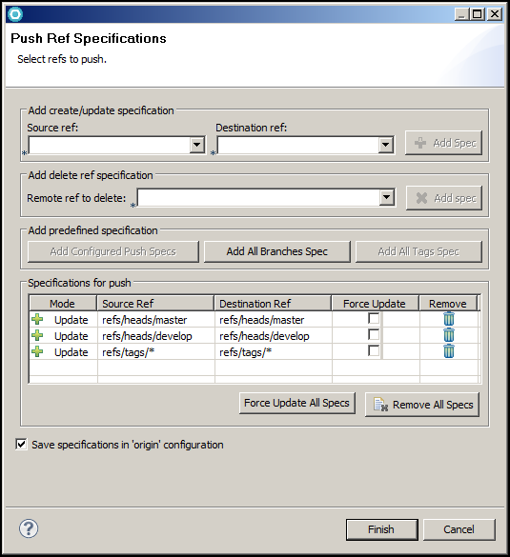

Click Finish

This is how your push configuration should look.

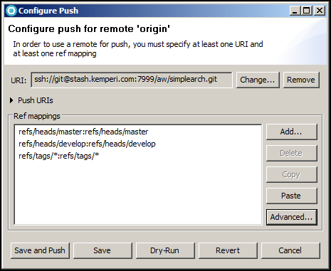

Click the Save. Next time you want to push changes to the Remote you are already setup.

**Setup Fetch Configuration:**

* In the Git Repository view, expand Remotes, Expand origin
* A green Fetch URL should exist. Right-mouse, Configure Fetch…

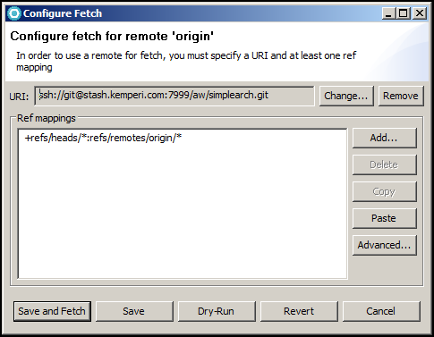

Click Advanced…

Make your Fetch Ref Specification look similar to below by using the “Add All Branches Spec” and “Add All tags Spec” buttons.

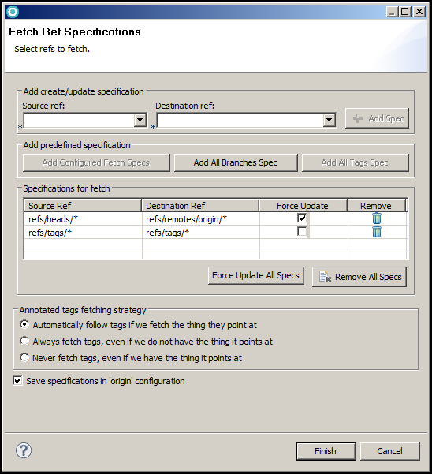

Click Finish

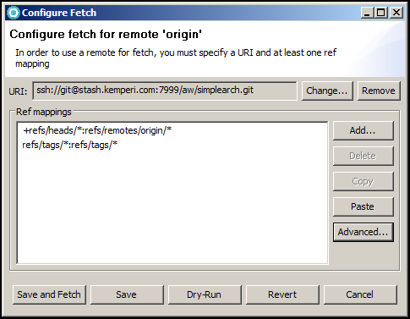

Click “Save and Fetch”

Your Git Repositories view should now look similar to below:

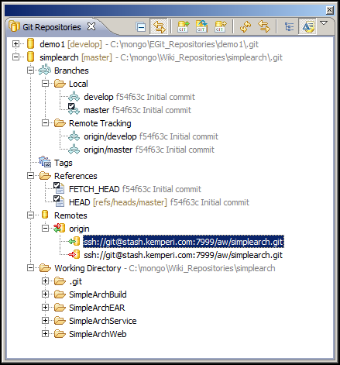

**Prepare each branch for Pull:**

* In the Git Repository view, expand Branches, Local, Right-mouse on the master branch, Configure Branch…
* Make your Git Branch Configuration look exactly as below.

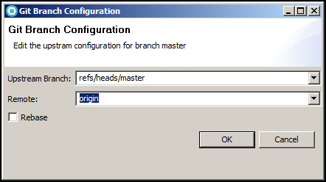

Click OK

Do the same for the develop branch

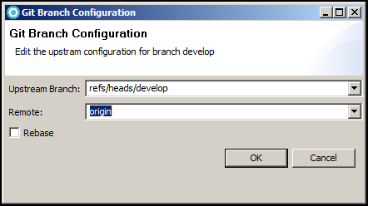

Click OK

**Verify “Pull” is configured correctly:**

* The Pull process works at the Repo level and only fetches and merges the currently checked out branch.
* In the Git Repository view,>
* Right-mouse on the Repo (top level folder), > Pull

You should see a dialog similar to below. Since there are no changes on the remote compared to locally, The “Pull Result” dialog reports that everything is up-to-date.

