**Introduction:**

Git provides two (2) distinct types of Tags:

* Lightweight
* Annotated

We will be using Annotated Tags exclusively.

**Assumptions:**

You have:

* A RAD Workspace with the projects imported from Git(Stash).
* A Git Repository view (Tab)

**View existing Tags (Optional):**

* In the Git Repository view, explore the Tags node
* Tags are listed with their name, commit SHA and message.

**Create a Tag:**

* In the Git Repository view
* Right-mouse on the repo, Show In > History

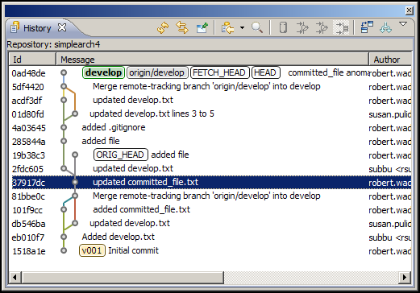

* Determine which commit you want to use for this tag.
* Right-mouse on the history line > Create Tag…

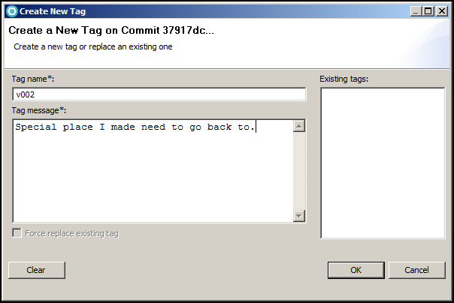

Updated History View

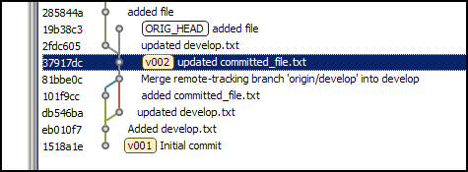

Updated Git Repository view.

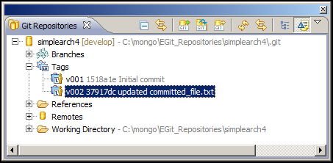

Tags are created locally and need to be “Pushed to” a Remote so others can see them. Tags also need to be “Fetched from” a Remote.

**Configure Fetch:**

* In the Git Repository view, expand Remotes, Expand origin
* A green Fetch URL should exist. Right-mouse, Configure Fetch…

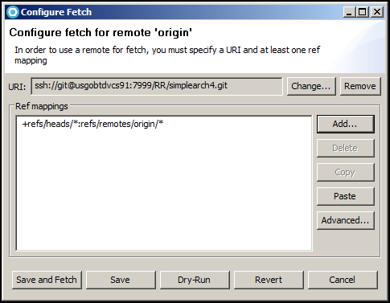

Click Advanced…

Click the “Add All Tags Spec” button to make your Fetch Ref Specifications like below:

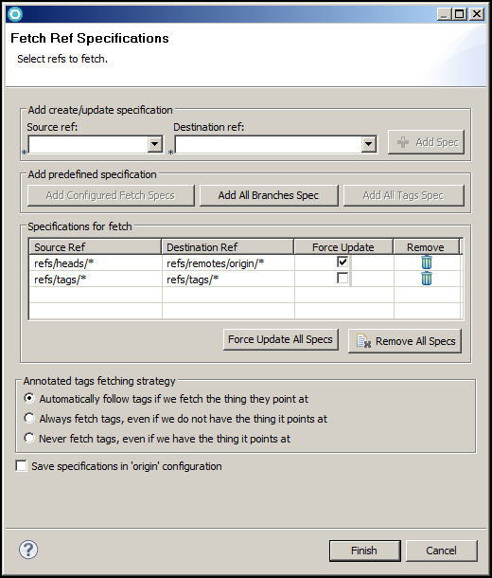

Click Finish

This is how your fetch configuration should look.

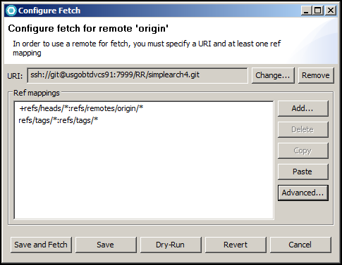

Click the Save. Next time you want to fetch changes/tags from the Remote you are setup.

**Configure Push:**

* In the Git Repository view, expand Remotes, Expand origin
* A red Push URL should exist. Right-mouse, Configure Push…

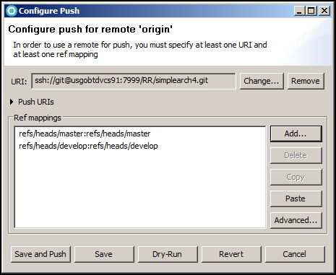

Click Advanced…

Click the “Add All Tags Spec” button to make your Push Ref Specifications like below:

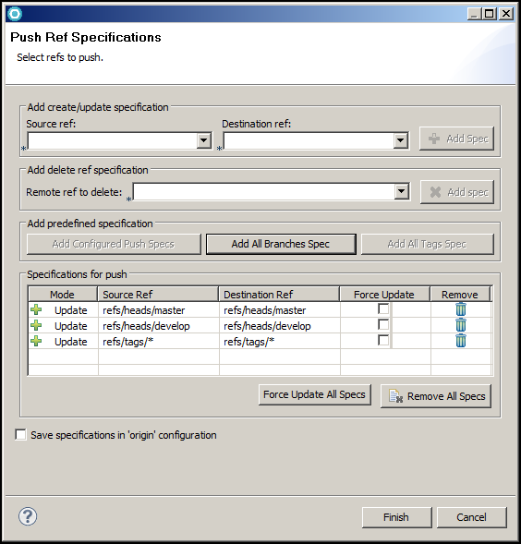

Click Finish

This is how your push configuration should look.

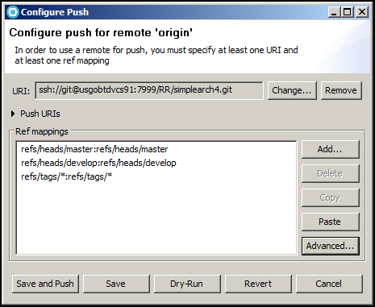

Click the Save. Next time you want to push changes/tags to the Remote you are setup.

**Pushing a new Tag to the Remote:**

* In the Git Repository view, expand Tags
* Right-mouse on the Tag, Push Tag…
* Click Next > (if “Configured remote repository:” is correct)

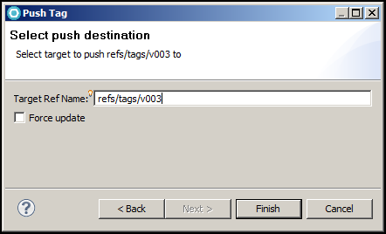

* Target Ref Name: refs/tags/<tag>
* Click Finish.

