**Assumptions:**

You have:

* A RAD Workspace with the projects imported from Git(Stash).
* A Git Repository view (Tab)
* A Git staging view (Fast-view)

**Verify your Remote Push Specification (Optional):**

* In the Git Repository view, expand Remotes
* Right-mouse on “origin”, Show In > Properties
* Ensure the Remote Push Specification matches below:

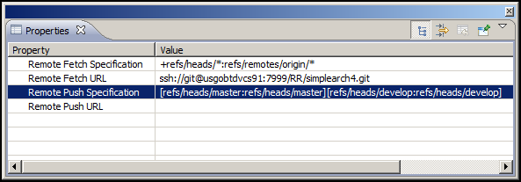

**Fetch the latest changes from the Remote:**

* In the Git Repository view, expand Remotes
* Right-mouse on “origin”, Fetch
* The dialog below shows that your local branches are current or ahead of the remote branches. This means a Push will work cleanly.

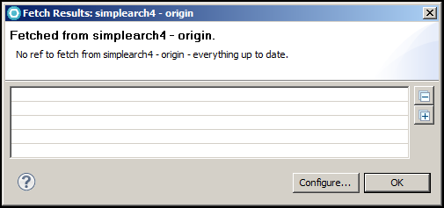

* The dialog below shows that your local “develop” branch is behind the remote branch. This means a Merge will be required before a Push of the “develop” branch will work cleanly.

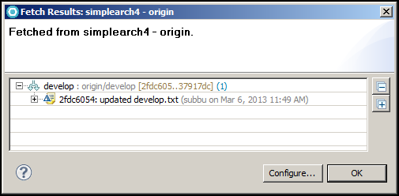

If you try and Push your changes without first merging the remote changes you will see a dialog similar to the one below.

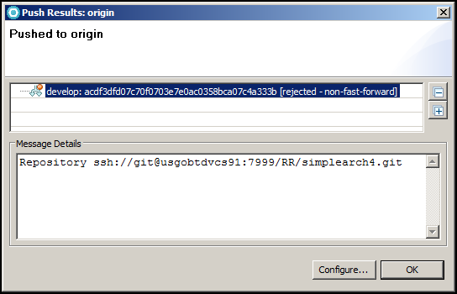

Follow the “Getting_the_latest_code_from_a_Remote” document for Merge instructions.

**Push your commits on a branch to the Remote:**

* In the Git Repository view
* Right-mouse on the Local “develop” branch > Push Branch…

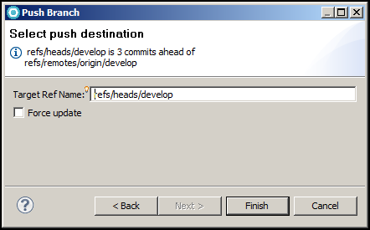

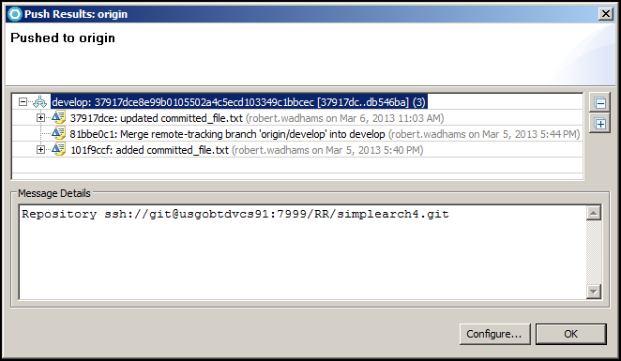

The Stash commit views below verifies the commit SHAs

