Use this document when you have created a brand new project or projects in RAD and now want to put them into Git. For projects that exist in a Harvest lifecycle, follow the instructions in the “Migrating Harvest Code into Git” document.

**Design:**

Eclipse projects should be logically grouped together in your Git Repository. A repository usually builds a single artifact (EAR, WAR, JAR, ZIP, etc). A typical JEE Application would consist of a Build, an EAR, a WAR and optionally multiple EJB / Utility projects.

**Request a GIT Repository:**

Each Stash project will have one or more “Project Administrators”. Have one of these administrators create you a Git repository.

**Minimum GIT Setup in RAD:**

Ensure you have followed the Developer Setup instructions on the Wiki. There are five (5) documents that you need to follow.

**Close all open files:**

* File > Close All

**Create a new Git Repository:**

* In stash, click in the SSH URL for your repo, then Ctrl-C to copy it to the clipboard.
* In the Git Repository view, click “Create a new Git Repository”. The dialog should look similar to the following:
* Keep the name all lowercase, punctuated with dashes. This is your repository name. It doesn’t have to match your Stash repository, but often it does.

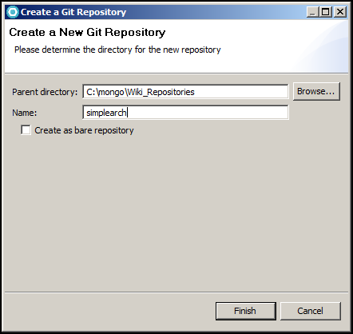

Finish

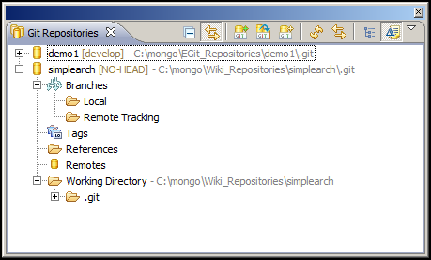

If your Git Repository view doesn’t look similar to above, STOP, contact your Team’s Git Admin or the Architecture Team’s Git Expert to resolve / fix your differences.

Share the Projects with GIT:

Select all projects, right-mouse, Team > Share project…

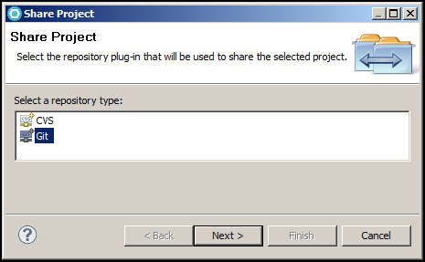

Make sure Git is selected. Next >

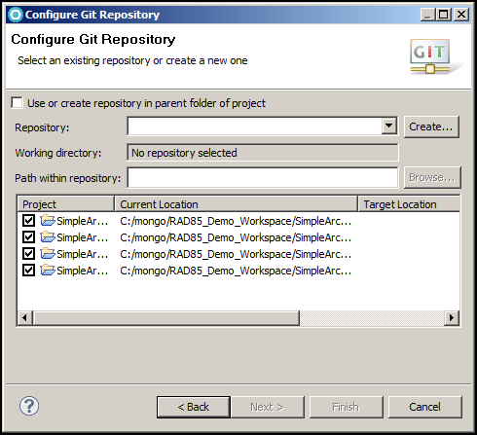

Click the Repository drop-down. Select your Repository.

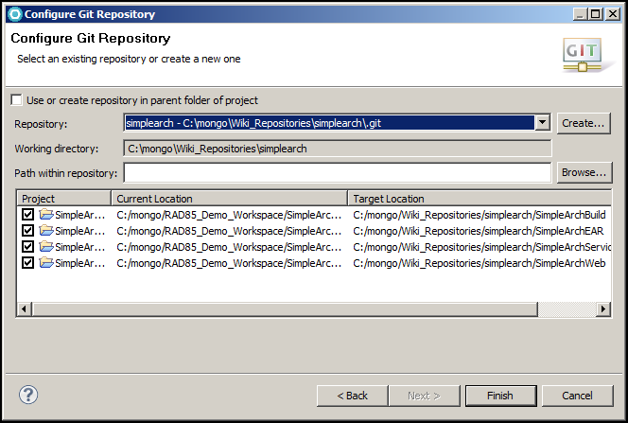

VERY IMPORTANT!!!

Before clicking Finish, ensure the Target Location is correct. EGit is about to move your projects out of your Workspace folder into the default repository folder. Make sure it’s correct.

Click Finish.

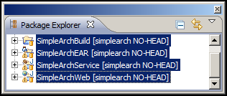

The label decoration may show either NO-HEAD or master.

**Stage and Commit your code locally:**

* Click on the Git Staging view

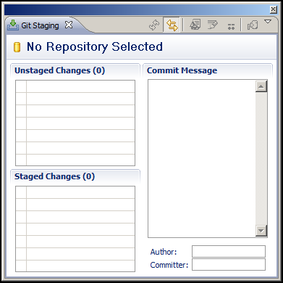

If you see everything empty, you need to select the repository in the Git Repository view before clicking Git staging.

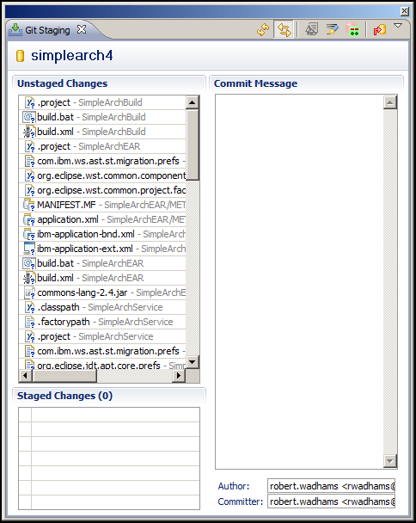

At this point, you are preparing for your first commit into the Git repo.

Take your time and carefully select what files you want under version control.

* Files and folders that shouldn’t be version controlled (e.g. bin, dist, build, testResults, etc) should be added to a .gitignore file. To do this return to the Package Explorer or Navigator view, right-mouse on the specific resource to ignore, Team > Ignore.
* Drag and drop files from the “Unstaged Changes” window to the “Staged Changes” window. Alternately, select files in the “Unstaged Changes” window, right-mouse, Add toGit Index. This will move them to the lower window.

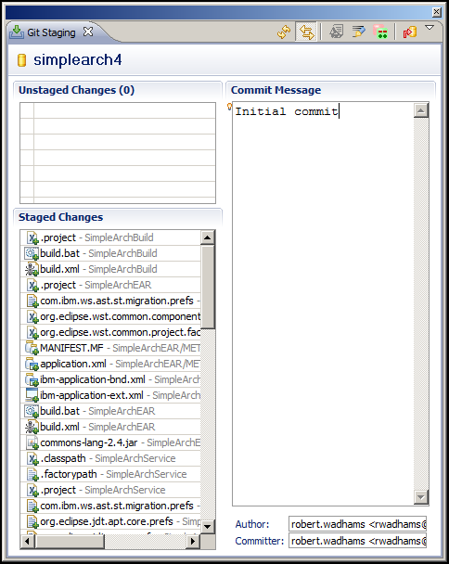

Once you have all your code staged, type a commit message (mandatory) and click the red arrow commit icon.

Your Git Repository view and Package Explorer view should now look similar to below:

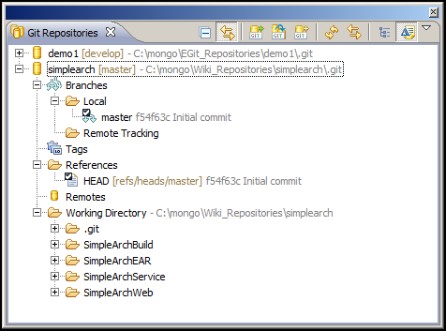

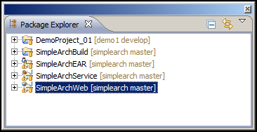

**Create a “develop” branch based off the “master” branch:**

The “master” branch represents the Production code base including short-term development and hot-fixes. The “develop” branch represents long-term development.

* In the Git Repository view, right-mouse, Local > Switch To > New Branch…
* Type: develop
* Uncheck > Checkout new branch
* Finish

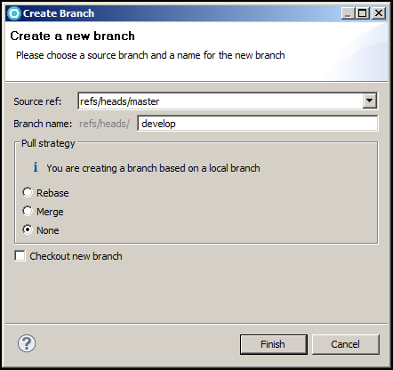

**Interactions with a Remote:**

There two (2) primary interactions that you will do with a Remote:

1. Fetch the latest changes from the Remote. Then Merge those changes into your local repository. Git provides a convenience command that combines both a Fetch and Merge called Pull.
2. Push your local changes to a Remote. Since you have at a minimum two (2) branches (master and develop) you need to configure your local master branch to push to the remote master branch and similarly configure your local develop branch to push to the remote develop branch.

At this stage you have:

* An empty Remote repo. Check Stash to be sure.
* An initial commit.
* Two (2) local branches (master and develop). The HEAD of both these branches points to the initial commit.
* Nothing in our local Git repository ties it back to the remote Stash repository. We will setup the remote configuration now.

**Adding a Remote:**

* Return to Stash and copy the SSH URL of your repository to your clipboard (Ctrl-C). Return to RAD.
* In the Git Repository view, right-mouse Remotes > Create remote…

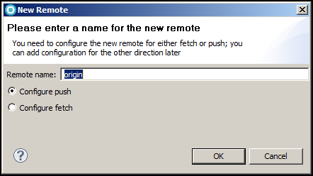

Click OK

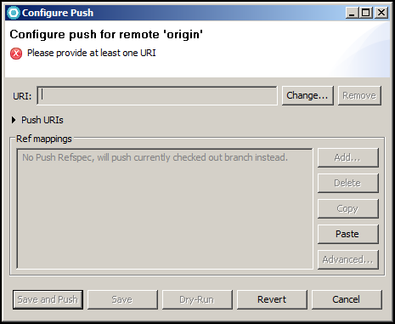

Click Change…

Paste the Stash repository URL into the URI: field.

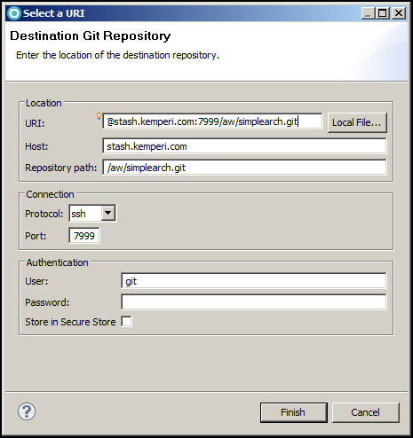

Click Finish

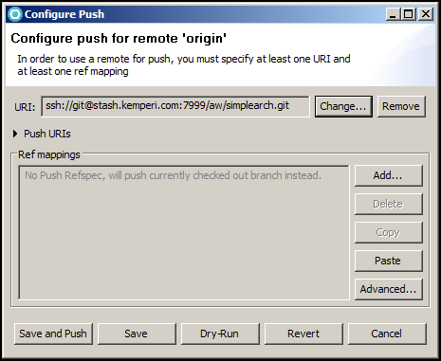

Click Advanced…

Make your Push Ref Specification look similar to below by using the “Add create/update specification” section and the “Add All tags Spec” button.

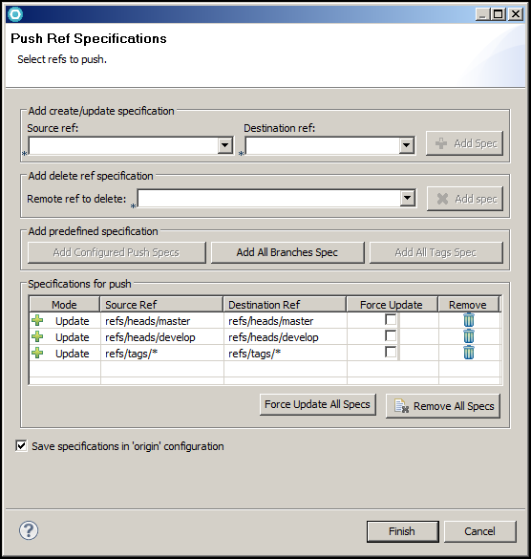

Click Finish

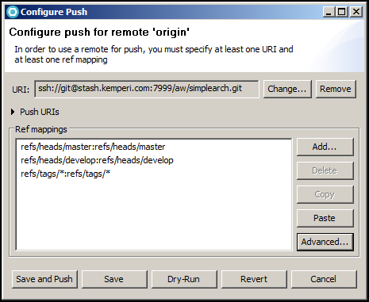

Click “Save and Push”

Click OK on any dialogs that may appear referring to SSH. This happens when you connect and use your SSH keys for the first time with a new remote.

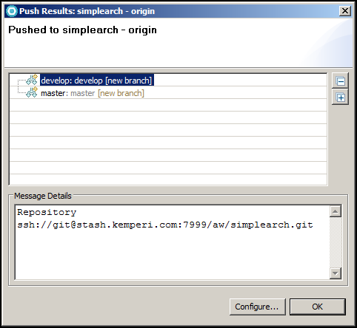

Click OK

Return to Stash and refresh the page. At this point, you should see files, a single commit (initial) and two branches in the dropdown. Return to RAD.

Your Git Repositories view should now look similar to below. Note: the Remote Tracking folder under Branches is still empty. We will now configure Git to track our local master and develop branches to Stash’s remote master and develop branches.

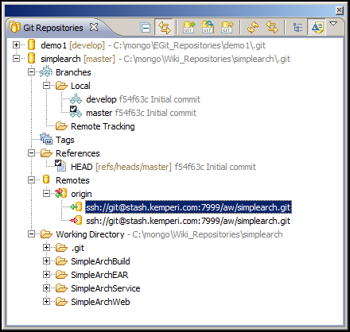

**Setup Fetch Configuration:**

* In the Git Repository view, expand Remotes, Expand origin
* A green Fetch URL should exist. Right-mouse, Configure Fetch…

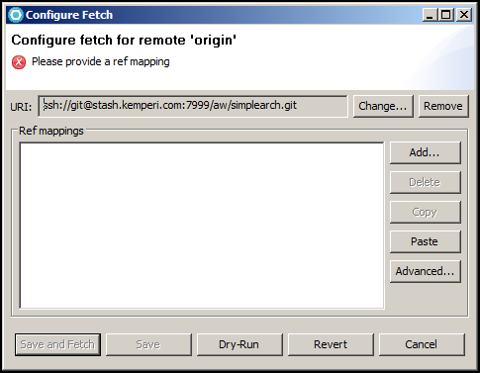

Click Advanced…

Make your Fetch Ref Specification look similar to below by using the “Add All Branches Spec” and “Add All tags Spec” buttons.

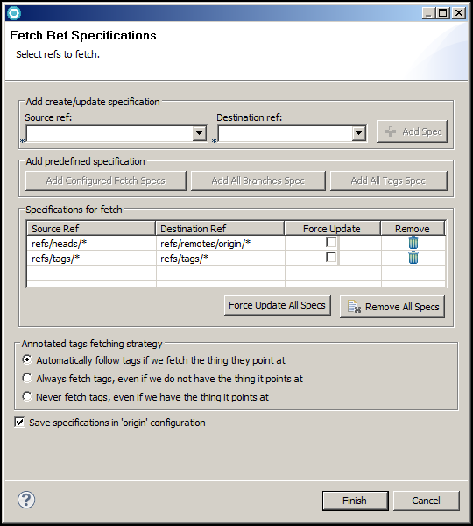

Click Finish

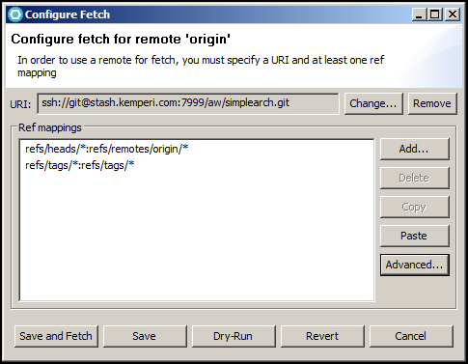

Click “Save and Fetch”

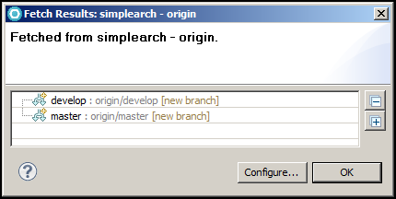

Your Git Repositories view should now look similar to below:

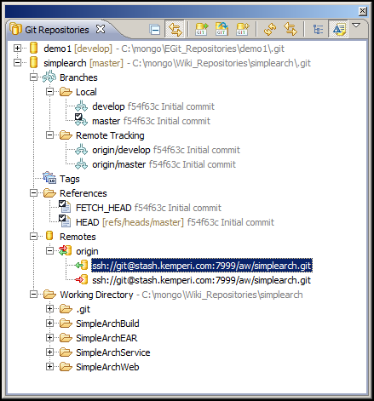

**Prepare each branch for Pull:**

* In the Git Repository view, expand Branches, Local, Right-mouse on the master branch, Configure Branch…
* Make your Git Branch Configuration look exactly as below.

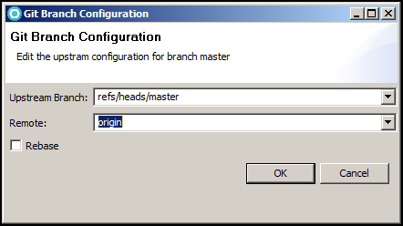

Click OK

Do the same for the develop branch

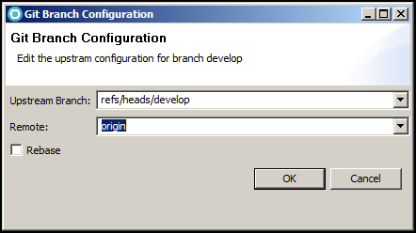

Click OK

**Verify “Pull” is configured correctly:**

* The Pull process works at the Repo level and only fetches and merges the currently checked out branch.
* In the Git Repository view,>
* Right-mouse on the Repo (top level folder), > Pull

You should see a dialog similar to below. Since there are no changes on the remote compared to locally, The “Pull Result” dialog reports that everything is up-to-date.

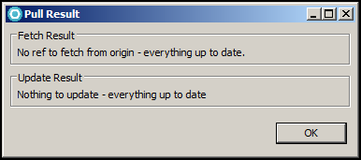

**Stash:**

Go back to Stash and refresh the repository page.

* Under Files,
  + Branch drop-down with both master and develop.
  + Folder structure representing your projects.
* Under Commits,
  + Author, commit SHA, commit message and commit date.

**Other Considerations:**

1. If you added a new Eclipse project into your workspace. The project is known to RAD (compiles, tests, etc), but Git has no knowledge of it. Follow the procedures above starting with Team> Share projects…