Overview
This interactive dashboard allows users to explore the progression of COVID-19 cases, recoveries, and deaths globally. Built with R Shiny, the app provides various visualisation options including:
- Time Series Plots of cumulative cases
- Daily Change Plots to track daily fluctuations
- Summary Tables for numerical insights
- An interactive World Map showing the spatial distribution of cases
Users can filter the data by country, metric (Confirmed, Recovered, Deaths), and time range. Faceting and log-scaling options are available for enhanced analysis.

Getting Started
To launch the app, ensure you have the `countries-aggregated.csv` dataset in your working directory, then run:
shiny::runApp("path_to_app_directory")
The dataset must include the columns: Date, Country, Confirmed, Recovered, Deaths.

App Features
Sidebar Filters
The sidebar includes dynamic controls that change based on your selected tab:
- Time Series Plot / Summary Table
- Country Selector: Choose up to 3 countries
- Metric Selector: Choose one or more of Confirmed, Recovered, Deaths
- Date Range: Filter the time period
- Logarithmic Scale: Toggle log scale for y-axis
- Faceting Options: Facet by country or metric depending on selection

- Daily Change Plot / Daily Table
- Same options as above but for daily changes in COVID-19 numbers.

- World Map
- Choose a daily metric
- Filter by date range
- Select globe projection

Main Panels
- Value Boxes: Displays total daily confirmed, recovered, and death cases for selected countries and dates.
- Time Series Plot: Shows cumulative trends over time with options to facet and log-transform the y-axis.
- Summary Table: Tabular view of selected metrics over time.
- Daily Change Plot: Displays daily new cases, deaths, or recoveries.
- Daily Table: Tabular view of daily metrics.
- COVID-19 Map: Animated map (Plotly) showing how cases spread over time globally.

Short Worked Example
Goal: Compare Daily Confirmed Cases Between South Africa and Germany for the period 01-July 2020 to 30 June 2021.
Step 1: Launch the app. You should then see the following window.
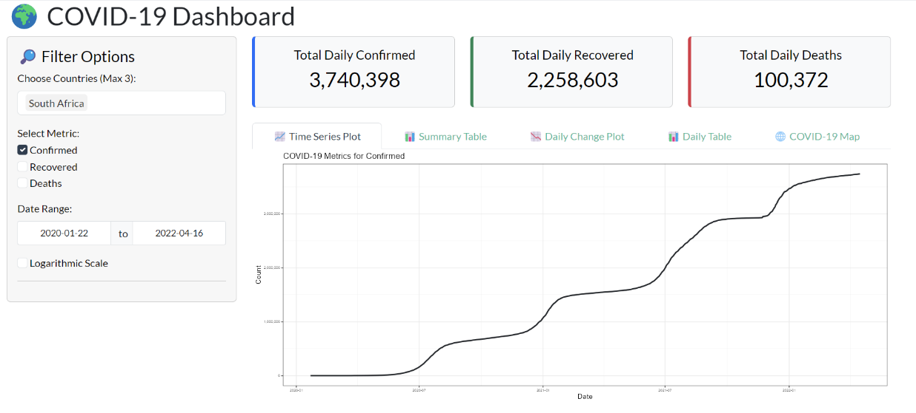

Step 2: Go to "Daily Change Plot". The tab should have the following page.
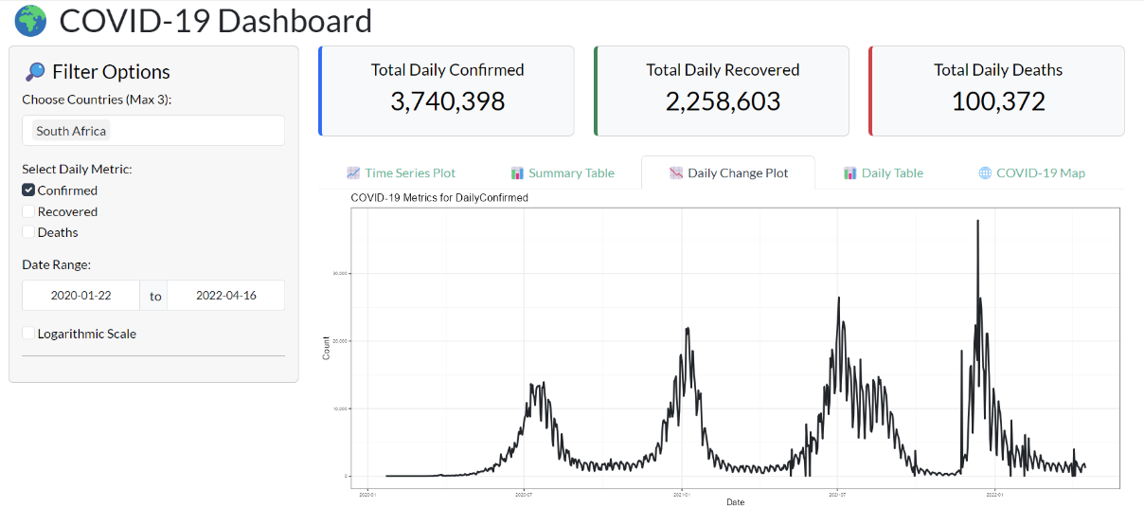
Step 3: In the sidebar
- Choose Countries: South Africa should already be selected, add Germany.
- Select Daily Metric: Leave the selected metric as is, it should be “Confirmed”.
- Date Range: Set the date range from 2020-07-01 to 2021-06-30.
- Logarithmic Scale: Leave as unchecked.
- Facet by Country: This option only appears if there is more than one country selected. Since we have South Africa and Germany as our selected countries this option should be there. For now, leave this option as unchecked.
After inputting all the options above you should get the following window.

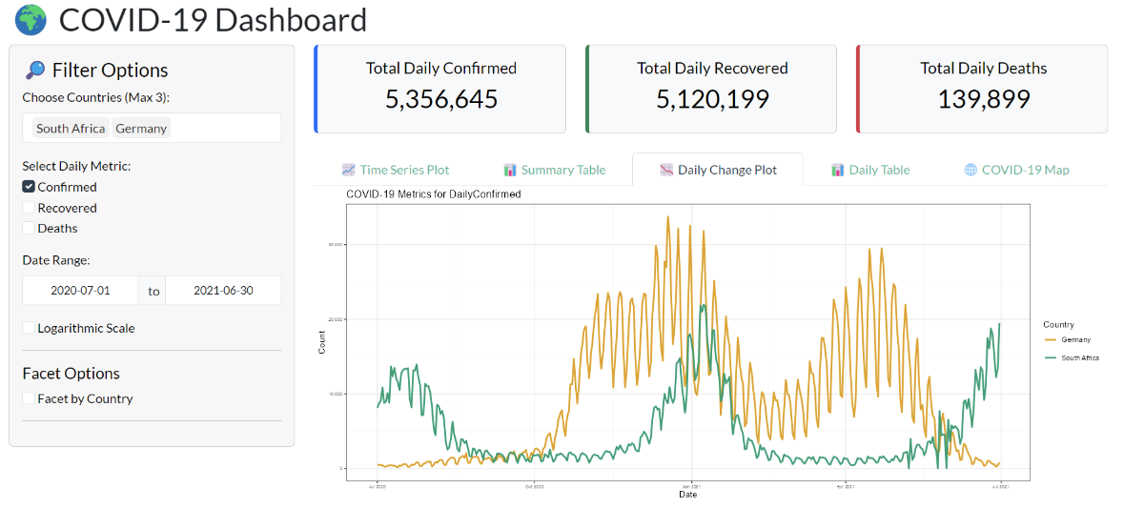

Notes
- Only 3 countries can be selected at a time.
- Blank plot? Ensure at least one country and metric is selected.
- Negative daily values are cleaned and replaced with 0.

Conclusion
This dashboard provides a flexible tool to explore COVID-19 data. Whether for global trends or local insights, it's built for exploration.

