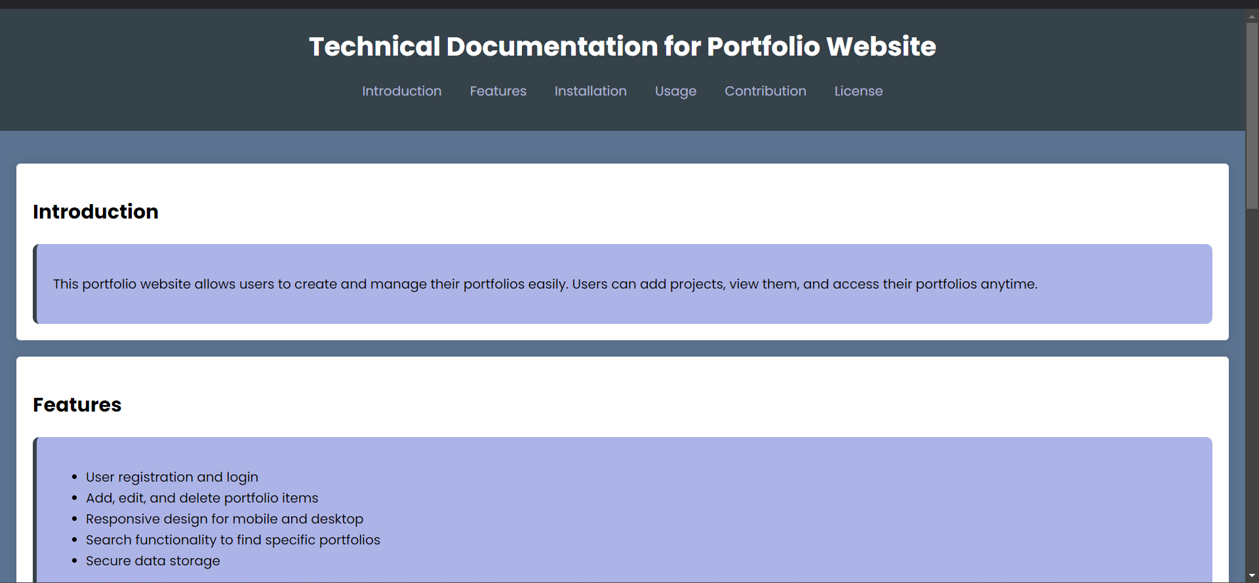

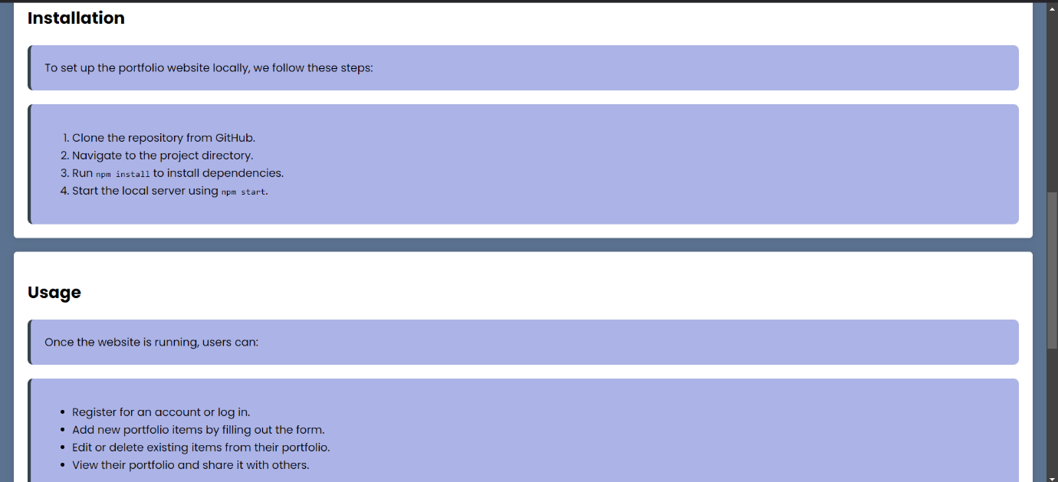

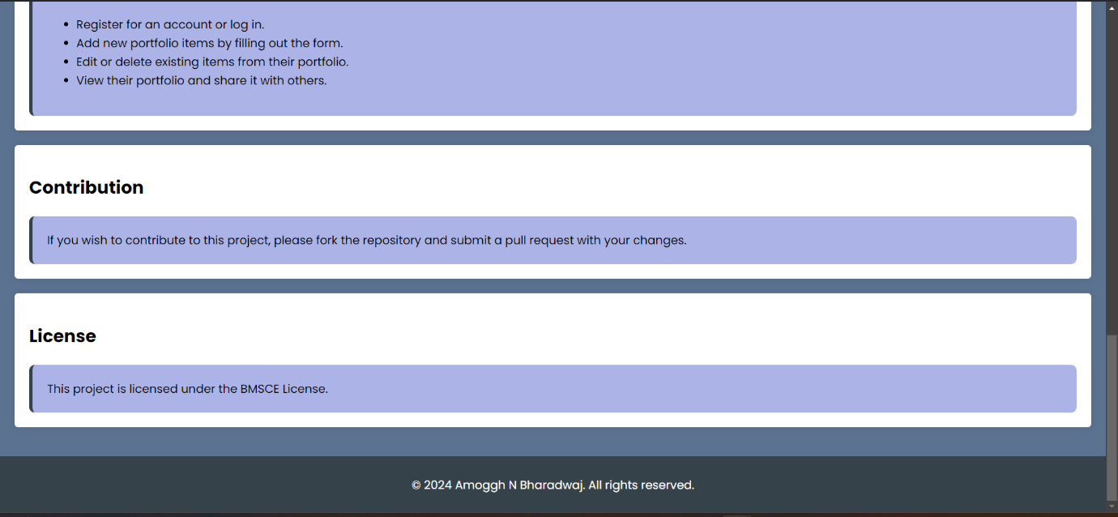

<!DOCTYPE html>

<html lang="en">

<head>

    <meta charset="UTF-8">

    <meta name="viewport" content="width=device-width, initial-scale=1.0">

    <title>Portfolio Website Documentation</title>

    <link rel="preconnect" href="https://fonts.googleapis.com">

<link rel="preconnect" href="https://fonts.gstatic.com" crossorigin>

<link href="https://fonts.googleapis.com/css2?family=Poppins:ital,wght@0,100;0,200;0,300;0,400;0,500;0,600;0,700;0,800;0,900;1,100;1,200;1,300;1,400;1,500;1,600;1,700;1,800;1,900&display=swap" rel="stylesheet">

</head>

<link rel="stylesheet" href="styles.css">

<body>

    <header>

        <h1>Technical Documentation for Portfolio Website</h1>

        <nav>

            <ul>

                <li><a href="#introduction">Introduction</a></li>

                <li><a href="#features">Features</a></li>

                <li><a href="#installation">Installation</a></li>

                <li><a href="#usage">Usage</a></li>

                <li><a href="#contribution">Contribution</a></li>

                <li><a href="#license">License</a></li>

            </ul>

        </nav>

    </header>

    <main>

        <section id="introduction">

            <h2>Introduction</h2>

            <div class="box"><p>This portfolio website allows users to create and manage their portfolios easily. Users can add projects, view them, and access their portfolios anytime.</p></div>

        </section>

        <section id="features">

            <h2>Features</h2>

            <div class="box">

            <ul>

                <li>User registration and login</li>

                <li>Add, edit, and delete portfolio items</li>

                <li>Responsive design for mobile and desktop</li>

                <li>Search functionality to find specific portfolios</li>

                <li>Secure data storage</li>

            </ul>

        </div>

        </section>

        <section id="installation">

            <h2>Installation</h2>

            <div class="box">To set up the portfolio website locally, we follow these steps:</div>

            <div class="box"><ol>

                <li>Clone the repository from GitHub.</li>

                <li>Navigate to the project directory.</li>

                <li>Run <code>npm install</code> to install dependencies.</li>

                <li>Start the local server using <code>npm start</code>.</li>

            </ol></div>

        </section>

        <section id="usage">

            <h2>Usage</h2>

            <div class="box">Once the website is running, users can:</div>

            <div class="box"><ul>

                <li>Register for an account or log in.</li>

                <li>Add new portfolio items by filling out the form.</li>

                <li>Edit or delete existing items from their portfolio.</li>

                <li>View their portfolio and share it with others.</li>

            </ul>

        </div>

        </section>

        <section id="contribution">

            <h2>Contribution</h2>

            <div class="box">If you wish to contribute to this project, please fork the repository and submit a pull request with your changes.

            </div>

        </section>

        <section id="license">

            <h2>License</h2>

            <div class="box">This project is licensed under the BMSCE License.

            </div>

        </section>

    </main>

    <footer>

        <p>&copy; 2024 Amoggh N Bharadwaj. All rights reserved.</p>

    </footer>

</body>

</html>

body {

    font-family: "Poppins", 'Arial Narrow', Arial, sans-serif;

    line-height: 1.6;

    margin: 0;

    padding: 0;

    background-color: #5b7290;

}

header {

    background: #35424a;

    color: #ffffff;

    padding: 20px 0;

    text-align: center;

}

header h1 {

    margin: 0;

}

nav ul {

    list-style: none;

    padding: 0;

}

nav ul li {

    display: inline;

    margin: 0 15px;

}

nav a {

    color: #b8bcdcec;

    text-decoration: none;

}

main {

    padding: 20px;

}

section {

    background: #ffffff;

    margin: 20px 0;

    padding: 20px;

    border-radius: 5px;

    box-shadow: 0 0 10px rgba(0, 0, 0, 0.1);

}

footer {

    text-align: center;

    padding: 10px 0;

    background: #35424a;

    color: #ffffff;

    position: relative;

    bottom: 0;

    width: 100%;

}

.poppins-regular {

    font-family: "Poppins", sans-serif;

    font-weight: 400;

    font-style: normal;

  }

  .box {

    display: flex;

    background-color: rgb(172, 179, 230);

    border-left: 5px solid #35424a;

    padding: 20px;

    margin-top: 20px;

    border-radius: 8px;

  }