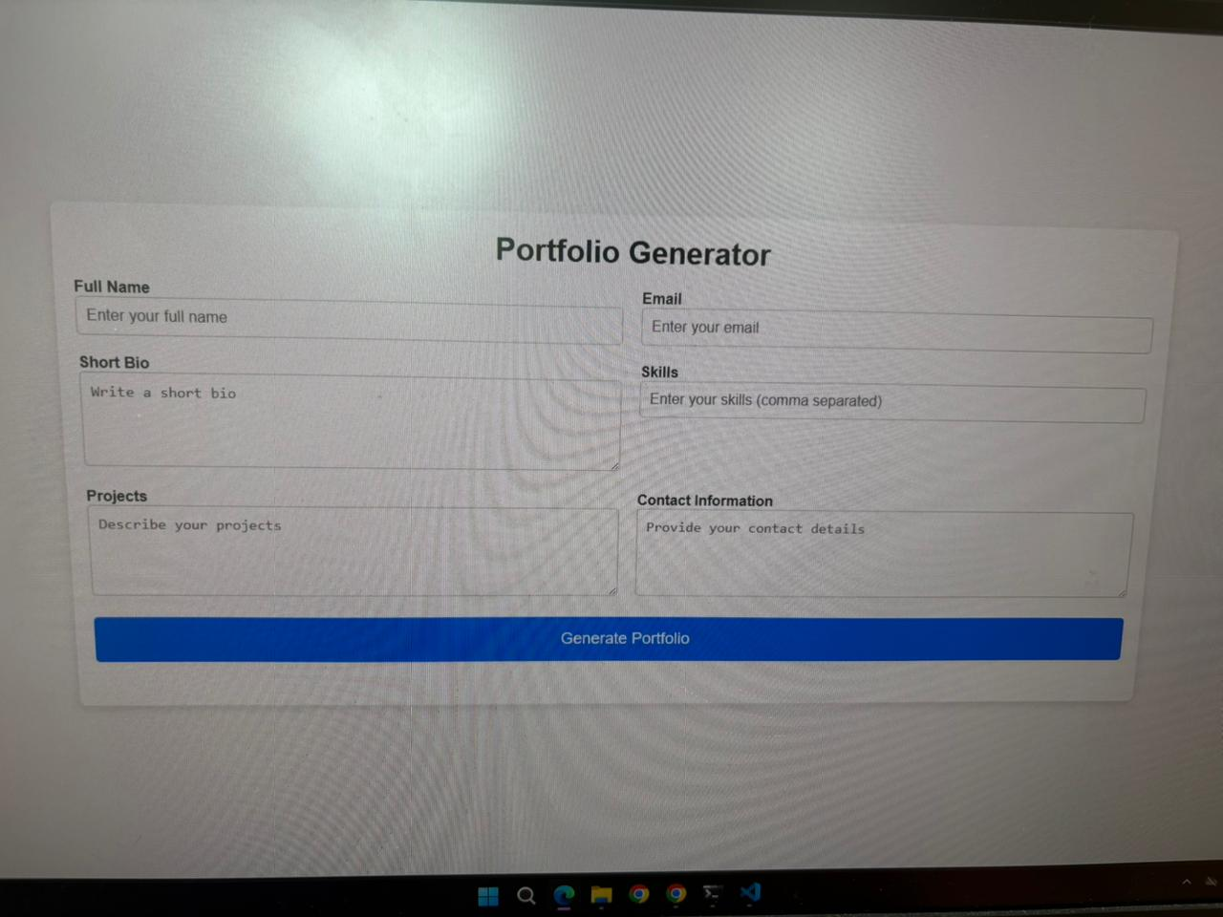

<!DOCTYPE html>

<html lang="en">

<head>

<meta charset="UTF-8">

<meta name="viewport" content="width=device-width, initial-scale=1.0">

<title>Portfolio Generator</title>

<style>

/\* Reset some default styles \*/

\* {

margin: 0;

padding: 0;

box-sizing: border-box;

}

body {

font-family: 'Arial', sans-serif;

background-color: #f5f5f5;

display: flex;

justify-content: center;

align-items: center;

min-height: 100vh;

padding: 20px;

}

.container {

background-color: white;

width: 80%;

max-width: 1200px;

padding: 20px;

box-shadow: 0 4px 10px rgba(0, 0, 0, 0.1);

border-radius: 8px;

transition: transform 0.3s ease-in-out;

}

.container:hover {

transform: scale(1.02);

}

h1 {

text-align: center;

margin-bottom: 20px;

color: #333;

}

form {

display: grid;

grid-template-columns: 1fr 1fr;

gap: 20px;

margin-bottom: 30px;

}

label {

font-weight: bold;

color: #555;

}

input,

textarea {

padding: 10px;

border: 1px solid #ccc;

border-radius: 5px;

font-size: 16px;

width: 100%;

}

textarea {

resize: vertical;

min-height: 100px;

}

button {

grid-column: span 2;

padding: 15px;

background-color: #007bff;

color: white;

font-size: 18px;

border: none;

border-radius: 5px;

cursor: pointer;

transition: background-color 0.3s ease;

}

button:hover {

background-color: #0056b3;

}

.portfolio-output {

margin-top: 40px;

background-color: #efefef;

padding: 20px;

border-radius: 8px;

}

.portfolio-output h2 {

color: #333;

margin-bottom: 10px;

}

.portfolio-output .info {

margin-bottom: 15px;

}

.portfolio-output .info strong {

font-weight: bold;

}

.portfolio-output ul {

list-style-type: none;

}

.portfolio-output ul li {

margin-bottom: 10px;

}

/\* Responsive Design \*/

@media screen and (max-width: 768px) {

.container {

width: 100%;

padding: 15px;

}

form {

grid-template-columns: 1fr;

}

}

</style>

</head>

<body>

<div class="container">

<h1>Portfolio Generator</h1>

<form id="portfolioForm">

<div class="form-group">

<label for="name">Full Name</label>

<input type="text" id="name" placeholder="Enter your full name" required>

</div>

<div class="form-group">

<label for="email">Email</label>

<input type="email" id="email" placeholder="Enter your email" required>

</div>

<div class="form-group">

<label for="bio">Short Bio</label>

<textarea id="bio" placeholder="Write a short bio" required></textarea>

</div>

<div class="form-group">

<label for="skills">Skills</label>

<input type="text" id="skills" placeholder="Enter your skills (comma separated)" required>

</div>

<div class="form-group">

<label for="projects">Projects</label>

<textarea id="projects" placeholder="Describe your projects" required></textarea>

</div>

<div class="form-group">

<label for="contacts">Contact Information</label>

<textarea id="contacts" placeholder="Provide your contact details" required></textarea>

</div>

<button type="submit">Generate Portfolio</button>

</form>

<div class="portfolio-output" id="portfolioOutput" style="display: none;">

<h2>Your Portfolio</h2>

<div class="info"><strong>Name:</strong> <span id="outputName"></span></div>

<div class="info"><strong>Email:</strong> <span id="outputEmail"></span></div>

<div class="info"><strong>Bio:</strong> <span id="outputBio"></span></div>

<div class="info"><strong>Skills:</strong> <span id="outputSkills"></span></div>

<div class="info"><strong>Projects:</strong> <span id="outputProjects"></span></div>

<div class="info"><strong>Contact Information:</strong> <span id="outputContacts"></span></div>

</div>

</div>

<script>

// JavaScript to handle form submission and display the portfolio

document.getElementById('portfolioForm').addEventListener('submit', function (e) {

e.preventDefault();

// Collect values from form fields

const name = document.getElementById('name').value;

const email = document.getElementById('email').value;

const bio = document.getElementById('bio').value;

const skills = document.getElementById('skills').value;

const projects = document.getElementById('projects').value;

const contacts = document.getElementById('contacts').value;

// Display the portfolio information

document.getElementById('outputName').textContent = name;

document.getElementById('outputEmail').textContent = email;

document.getElementById('outputBio').textContent = bio;

document.getElementById('outputSkills').textContent = skills;

document.getElementById('outputProjects').textContent = projects;

document.getElementById('outputContacts').textContent = contacts;

// Show the portfolio section

document.getElementById('portfolioOutput').style.display = 'block';

});

</script>

</body>

</html>