TASK 1 — Configure Git
Set your Git:
- Name
- Email
Evidence
Screenshot 1: Show your Git name and email.

TASK 2 — Initialize Git
Create a website folder containing:
index.html
style.css
Initialize the folder as a Git repository.
Evidence
Screenshot 2: Show that Git has been initialized.

TASK 3 — First Commit
Add and commit only index.html.
Do not commit style.css yet.
Evidence
Screenshot 3: Show the first Git commit/history.

TASK 4 — Create GitHub Repository
Create a GitHub repository named:
my-website026
Evidence
Screenshot 4: Show your GitHub repository.
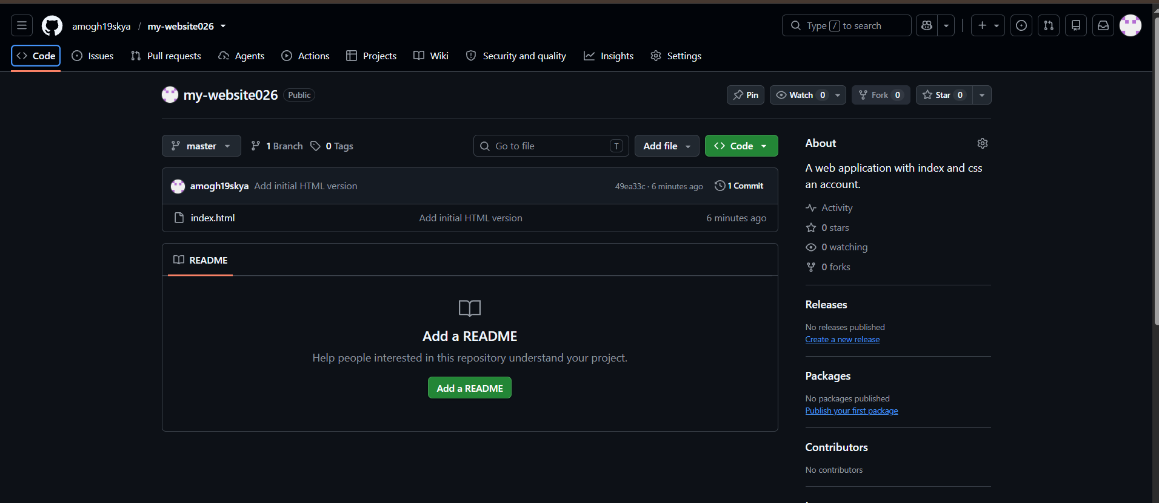

TASK 5 — Connect and Push
Connect your local Git repository to GitHub and push the first version.
At this stage GitHub should contain:
index.html
Evidence
Screenshot 5: Show the repository connection.
Screenshot 6: Show index.html on GitHub.
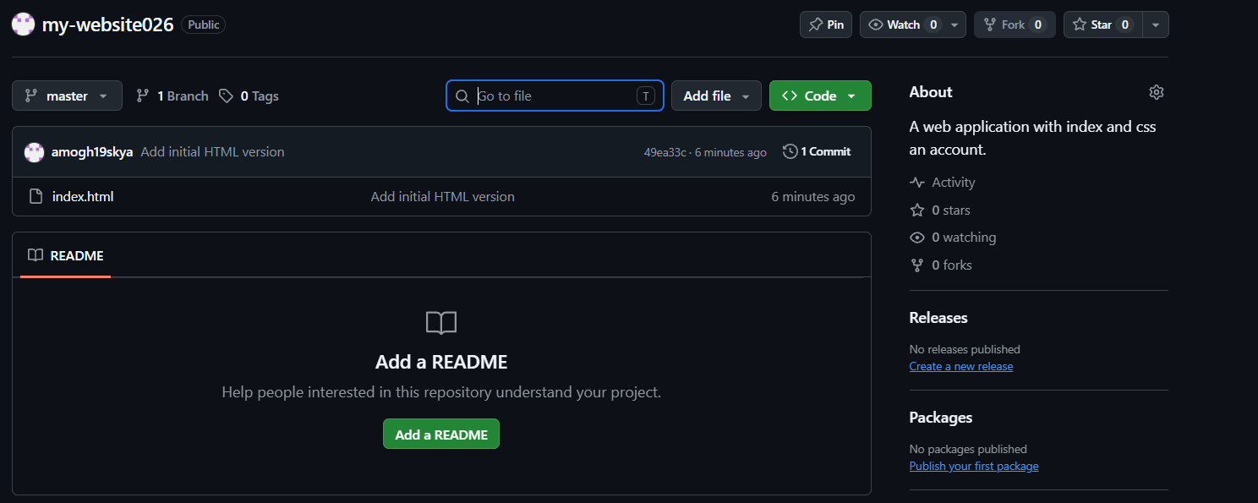

TASK 6 — Create CSS Branch
Create a new branch:
add-css
Switch to the branch and add/complete your style.css.
Commit the CSS changes.
Evidence
Screenshot 7: Show:
- add-css branch
- CSS commit
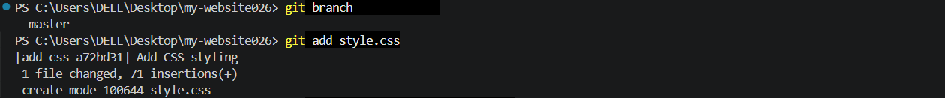
- Current branch

TASK 7 — Merge CSS
Switch back to:
master
Merge the:
add-css
branch into master.
Evidence
Screenshot 8: Show that the CSS branch has been merged into master.
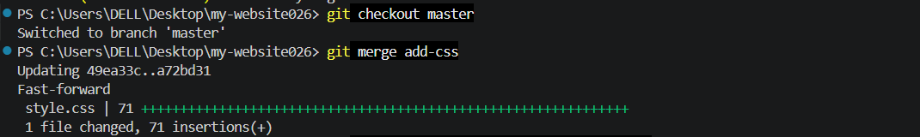

TASK 8 — Final Push
Push the final master branch to GitHub.
Your GitHub repository should now contain:
index.html
style.css
Evidence
Screenshot 9: Show both files on GitHub and your final Git history.
