**Car Parking System**

Amogh Kulkarni

(231EC106)

Design and implementation of car parking system on FPGA.

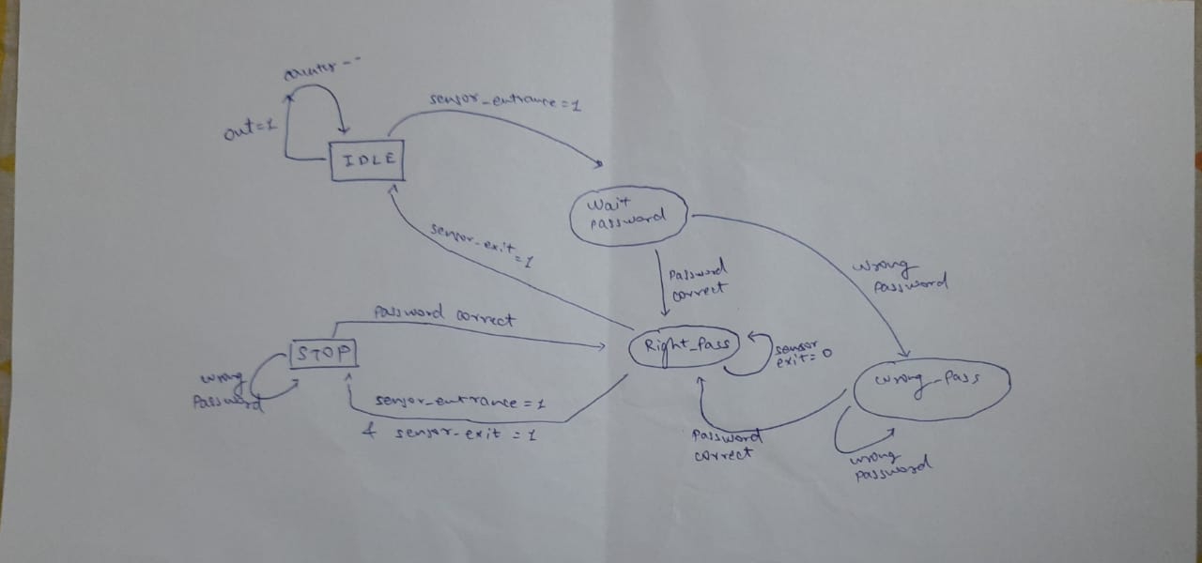

**Resource utilization**

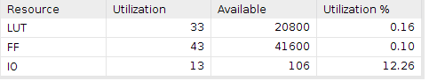

**Resources Used**

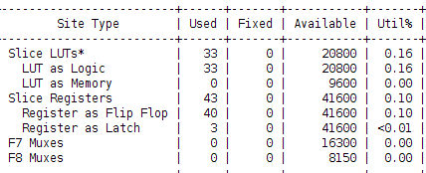

**Percentage Utilization**

