SKIN DIAGNOSIS REPORT

DATE:2022-12-21  
NAME:Rahul Punekar   
AGE:30   
GENDER:Male

PROVIDED IMAGE:  
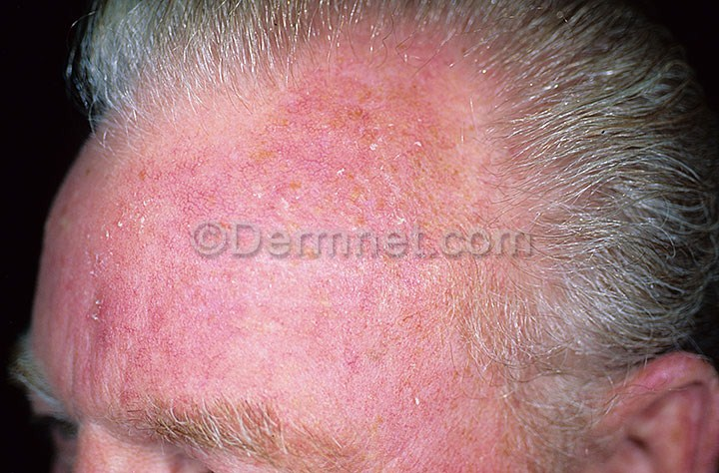  
  
PREDICTED DISEASE: actinic-keratosis  
GENERAL LOCATION: Sun-Exposed Areas like head, neck, forearms, hands,etc.   
SEVERITY: Mild  
RECOVERY TIME:3 weeks