**OS PRACTICAL-EXAMINATION**

Name: Amogh Garg

Roll Number: 2020UCO1688

Branch: Computer Science and Engineering

Date of Examination: 27.04.2022

Course: Operating System

Course Code: COCSC09

-------------------------------------------------------------------------------------­­­­­­­­­­­­­­­­---------

**Question-1: Priority Scheduling Implementation**

Code:  
#include<stdio.h>

struct process{

int WT,AT,BT,TAT,PT;

};

struct process a[10]; //Array of processes

//Higher number denotes lower priority

// Therefore 1 means highest priority

int main(){

int n,temp[10],t,count=0,prior;

float total_WT=0,total_TAT=0,Avg_WT,Avg_TAT;

printf("Enter the number of the process(<=8):");

scanf("%d",&n);

printf("Enter the arrival time , burst time and priority of the process:");

printf("AT BT PT\n");

for(int i=0;i<n;i++){

scanf("%d%d%d",&a[i].AT,&a[i].BT,&a[i].PT);

temp[i]=a[i].BT;

}

a[9].PT=10000; // 10000 here denotes very low priority

for(t=0;count!=n;t++){ //t is time counter here

prior=9; // Assuming imaginary process 9 has highest priority

//Loop for finding highest priority

for(int i=0;i<n;i++){

if(a[prior].PT>a[i].PT && a[i].AT<=t && a[i].BT>0){

prior=i;

}

}

a[prior].BT=a[prior].BT-1;

//Count denotes number of completed processes

if(a[prior].BT==0){

count++;

a[prior].WT=t+1-a[prior].AT-temp[prior];

a[prior].TAT=t+1-a[prior].AT;

total_WT=total_WT+a[prior].WT;

total_TAT=total_TAT+a[prior].TAT;

}

}

Avg_WT=total_WT/n;

Avg_TAT=total_TAT/n;

printf("ID WT TAT\n");

for(int i=0;i<n;i++){

printf("%d\t%d\t%d\n",i+1,a[i].WT,a[i].TAT);

}

printf("Avg waiting time of the process is %f\n",Avg_WT);

printf("Avg turn around time of the process is %f\n",Avg_TAT);

return 0;

}

OUTPUT:  
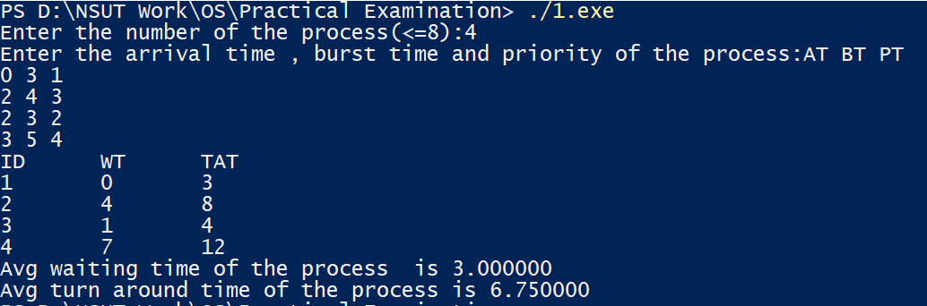

**Question-2: Shortest Seek Time First (SSTF) Implementation**

Code:  
#include<stdio.h>

#include<stdlib.h>

int main(){

int RS[100],i,n,TotalHead=0,initial,count=0;

printf("Enter the number of Requests:");

scanf("%d",&n);

printf("Enter the Requests sequence:");

for(i=0;i<n;i++)

scanf("%d",&RS[i]);

printf("Enter initial head position:");

scanf("%d",&initial);

//Count is the count of serviced requests

while(count!=n){

//1000 here denotes very large number

int min=1000,d,index;

//Finding shortest seek-time

for(i=0;i<n;i++){

d=abs(RS[i]-initial);

if(min>d){

min=d;

index=i;

}

}

TotalHead=TotalHead+min;

initial=RS[index];

//So that this request doesn't get serviced again

RS[index]=1000;

count++;

}

printf("Total head movement is %d",TotalHead);

return 0;

}

Output:

