**COCSC20 - INTERNET OF THINGS  
EXERCISE - 1**

**JANUARY 12, 2023  
AMOGH GARG – 2020UCO1688  
_______________________________________________________________________________________________**

**PROBLEM:**

Design a circuit for turning on LED, blinking the LEDs, draw a circuit diagram of your solution (TINKERCAD software).

**COMPONENTS REQUIRED:**

* 1 x Arduino Uno R3
* 5 x Red LEDs
* 5 x 1 kilo-ohm resistors
* Breadboard

**UNDERSTANDING REQUIRED:**

* Knowledge about microcontrollers.
* Arduino Backgrounds, Type of Arduino
* Components of Arduino Uno
* Interfacing of LEDs and resistors.
* Making a circuit.
* Programming in Arduino

**SOLUTION:**

* Connect the 5V point of the Arduino Uno to the positive power rail of the breadboard and GND to the negative power rail.
* Connect the 5 LEDs on the breadboard as shown in the circuit diagram.
* Connect the Pins 3,4,5,6,7 of the Arduino Uno to the cathodes of the 5 LEDs respectively.
* The anode of the LEDs is connected to the negative power rail through 1 kilo-ohm resistor each. This is done to control the current passing through each LED and prevent short-circuiting.

**CIRCUIT DIAGRAM:**

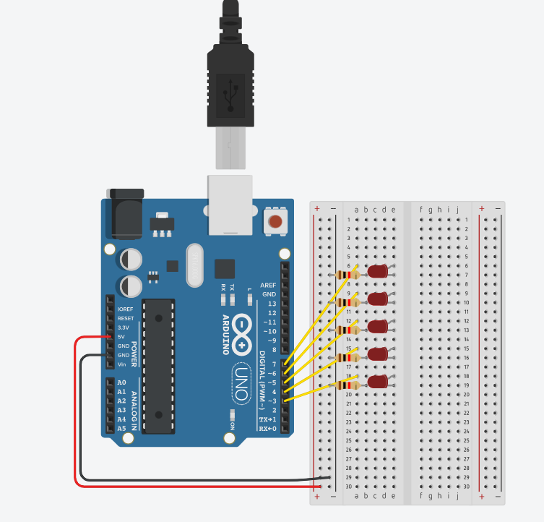

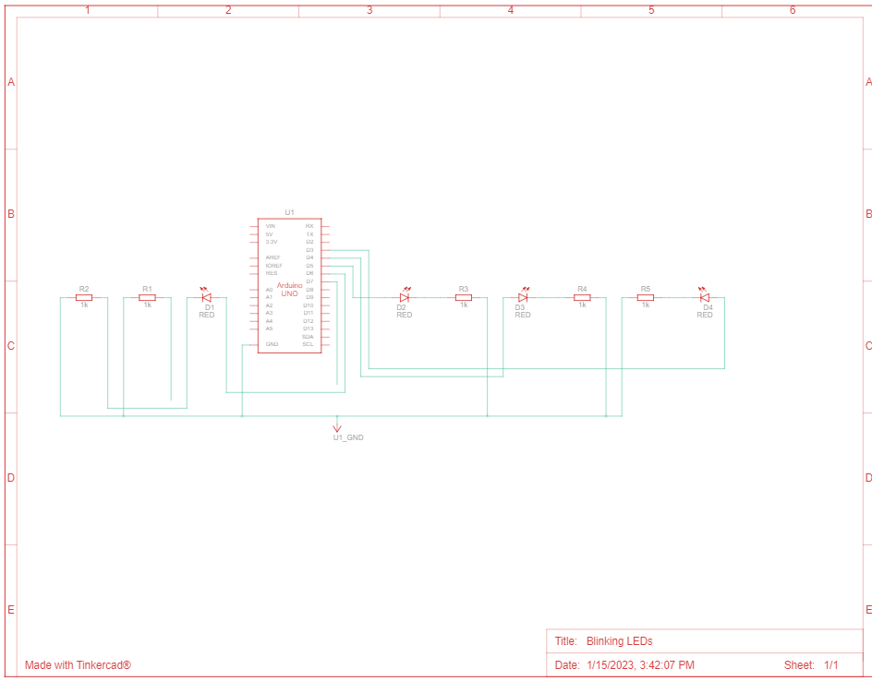

**CODE:**

int timer = 500;

void setup() {

// Initialising the pins as output pins

for (int pin = 3; pin < 8; pin++) {

pinMode(pin, OUTPUT);

}

}

void loop() {

// Loop to light the LED from highest pin - lowest pin

for (int pin = 7; pin >= 3; pin--) {

// Turn the pin on

digitalWrite(pin, HIGH);

// Wait for half second (500 ms)

delay(timer);

// Turn the pin off:

digitalWrite(pin, LOW);

}

// Loop to light the LED from lowest pin - highest pin

for (int pin = 3; pin < 8; pin++) {

// Turn the pin on:

digitalWrite(pin, HIGH);

// Wait for half second (500ms)

delay(timer);

// Turn the pin off:

digitalWrite(pin, LOW);

}

}

**DIFFICULTY ISSUES:**

* Understanding how to make connections on the breadboard.
* Making the circuit with the help of breadboard.
* Getting familiar with TINKERCAD software.