**COCSC20 - INTERNET OF THINGS  
EXERCISE - 3**

**FEBRUARY 07, 2023  
AMOGH GARG – 2020UCO1688  
_______________________________________________________________________________________________**

**PROBLEM:**

1. Design a circuit for interfacing the LDR Sensor and print the value of light intensity at various instances.
2. Design a circuit for interfacing PIR Sensor and discuss the use of status variable in the sketch.

**COMPONENTS REQUIRED:**

* 1 x Arduino Uno R3
* 1 x Breadboard
* 1 x LDR
* Resistors, LEDs
* 1 x PIR
* 1 x LED
* Jumper cables

**UNDERSTANDING REQUIRED:**

* Knowledge about sensor technology, various types of sensors
* Arduino Backgrounds, Type of Arduino
* Basic understanding about LDR and its working
* Basic understanding about PIR and its working
* Writing code on Arduino IDE

**CIRCUIT DIAGRAM:**

**LDR:**

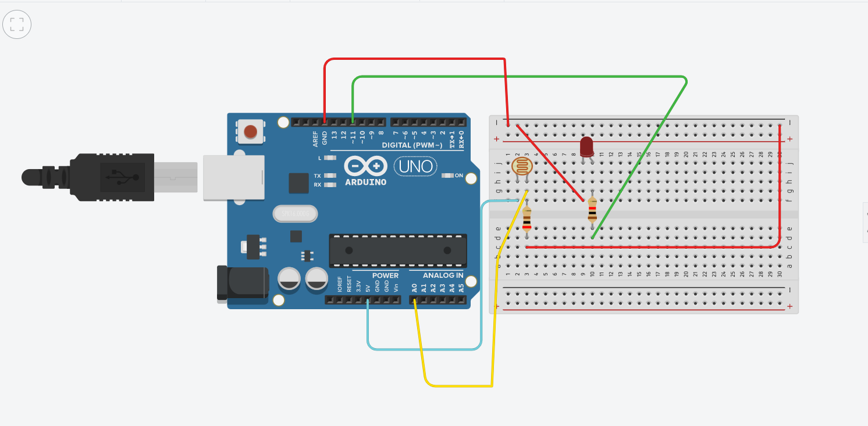

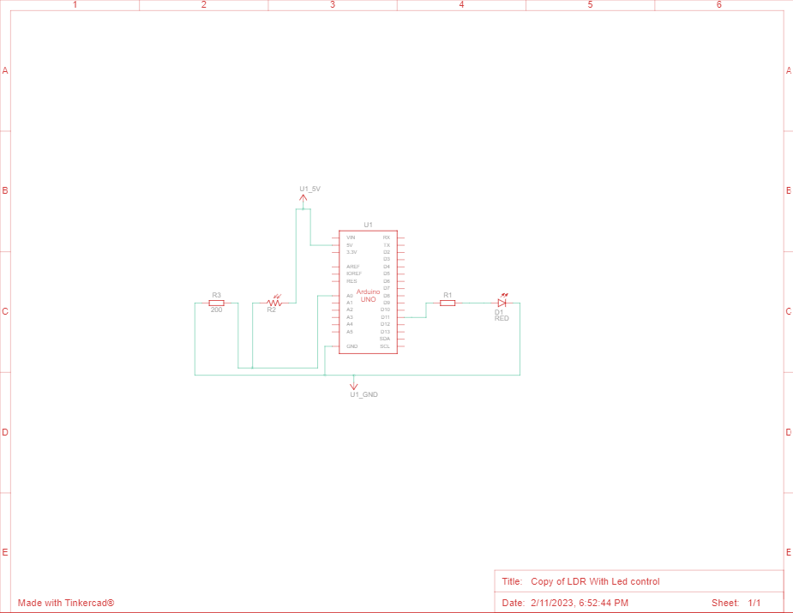

**PIR:**

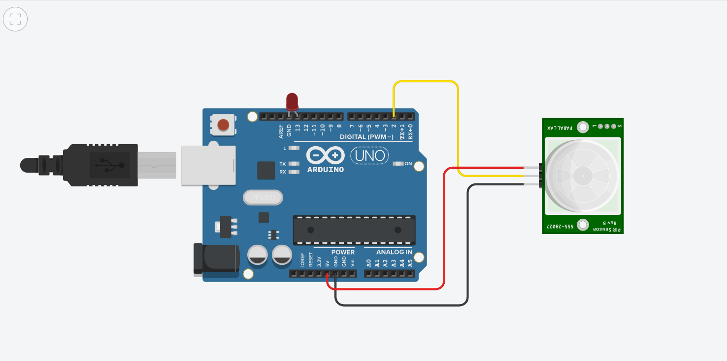

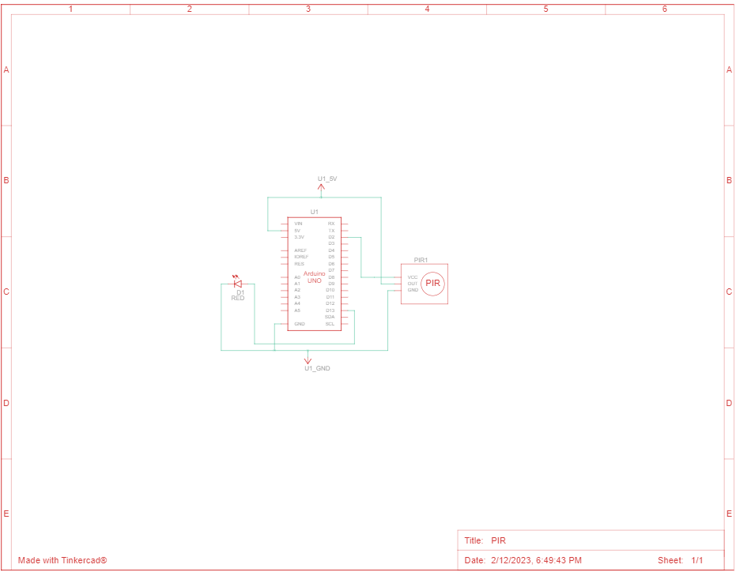

**CODE:**

**LDR Code:**

int value=0;

void setup()

{

Serial.begin(9600);

pinMode(11, OUTPUT);

pinMode(A0, INPUT);

}

void loop()

{

value= analogRead(A0);

if(value<10)

{

digitalWrite(11, HIGH);

Serial.println("Light ON");

Serial.println(value);

}

else

{

digitalWrite(11, LOW);

Serial.println("Light OFF");

Serial.println(value);

}

}

**PIR Code:**

/*

Arduino with PIR motion sensor

For complete project details, visit: http://RandomNerdTutorials.com/pirsensor

Modified by Rui Santos based on PIR sensor by Limor Fried

*/

int led = 13; // the pin that the LED is atteched to

int sensor = 2; // the pin that the sensor is atteched to

int state = LOW; // by default, no motion detected

int val = 0; // variable to store the sensor status (value)

void setup() {

pinMode(led, OUTPUT); // initalize LED as an output

pinMode(sensor, INPUT); // initialize sensor as an input

Serial.begin(9600); // initialize serial

}

void loop(){

val = digitalRead(sensor); // read sensor value

if (val == HIGH) { // check if the sensor is HIGH

digitalWrite(led, HIGH); // turn LED ON

delay(100); // delay 100 milliseconds

if (state == LOW) {

Serial.println("Motion detected!");

state = HIGH; // update variable state to HIGH

}

}

else {

digitalWrite(led, LOW); // turn LED OFF

delay(200); // delay 200 milliseconds

if (state == HIGH){

Serial.println("Motion stopped!");

state = LOW; // update variable state to LOW

}

}

}

**RESULT:**

**LDR:**

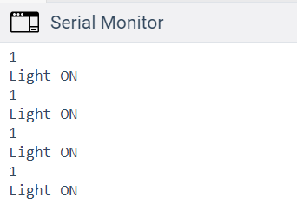

The first line of output shows whether the LED is on or not and the second line shows its intensity.

**PIR:**

Circuit to interface PIR Sensor is designed successfully.

**SOURCES OF ERROR:**

Sources of error in LDR:

* Temperature sensitivity: The resistance of an LDR can change with temperature, leading to variations in its output signal. To minimize this error, temperature compensation should be used in the LDR circuit.
* Non-linearity: The resistance-light intensity relationship of an LDR is non-linear, which can cause errors in light intensity measurements. To overcome this, linearization techniques may be used.
* Spectral sensitivity: LDRs have different spectral sensitivities, which means they respond differently to different wavelengths of light. This can lead to errors if the LDR is used to measure light of a different wavelength than it is calibrated for.

Sources of error in PIR:

* False triggers: The PIR sensor may be triggered by non-human movements, such as insects, small animals, or moving objects such as leaves or curtains. To minimize this error, the sensor should be properly positioned and shielded from non-human sources of movement.
* Slow response time: The response time of a PIR sensor may be slow, which can result in missed detections or false triggers. To minimize this error, the sensor should be properly configured and the response time should be carefully optimized.
* Sensitivity variability: The sensitivity of a PIR sensor can vary with temperature, humidity, and other environmental factors. This can result in incorrect detections or missed detections. To minimize this error, the sensor should be regularly calibrated and its sensitivity should be adjusted as needed.

**What is the maximum and minimum Analog Digital value of LDR Sensor?**

The maximum and minimum analog values of an LDR sensor depend on the specific LDR model and the voltage range of the analog-to-digital (ADC) converter used in the system. In general, the maximum analog value of an LDR is determined by the supply voltage and the minimum analog value is close to 0V.

For example, if the supply voltage is 5V and the ADC has a resolution of 10 bits, then the maximum analog value would be 5V and the minimum analog value would be 0V. The ADC would convert the analog signal from the LDR into a digital value with a range of 0 to 1023, where 1023 represents the maximum analog value and 0 represents the minimum analog value.

**Write five real time applications (not from internet) of both the sensors.**

LDRs:

* Street lighting control: LDRs are used to control the brightness of streetlights, turning them on when it is dark and adjusting their brightness according to the ambient light levels.
* Automotive headlamps: LDRs are used in automotive headlamps to adjust their brightness according to the ambient light levels and to prevent dazzling other drivers on the road.
* Home lighting systems: LDRs are used in home lighting systems to control the brightness of lights and to turn them off when there is enough natural light.
* Camera exposure control: LDRs are used in cameras to control the exposure time, adjusting it according to the ambient light levels to ensure a correctly exposed image.
* Light meters: LDRs are used in light meters to measure the intensity of light in photography, film, and other applications.

PIRs:

* Burglar alarms: PIRs are used in burglar alarms to detect movement in a protected area and trigger an alarm if movement is detected.
* Motion-activated lights: PIRs are used in motion-activated lights to turn lights on when movement is detected and turn them off when there is no movement.
* Presence detection: PIRs are used in various devices to detect the presence of a person, such as in automatic doors or toilets with automatic flushing systems.
* Wildlife monitoring: PIRs are used in wildlife monitoring to detect the movement of animals in their habitats and collect data on their behaviour.
* Energy conservation: PIRs are used in buildings to detect the presence of people and turn off lights and other devices when there is no one in the room, helping to conserve energy.