**COCSC20 - INTERNET OF THINGS  
EXERCISE - 3**

**FEBRUARY 13, 2023  
AMOGH GARG – 2020UCO1688  
_______________________________________________________________________________________________**

**PROBLEM:**

Design a circuit for interfacing the Relay with Arduino Mega board and control the two high power electronic equipment’s.

**COMPONENTS REQUIRED:**

* 1 x Arduino Uno
* 1 x Relay SPDT
* 1 x 10V,5A Power supply
* 2 x Light Bulb
* 2 x Pushbutton
* 2 x 10 kilo-ohm resistor

**UNDERSTANDING REQUIRED:**

* Basic knowledge about Switch (Relay).
* Knowledge about the application of relay.
* Basic Arduino programming.

**CIRCUIT DIAGRAM:**

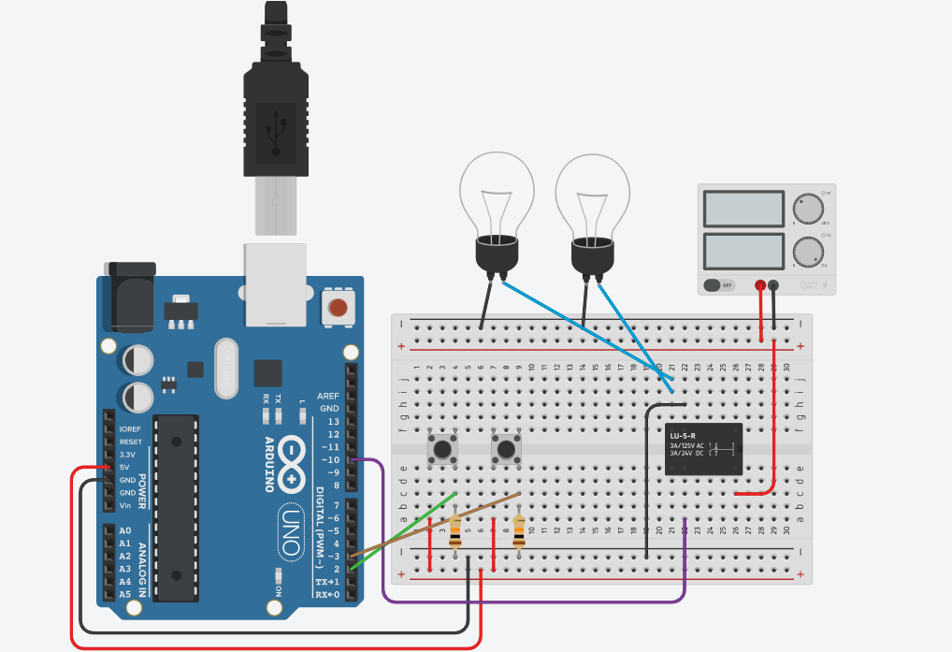

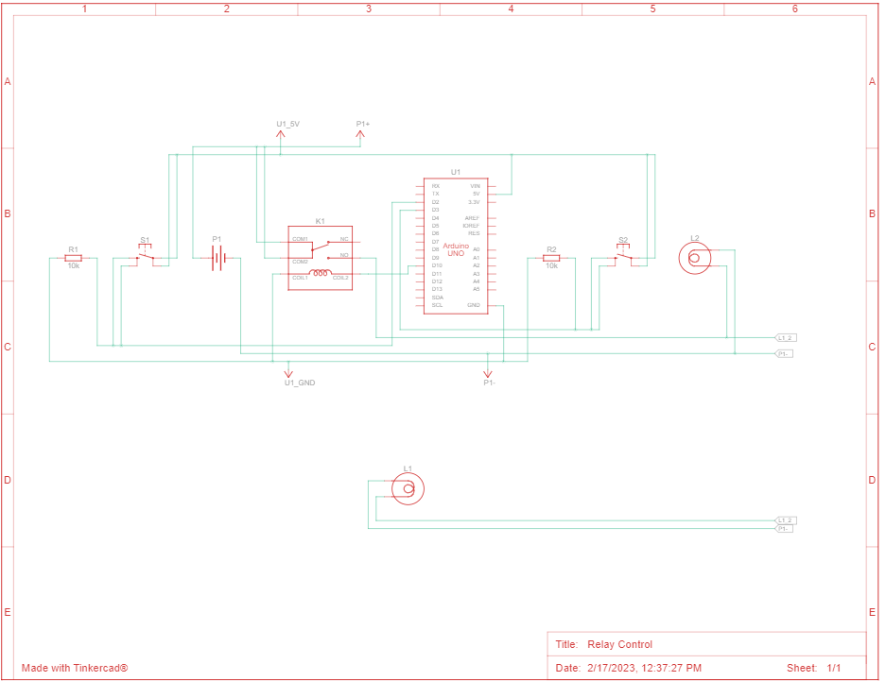

**CODE/PROGRAM:**

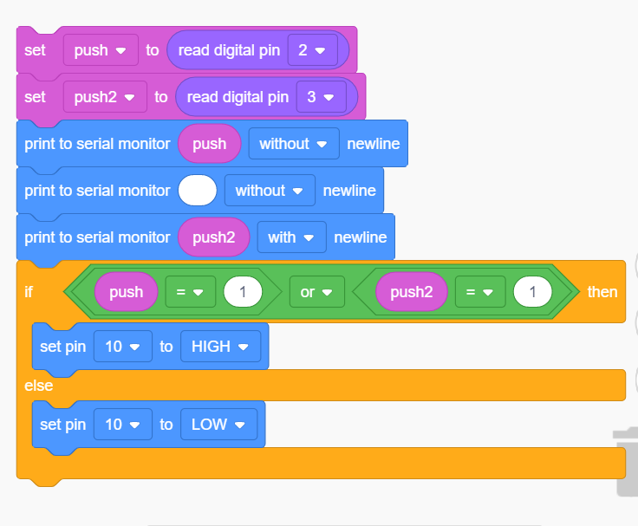

**Programming Skills Gained**: Learned programming using block codes.

**RESULT:**

1. **10V Relay**

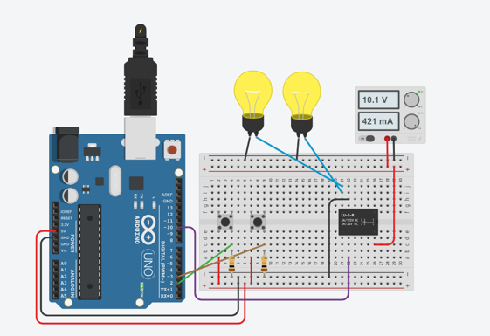

1. **30V Relay**

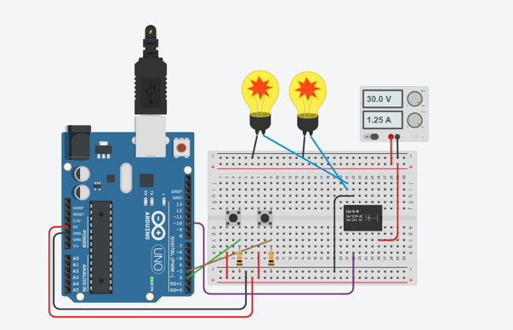

Since the Arduino operates at 5V it cannot control higher voltage devices directly, but we have successfully used a 5V relay to switch the higher voltage devices and use the Arduino to control the relay.

**SOURCES OF ERROR:**

Here are some possible sources of error:

1. Power Supply: One of the most common sources of error in such circuits is inadequate power supply. If the power supply is not sufficient to meet the demands of the equipment or the relay, it can lead to erratic behaviour, unpredictable results, or even equipment damage.
2. Voltage and Current Ratings: Relays and electronic equipment have specific voltage and current rating requirements. If these requirements are not met, it can lead to equipment failure or damage.
3. Wiring: Incorrect wiring connections can lead to faulty or unreliable operation. It is important to ensure that the wiring connections are secure, correctly labeled, and properly insulated.
4. Interference: Electrical interference from other equipment or power sources can disrupt the circuit's performance. Shielding, filtering, and grounding techniques can help to minimize the effect of interference.
5. Programming: Inadequate or incorrect programming can lead to erratic behavior, including false triggers or improper timing. It is essential to ensure that the code used to control the relay and equipment is correct and has been tested thoroughly.

**Write five real time applications (not from internet) of relay.**

* Industrial Automation: Relays are commonly used in industrial automation systems to control large motors, pumps, and other high-power equipment. They can be used to switch circuits on and off, control the direction of motors, and protect equipment from damage due to overload or other faults.
* Automotive Systems: In modern automobiles, relays are used in various systems such as power windows, power door locks, starter motors, wipers, and headlights. For example, a headlight relay can be used to control the high-current flow required by the headlight circuit, while protecting the switch from damage.
* Home Automation: Relays can be used in home automation systems to control various household appliances, such as lights, fans, and air conditioning systems. They can be used to switch circuits on and off based on input from sensors or remote controls, making it possible to automate tasks and reduce energy consumption.
* Medical Equipment: Relays are used in various medical equipment, such as ultrasound machines, electrocardiograms, and X-ray machines. They can be used to switch circuits on and off, control the direction of motors, and ensure the safety of patients by preventing equipment malfunction.
* Power Distribution: Relays are also used in power distribution systems to protect equipment and prevent overloads. For example, in a transformer substation, a relay can be used to trip a circuit breaker if the current exceeds a certain level, protecting the transformer from damage and preventing power outages.