**COCSC20 - INTERNET OF THINGS  
EXERCISE - 5**

**FEBRUARY 20, 2023  
AMOGH GARG – 2020UCO1688  
_______________________________________________________________________________________________**

**PROBLEM:**

Explore ThingSpeak cloud platform for capturing, analyse and process the different sensors data. Transmit any random data from your microcontroller to ThingSpeak Cloud.

**COMPONENTS REQUIRED:**

* 1 x Arduino Uno
* 1 x Temperature sensor
* 1 x Wifi Module
* 2 x 1 kilo ohm resistor

**CIRCUIT DIAGRAM:**

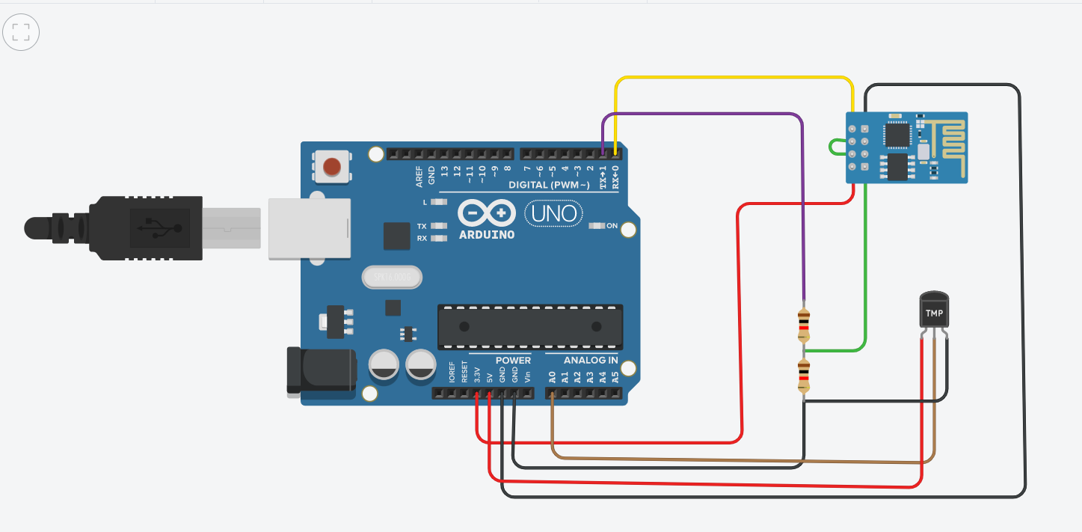

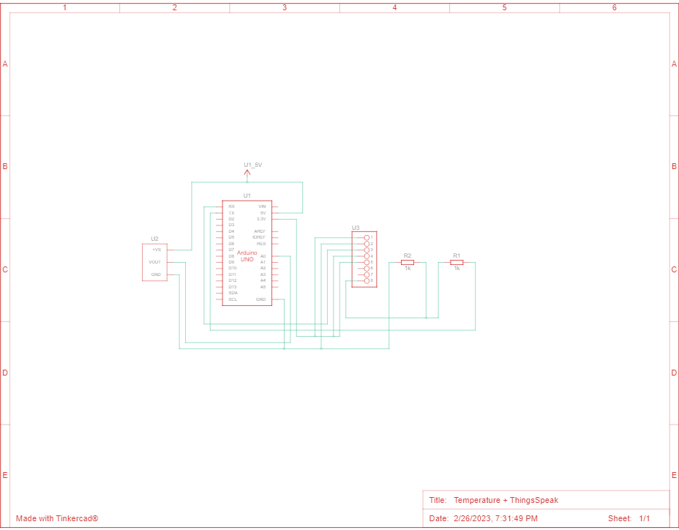

**CODE:**

String ssid = "Simulator Wifi"; // SSID to connect to

String password = ""; // Our virtual wifi has no password

String host = "api.thingspeak.com"; // Open Weather Map API

const int httpPort = 80;

String url = "/update?api_key=V6Y9GC47ML8RHVZ4&field1="; // Data write API Key

int setupESP8266(void) {

// Start our ESP8266 Serial Communication

Serial.begin(115200); // Serial connection over USB to computer

Serial.println("AT"); // Serial connection on Tx / Rx port to ESP8266

delay(10); // Wait a little for the ESP to respond

if (!Serial.find("OK")) return 1;

// Connect to 123D Circuits Simulator Wifi

Serial.println("AT+CWJAP=\"" + ssid + "\",\"" + password + "\"");

delay(10); // Wait a little for the ESP to respond

if (!Serial.find("OK")) return 2;

// Open TCP connection to the host:

Serial.println("AT+CIPSTART=\"TCP\",\"" + host + "\"," + httpPort);

delay(50); // Wait a little for the ESP to respond

if (!Serial.find("OK")) return 3;

return 0;

}

void anydata(void) {

int temp = map(analogRead(A0),20,358,-40,125);

// Construct our HTTP call

String httpPacket = "GET " + url + String(temp) + " HTTP/1.1\r\nHost: " + host + "\r\n\r\n";

int length = httpPacket.length();

// Send our message length

Serial.print("AT+CIPSEND=");

Serial.println(length);

delay(10); // Wait a little for the ESP to respond if (!Serial.find(">")) return -1;

// Send our http request

Serial.print(httpPacket);

delay(10); // Wait a little for the ESP to respond

if (!Serial.find("SEND OK\r\n")) return;

}

void setup() {

setupESP8266();

}

void loop() {

anydata();

delay(10000);

}

**Programming Skills Gained**: Learnt to interface ThingsSpeak with microcontroller and transfer data for analysis.

**RESULT:**

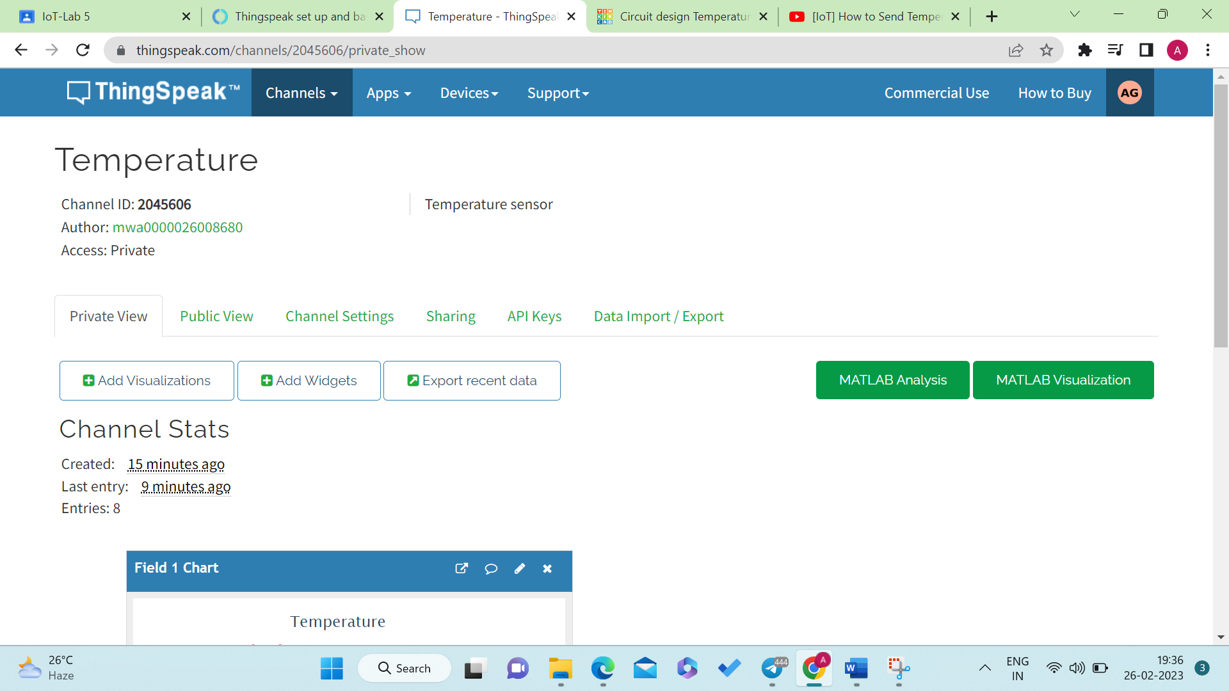

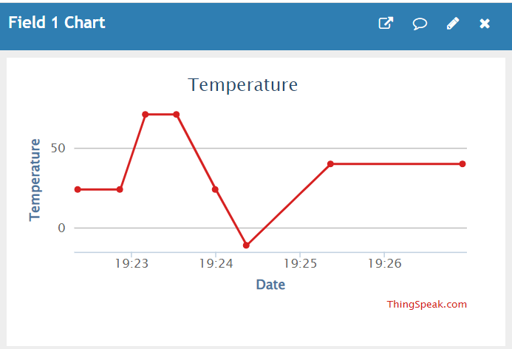

The data read by the temperature sensor has been successfully transferred to ThingSpeak cloud platform. The line chart shows the variation in temperature as measured by the sensor with respect to time. Further MATLAB can be used in addition with ThingSpeak platform to analyze data and for data analytics.

Similarly, data from other sensors can also be transferred to the cloud platform using the API key for the read and write operations.