**COCSC20 - INTERNET OF THINGS  
EXERCISE - 7**

**MARCH 26, 2023  
AMOGH GARG – 2020UCO1688  
_______________________________________________________________________________________________**

**PROBLEM:**

1. Explore Raspberry PI 4B microcomputer device and capture the sensor's value using GPIO pins.

• Introduction to Raspberry PI and their components.   
• Connect with LED and blink the LED with python code. And include the code for handling a keyboard interrupt during the program.

1. Interface DHT (Humidity and Temperature) Sensor in RPi for getting the value of sensors. Store the value of the sensor in an excel/csv file.

**PART-1**

**COMPONENTS REQUIRED:**

* Raspberry Pi with GPIO header
* Breadboard
* Connecting wires (Male to Female wires)
* LED
* Resistor
* Power Supply
* Computer Hardware/ Laptop

**UNDERSTANDING REQUIRED:**

Raspberry Pi is a series of small single-board computer hardware component with greater memory as compared to an Arduino board. It has the ability to insert extra space on itself with the help of SD card, it is usually used for higher computation considering it has large memory, the entire code along with the entire computation can be done on the board itself. It has different ports for connecting the peripherals like the keyboard, mouse, display and also connection with the internet becomes easy. It is usually used for running on a linux based operating system.

**CIRCUIT DIAGRAM:**

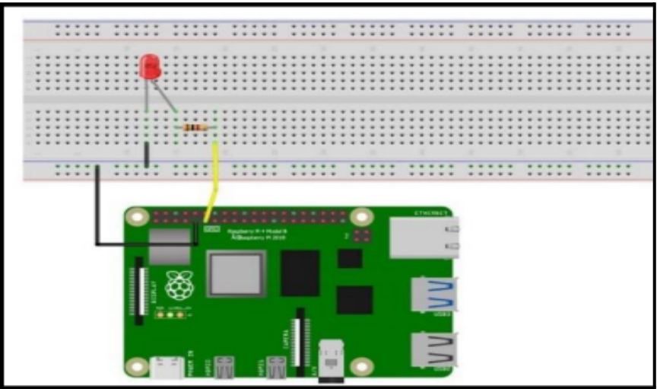

**CODE:**

#importing the necessary libraries import RPi.GPIO as GPIO   
import time import sys   
# Seting up the GPIO pin   
led_pin = 17   
GPIO.setmode(GPIO.BCM)   
GPIO.setup(led_pin, GPIO.OUT)   
#code for the LED blinking  
try:   
while True:   
GPIO.output(led_pin, GPIO.HIGH)   
time.sleep(1) GPIO.output(led_pin, GPIO.LOW)  
 time.sleep(1)   
# Handling the keyboard interrupt   
except KeyboardInterrupt:   
print("Program stopped by user.")   
GPIO.cleanup()   
sys.exit()

**Programming Skills Gained**: Learnt to program in Python to control RaspberryPi.

**RESULT:**

* Connection was made and program was written to blink the LED successfully.

**SOURCES OF ERROR:**

* The Raspberry Pi is most likely underpowered, and hence unable to power the USB device. As a result, make sure your Pi is well-powered.
* The USB device could be defective. To ensure that everything is working properly, test it on your PC or another machine

**APPLICATIONS:**

* Estimate Crowd Sizes and Fight the Virus.
* Smart Energy Monitor Based on IoT.
* Build a Wi-Fi Range Extender with Raspberry Pi.
* Create an IoT-Based Agricultural Solution.
* Develop a Face Recognizing Robot with Raspberry Pi.
* Build an IoT-based Smart Home System with Raspberry Pi.

___________________________________________________________________________________________

**PART-2:**

**COMPONENTS REQUIRED:**

* Raspberry Pi with GPIO header
* Breadboard piece
* DHT11 Temperature and Humidity sensor
* Power supply
* Connecting wires (Male to Female wires)
* Computer hardware/Laptop

**UNDERSTANDING REQUIRED:**

DHT11 is a digital sensor with the ability to perform two different functionalities under 1 package, it contains an NTC temperature sensor and a resistive humidity sensor along with a MCU to convert the analog signal to digital signal. It has 4 pins which are as follows: - VCC - Data - Not Connected (NC) - Ground.

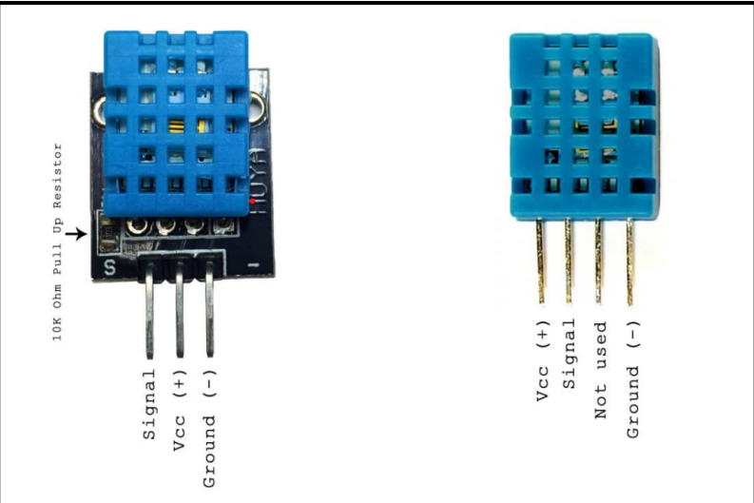

**CIRCUIT:**

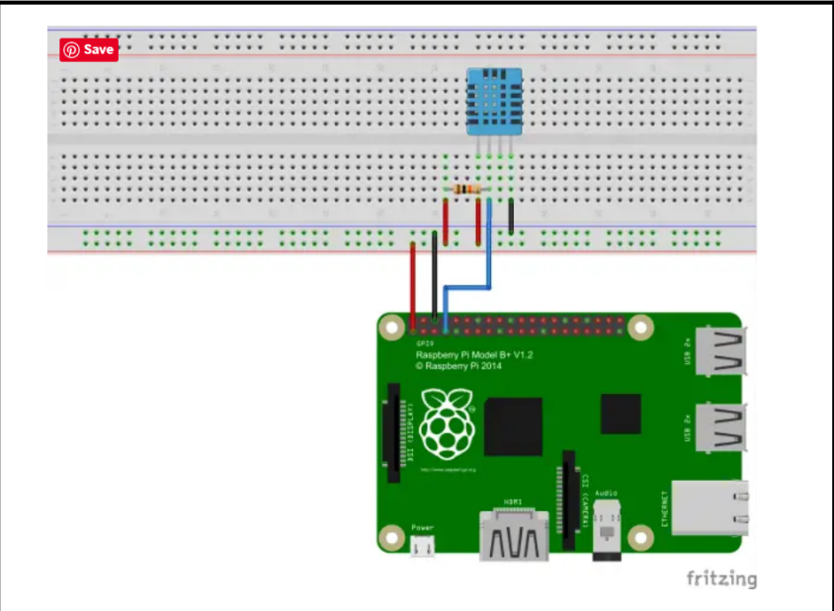

**RESULT:**

Successfully interfaced DHT module in RaspberryPI to obtain sensor values.

**SOURCES OF ERROR:**

* Bad USB port or USB cable. Sometimes powering the ESP32, ESP8266, Arduino or similar boards directly from a PC USB port is not enough.
* Timeout error: The timeout error means there is no signal in the time span, the sensor may be broken. This sensor does not need to be calibrated. You can use three male-female jumper wires to connect the wire pins to Rpi.