

Session 2020-21

Central Board Of Secondary Education

Computer Science Project On
Banking Management

Prepared By:
Amogh Krishna
Kushal Sena


Certified that the Project Report Entitled
Banking Management

Is bonafied work carried out by Amogh Krishna And Kushal Sena in Fulfillment prescribed by the CENTRAL BOARD OF SECONDARY EDUCATION for CBSE+2 COMPUTER SCIENCE during the academic year 2020-2021. The project report has been approved as it satisfies the academic requirements in respect of Project prescribed for CBSE+2.

……………………… ………………………
Mrs. Gayatri G Anantha Rao
Respected Teacher Respected Principal

Externals Signature: 1)………………………

2)………………………

We would like to thank Mrs. Gayatri for her able guidance and the support exhibited by her in the completion of the project.

It gives us great pleasure in presenting this project. We extend our gratitude to our worthy colleagues for conveying their valuable suggestions to improve the quality of this Project and its value. This project has contributed invariably in improving and increasing our knowledge about this language which will hopefully prove to be profitable for us in future.

Students Name

Amogh Krishna
Kushal Sena

>Abstract
>About Python
>About MySQL
>About Banking
>Program Source Code
>Output
>Structure Of SQL Table
>Hardware
>Software
>Minimum Requirements
>Scope Of The Project
>Conclusion
>Bibliography
-ᗩᗷᔕTᖇᗩᑕT
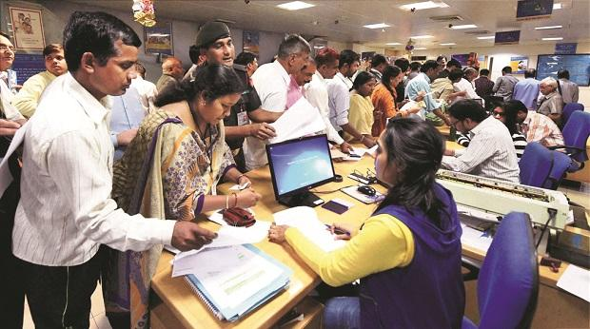

𝘛𝘩𝘦 𝘉𝘢𝘯𝘬 𝘔𝘢𝘯𝘢𝘨𝘦𝘮𝘦𝘯𝘵 𝘚𝘺𝘴𝘵𝘦𝘮 𝘪𝘴 𝘢𝘯 𝘢𝘱𝘱𝘭𝘪𝘤𝘢𝘵𝘪𝘰𝘯 𝘧𝘰𝘳 𝘮𝘢𝘪𝘯𝘵𝘢𝘪𝘯𝘪𝘯𝘨 𝘢 𝘱𝘦𝘳𝘴𝘰𝘯'𝘴 𝘢𝘤𝘤𝘰𝘶𝘯𝘵 𝘪𝘯 𝘢 𝘣𝘢𝘯𝘬. 𝘐𝘯 𝘵𝘩𝘪𝘴 𝘱𝘳𝘰𝘫𝘦𝘤𝘵 𝘐 𝘵𝘳𝘪𝘦𝘥 𝘵𝘰 𝘴𝘩𝘰𝘸 𝘵𝘩𝘦 𝘸𝘰𝘳𝘬𝘪𝘯𝘨 𝘰𝘧 𝘢 𝘣𝘢𝘯𝘬𝘪𝘯𝘨 𝘢𝘤𝘤𝘰𝘶𝘯𝘵 𝘴𝘺𝘴𝘵𝘦𝘮 𝘢𝘯𝘥 𝘤𝘰𝘷𝘦𝘳 𝘵𝘩𝘦 𝘣𝘢𝘴𝘪𝘤 𝘧𝘶𝘯𝘤𝘵𝘪𝘰𝘯𝘢𝘭𝘪𝘵𝘺 𝘰𝘧 𝘢 𝘉𝘢𝘯𝘬 𝘔𝘢𝘯𝘢𝘨𝘦𝘮𝘦𝘯𝘵 𝘚𝘺𝘴𝘵𝘦𝘮. 𝘛𝘰 𝘥𝘦𝘷𝘦𝘭𝘰𝘱 𝘢 𝘱𝘳𝘰𝘫𝘦𝘤𝘵 𝘧𝘰𝘳 𝘴𝘰𝘭𝘷𝘪𝘯𝘨 𝘧𝘪𝘯𝘢𝘯𝘤𝘪𝘢𝘭 𝘢𝘱𝘱𝘭𝘪𝘤𝘢𝘵𝘪𝘰𝘯𝘴 𝘰𝘧 𝘢 𝘤𝘶𝘴𝘵𝘰𝘮𝘦𝘳 𝘪𝘯 𝘣𝘢𝘯𝘬𝘪𝘯𝘨 𝘦𝘯𝘷𝘪𝘳𝘰𝘯𝘮𝘦𝘯𝘵 𝘪𝘯 𝘰𝘳𝘥𝘦𝘳 𝘵𝘰 𝘯𝘶𝘳𝘵𝘶𝘳𝘦 𝘵𝘩𝘦 𝘯𝘦𝘦𝘥𝘴 𝘰𝘧 𝘢𝘯 𝘦𝘯𝘥 𝘣𝘢𝘯𝘬𝘪𝘯𝘨 𝘶𝘴𝘦𝘳 𝘣𝘺 𝘱𝘳𝘰𝘷𝘪𝘥𝘪𝘯𝘨 𝘷𝘢𝘳𝘪𝘰𝘶𝘴 𝘸𝘢𝘺𝘴 𝘵𝘰 𝘱𝘦𝘳𝘧𝘰𝘳𝘮 𝘣𝘢𝘯𝘬𝘪𝘯𝘨 𝘵𝘢𝘴𝘬𝘴.
-About Python

Python is an interpreted, object-oriented, high-level programming language with dynamic semantics. Its high-level built in data structures, combined with dynamic typing and dynamic binding, make it very attractive for Rapid Application Development, as well as for use as a scripting or glue language to connect existing components together. Python's simple, easy to learn syntax emphasizes readability and therefore reduces the cost of program maintenance. Python supports modules and packages, which encourages program modularity and code reuse. The Python interpreter and the extensive standard library are available in source or binary form without charge for all major platforms, and can be freely distributed.

-About MySQL

MySQL is a relational database management system based on SQL – Structured Query Language. The application is used for a wide range of purposes, including data warehousing, e-commerce, and logging applications.
The most common use for MySQL however, is for the purpose of a web database. It can be used to store anything from a single record of information to an entire inventory of available products for an online store.
In association with a scripting language such as PHP or Perl (both offered on our hosting accounts) it is possible to create websites which will interact in real-time with a MySQL database to rapidly display categorized and searchable information to a website user.
-About Banking

Banks act as payment agents by conducting checking or current accounts for customers, paying check drawn by customers on the bank, and collecting checks deposited to customers' current accounts. Banks also enable customer payments via other payment methods such as Automated Clearing House (ACH), Wire transfers or telegraphic transfer, EFTPOS, and automated teller machine (ATM).

Banks borrow money by accepting funds deposited on current accounts, by accepting term deposits, and by issuing debt securities such as banknotes and bonds. Banks lend money by making advances to customers on current accounts, by making installment loans, and by investing in marketable debt securities and other forms of money lending.

Banks provide almost all payment services, and a bank account is considered indispensable by most businesses, individuals and governments. Non-banks that provide payment services such as remittance companies are not normally considered an adequate substitute for having a bank account.

Banks borrow most funds from households and non-financial businesses, and lend most funds to households and non-financial businesses, but non-bank lenders provide a significant and in many cases adequate substitute for bank loans, and money market funds, cash management trusts and other non-bank financial institutions in many cases provide an adequate substitute to banks for lending savings too.

Therefore, this program is a simple example of commercial programs used by Banks and their Managements.

# Project Name : Banking System
# Created by : Amogh Krishna
# Kushal Sena

import mysql.connector
from datetime import date

def clear():
for _ in range(65):
print()

def account_status(acno):
conn = mysql.connector.connect(

host='localhost', database='bankproject', user='root', password='amogh')
cursor = conn.cursor()
sql ="select status,balance from customer where acno ='"+acno+"'"
result = cursor.execute(sql)
result = cursor.fetchone()
conn.close()
return result

def deposit_amount():
conn = mysql.connector.connect(
host='localhost', database='bankproject', user='root', password='amogh')
cursor = conn.cursor()
clear()
acno = input('Enter account No :')
amount = input('Enter amount :')
today = date.today()
result = account_status(acno)
if result [0]== 'active':

sql1 ="update customer set balance = balance+"+amount + ' where acno = '+acno+' and status="active";'
sql2 = 'insert into transaction(amount,type,acno,dot) values(' + amount +',"deposit",'+acno+',"'+str(today)+'");'
cursor.execute(sql2)
cursor.execute(sql1)
#print(sql1)
#print(sql2)
print('\n\nAmount deposited')

else:
print('\n\nClosed or Suspended Account.…')

wait= input('\n\n\n Press any key to continue....')
conn.close()

def withdraw_amount():
conn = mysql.connector.connect(
host='localhost', database='bankproject', user='root', password='amogh')
cursor = conn.cursor()
clear()
acno = input('Enter account No :')
amount = input('Enter amount :')
today = date.today()
result = account_status(acno)
if result[0] == 'active' and int(result[1])>=int(amount):
sql1 = "update customer set balance = balance-" + \
amount + ' where acno = '+acno+' and status="active";'
sql2 = 'insert into transaction(amount,type,acno,dot) values(' + \
amount + ',"withdraw",'+acno+',"'+str(today)+'");'

cursor.execute(sql2)
cursor.execute(sql1)
#print(sql1)
#print(sql2)
print('\n\nAmount Withdrawn')

else:
print('\n\nClosed or Suspended Account.Or Insufficient amount')

wait = input('\n\n\n Press any key to continue....')
conn.close()

def transaction_menu():
while True:
clear()
print(' Trasaction Menu')
print("\n1. Deposit Amount")
print('\n2. WithDraw Amount')
print('\n3. Back to Main Menu')
print('\n\n')
choice = int(input('Enter your choice ...: '))
if choice == 1:
deposit_amount()
if choice == 2:
withdraw_amount()
if choice == 3:
break

def find_account():
conn = mysql.connector.connect(
host='localhost', database='bankproject', user='root', password='amogh')
cursor = conn.cursor()
while True:
clear()
print(' Find account')
print("\n1. Account No")
print('\n2. Aadhar Card')
print('\n3. Phone No')
print('\n4. Email')
print('\n5. Names')
print('\n6. Back to Main Menu')
print('\n\n')
choice = int(input('Enter your choice ...: '))
field_name=''

if choice == 1:
field_name ='acno'

if choice == 2:
field_name ='aadhar_no'

if choice == 3:
field_name = 'phone'

if choice == 4:
field_name = 'email'

if choice == 5:
field_name = 'name'

if choice == 6:
break

msg ='Enter '+field_name+': '
value = input(msg)
if field_name=='acno':
sql = 'select * from customer where '+field_name + ' = '+value+';'
else:
sql = 'select * from customer where '+field_name +' like "%'+value+'%";'
#print(sql)
cursor.execute(sql)
records = cursor.fetchall()
n = len(records)
clear()
print('Search Result for ', field_name, ' ',value)
print('-'*80)
for record in records:
print('Account No :',record[0])
print('Account Name :',record[1])
print('Address :',record[2])
print('Phone NO :',record[3])
print('Email ID :',record[4])
print('Aadhar No :',record[5])
print('Account Type :',record[6])
print('Account Status :',record[7])
print('Current Balance :',record[8])
print("-"*80)
if(n <= 0):
print(field_name, ' ', value, ' does not exist')
wait = input('\n\n\n Press any key to continue....')

conn.close()
wait=input('\n\n\n Press any key to continue.…')

def daily_report():
clear()

conn = mysql.connector.connect(
host='localhost', database='bankproject', user='root', password='amogh')
today = date.today()
cursor = conn.cursor()
sql = 'select tid,dot,amount,type,acno from transaction t where dot="'+ str(today)+'";'
cursor.execute(sql)
records = cursor.fetchall()
clear()
print('Daily Report :',today)
print('-'*60)
for record in records:
print('Account Number :',record[4])
print('Date :',record[1])
print('Amount :',record[2])
print('Transaction type :',record[3])
print('-'*60)

conn.close()
wait = input('\n\n\n Press any key to continue.…')

def account_details():
clear()
acno = input('Enter account no :')
conn = mysql.connector.connect(
host='localhost', database='bankproject', user='root', password='amogh')
cursor = conn.cursor()
sql ='select * from customer where acno ='+acno+';'
sql1 = 'select tid,dot,amount,type from transaction t where t.acno='+acno+';'
cursor.execute(sql)
result = cursor.fetchone()
clear()
print('Account Details')
print('-'*60)
print('Account No :',result[0])

print('Account Name :',result[1])
print('Address :',result[2])
print('Phone NO :',result[3])
print('Email ID :',result[4])
print('Aadhar No :',result[5])
print('Account Type :',result[6])
print('Account Status :',result[7])
print('Current Balance :',result[8])
print('-'*60)
cursor.execute(sql1)
results = cursor.fetchall()
for result in results:

print('Date :',result[1])
print('Amount :',result[2])
print('Transaction type :',result[3])
print('-'*60)

conn.close()
wait=input('\n\n\nPress any key to continue..…')

def report_menu():
while True:
clear()
print(' Report Menu')
print("\n1. Daily Report")
print('\n2. Account Details')
print('\n3. Back to Main Menu')
print('\n\n')
choice = int(input('Enter your choice ...: '))
if choice == 1:
daily_report()
if choice == 2:
account_details()
if choice == 3:
break

def add_account():
conn = mysql.connector.connect(
host='localhost', database='bankproject', user='root', password='amogh')
cursor = conn.cursor()

name = input('Enter Name :')
addr = input('Enter address :')
phone = input('Enter Phone no :')
email = input('Enter Email :')
aadhar = input('Enter Aadhar no :')
actype = input('Account Type (saving/current ) :')
balance = input('Enter opening balance :')
sql = 'insert into customer(name,address,phone,email,aadhar_no,acc_type,balance,status) values ( "' + name +'","'+ addr+'","'+phone+'","'+email+'","'+aadhar+'","'+actype+'",'+balance+',"active" );'
#print(sql)
cursor.execute(sql)
conn.close()
print('\n\nNew account created successfully')
wait= input('\n\n\n Press any key to continue.…')

def modify_account():
conn = mysql.connector.connect(
host='localhost', database='bankproject', user='root', password='amogh')
cursor = conn.cursor()
clear()
acno = input('Enter Account No :')
print('Modify screen ')
print('\n 1. User Name')
print('\n 2. User Address')
print('\n 3. User Phone No')
print('\n 4. User Email ID')
choice = int(input('What do you want to change ? '))
new_data = input('Enter New value :')
field_name=''
if choice == 1:
field_name ='name'
if choice == 2:
field_name = 'address'
if choice == 3:
field_name = 'phone'
if choice == 4:
field_name = 'email'
sql ='update customer set ' + field_name + '="'+ new_data +'" where acno='+acno+';'
cursor.execute(sql)
print('\n\nUser Information modified..')
wait = input('\n\n\n Press any key to continue.…')

def close_account():
conn = mysql.connector.connect(
host='localhost', database='bankproject', user='root', password='amogh')
cursor = conn.cursor()
clear()
acno = input('Enter Account No :')
sql ='update customer set status="close" where acno ='+acno+';'
cursor.execute(sql)
print('\n\nAccount closed')
wait = input('\n\n\n Press any key to continue.…')

def activate_account():
conn = mysql.connector.connect(
host='localhost', database='bankproject', user='root', password='amogh')
cursor = conn.cursor()
clear()
acno = input('Enter Account No :')
sql = 'update customer set status="active" where acno ='+acno+';'
cursor.execute(sql)
print('\n\nAccount Activated')
wait = input('\n\n\n Press any key to continue.…')

def main_menu():
while True:
clear()
print(' CREATED BY: AMOGH AND KUSHAL ')
print('\n\n')
print(' Main Menu')
print("\n1. Add Account")
print('\n2. Modify Account')
print('\n3. Close Account')
print('\n4. Activate Account')
print('\n5. Transaction Menu')
print('\n6. Find Account')
print('\n7. Report Menu')
print('\n8. Close Application')
print('\n\n')
choice = int(input('Enter your choice ...: '))

if choice == 1:
add_account()

if choice == 2:
modify_account()

if choice == 3:
close_account()

if choice == 4:
activate_account()

if choice ==5 :
transaction_menu()

if choice ==6 :
find_account()

if choice == 7:
report_menu()

if choice ==8:
break

if __name__ == "__main__":
main_menu()

# Source Code ends.. :D


MAIN MENU
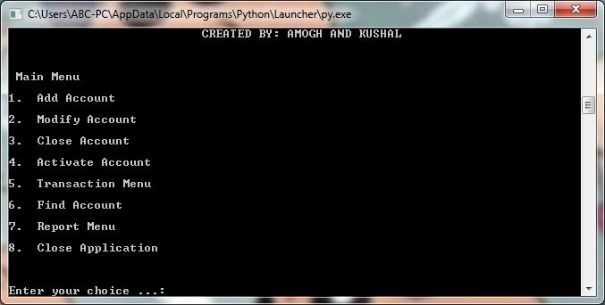
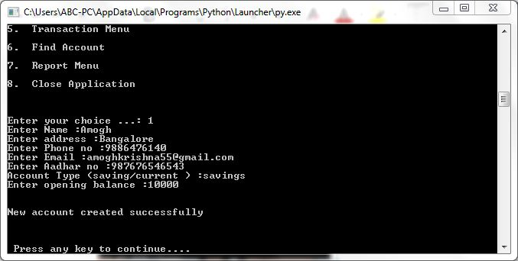
ADD ACCOUNT

MODIFY ACCOUNT
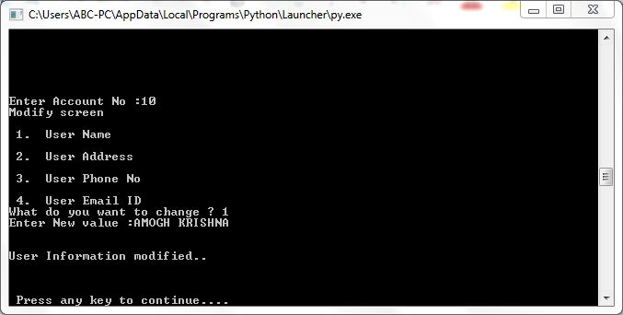
CLOSE ACCOUNT
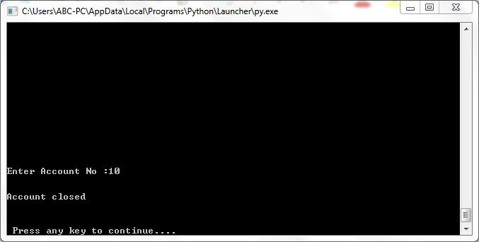
ACTIVATE ACCOUNT
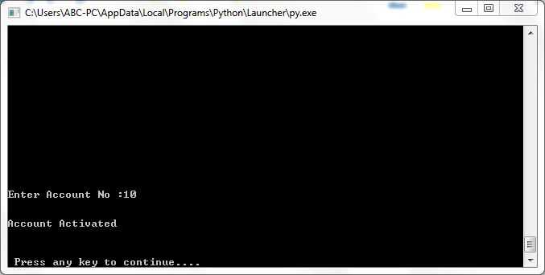
TRANSACTION MENU
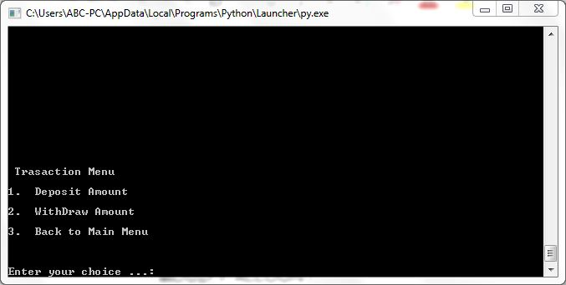
DEPOSIT AMOUNT
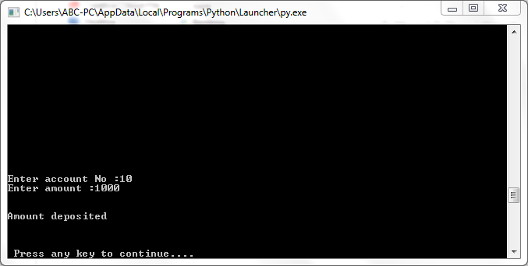
WITHDRAW AMOUNT
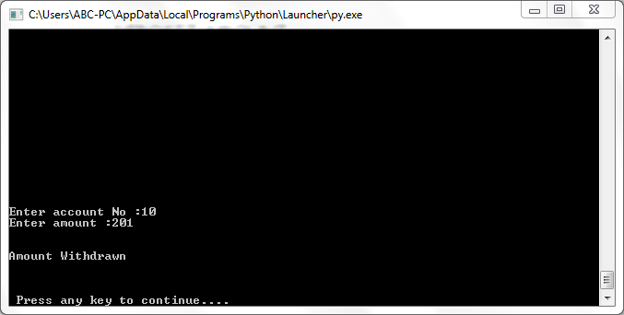
FIND ACCOUNT
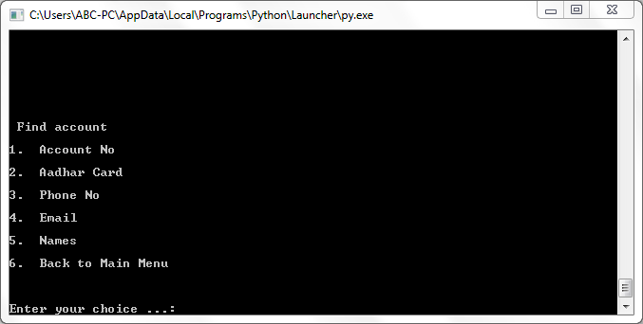

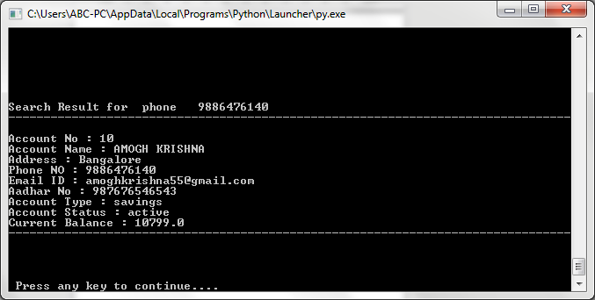

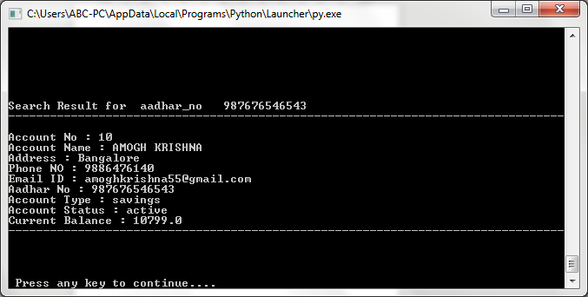

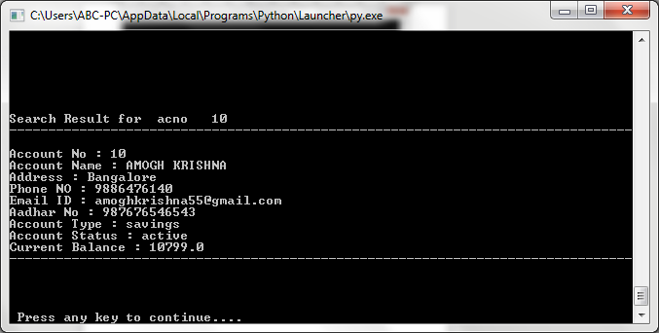

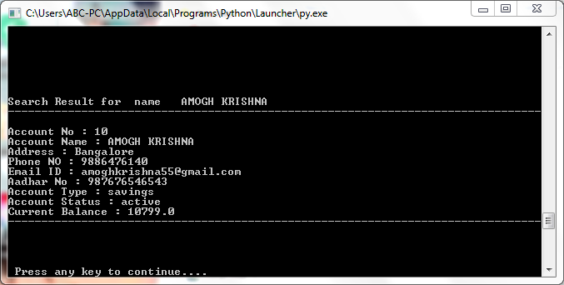

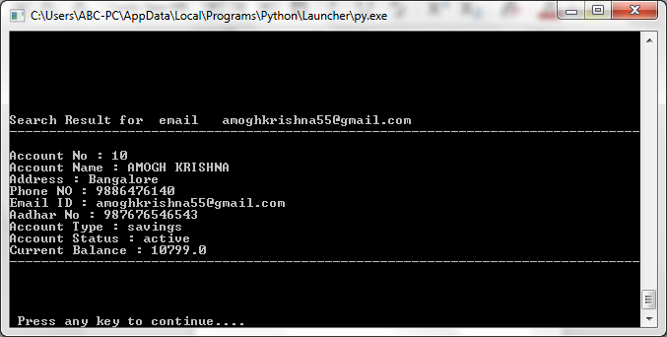
REPORT MENU
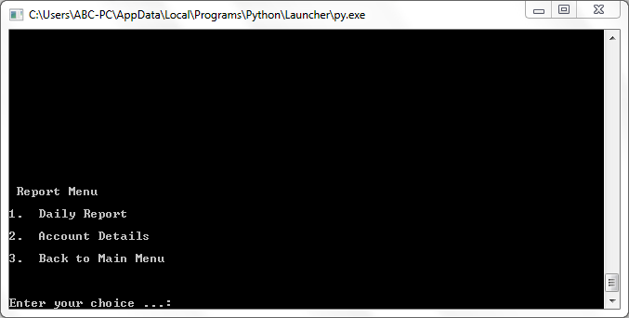
DAILY REPORT
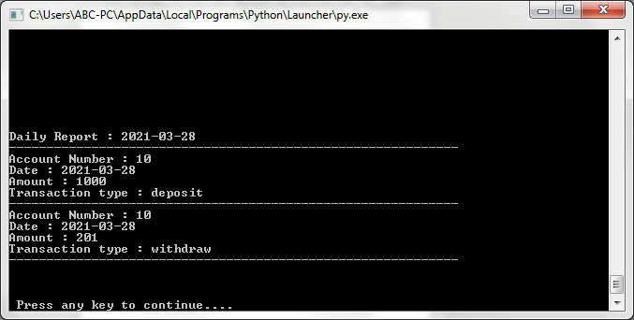
ACCOUNT DETAILS
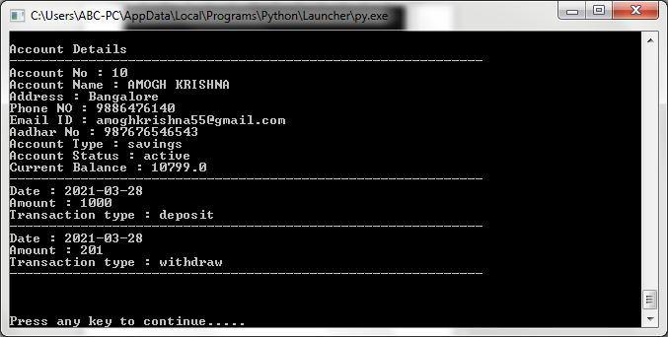

When the users account is closed or suspended and tries to perform transaction-
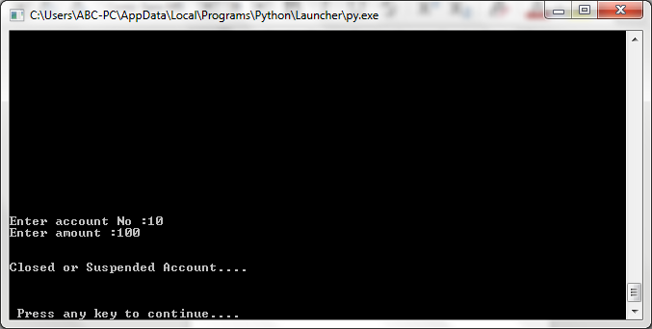
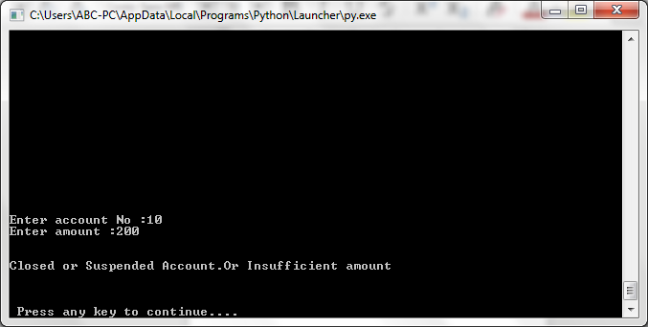
When the account holders full Name, E-mail address, Phone Number is not known-
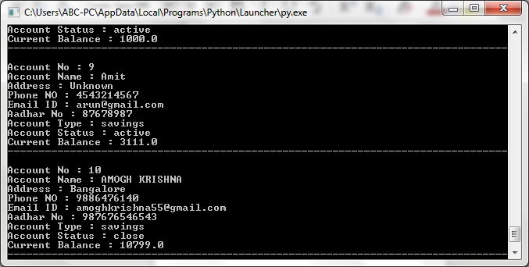
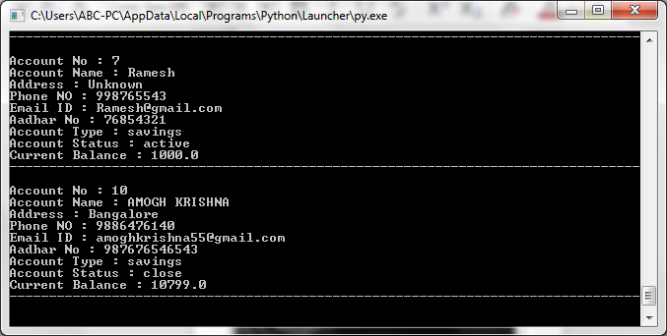

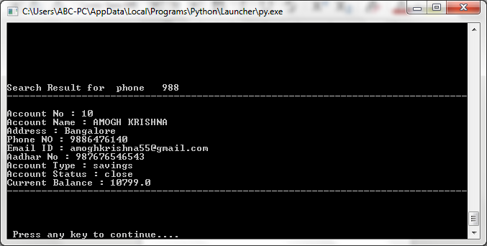

-STRUCTURE OF SQL TABLE

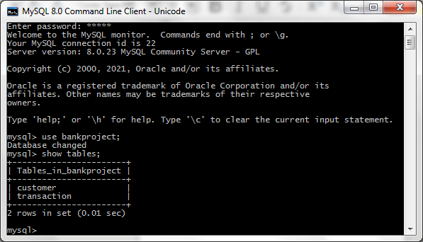

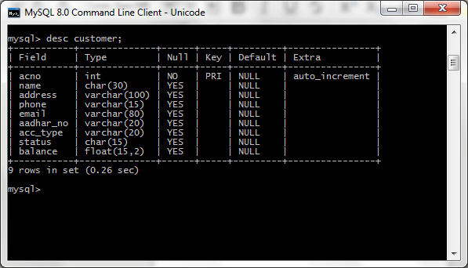

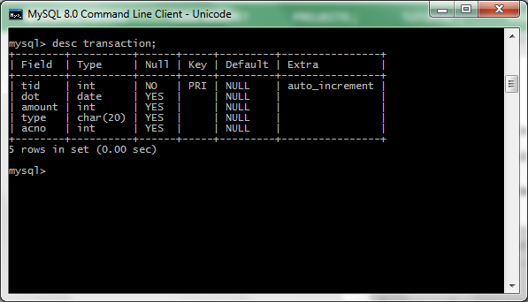

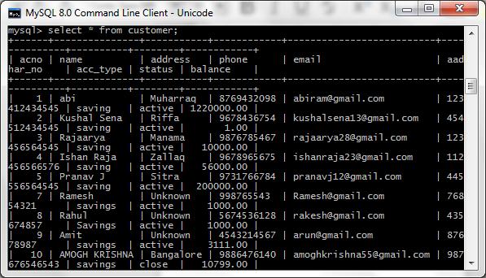

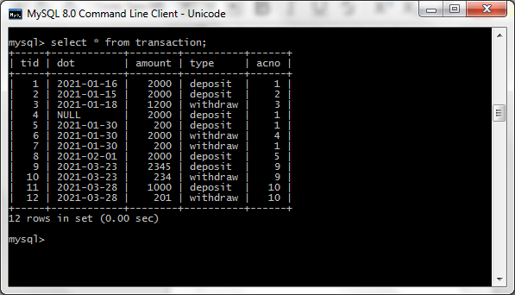

-Hardware

>Lenovo IdeaPad S540

>Lenovo 300 Wireless Compact >Mouse (GX30K79401)

-Software

>Python 3.7.9
>MySQL server 8.0
>MySQL workbench
>LibreOffice Writer
>Adobe Acrobat Reader
>Snipping Tool
-Minimum Requirement

>Processors: Intel Atom® processor or Intel® Core™ i3 processor.

>Disk space: 1 GB.

>Operating systems: Windows* 7 or later, macOS, and Linux.

>Python* versions: 2.7.X, 3.6.X.

>MySQL* versions: 8.0.X and below.
-Scope of the project

This program was created to make bank management simpler and to avoid any human made errors while entering data.
While creating this program we made sure that it was user friendly so that it is accessible to each and everyone. This program provides various options from creating an account to depositing and withdrawing cash from that account.
We can also monitor the date when the amount was credited or debited from that account. All the entered data is stored in a secure database in MySQL
so non of the stored data is being tampered with.
-Conclusion
This project is developed to nurture the needs of a user in a banking sector by embedding all the tasks of transactions taking place in a bank. Future version of this project will still be much enhanced than the current version. Writing and depositing checks are perhaps the most fundamental ways to move money in and out of a checking account, but advancements in technology have added ATM and debit card transactions. All banks have rules about how long it takes to access your deposits, how many debit card transactions you're allowed in a day, and how much cash you can withdraw from an ATM. Access to the balance in your checking account can also be limited by businesses that place holds on your funds. Banks are providing internet banking services also so that the customers can be attracted. By asking the bank employs we came to know that maximum numbers of internet bank account holders are youth and business man. Online banking is an innovative tool that is fast becoming a necessity. It is a successful strategic weapon for banks to remain profitable in a volatile and competitive marketplace of today. If proper training should be given to customer by the bank employs to open an account will be beneficial secondly the website should be made friendlier from where the first time customers can directly make and access their accounts.


We would like to show our deep gratitude towards the people who have helped us and the sources that we have used in the completion of our project.

This project is the outcome of our persistent efforts and the invariable support and guidance of our senior computer lecturer Mrs. Gayatri, the support of our worthy colleagues and a valuable reference provided by the websites such as www.icbse.nic.in and other sites supported by www.google.co.in .

