Table of Contents

1 Doctor Digital Twin

1.1 Technical Documentation
Project type: Full-stack clinical workflow prototype
Audience: Academic review, technical demonstration, and engineering handover
Document date: 20 September 2026
Status: Implemented and locally verified
Important: This system uses synthetic data and is a software prototype. It is not a medical device, does not provide autonomous diagnosis, and requires clinical, privacy, security, and regulatory review before any real-world use.

1.2 1. Executive Summary
Doctor Digital Twin is a configurable clinical-assistance prototype that models an individual doctor’s working preferences while retaining deterministic safety controls and human oversight. A patient submits symptoms through a conversational intake. The system combines patient context, the selected doctor’s profile, approved doctor memories, and prior visits to produce a structured assessment with Google Gemini. A separate deterministic safety engine then checks patient-authored statements and can override the model’s risk classification.
The same Doctor Twin implementation supports four deployment modes:
- SHADOW: collects information and creates a factual case; it does not suggest diagnosis or action.
- COPILOT: proposes an assessment and diagnostic tests for doctor review.
- INTAKE: structures the case and escalates AMBER or RED cases to a doctor.
- AUTONOMOUS: permits only allowlisted low-risk actions and evidence-gated diagnostic-test ordering; all unsafe or insufficiently supported cases go to a doctor.
The project also includes doctor review and case closure, governed memory learning, appointment scheduling, an admin-managed diagnostic-test catalog, doctor-specific test-decision learning, an evaluation suite, audit events, and patient/doctor/admin web experiences.

1.2.1 Verified implementation snapshot
Area | Current state
Backend | FastAPI, Pydantic v2, SQLAlchemy, SQLite
AI provider | Google Gemini through a replaceable LLMClient protocol
Frontend | Next.js 16.3.5, React 19.2.0, TypeScript 5.6.3
API surface | 31 operations including health
Synthetic evaluation set | 32 cases: 10 GREEN, 10 AMBER, 6 RED, 6 ambiguous
Automated verification | 119 backend tests and 3 frontend tests passing; production frontend build successful
External clinical integration | Mock adapter only; no real EHR/MCP transport

1.3 2. Problem Statement and Objectives
Clinical AI systems must gather useful information without allowing uncertain model output to bypass safety or human governance. A generic assistant also cannot represent differences in how individual doctors ask questions, escalate cases, communicate, or select tests.
This project addresses those concerns through five objectives:
- Create one reusable Doctor Twin that is personalized at runtime for each doctor.
- Separate probabilistic AI reasoning from deterministic safety and deployment policy.
- Keep the doctor as final authority for assessment, tests, memory, and case closure.
- Learn only from explicitly governed data: approved memories and finalized doctor decisions.
- Provide measurable, testable behavior through synthetic evaluations and hermetic automated tests.

1.3.1 Scope
Implemented:
- Patient registration, profile selection, known conditions, allergies, and resumable intake.
- Multi-turn intake with one natural follow-up question per model response.
- Structured Gemini assessment and fail-safe handling.
- Deterministic red-flag override and escalation.
- Four deployment modes stored per doctor and snapshotted per encounter.
- Doctor assessment approval/modification, test selection, and explicit closure.
- Governed candidate/approve/reject memory lifecycle.
- Diagnostic-test catalog, recommendations, feedback labels, evidence retrieval, and autonomous gates.
- Synthetic appointments and clinical-note audit capture.
- Evaluation runner and persisted results.
- Admin onboarding, catalog management, and protected data reset.
- Patient, doctor, and admin frontend experiences.
Not implemented:
- Production authentication, authorization, consent, or tenancy.
- Real patient data, EHR, laboratory, billing, or scheduling integrations.
- A real MCP stdio/JSON-RPC server.
- Semantic vector retrieval with pgvector.
- Database migrations, containers, production deployment, or observability infrastructure.

1.4 3. System Context
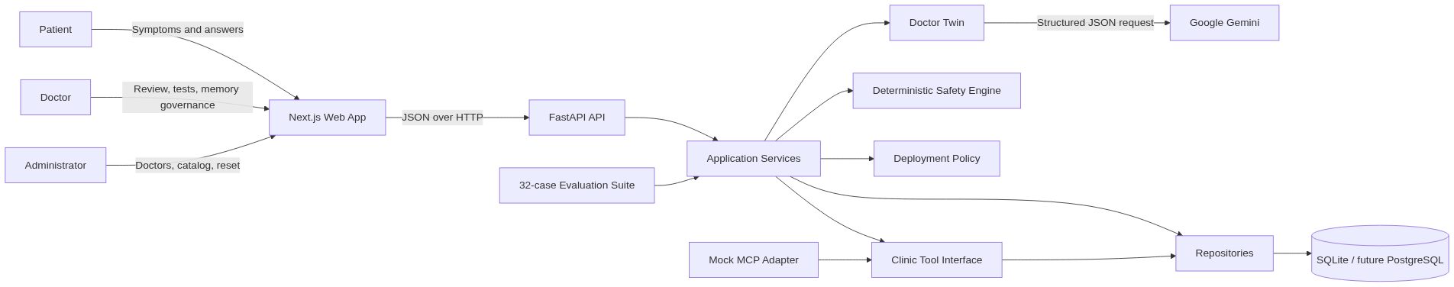
System Context

1.4.1 Architectural principle
The LLM proposes structured information; it does not own final safety or operational authority. Safety, deployment permissions, lifecycle transitions, memory promotion, and autonomous diagnostic-test gates are enforced in deterministic application code.

1.5 4. Technology Stack
Layer | Technology | Purpose
Web | Next.js App Router | Persona-based frontend and production build
UI | React + TypeScript + CSS | Typed components and custom clinical design system
HTTP API | FastAPI | Routing, validation, dependency injection, OpenAPI
Contracts | Pydantic v2 | Request, response, and LLM structured-output validation
Persistence | SQLAlchemy 2 | ORM models and repository abstraction
Local database | SQLite | Disposable synthetic development storage
AI | google-generativeai | Gemini JSON generation for assessments and memory extraction
Backend tests | pytest + FastAPI TestClient | Unit and integration tests with in-memory SQLite
Frontend tests | Vitest + Testing Library | Component and interaction tests
Development | Uvicorn + Next.js dev server | Reloading local application servers
The backend dependencies use bounded major versions rather than exact pins. The frontend package versions are exact. Node.js 22.12+ and Python 3.11+ are expected.

1.6 5. Component Architecture
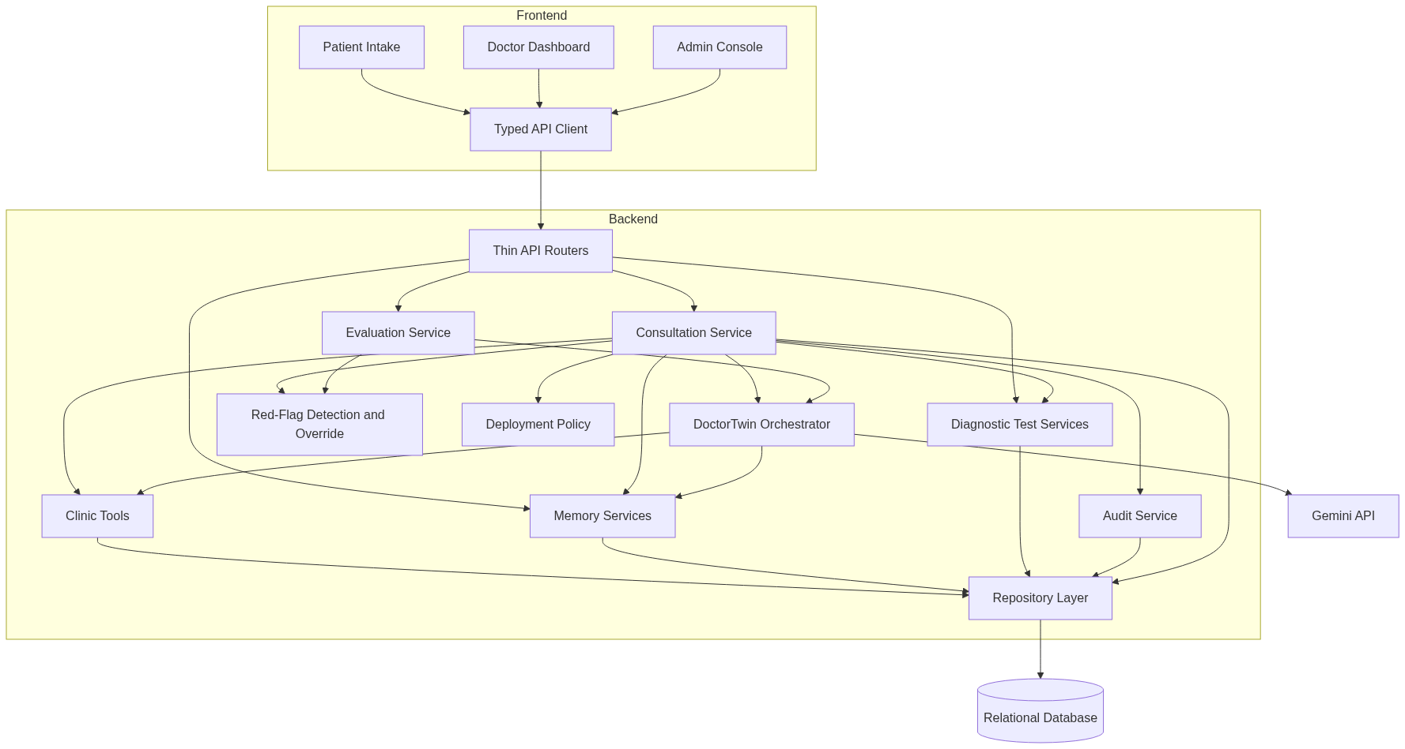
Component Architecture

1.6.1 Backend responsibilities
Package | Responsibility
api/ | HTTP routing, dependency injection, status-code mapping
agents/ | Prompt construction, Gemini client, structured parsing, deployment policy
safety/ | Deterministic red-flag detection and risk override
services/ | Cross-module consultation, evaluation, audit, test, and reset workflows
memory/ | Approved-memory retrieval and governed learning lifecycle
tools/ | Controlled patient, visit, appointment, and note operations
repositories/ | Entity-specific persistence operations
models/ | Shared Pydantic contracts, enums, and SQLAlchemy entities
The API routers remain deliberately thin. Business rules are concentrated in services, agents, safety, memory, and tools so they can be tested independently.

1.7 6. Personas and Frontend
The root route redirects to the route associated with the selected persona.
Route | Persona | Main capabilities
/intake | Patient | Select/register profile, select doctor, resume an open case, submit symptoms, answer follow-ups, view emergency guidance or appointment slots
/dashboard | Doctor | Select doctor, set mode, review cases, approve/modify assessments, finalize tests, create appointments, close cases, govern memory, run evaluations
/admin | Administrator | Onboard doctors, manage the diagnostic-test catalog, inspect row counts, reset non-baseline data
Memory management is integrated into the doctor dashboard as a top-level tab. The older standalone /memory route described in some historical context is not part of the current route tree.

1.7.1 Patient experience
- Existing patients select a synthetic profile; new patients can self-register.
- Known chronic/general conditions, medications, and allergies are included in model context.
- Open, unreviewed encounters can be resumed.
- Patient messages render optimistically while the twin is processing.
- The composer is disabled for RED emergencies; the patient is directed to show the case to a doctor.
- Clinical assessment details remain doctor-facing; the patient receives collection, scheduling, or escalation guidance.

1.7.2 Doctor experience
- Cases are sorted for review, with optional closed history.
- SHADOW cases show a factual intake summary and require the doctor to author the clinical response.
- Other modes can show structured model proposals, while the doctor may approve or modify them.
- Diagnostic recommendations are visually distinct from doctor selections.
- Closing a reviewed case triggers best-effort memory extraction.
- Memory is organized by five categories and three statuses.

1.7.3 Admin experience
- New doctors always start in SHADOW mode.
- Catalog entries can be created, edited, activated/deactivated, and marked autonomous-eligible.
- Data reset requires the exact phrase RESET ADDED DATA and preserves deterministic baseline records.

1.8 7. Core Consultation Workflow
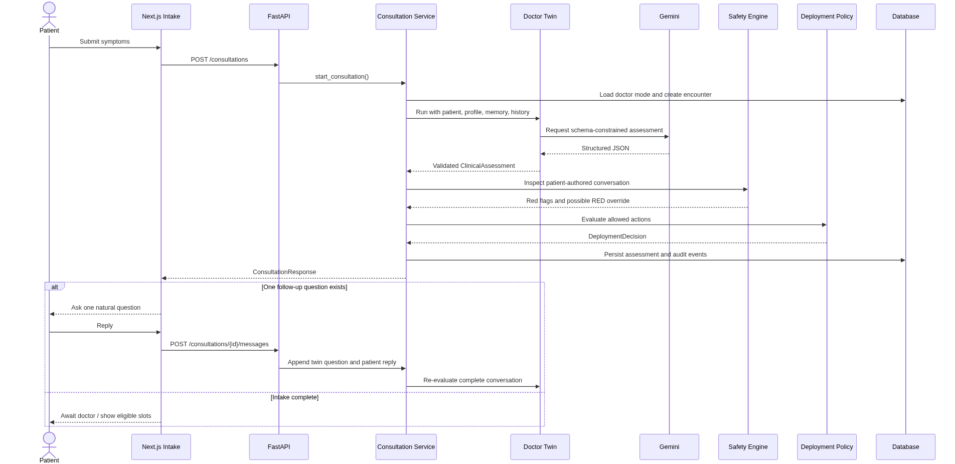
Consultation Sequence

1.8.1 Structured assessment contract
Every model assessment must validate as ClinicalAssessment:
- symptoms;
- zero or one missing-information question;
- GREEN, AMBER, or RED risk;
- escalation decision and reason;
- factual summary;
- recommended action;
- confidence in the range $[0,1]$;
- fail-safe marker;
- up to five catalog-coded diagnostic-test recommendations.
Follow-up collection is bounded to five answered questions. Previously asked questions are suppressed to prevent loops. Each persisted conversation alternates explicit patient and twin turns so safety checks and subsequent prompts receive reliable context.

1.8.2 Failure behavior
If Gemini is missing, unavailable, rate-limited, returns malformed JSON, or violates the schema, the Doctor Twin returns a deterministic fallback:
- risk becomes AMBER;
- escalation is required;
- confidence becomes 0.0;
- fallback_used becomes true;
- the case remains visible for doctor review;
- the API does not expose a provider failure to the patient.
Unreadable stored assessments are also converted to an AMBER fallback while listing cases, preventing one corrupted row from crashing an entire dashboard.

1.9 8. Safety Architecture
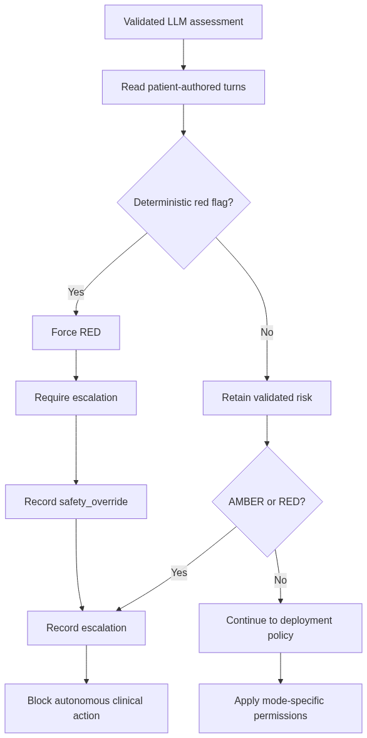
Safety Workflow
The detector recognizes synthetic keyword categories for severe chest pain, breathing difficulty, loss of consciousness, stroke-like symptoms, severe allergic reaction, and severe bleeding. It evaluates patient-authored statements, handles local negation, and treats a short affirmative reply as confirmation only when the immediately preceding twin question is an unambiguous single safety question. A twin-authored question cannot trigger its own red flag.

1.9.1 Safety invariants
- The model never has final authority over risk.
- A detected red flag forces RED and escalation in every deployment mode.
- AMBER and RED cannot execute autonomous actions.
- Invalid model output fails toward human review, not silent success.
- Patients do not receive the internal assessment except emergency guidance required by the UI flow.
- Safety overrides, escalations, review decisions, test decisions, closure, and extraction failures are auditable.

1.10 9. Deployment Modes
Mode | Twin behavior | Doctor role | Automated action
SHADOW | Ask preliminary questions and create a factual summary only | Writes assessment/action and selects tests | None
COPILOT | Propose assessment and catalog-constrained tests | Approves, rejects, modifies, or replaces | None
INTAKE | Collect information and create structured case | Reviews escalated case | No clinical action; AMBER/RED escalation
AUTONOMOUS | Propose assessment/tests | Reviews anything gated or escalated | Only allowlisted GREEN actions and separately gated tests
AUTONOMOUS clinical actions are limited to provide_informational_guidance and close_case for GREEN assessments. Any other action is routed to a doctor. Diagnostic-test autonomy has stricter independent gates described below.

1.11 10. Doctor Review and Case Lifecycle
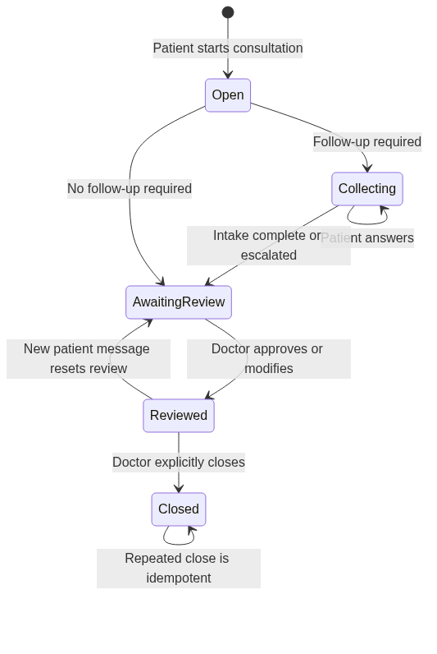
Consultation Lifecycle
The doctor can approve the assessment as-is or modify risk, escalation fields, summary, recommended action, and selected tests. Review does not rerun automated safety because the doctor is the final human authority. A new patient message invalidates the earlier review. Closed encounters reject further messages and review changes.
Closure is permitted only after review. It persists closed_at, records closure events, and attempts memory extraction. Extraction failure does not roll back or block case closure.

1.12 11. Governed Memory Learning
Doctor memory and diagnostic-test learning are separate mechanisms. Memory captures durable preferences and patterns; test decisions capture structured evidence about catalog selections in comparable scenarios.
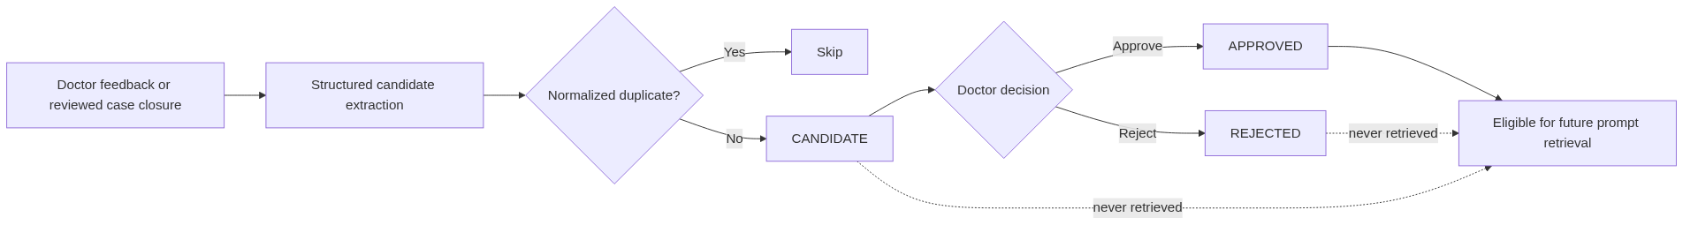
Memory Governance

1.12.1 Memory categories
- preference;
- escalation rule;
- communication style;
- clinical pattern;
- workflow preference.
Closure extraction may create at most one candidate per category. Exact normalized duplicates are skipped across all statuses. Only APPROVED memory is retrievable by the twin. Current retrieval ranks approved entries using naive keyword overlap and returns up to five; pgvector semantic retrieval is future work.

1.13 12. Diagnostic-Test Decision Learning
The hospital owns a catalog of test codes, names, categories, descriptions, activation state, and autonomous eligibility. Decisions reference catalog IDs, preserving consistent terminology and historical provenance.
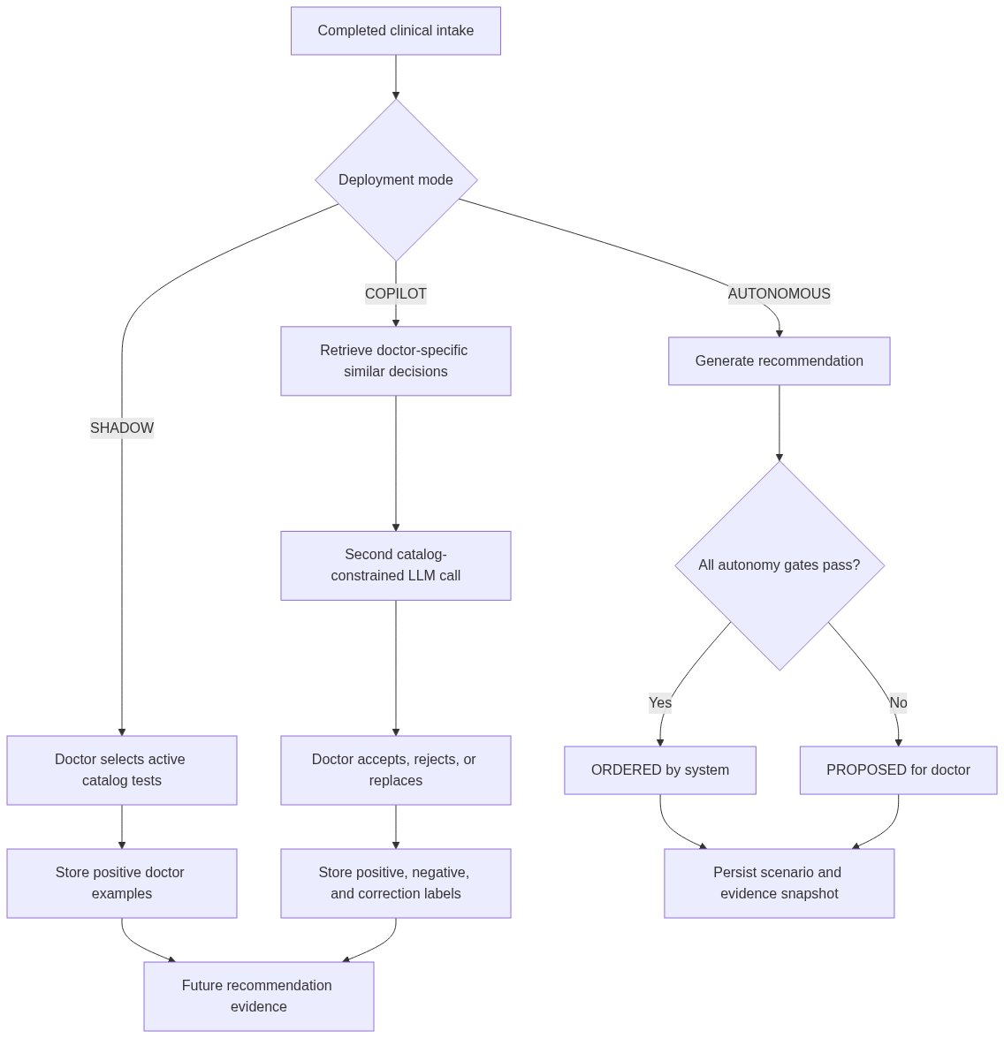
Diagnostic Test Learning

1.13.1 Scenario matching
Evidence is isolated by doctor and derived from de-identified features: symptoms, risk, age band, sex, and relevant conditions. The similarity score is:
$$S=0.65J_{symptoms}+0.15J_{conditions}+0.10I_{risk}+0.05I_{age}+0.05I_{sex}$$
where $J$ is token-set Jaccard similarity and $I$ is an exact-match indicator. Symptom overlap must be non-zero, and evidence is retained only when $S≥0.45$.

1.13.2 Learning labels
Source | Stored interpretation
SHADOW doctor-selected ORDERED test | Positive example
COPILOT recommended and accepted test | Positive example
COPILOT recommended and removed test | Negative example
COPILOT doctor-added replacement | Positive correction
AUTONOMOUS system decision | Never used to train itself
Open/unreviewed encounter | Excluded

1.13.3 Autonomous ordering gates
Every gate must pass:
- Intake is complete, non-fallback, GREEN, and not escalated.
- Catalog entry is active and autonomous_eligible.
- Current recommendation confidence is at least 0.8 by default.
- At least 2 matching SHADOW orders exist for that doctor.
- At least 2 matching COPILOT decisions exist for that doctor.
- Matching COPILOT acceptance rate is at least 0.75 by default.
Failed gates store the decision as PROPOSED with a gate_reason. Evidence snapshots are immutable so later history cannot change the explanation for an earlier decision. A doctor can finalize a proposal while retaining that evidence.

1.14 13. Data Model
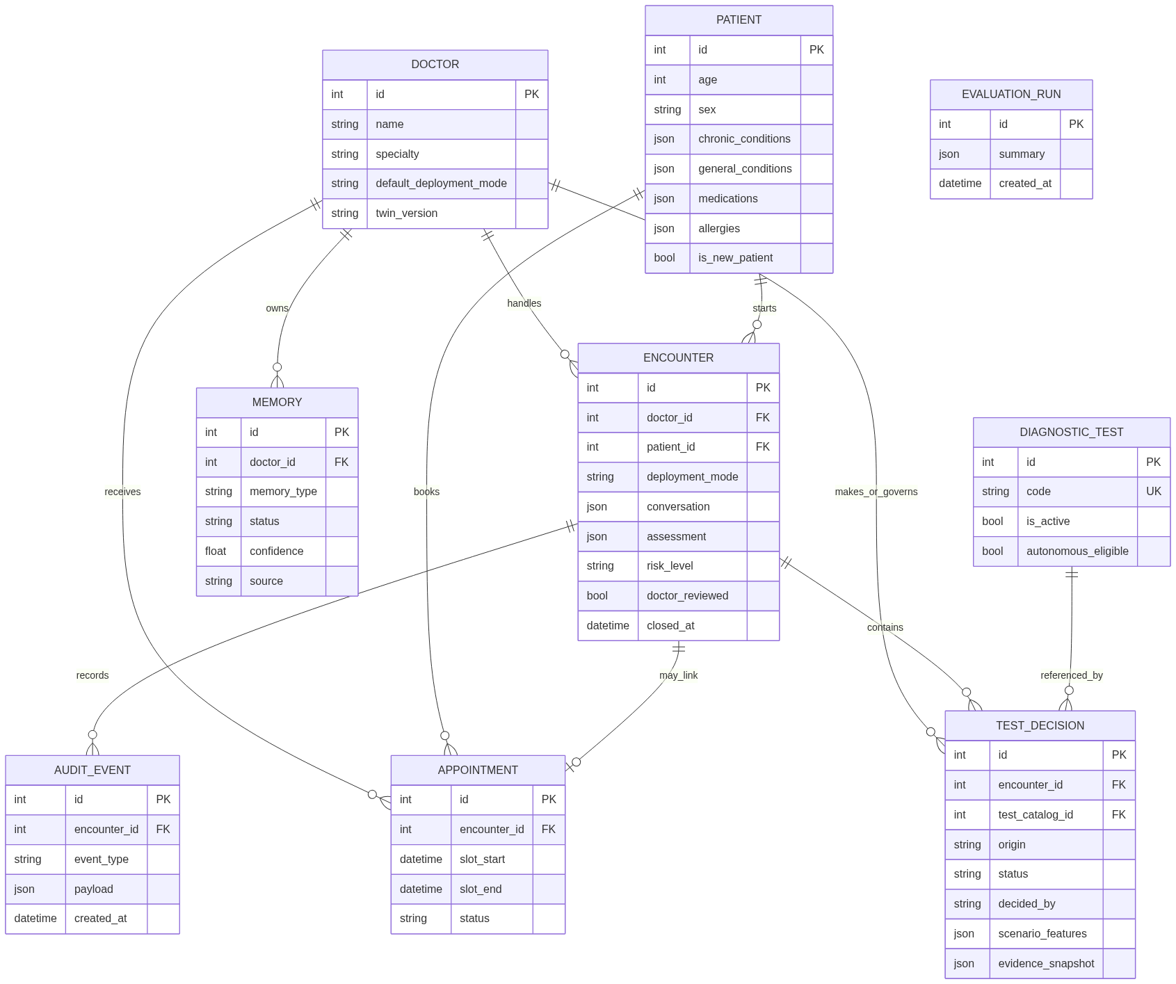
Entity Relationship Model
JSON columns are used for evolving structured content such as conversations, assessments, patient condition lists, audit payloads, and evidence snapshots. Enum values are stored as strings. Appointment times are intentionally naive datetimes because SQLite timezone round-tripping is inconsistent in this prototype.

1.15 14. API Reference
Interactive OpenAPI documentation is available at http://127.0.0.1:8014/docs while the backend is running.

1.15.1 Health and profiles
Method | Path | Purpose
GET | /health | Service health check
GET | /doctors | List visible doctors
POST | /doctors | Onboard doctor in SHADOW mode
GET | /doctors/{doctor_id} | Get doctor profile
POST | /doctors/{doctor_id}/mode | Change default deployment mode
GET | /patients | List visible patients
POST | /patients | Register a new patient
GET | /patients/{patient_id} | Get patient profile
POST | /patients/{patient_id}/conditions | Append chronic/general condition

1.15.2 Consultations
Method | Path | Purpose
POST | /consultations | Start consultation and run twin/safety workflow
GET | /consultations?doctor_id={id} | List a doctor’s cases
GET | /consultations/patient/{patient_id} | List patient’s open, unreviewed cases
GET | /consultations/{consultation_id} | Get one case
POST | /consultations/{id}/messages | Add patient answer and re-evaluate
POST | /consultations/{id}/review | Approve/modify assessment and finalize tests
POST | /consultations/{id}/close | Close reviewed case and extract memory candidates

1.15.3 Memory, appointments, and evaluations
Method | Path | Purpose
GET | /memories/{doctor_id} | List all memory statuses for doctor
POST | /memories | Create candidate from doctor feedback
POST | /memories/{memory_id}/approve | Promote candidate to APPROVED
POST | /memories/{memory_id}/reject | Mark memory REJECTED
GET | /appointments | List appointments, optionally by doctor
GET | /appointments/available-slots | Get synthetic available slots
POST | /appointments | Book and optionally link appointment
POST | /evaluations/run | Execute and persist full evaluation suite
GET | /evaluations/results | Return latest persisted evaluation

1.15.4 Diagnostic-test catalog and administration
Method | Path | Purpose
GET | /diagnostic-tests | List active tests
GET | /admin/diagnostic-tests | List complete catalog
POST | /admin/diagnostic-tests | Create catalog entry
PATCH | /admin/diagnostic-tests/{test_id} | Edit or deactivate entry
GET | /admin/data-summary | Get resettable/protected row counts
POST | /admin/reset-data | Delete added data after typed confirmation

1.15.5 Representative request
POST /consultations
{
"doctor_id": 1,
"patient_id": 1,
"message": "I have had a persistent cough and fever for two days."
}
All frontend requests pass through the typed client in frontend/lib/api.ts; page components do not call fetch directly.

1.16 15. Clinic Tools and Mock MCP
The controlled clinic interface exposes:
- get_patient;
- get_previous_visits;
- get_available_slots;
- create_appointment;
- create_clinical_note.
The twin does not access the database directly. Clinic operations pass through tools and repositories. Available slots are synthetic hourly periods from 09:00 to 17:00, excluding existing bookings. Appointment creation can link the appointment to an encounter and emits an audit event. Clinical notes are represented as audit events rather than a dedicated table.
mcp/clinic_server.py mirrors this interface but delegates locally. It demonstrates the future integration boundary; it is not a protocol-compliant MCP server and does not connect to an EHR.

1.17 16. Evaluation Framework
The evaluation suite runs the same Doctor Twin and safety policy used by live consultations. It validates each synthetic case against the shared Pydantic schema and persists the complete result.
Metric | Meaning
Red-flag recall | Fraction of expected RED cases classified RED
Escalation recall | Fraction of expected escalations actually escalated
Required-question coverage | Expected intake questions represented in model follow-ups
Structured-output validity | Responses satisfying the assessment schema
Doctor-preference alignment | Recommended action matching the expected action
Evaluation Pipeline
Metrics are computed from each actual run and are never hard-coded. Tests use scripted model doubles; a live CLI evaluation uses Gemini and therefore requires a configured API key.

1.18 17. Auditability and Governance
AuditEvent provides an append-only application-level record. Important event types include:
- safety_override;
- escalation;
- doctor_approved_assessment;
- doctor_modified_assessment;
- doctor_finalized_test_decisions;
- autonomous_test_decisions_evaluated;
- appointment_created;
- clinical_note;
- case_closed;
- case_memory_extraction_failed.
Assessment review events retain before/final assessment snapshots. Test decisions retain scenario and evidence snapshots. These records make automated and human decisions explainable within the limits of the prototype.

1.19 18. Configuration
Backend settings use the TWIN_ prefix and are loaded through pydantic-settings.
Variable | Default | Purpose
TWIN_APP_NAME | Doctor Digital Twin | OpenAPI/application name
TWIN_ENVIRONMENT | development | Environment label
TWIN_DATABASE_URL | sqlite:///./twin.db | SQLAlchemy connection URL
TWIN_GEMINI_API_KEY | empty | Gemini credential; never commit it
TWIN_GEMINI_MODEL | gemini-3.1-flash-lite | Model identifier
TWIN_EVAL_CASES_PATH | unset | Optional evaluation-case override
TWIN_CORS_ALLOW_ORIGINS | http://localhost:3000 | Comma-separated frontend origins
TWIN_AUTONOMOUS_TEST_MIN_CONFIDENCE | 0.8 | Test recommendation confidence gate
TWIN_AUTONOMOUS_TEST_MIN_SHADOW_ORDERS | 2 | Required matching SHADOW evidence
TWIN_AUTONOMOUS_TEST_MIN_COPILOT_DECISIONS | 2 | Required matching COPILOT evidence
TWIN_AUTONOMOUS_TEST_MIN_COPILOT_ACCEPTANCE | 0.75 | Minimum historical acceptance rate
NEXT_PUBLIC_API_BASE_URL | http://127.0.0.1:8014 | Browser API base URL
Secrets belong only in ignored local environment files or a deployment secret manager. A previously shared key should be treated as compromised and rotated; documentation must never contain it.

1.20 19. Local Setup and Operation

1.20.1 Prerequisites
- Python 3.11 or newer;
- Node.js 22.12 or newer;
- npm;
- optional Gemini key for live model calls.

1.20.2 Install
cd C:\Users\ampathania\Desktop\Projects\Twin
.\.venv\Scripts\python.exe -m pip install -r backend\requirements.txt
cd frontend
npm install
cd ..
Create local environment files from the supplied examples and add secrets locally.

1.20.3 Seed synthetic data
npm run seed
The idempotent seed includes four doctors, eight patients, doctor-specific memory, and eight diagnostic tests.

1.20.4 Start both applications
npm run dev
- Frontend: http://localhost:3000
- Backend: http://127.0.0.1:8014
- OpenAPI: http://127.0.0.1:8014/docs
For a clean disposable database before startup:
npm run dev:backend:fresh
This checks port 8014 before resetting. The reset is destructive and intended only for synthetic local development.

1.21 20. Testing and Quality Strategy
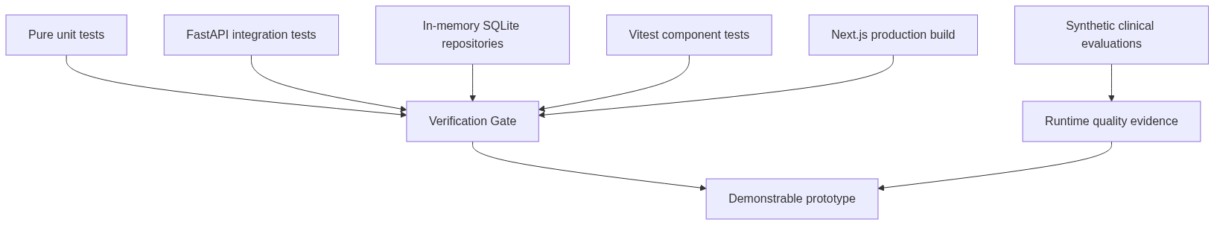
Testing Strategy

1.21.1 Backend
.\.venv\Scripts\python.exe -m pytest backend\tests -v
The suite uses a fresh in-memory SQLite database, StaticPool, and fake/scripted LLM clients. It performs no network calls and requires no real API key. Coverage includes repositories, structured output, fail-safe behavior, safety categories and negation, all deployment modes, consultation APIs, memory governance, closure extraction, appointments, admin reset, diagnostic-test learning/gates, and evaluations.

1.21.2 Frontend
cd frontend
npm test
npm run build
Current frontend tests cover optimistic intake/loading behavior and diagnostic-test recommendation/selection behavior.

1.21.3 Latest verification
Check | Result on 20 September 2026
Backend pytest suite | 119 passed
Frontend Vitest suite | 3 passed across 2 files
Next.js production build | Successful; all routes generated
Noted warnings | Dependency/config deprecations only; no test or build failure

1.22 21. Security, Privacy, and Clinical Risk

1.22.1 Existing controls
- Synthetic-only data and explicit prototype positioning.
- Pydantic validation at API and model-output boundaries.
- Gemini JSON-mode structured responses.
- Deterministic safety override independent of the LLM.
- Conservative fallback when the provider or schema fails.
- Human review before closure and memory learning.
- Approved-only memory retrieval.
- Doctor-specific test evidence and strict autonomy gates.
- Catalog allowlisting and soft deactivation.
- Typed confirmation for destructive admin reset.
- CORS configured through environment settings.
- Audit records for material safety and workflow events.

1.22.2 Production gaps
- No authentication, authorization, role enforcement, or patient identity verification.
- Patient consultation lookup trusts a caller-supplied patient ID.
- No encryption/key-management design beyond local environment variables.
- No rate limiting, abuse controls, session management, or CSRF strategy.
- No formal PHI handling, retention, consent, deletion, or residency policy.
- No validated clinical ruleset, formal hazard analysis, or regulatory approval.
- SQLite foreign-key enforcement and production concurrency guarantees are insufficient.
- Audit records are application append-only, not cryptographically tamper-evident.
- Raw provider SDK package is deprecated upstream and should be migrated before production.
The correct production posture is therefore human-supervised research prototype, not clinical deployment.

1.23 22. Known Limitations and Technical Debt
- SQLite schema creation uses create_all; it creates tables but does not migrate existing columns. Local schema changes require reset/reseed unless manually migrated.
- The read side tolerates incomplete stored assessments, but the write path can still leave an initially created encounter if a failure occurs between commits.
- Memory retrieval uses lexical overlap rather than embeddings.
- Test-scenario similarity is deterministic and explainable but clinically unvalidated.
- Evaluation required-question matching is substring-based; one-question-per-turn behavior can lower coverage for cases listing multiple simultaneous required questions.
- The MCP layer is an adapter demonstration, not a transport implementation.
- Appointment inventory is synthetic and has no timezone, clinician schedule, cancellation, or external synchronization model.
- Frontend automated coverage is small relative to the number of user workflows.
- No background job queue exists; live evaluation and LLM operations run within request workflows.
- No deployment manifests, containers, CI pipeline, telemetry, or production database configuration are included.

1.24 23. Recommended Production Roadmap
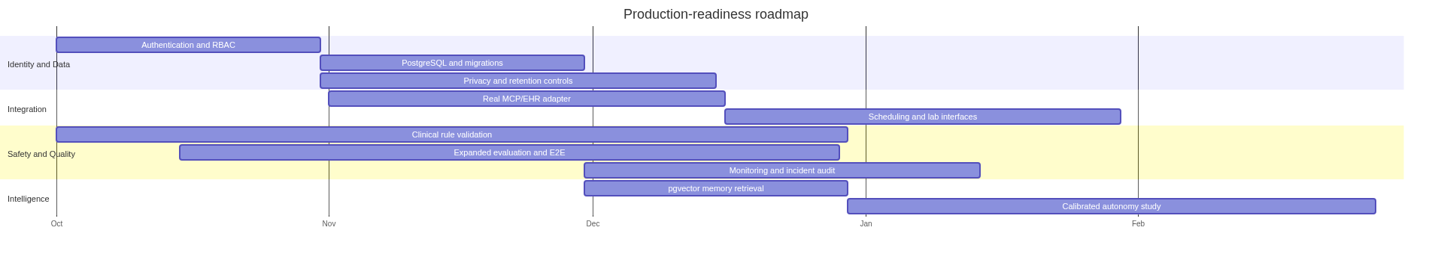
Production Roadmap
Priority should be authentication/RBAC, database migrations, privacy controls, and clinical safety validation before expanding autonomous behavior. Autonomous thresholds should ultimately be calibrated from reviewed evidence rather than treated as universal constants.

1.25 24. Project Evolution and Design Decisions
The implementation history shows an incremental, test-driven progression:
- A minimal FastAPI scaffold was replaced with the domain-oriented backend/app structure.
- Core doctor, patient, repository, Twin, safety, and deployment-mode phases were implemented.
- Clinic tools, mock MCP, governed memory, and synthetic evaluations were added.
- Next.js patient, doctor, and admin experiences were connected through additive APIs.
- Doctor review/modify behavior and per-doctor deployment modes were introduced.
- SHADOW mode was tightened to factual collection only, with the doctor authoring the response.
- Patient profile handling was separated into chronic and general conditions.
- Emergency intake disabled further chat and routed the case to the dashboard.
- Explicit closure and best-effort candidate-memory extraction completed the learning loop.
- Diagnostic-test catalog, labels, evidence retrieval, and autonomous gates added a separate decision-learning loop.
- Structured-output enforcement, repeated-question limits, provider fail-safe behavior, and defensive stored-assessment parsing hardened reliability.
The key design decision remained stable throughout: use one reusable Doctor Twin implementation and personalize it with doctor profile, approved memory, and doctor-scoped evidence. Maintaining a separate agent implementation per doctor would duplicate code, fragment safety controls, and make governance harder.

1.26 25. Repository Map
Twin/
|-- backend/
| |-- app/
| | |-- agents/ # Doctor Twin, prompts, Gemini client, mode policy
| | |-- api/ # FastAPI routers
| | |-- memory/ # Retrieval, candidate lifecycle, extraction
| | |-- models/ # Pydantic and SQLAlchemy models
| | |-- repositories/ # Persistence abstraction
| | |-- safety/ # Red flags and deterministic override
| | |-- services/ # Workflow orchestration
| | `-- tools/ # Controlled clinic operations
| `-- tests/ # Hermetic backend test suite
|-- evals/ # Synthetic cases and CLI wrappers
|-- frontend/
| |-- app/ # /intake, /dashboard, /admin
| |-- components/ # Shared clinical UI components
| |-- lib/api.ts # Typed backend client
| `-- test/ # Vitest setup
|-- mcp/ # Mock clinic MCP adapter
|-- README.md # Quickstart and project overview
`-- TECHNICAL_DOCUMENTATION.md

1.27 26. Conclusion
Doctor Digital Twin demonstrates a practical architecture for incrementally deploying doctor-personalized AI while preserving deterministic safety controls and explicit human governance. Its strongest engineering properties are separation of concerns, schema-constrained model output, fail-safe escalation, immutable decision evidence, approved-only learning, and broad hermetic backend testing.
The prototype is complete enough to demonstrate patient intake, doctor oversight, governed learning, evidence-gated test decisions, and system evaluation end to end. Its limitations are also explicit: it remains synthetic, unauthenticated, locally persisted, and clinically unvalidated. Those boundaries are essential to interpreting the project responsibly.

1.28 Appendix A: Key Source Files
- backend/app/main.py - application composition and CORS.
- backend/app/config.py - environment configuration.
- backend/app/agents/doctor_twin.py - personalized Twin orchestration and fail-safe parsing.
- backend/app/agents/prompts.py - assessment and extraction prompts.
- backend/app/agents/deployment_policy.py - mode permissions.
- backend/app/safety/red_flags.py - deterministic detection.
- backend/app/safety/policy.py - risk override.
- backend/app/services/consultation_service.py - consultation lifecycle.
- backend/app/services/diagnostic_test_service.py - decision labeling and autonomous gates.
- backend/app/services/test_learning_service.py - scenario matching and evidence.
- backend/app/services/evaluation_service.py - evaluation source of truth.
- backend/app/memory/extraction.py - case-closure extraction.
- backend/app/memory/retrieval.py - approved-only retrieval.
- backend/app/tools/clinic_tools.py - clinic operations.
- backend/app/models/domain.py - persistence model.
- backend/app/models/schemas.py - API and structured-output contracts.
- frontend/app/intake/page.tsx - patient workflow.
- frontend/app/dashboard/page.tsx - doctor workflow, memory, and evaluations.
- frontend/app/admin/page.tsx - administration.
- frontend/lib/api.ts - frontend/backend contract.
- evals/cases.json - synthetic evaluation corpus.
- mcp/clinic_server.py - mock integration boundary.

1.29 Appendix B: Glossary
Term | Definition
Doctor Twin | Runtime-personalized agent using doctor profile, approved memory, and governed evidence
ClinicalAssessment | Validated structured output produced by the model or fail-safe
Red flag | Deterministically detected emergency indicator that forces RED escalation
Candidate memory | Proposed learning item that cannot influence the twin until approved
Evidence snapshot | Immutable record of supporting historical decisions at decision time
Deployment mode | Policy controlling which actions the same Twin may take
MCP | Model Context Protocol; represented here only by a mock adapter boundary

