Department of Computer Science and Engineering
(AI & ML)
B. Tech. CSE - 5th Semester
Aug – Dec 2026

UE23CS351A
DATABASE MANAGEMENT SYSTEMS (DBMS)

PROJECT REPORT on

Comps Engine: Comparable Company Analysis using SQL, Vector and Document Databases

Submitted by:
PES1UG24AM034 | Amogh Shetty | 5A
PES1UG24AM029 | Allen Anish | 5A

Class of Prof. Smitha G R
Lab Faculty: Prof. Rati Joshi

Abstract
Equity research and investment banking analysts value a company by comparing it with similar listed companies (comparable company analysis, or "comps"). Peers are usually chosen by industry code and size, which misses businesses that genuinely do similar work but carry a different sector label. Comps Engine is a web application that finds comparable companies in two complementary ways. A PostgreSQL database stores four fiscal years of real financial statements and market data for 19 NSE-listed companies across IT services, consumer internet and private banking, and computes valuation multiples (EV/EBITDA, P/E, P/B) through views, stored functions and a transactional procedure guarded by triggers and an audit log. The pgvector extension stores 384-dimensional sentence embeddings of each company's business description, so the application can rank companies by what they actually do. MongoDB holds deal history (acquisitions, mergers, IPOs, fundraises), whose fields differ by deal type, with schema validation and aggregation pipelines. A Next.js application with login, two roles (Analyst and Admin) and role-based access enforced both in the application and inside PostgreSQL ties the three data stores together. All 25 functional and security test cases pass.
Keywords: comparable company analysis, PostgreSQL, pgvector, MongoDB, semantic search, role-based access control, Next.js
Table of Contents
Sl. No | Topic | Page No.
 | Introduction  - Problem Statement | 4
 | User Requirements Specification- Tech Stack | 6
 | E-R Model  - List of Entities [labeling Weak ones]  - List non-simple Attributes  - ER Diagram Snapshot  - ERD from tool like draw.io | 9
 | Relational Model  - List of Relations that are not Entities in ER Model  - Schema Diagram [ensure light background image] | 12
 | SQL DDL Statements | 16
 | SQL DML Statements | 25
 | NoSQL/ Vector Database Commands | 31
8. | Results  - Resulting Tables’ Screenshots | 39
9. | Next.js-Project Tree Structure | 43
10. | Few sample Screenshots of application code and demo | 45
11. | Evaluation Rubrics- Completion Status | 50
12. | Conclusion and Future Enhancements | 50

1. Introduction

a) Problem Statement
When an investment banker or equity research analyst values a company, the first step is to find comparable listed companies and benchmark the target against their valuation multiples. In practice the peer set is picked by industry classification and size. That approach has two weaknesses: it misses companies whose business is genuinely similar but which sit under a different sector label, and the supporting information (financials, prices, descriptions, deal history) lives in different places with different shapes.
The problem this project solves is to store, connect and query that information in the database best suited to each part, so that an analyst can open one page for a company and see (i) a correct, auditable comps table, (ii) businesses that are similar by description, and (iii) the company's deal history, with access controlled by role.

Short Description
Comps Engine covers 19 NSE-listed companies in three sectors (IT services, consumer internet and private banks) with four fiscal years (FY2023 to FY2026) of real financial statements loaded from Yahoo Finance. Amounts are stored in INR crore; Infosys, which Yahoo reports in US dollars, is translated to rupees using the fiscal-year average rate for income items and the year-end rate for balance-sheet items.
• PostgreSQL holds the structured data: companies, sectors, financial statements, market snapshots, users and saved comp sets. Valuation multiples are never stored; they are derived on demand by views, so they can never go out of date.
• pgvector (inside the same PostgreSQL instance) stores a 384-dimensional embedding of each company's business description, created with the all-MiniLM-L6-v2 sentence-transformer, and answers "which companies read most like this one?" by cosine distance with an HNSW index.
• MongoDB stores deal news. An acquisition, a merger, an IPO and a fundraise each carry different fields, which suits a document model with a JSON-schema validator.
• Next.js provides the web interface and JSON API with two roles: Analysts read, Admins may also record financials through a stored procedure. Every change is written to an audit log by triggers, together with the admin who made it.

Objectives
1. Design a normalised relational schema with keys, constraints, views, functions, a transactional procedure and triggers for comparable company analysis.
2. Use a vector database for semantic similarity between companies, and a document database for variable-shape deal data, each justified by the shape of the data.
3. Build a role-based web application where access rules are enforced in the application and again inside the database.
4. Keep the whole dataset reproducible offline from the GitHub repository.

Scope
In scope: 19 NSE-listed companies in three sectors (IT services, consumer internet, private banks); four fiscal years (FY2023 to FY2026) of annual financial statements; one market snapshot per load; trading multiples (EV/EBITDA, EV/Revenue, P/E, P/B, margins) and sector medians; description-based similarity; 14 documented deals (acquisitions, mergers, IPOs, fundraises, a delisting); a web application with Analyst and Admin roles, audit logging and full-text search.
Out of scope: live or intraday prices, quarterly results, forecasts and DCF valuation, precedent-transaction multiples, companies outside the three sectors, and automatic news collection. These are listed as future enhancements in Section 12.

2. User Requirements Specification

2.1 Users and roles
Role | What the user can do | How it is enforced
Analyst (self-registers) | Log in; browse and sort all companies; open a company's comps table, similar businesses and deal history; full-text search; view sector benchmarks. | Next.js middleware + database role app_analyst (SELECT only).
Admin (created from the command line only) | Everything an analyst can do, plus record or correct a fiscal year's financials and view the audit log. | Middleware, a second check inside each admin route, and database role app_admin.

2.2 Functional requirements
• FR1: Users register with name, email and a password of at least 8 characters, and log in and out.
• FR2: The home page lists every company with market cap, EV/EBITDA, P/E, P/B and EBITDA margin, sortable by each column.
• FR3: A company page shows a sector comps table (same sector, closest market cap first) with the sector median.
• FR4: The same page lists the most similar businesses by description, including ones from other sectors.
• FR5: The same page shows the company's deal history from MongoDB.
• FR6: Users can search company descriptions by keywords (PostgreSQL full-text search).
• FR7: Admins can insert or update a fiscal year's financials; invalid data is rejected with a clear reason.
• FR8: Every change to companies and financial statements is recorded in an audit log with the user who made it.

2.3 Non-functional requirements
• Security: bcrypt password hashes; signed session token in an httpOnly cookie; parameterised SQL everywhere; access rules checked twice.
• Integrity: primary, foreign, unique and check constraints; triggers reject financially impossible data; procedures are atomic.
• Reproducibility: raw downloads are cached and committed, so --offline rebuilds the exact dataset.
• Usability: works on desktop and phone widths; Indian number formatting (₹ crore).

2.4 Tech stack and justification
Layer | Technology | Why it fits this problem
Relational database | PostgreSQL 16 | Financial statements are uniform and relational; comps need joins, aggregates (medians via percentile_cont), views, procedures, triggers and transactions. PostgreSQL also has native full-text search (tsvector + GIN) and supports column- and role-level privileges.
Vector database | pgvector 0.8 (in PostgreSQL) | Similarity of businesses is a question of meaning, not of matching columns. Keeping vectors next to the relational data lets one SQL query combine similarity with sector, multiples and keys, with cascading deletes and one transaction model.
Document database | MongoDB 7 | Each deal type has different fields (target and consideration, swap ratio, issue size). Documents store exactly what each deal has; a $jsonSchema validator still enforces the core fields.
Embedding model | all-MiniLM-L6-v2 | Free, runs locally, 384 dimensions, strong on short business descriptions.
Data ingestion | Python 3 (psycopg, pymongo, yfinance, sentence-transformers) | Downloads, cleans, converts currency and loads each year through the stored procedure in its own transaction.
Web application | Next.js 14 (App Router), React 18 | Server-rendered pages and API route handlers in one project; edge middleware for authentication checks on every request.
Security | bcryptjs, jose (JWT), zod | Password hashing, signed session tokens, input validation.
Environment | Docker Compose, Git/GitHub | One command starts PostgreSQL (with pgvector) and MongoDB identically on any machine.

2.5 Justification of the NoSQL choice (MongoDB)
Deal records are naturally heterogeneous. In a relational design they would need either one wide table with many mostly-NULL columns, or one table per deal type plus a union for every timeline query. As documents, each deal stores only its own fields in a nested object (deal, merger, ipo or raise), while common fields (ticker, sector, date, type, headline, tags) stay at the top level for indexing and aggregation. Flexibility does not mean no rules: a $jsonSchema validator makes MongoDB reject documents that miss a core field or use an unknown deal type. Because there is no foreign key between MongoDB and PostgreSQL, the loader checks every ticker against PostgreSQL before inserting, and copies the sector into each document (deliberate denormalisation) so that aggregations can group by sector without a cross-database join.

2.6 Justification of the vector database choice (pgvector)
A dedicated vector store (Qdrant, Pinecone, Chroma) would hold the embeddings away from the data they describe. With pgvector the company_embeddings table has a foreign key to companies with ON DELETE CASCADE, so a vector can never outlive its company, and the similar_companies() function returns neighbours already joined to their sector and multiples in a single query. For 19 to a few thousand companies this is simpler, consistent and fast; the HNSW index keeps nearest-neighbour search fast as the table grows.

2.7 System architecture
The browser talks only to the Next.js application. Every request passes through the middleware (login and role check) before reaching a server-rendered page or an API route handler, which share one data-access layer. That layer runs every PostgreSQL query inside a short transaction under the database role that matches the user (app_analyst or app_admin), and reads deals from MongoDB. Data enters through three Python scripts: financials from Yahoo Finance through the record_financials procedure, embeddings from the MiniLM model into pgvector, and deals from deals.json into MongoDB after each ticker is checked against PostgreSQL. Both databases run in Docker Compose; all credentials come from environment files that are not committed.
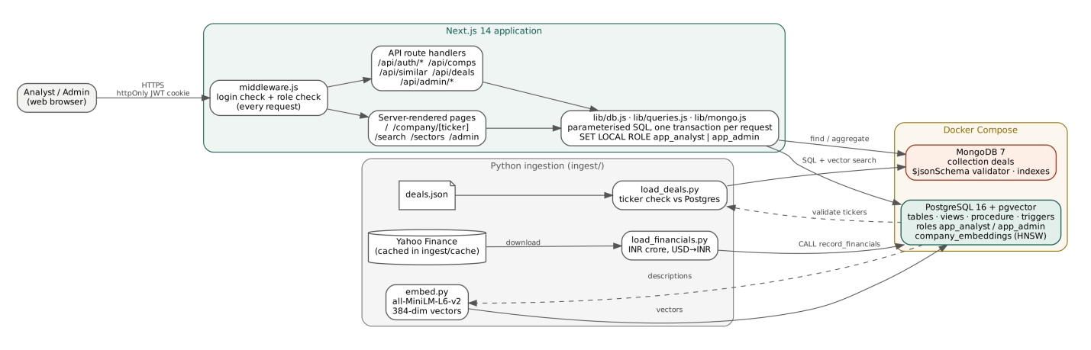
Figure 1. System architecture.

3. E-R Model

a) List of Entities (weak entities highlighted)
Entity | Type | Key | Description
SECTOR | Strong | sector_id | Industry group; flag uses_ev_multiples is FALSE for banks.
COMPANY | Strong | company_id (ticker is a candidate key) | A listed company and its business description.
FINANCIAL_STATEMENT | Weak (owner: COMPANY) | partial key fiscal_year | One fiscal year of revenue, EBITDA, net income, debt, cash, equity. Cannot exist without its company.
MARKET_SNAPSHOT | Weak (owner: COMPANY) | partial key as_of_date | Price and market capitalisation on a date.
COMPANY_EMBEDDING | Weak (owner: COMPANY) | identified by its company (1:1) | 384-dimensional description vector and the model that produced it.
USER | Strong | user_id (email is a candidate key) | Application login with role admin or analyst.
COMP_SET | Strong | set_id | A saved peer group built by a user for a target company.
AUDIT_LOG | Strong | log_id | Before/after image of every change, written by triggers.

Relationships
Relationship | Between | Cardinality | Participation
BELONGS_TO | COMPANY – SECTOR | N : 1 | Total for COMPANY
REPORTS (identifying) | COMPANY – FINANCIAL_STATEMENT | 1 : N | Total for FINANCIAL_STATEMENT
PRICED_AT (identifying) | COMPANY – MARKET_SNAPSHOT | 1 : N | Total for MARKET_SNAPSHOT
DESCRIBED_BY (identifying) | COMPANY – COMPANY_EMBEDDING | 1 : 1 | Total for COMPANY_EMBEDDING
CREATES | USER – COMP_SET | 1 : N | Total for COMP_SET
TARGETS | COMP_SET – COMPANY | N : 1 | Total for COMP_SET
INCLUDES | COMP_SET – COMPANY | M : N | Partial on both sides

b) Non-simple attributes
Attribute | Entity | Kind | How it is realised
enterprise_value | COMPANY | Derived | market_cap + total_debt − cash, computed in view latest_multiples
ev_ebitda, ev_revenue, pe_ratio, pb_ratio | COMPANY | Derived | Ratios computed in latest_multiples; NULL when the denominator is ≤ 0 or for banks
ebitda_margin_pct, net_margin_pct | COMPANY | Derived | Computed in latest_multiples
description_tsv | COMPANY | Derived | GENERATED ALWAYS AS to_tsvector(description) STORED, GIN-indexed
embedding | COMPANY_EMBEDDING | Multi-valued | An ordered set of 384 values stored as one vector(384) column
debt / cash / equity | FINANCIAL_STATEMENT | Grouped (balance-sheet items) | Stored as atomic columns total_debt, cash, total_equity
tags (MongoDB) | Deal document | Multi-valued | Array field; unwound in an aggregation pipeline

c) ER Diagram Snapshot
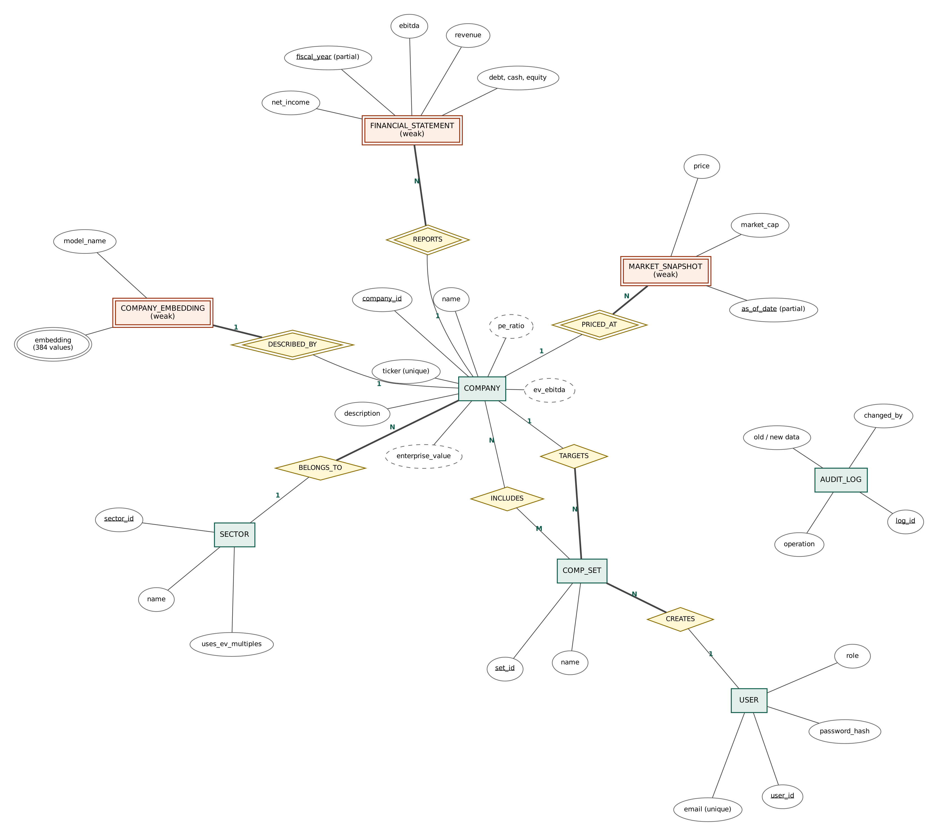
Figure 2. ER diagram (Chen notation). Double rectangles: weak entities; double diamonds: identifying relationships; dashed ellipses: derived attributes; double ellipse: multi-valued attribute; bold lines: total participation.

d) ERD from a tool
The ER diagram above was produced with Graphviz from the source file docs/er.dot in the repository, so it can be regenerated or edited. A crow's-foot version of the same model can be opened in dbdiagram.io by pasting docs/schema.dbml.

4. Relational Model

a) List of Relations
Relations marked Not an entity do not appear as entities in the ER model: they come from a relationship or are derived views.
Relation | Primary key | Foreign keys | Origin in ER model
sectors | sector_id | — | Entity SECTOR
companies | company_id | sector_id → sectors | Entity COMPANY (+ BELONGS_TO)
financial_statements | statement_id; UNIQUE(company_id, fiscal_year) | company_id → companies | Weak entity FINANCIAL_STATEMENT
market_data | market_id; UNIQUE(company_id, as_of_date) | company_id → companies | Weak entity MARKET_SNAPSHOT
company_embeddings | company_id | company_id → companies | Weak entity COMPANY_EMBEDDING
users | user_id | — | Entity USER
comp_sets | set_id | user_id → users; target_company_id → companies | Entity COMP_SET (+ CREATES, TARGETS)
comp_set_members | (set_id, company_id) | set_id → comp_sets; company_id → companies | Not an entity: M:N relationship INCLUDES
audit_log | log_id | — (changed_by kept without FK so history survives user deletion) | Entity AUDIT_LOG
latest_financials, latest_market (views) | — | — | Not an entity: latest row per company
latest_multiples, sector_summary (views) | — | — | Not an entity: derived attributes and sector medians

Normalisation. Every non-key attribute depends on the whole key and nothing else, so the base relations are in BCNF. In particular, multiples and margins are never stored (they depend on a statement and a price from two different relations); keeping them in views removes any chance of update anomalies. The surrogate keys statement_id and market_id sit alongside the natural composite keys, which are enforced as UNIQUE constraints.

b) Schema Diagram
The diagram is rotated to fit the page; turn the page clockwise to read it.
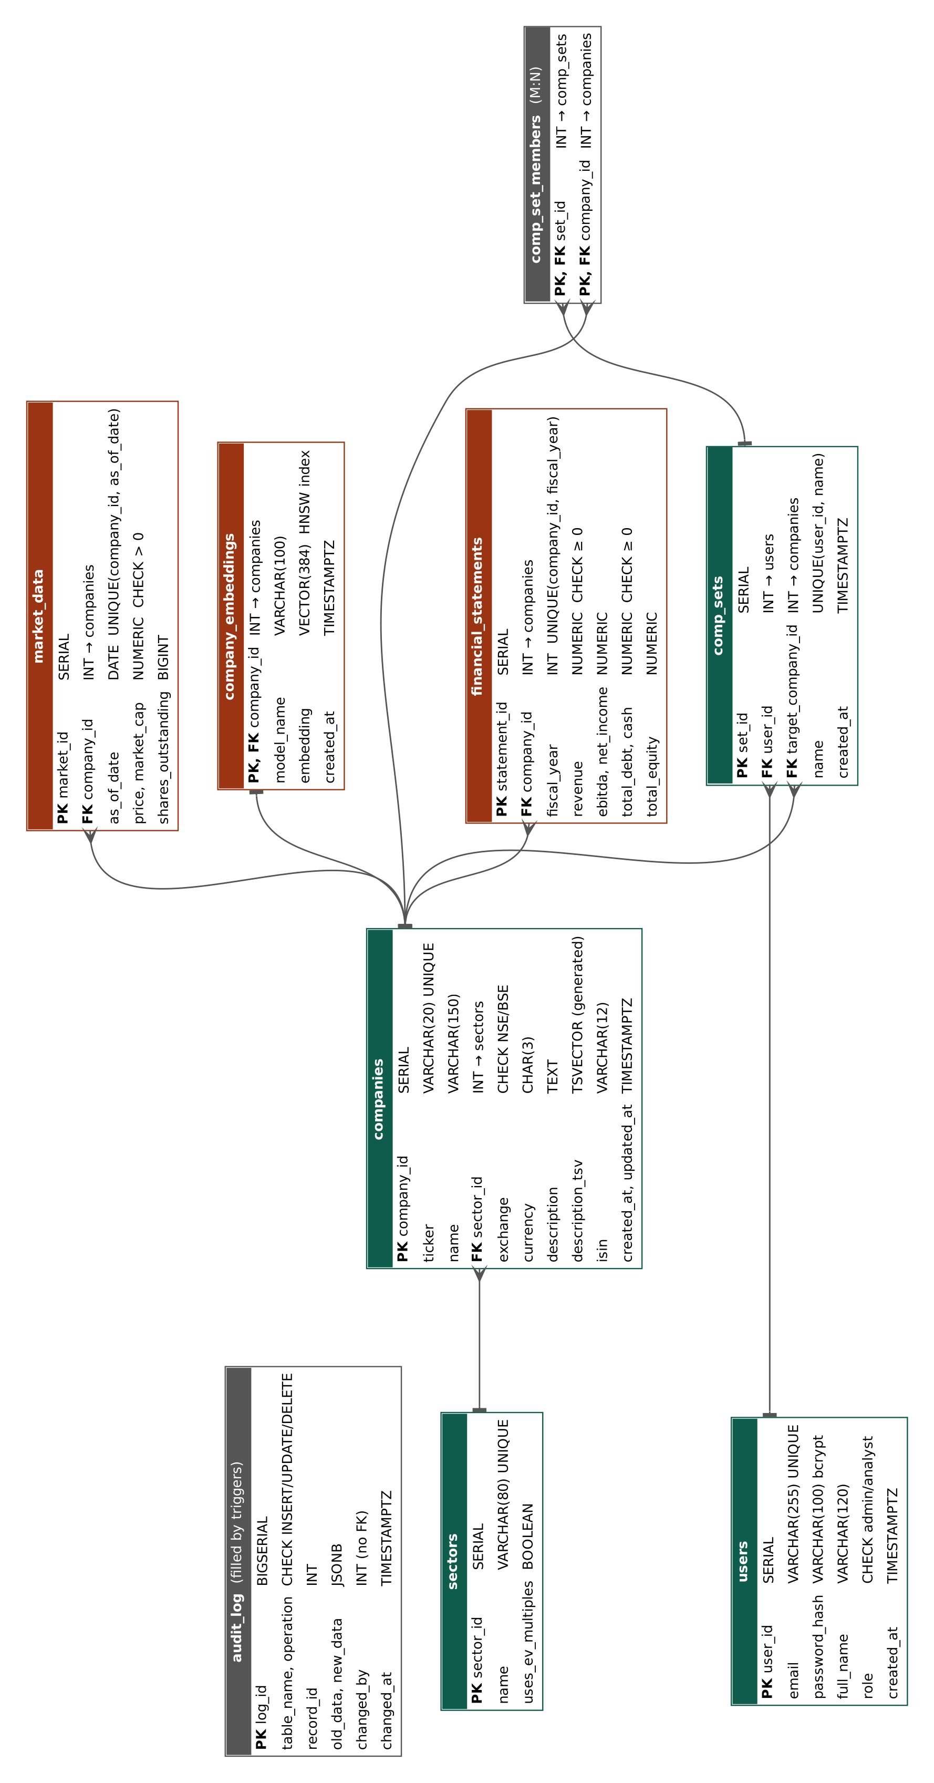
Figure 3. Relational schema with primary keys, foreign keys and main constraints (crow's foot = many, bar = one).

c) Data dictionary
Types, nullability and keys are read from the database catalogue (information_schema); PK = primary key, FK = foreign key, UQ = unique. Amounts are in INR crore.
Relation | Column | Type | Null | Key | Description
sectors | sector_id | integer | no | PK | Surrogate key
sectors | name | varchar(80) | no | UQ | Sector name, e.g. IT Services
sectors | uses_ev_multiples | boolean | no |  | FALSE for banks: EV-based multiples not computed
companies | company_id | integer | no | PK | Surrogate key
companies | ticker | varchar(20) | no | UQ | Yahoo/NSE symbol, e.g. INFY.NS
companies | name | varchar(150) | no |  | Company name
companies | sector_id | integer | no | FK | Sector of the company (ON DELETE RESTRICT)
companies | exchange | varchar(5) | no |  | CHECK NSE or BSE; default NSE
companies | currency | char(3) | no |  | Reporting currency after conversion; default INR
companies | description | text | yes |  | Business description from Yahoo Finance
companies | description_tsv | tsvector | yes |  | Generated tsvector of description; GIN index
companies | created_at | timestamptz | no |  | Row creation time
companies | updated_at | timestamptz | no |  | Last change; kept current by trigger
companies | isin | varchar(12) | yes |  | Added by ALTER TABLE; CHECK length 12
financial_statements | statement_id | integer | no | PK | Surrogate key
financial_statements | company_id | integer | no | FK, UQ | Owner company (ON DELETE CASCADE)
financial_statements | fiscal_year | integer | no | UQ | FY ending 31 March; UQ with company_id; CHECK 2000-2100
financial_statements | revenue | numeric(18,2) | no |  | Total revenue; CHECK >= 0
financial_statements | ebitda | numeric(18,2) | yes |  | EBITDA; NULL for banks; trigger: not above revenue
financial_statements | net_income | numeric(18,2) | yes |  | Net profit (can be negative)
financial_statements | total_debt | numeric(18,2) | no |  | Total borrowings; CHECK >= 0
financial_statements | cash | numeric(18,2) | no |  | Cash and equivalents; CHECK >= 0
financial_statements | total_equity | numeric(18,2) | yes |  | Shareholders' equity
financial_statements | created_at | timestamptz | no |  | Row creation time
market_data | market_id | integer | no | PK | Surrogate key
market_data | company_id | integer | no | FK, UQ | Owner company (ON DELETE CASCADE)
market_data | as_of_date | date | no | UQ | Date of the snapshot; UQ with company_id
market_data | price | numeric(14,2) | no |  | Share price in rupees; CHECK > 0
market_data | market_cap | numeric(18,2) | no |  | Market capitalisation; CHECK > 0
market_data | shares_outstanding | bigint | yes |  | Number of shares
company_embeddings | company_id | integer | no | FK, PK | Owner company; one vector per company
company_embeddings | model_name | varchar(100) | no |  | Embedding model used (metadata)
company_embeddings | embedding | vector(384) | no |  | 384-dim description vector; HNSW index
company_embeddings | created_at | timestamptz | no |  | When the vector was made
users | user_id | integer | no | PK | Surrogate key
users | email | varchar(255) | no | UQ | Login name; CHECK email pattern
users | password_hash | varchar(100) | no |  | bcrypt hash (never plain text)
users | full_name | varchar(120) | no |  | Display name
users | role | varchar(10) | no |  | CHECK admin or analyst; default analyst
users | created_at | timestamptz | no |  | Registration time
comp_sets | set_id | integer | no | PK | Surrogate key
comp_sets | user_id | integer | no | FK, UQ | Owner (ON DELETE CASCADE)
comp_sets | target_company_id | integer | no | FK | Company being valued
comp_sets | name | varchar(120) | no | UQ | Set name; UQ per user
comp_sets | created_at | timestamptz | no |  | Creation time
comp_set_members | set_id | integer | no | FK, PK | Comp set (composite PK)
comp_set_members | company_id | integer | no | FK, PK | Peer company (composite PK)
audit_log | log_id | bigint | no | PK | Surrogate key
audit_log | table_name | varchar(63) | no |  | Table that changed
audit_log | operation | varchar(10) | no |  | CHECK INSERT, UPDATE or DELETE
audit_log | record_id | integer | yes |  | Primary key of the changed row
audit_log | old_data | jsonb | yes |  | Row before the change (JSONB)
audit_log | new_data | jsonb | yes |  | Row after the change (JSONB)
audit_log | changed_by | integer | yes |  | user_id from app.user_id (no FK)
audit_log | changed_at | timestamptz | no |  | Time of change

5. SQL DDL Statements
The schema is created by seven files in db/, applied in order by python ingest/apply_sql.py (each file runs in its own transaction). Execution log:
[OK] 01_schema.sql
[OK] 02_views.sql
[OK] 03_functions.sql
[OK] 04_triggers.sql
[OK] 05_alter_demo.sql
[OK] 06_seed.sql
[OK] 07_roles.sql

5.1 01_schema.sql: CREATE TABLE with primary, foreign, unique and check constraints; GIN and HNSW indexes
-- =====================================================================
-- 01_schema.sql | Comps Engine core schema (DDL)
-- All monetary amounts are stored in INR crore (1 crore = 10,000,000).
-- =====================================================================

CREATE EXTENSION IF NOT EXISTS vector;

-- ---------------------------------------------------------------------
-- sectors
-- uses_ev_multiples = FALSE for banks/financials: EV/EBITDA is not
-- meaningful for them (deposits are their raw material, not debt), so
-- they are valued on P/E and P/B instead.
-- ---------------------------------------------------------------------
CREATE TABLE sectors (
sector_id SERIAL PRIMARY KEY,
name VARCHAR(80) NOT NULL UNIQUE,
uses_ev_multiples BOOLEAN NOT NULL DEFAULT TRUE
);

-- ---------------------------------------------------------------------
-- companies
-- description_tsv is a generated column used for full-text search.
-- ---------------------------------------------------------------------
CREATE TABLE companies (
company_id SERIAL PRIMARY KEY,
ticker VARCHAR(20) NOT NULL UNIQUE,
name VARCHAR(150) NOT NULL,
sector_id INT NOT NULL
REFERENCES sectors (sector_id) ON DELETE RESTRICT,
exchange VARCHAR(5) NOT NULL DEFAULT 'NSE',
currency CHAR(3) NOT NULL DEFAULT 'INR',
description TEXT,
description_tsv TSVECTOR GENERATED ALWAYS AS
(to_tsvector('english', coalesce(description, ''))) STORED,
created_at TIMESTAMPTZ NOT NULL DEFAULT now(),
updated_at TIMESTAMPTZ NOT NULL DEFAULT now(),
CONSTRAINT chk_companies_exchange CHECK (exchange IN ('NSE', 'BSE'))
);

-- ---------------------------------------------------------------------
-- financial_statements: one row per company per fiscal year
-- ---------------------------------------------------------------------
CREATE TABLE financial_statements (
statement_id SERIAL PRIMARY KEY,
company_id INT NOT NULL
REFERENCES companies (company_id) ON DELETE CASCADE,
fiscal_year INT NOT NULL,
revenue NUMERIC(18,2) NOT NULL,
ebitda NUMERIC(18,2),
net_income NUMERIC(18,2),
total_debt NUMERIC(18,2) NOT NULL DEFAULT 0,
cash NUMERIC(18,2) NOT NULL DEFAULT 0,
total_equity NUMERIC(18,2),
created_at TIMESTAMPTZ NOT NULL DEFAULT now(),
CONSTRAINT uq_fin_company_year UNIQUE (company_id, fiscal_year),
CONSTRAINT chk_fin_year CHECK (fiscal_year BETWEEN 2000 AND 2100),
CONSTRAINT chk_fin_revenue CHECK (revenue >= 0),
CONSTRAINT chk_fin_debt CHECK (total_debt >= 0),
CONSTRAINT chk_fin_cash CHECK (cash >= 0)
);

-- ---------------------------------------------------------------------
-- market_data: price / market cap snapshots
-- ---------------------------------------------------------------------
CREATE TABLE market_data (
market_id SERIAL PRIMARY KEY,
company_id INT NOT NULL
REFERENCES companies (company_id) ON DELETE CASCADE,
as_of_date DATE NOT NULL,
price NUMERIC(14,2) NOT NULL,
market_cap NUMERIC(18,2) NOT NULL,
shares_outstanding BIGINT,
CONSTRAINT uq_market_company_date UNIQUE (company_id, as_of_date),
CONSTRAINT chk_market_price CHECK (price > 0),
CONSTRAINT chk_market_cap CHECK (market_cap > 0)
);

-- ---------------------------------------------------------------------
-- users (application login; password_hash is a bcrypt hash)
-- ---------------------------------------------------------------------
CREATE TABLE users (
user_id SERIAL PRIMARY KEY,
email VARCHAR(255) NOT NULL UNIQUE,
password_hash VARCHAR(100) NOT NULL,
full_name VARCHAR(120) NOT NULL,
role VARCHAR(10) NOT NULL DEFAULT 'analyst',
created_at TIMESTAMPTZ NOT NULL DEFAULT now(),
CONSTRAINT chk_users_role CHECK (role IN ('admin', 'analyst')),
CONSTRAINT chk_users_email CHECK (email LIKE '%_@_%.__%')
);

-- ---------------------------------------------------------------------
-- comp_sets: a saved comps list built by an analyst for a target company
-- ---------------------------------------------------------------------
CREATE TABLE comp_sets (
set_id SERIAL PRIMARY KEY,
user_id INT NOT NULL
REFERENCES users (user_id) ON DELETE CASCADE,
target_company_id INT NOT NULL
REFERENCES companies (company_id) ON DELETE CASCADE,
name VARCHAR(120) NOT NULL,
created_at TIMESTAMPTZ NOT NULL DEFAULT now(),
CONSTRAINT uq_comp_sets_user_name UNIQUE (user_id, name)
);

CREATE TABLE comp_set_members (
set_id INT NOT NULL REFERENCES comp_sets (set_id) ON DELETE CASCADE,
company_id INT NOT NULL REFERENCES companies (company_id) ON DELETE CASCADE,
PRIMARY KEY (set_id, company_id)
);

-- ---------------------------------------------------------------------
-- audit_log: filled by triggers (see 04_triggers.sql)
-- ---------------------------------------------------------------------
CREATE TABLE audit_log (
log_id BIGSERIAL PRIMARY KEY,
table_name VARCHAR(63) NOT NULL,
operation VARCHAR(10) NOT NULL,
record_id INT,
old_data JSONB,
new_data JSONB,
changed_by INT,
changed_at TIMESTAMPTZ NOT NULL DEFAULT now(),
CONSTRAINT chk_audit_op CHECK (operation IN ('INSERT', 'UPDATE', 'DELETE'))
);

-- ---------------------------------------------------------------------
-- company_embeddings: vector(384) matches all-MiniLM-L6-v2
-- ---------------------------------------------------------------------
CREATE TABLE company_embeddings (
company_id INT PRIMARY KEY
REFERENCES companies (company_id) ON DELETE CASCADE,
model_name VARCHAR(100) NOT NULL,
embedding vector(384) NOT NULL,
created_at TIMESTAMPTZ NOT NULL DEFAULT now()
);

-- ---------------------------------------------------------------------
-- Indexes (the UNIQUE/PK constraints above already create their own)
-- ---------------------------------------------------------------------
CREATE INDEX idx_companies_sector ON companies (sector_id);
CREATE INDEX idx_companies_desc_fts ON companies USING GIN (description_tsv);
CREATE INDEX idx_fin_company_year_desc ON financial_statements (company_id, fiscal_year DESC);
CREATE INDEX idx_market_company_date ON market_data (company_id, as_of_date DESC);
CREATE INDEX idx_comp_sets_user ON comp_sets (user_id);
CREATE INDEX idx_audit_table_time ON audit_log (table_name, changed_at DESC);
CREATE INDEX idx_embeddings_hnsw ON company_embeddings
USING hnsw (embedding vector_cosine_ops);

5.2 02_views.sql: Views: latest_financials, latest_market, latest_multiples, sector_summary
-- =====================================================================
-- 02_views.sql | Views for the comps table
-- =====================================================================

-- Most recent fiscal year per company
CREATE VIEW latest_financials AS
SELECT DISTINCT ON (company_id) *
FROM financial_statements
ORDER BY company_id, fiscal_year DESC;

-- Most recent market snapshot per company
CREATE VIEW latest_market AS
SELECT DISTINCT ON (company_id) *
FROM market_data
ORDER BY company_id, as_of_date DESC;

-- ---------------------------------------------------------------------
-- latest_multiples: the comps table.
-- EV = market cap + total debt - cash
-- EV-based multiples are NULL for sectors with uses_ev_multiples = FALSE
-- (banks). EV/EBITDA and P/E are NULL when the denominator is <= 0,
-- because a negative multiple has no valuation meaning.
-- ---------------------------------------------------------------------
CREATE VIEW latest_multiples AS
SELECT
c.company_id,
c.ticker,
c.name,
s.name AS sector,
f.fiscal_year,
m.as_of_date,
m.price,
m.market_cap,
f.revenue,
f.ebitda,
f.net_income,
CASE WHEN s.uses_ev_multiples
THEN m.market_cap + f.total_debt - f.cash END AS enterprise_value,
CASE WHEN s.uses_ev_multiples AND f.revenue > 0
THEN ROUND((m.market_cap + f.total_debt - f.cash) / f.revenue, 2) END AS ev_revenue,
CASE WHEN s.uses_ev_multiples AND f.ebitda > 0
THEN ROUND((m.market_cap + f.total_debt - f.cash) / f.ebitda, 2) END AS ev_ebitda,
CASE WHEN f.net_income > 0
THEN ROUND(m.market_cap / f.net_income, 2) END AS pe_ratio,
CASE WHEN f.total_equity > 0
THEN ROUND(m.market_cap / f.total_equity, 2) END AS pb_ratio,
CASE WHEN f.revenue > 0 AND f.ebitda IS NOT NULL
THEN ROUND(100 * f.ebitda / f.revenue, 1) END AS ebitda_margin_pct,
CASE WHEN f.revenue > 0 AND f.net_income IS NOT NULL
THEN ROUND(100 * f.net_income / f.revenue, 1) END AS net_margin_pct
FROM companies c
JOIN sectors s ON s.sector_id = c.sector_id
JOIN latest_financials f ON f.company_id = c.company_id
JOIN latest_market m ON m.company_id = c.company_id;

-- Median and average multiples per sector (medians resist outliers,
-- which is why bankers quote them in comps)
CREATE VIEW sector_summary AS
SELECT
sector,
COUNT(*) AS companies,
ROUND(AVG(ev_ebitda), 2) AS avg_ev_ebitda,
ROUND((percentile_cont(0.5) WITHIN GROUP (ORDER BY ev_ebitda))::numeric, 2) AS median_ev_ebitda,
ROUND(AVG(pe_ratio), 2) AS avg_pe,
ROUND((percentile_cont(0.5) WITHIN GROUP (ORDER BY pe_ratio))::numeric, 2) AS median_pe,
ROUND(AVG(pb_ratio), 2) AS avg_pb
FROM latest_multiples
GROUP BY sector;

5.3 03_functions.sql: Functions get_multiples, get_sector_comps, similar_companies; procedure record_financials
-- =====================================================================
-- 03_functions.sql | Stored functions and procedures
-- =====================================================================

-- ---------------------------------------------------------------------
-- get_multiples: comps row for one company
-- ---------------------------------------------------------------------
CREATE OR REPLACE FUNCTION get_multiples(p_company_id INT)
RETURNS SETOF latest_multiples
LANGUAGE sql STABLE AS $$
SELECT * FROM latest_multiples WHERE company_id = p_company_id;
$$;

-- ---------------------------------------------------------------------
-- get_sector_comps: peers in the same sector as the target, closest
-- market cap first. Ordering by |ln(cap ratio)| treats a company twice
-- as large and one half as large as equally distant.
-- ---------------------------------------------------------------------
CREATE OR REPLACE FUNCTION get_sector_comps(p_company_id INT, p_limit INT DEFAULT 10)
RETURNS SETOF latest_multiples
LANGUAGE sql STABLE AS $$
SELECT p.*
FROM latest_multiples t
JOIN latest_multiples p
ON p.sector = t.sector AND p.company_id <> t.company_id
WHERE t.company_id = p_company_id
ORDER BY ABS(LN(p.market_cap / t.market_cap))
LIMIT p_limit;
$$;

-- ---------------------------------------------------------------------
-- similar_companies: semantic neighbours via pgvector.
-- <=> is cosine distance, so similarity = 1 - distance.
-- Unlike get_sector_comps, this can cross sector boundaries.
-- ---------------------------------------------------------------------
CREATE OR REPLACE FUNCTION similar_companies(p_company_id INT, p_limit INT DEFAULT 5)
RETURNS TABLE (company_id INT, ticker VARCHAR, name VARCHAR, sector VARCHAR, similarity NUMERIC)
LANGUAGE sql STABLE AS $$
SELECT c.company_id, c.ticker, c.name, s.name,
ROUND((1 - (e.embedding <=> t.embedding))::numeric, 4)
FROM company_embeddings t
JOIN company_embeddings e ON e.company_id <> t.company_id
JOIN companies c ON c.company_id = e.company_id
JOIN sectors s ON s.sector_id = c.sector_id
WHERE t.company_id = p_company_id
ORDER BY e.embedding <=> t.embedding
LIMIT p_limit;
$$;

-- ---------------------------------------------------------------------
-- record_financials: ONE transaction that
-- 1. upserts a fiscal-year statement,
-- 2. optionally upserts today's market snapshot,
-- 3. bumps companies.updated_at.
-- A PROCEDURE runs inside the caller's transaction, so if any step
-- fails (e.g. a CHECK constraint or trigger rejects the data) every
-- step is rolled back together.
-- ---------------------------------------------------------------------
CREATE OR REPLACE PROCEDURE record_financials(
p_company_id INT,
p_fiscal_year INT,
p_revenue NUMERIC,
p_ebitda NUMERIC,
p_net_income NUMERIC,
p_total_debt NUMERIC,
p_cash NUMERIC,
p_total_equity NUMERIC DEFAULT NULL,
p_price NUMERIC DEFAULT NULL,
p_market_cap NUMERIC DEFAULT NULL
)
LANGUAGE plpgsql AS $$
BEGIN
IF NOT EXISTS (SELECT 1 FROM companies WHERE company_id = p_company_id) THEN
RAISE EXCEPTION 'Company % does not exist', p_company_id;
END IF;

INSERT INTO financial_statements
(company_id, fiscal_year, revenue, ebitda, net_income, total_debt, cash, total_equity)
VALUES
(p_company_id, p_fiscal_year, p_revenue, p_ebitda, p_net_income,
p_total_debt, p_cash, p_total_equity)
ON CONFLICT (company_id, fiscal_year) DO UPDATE SET
revenue = EXCLUDED.revenue,
ebitda = EXCLUDED.ebitda,
net_income = EXCLUDED.net_income,
total_debt = EXCLUDED.total_debt,
cash = EXCLUDED.cash,
total_equity = EXCLUDED.total_equity;

IF p_price IS NOT NULL AND p_market_cap IS NOT NULL THEN
INSERT INTO market_data (company_id, as_of_date, price, market_cap)
VALUES (p_company_id, CURRENT_DATE, p_price, p_market_cap)
ON CONFLICT (company_id, as_of_date) DO UPDATE SET
price = EXCLUDED.price,
market_cap = EXCLUDED.market_cap;
END IF;

UPDATE companies SET updated_at = now() WHERE company_id = p_company_id;
END;
$$;

5.4 04_triggers.sql: Triggers: audit log, financial validation, updated_at
-- =====================================================================
-- 04_triggers.sql | Triggers
-- =====================================================================

-- ---------------------------------------------------------------------
-- 1. Generic audit trigger. The primary-key column name is passed as the
-- trigger argument. The web app can record who made the change with:
-- SELECT set_config('app.user_id', '<user_id>', true);
-- inside the same transaction; otherwise changed_by stays NULL.
-- ---------------------------------------------------------------------
CREATE OR REPLACE FUNCTION audit_row_change() RETURNS TRIGGER
LANGUAGE plpgsql AS $$
DECLARE
v_pk TEXT := TG_ARGV[0];
v_old JSONB;
v_new JSONB;
v_user INT;
v_rec_id INT;
BEGIN
v_user := NULLIF(current_setting('app.user_id', true), '')::INT;

IF TG_OP <> 'INSERT' THEN v_old := to_jsonb(OLD); END IF;
IF TG_OP <> 'DELETE' THEN v_new := to_jsonb(NEW); END IF;

v_rec_id := COALESCE(v_new ->> v_pk, v_old ->> v_pk)::INT;

-- description_tsv is derived data and only adds noise to the log
INSERT INTO audit_log (table_name, operation, record_id, old_data, new_data, changed_by)
VALUES (TG_TABLE_NAME, TG_OP, v_rec_id,
v_old - 'description_tsv', v_new - 'description_tsv', v_user);

RETURN COALESCE(NEW, OLD);
END;
$$;

CREATE TRIGGER trg_audit_financials
AFTER INSERT OR UPDATE OR DELETE ON financial_statements
FOR EACH ROW EXECUTE FUNCTION audit_row_change('statement_id');

CREATE TRIGGER trg_audit_companies
AFTER INSERT OR UPDATE OR DELETE ON companies
FOR EACH ROW EXECUTE FUNCTION audit_row_change('company_id');

-- ---------------------------------------------------------------------
-- 2. Business-rule validation: reject data that is individually legal
-- for the column types but makes no financial sense.
-- ---------------------------------------------------------------------
CREATE OR REPLACE FUNCTION validate_financials() RETURNS TRIGGER
LANGUAGE plpgsql AS $$
BEGIN
IF NEW.ebitda IS NOT NULL AND NEW.ebitda > NEW.revenue THEN
RAISE EXCEPTION 'EBITDA (%) cannot exceed revenue (%)', NEW.ebitda, NEW.revenue
USING ERRCODE = 'check_violation';
END IF;

IF NEW.fiscal_year > EXTRACT(YEAR FROM CURRENT_DATE)::INT + 1 THEN
RAISE EXCEPTION 'Fiscal year % is too far in the future', NEW.fiscal_year
USING ERRCODE = 'check_violation';
END IF;

RETURN NEW;
END;
$$;

CREATE TRIGGER trg_validate_financials
BEFORE INSERT OR UPDATE ON financial_statements
FOR EACH ROW EXECUTE FUNCTION validate_financials();

-- ---------------------------------------------------------------------
-- 3. Keep companies.updated_at current on any edit
-- ---------------------------------------------------------------------
CREATE OR REPLACE FUNCTION touch_updated_at() RETURNS TRIGGER
LANGUAGE plpgsql AS $$
BEGIN
NEW.updated_at := now();
RETURN NEW;
END;
$$;

CREATE TRIGGER trg_companies_touch
BEFORE UPDATE ON companies
FOR EACH ROW EXECUTE FUNCTION touch_updated_at();

5.5 05_alter_demo.sql: ALTER TABLE, CREATE INDEX and DROP INDEX
-- =====================================================================
-- 05_alter_demo.sql | ALTER / DROP examples for the viva
-- Written to be re-runnable (IF NOT EXISTS / IF EXISTS).
-- =====================================================================

-- ALTER: add a column and a constraint to an existing table
ALTER TABLE companies ADD COLUMN IF NOT EXISTS isin VARCHAR(12);

ALTER TABLE companies DROP CONSTRAINT IF EXISTS chk_companies_isin;
ALTER TABLE companies ADD CONSTRAINT chk_companies_isin
CHECK (isin IS NULL OR LENGTH(isin) = 12);

-- CREATE + DROP: a throw-away index, to demonstrate index management
CREATE INDEX IF NOT EXISTS idx_tmp_companies_name ON companies (name);
DROP INDEX IF EXISTS idx_tmp_companies_name;

5.6 07_roles.sql: Database roles app_analyst and app_admin, GRANT and REVOKE
-- =====================================================================
-- 07_roles.sql | Role-based access control inside the database
--
-- Two group roles mirror the two application roles:
-- app_analyst : read-only access to market data, views and functions
-- app_admin : everything app_analyst can do, plus recording financials
--
-- The web app connects as the database owner but, for every request,
-- switches to the matching role with SET LOCAL ROLE app_analyst|app_admin
-- inside a transaction. So even if the application had a bug, Postgres
-- itself refuses an analyst's write.
--
-- Roles are cluster-wide (they survive DROP SCHEMA), hence IF NOT EXISTS.
-- =====================================================================

DO $$
BEGIN
IF NOT EXISTS (SELECT 1 FROM pg_roles WHERE rolname = 'app_analyst') THEN
CREATE ROLE app_analyst NOLOGIN;
END IF;
IF NOT EXISTS (SELECT 1 FROM pg_roles WHERE rolname = 'app_admin') THEN
CREATE ROLE app_admin NOLOGIN;
END IF;
END
$$;

-- Admins inherit every analyst privilege.
GRANT app_analyst TO app_admin;
-- The connecting user must be a member to be allowed to SET ROLE.
GRANT app_analyst, app_admin TO CURRENT_USER;

GRANT USAGE ON SCHEMA public TO app_analyst;

-- ---------------------------------------------------------------- analyst
GRANT SELECT ON sectors, companies, financial_statements, market_data,
company_embeddings, comp_sets, comp_set_members
TO app_analyst;
GRANT SELECT ON latest_financials, latest_market, latest_multiples, sector_summary
TO app_analyst;
GRANT EXECUTE ON FUNCTION get_multiples(INT), get_sector_comps(INT, INT),
similar_companies(INT, INT)
TO app_analyst;
-- Deliberately NOT granted to analysts: users (password hashes), audit_log,
-- and any INSERT / UPDATE / DELETE.

-- ---------------------------------------------------------------- admin
GRANT INSERT, UPDATE ON financial_statements, market_data TO app_admin;
GRANT UPDATE (description, updated_at) ON companies TO app_admin; -- column-level
GRANT USAGE ON SEQUENCE financial_statements_statement_id_seq,
market_data_market_id_seq TO app_admin;
-- New procedures are executable by PUBLIC by default; take that away first so
-- only admins may even call it (table privileges would also stop an analyst).
REVOKE EXECUTE ON PROCEDURE record_financials(INT, INT, NUMERIC, NUMERIC, NUMERIC,
NUMERIC, NUMERIC, NUMERIC, NUMERIC, NUMERIC)
FROM PUBLIC;
GRANT EXECUTE ON PROCEDURE record_financials(INT, INT, NUMERIC, NUMERIC, NUMERIC,
NUMERIC, NUMERIC, NUMERIC, NUMERIC, NUMERIC)
TO app_admin;
GRANT SELECT ON audit_log TO app_admin;
GRANT SELECT (user_id, email) ON users TO app_admin; -- never password_hash

-- ---------------------------------------------------------------- audit
-- Nobody gets INSERT/UPDATE/DELETE on audit_log, so the log cannot be edited
-- by hand. The audit trigger function instead runs with its owner's rights
-- (SECURITY DEFINER), which is the only way rows get into the log.
ALTER FUNCTION audit_row_change() SECURITY DEFINER SET search_path = public;
REVOKE ALL ON FUNCTION audit_row_change() FROM PUBLIC;

5.7 06_seed.sql (initial data)
Inserts the 3 sectors and 19 companies with INSERT ... ON CONFLICT DO NOTHING, so it is safe to re-run. Financials, prices and descriptions are then loaded by ingest/load_financials.py.

6. SQL DML Statements

6.1 INSERT, UPDATE, DELETE and the transactional procedure
db/queries/demo_dml.sql runs inside one transaction that is rolled back at the end, so it can be shown repeatedly without changing data. It demonstrates INSERT with RETURNING, INSERT … SELECT, UPDATE, an upsert through the stored procedure (recorded by the audit trigger), a CHECK constraint rejecting bad data inside a SAVEPOINT, and DELETE with ON DELETE CASCADE.
-- =====================================================================
-- demo_dml.sql | DML examples. Everything runs inside one transaction and
-- is ROLLED BACK at the end, so running it never changes your data.
-- Run with: docker compose exec -T postgres psql -U comps_admin -d comps_engine < db/queries/demo_dml.sql
-- =====================================================================
BEGIN;

-- INSERT: a user and a saved comp set (with RETURNING to see generated keys)
INSERT INTO users (email, password_hash, full_name, role)
VALUES ('demo.analyst@example.com', '$2a$12$placeholderhashplaceholderhashplacehold', 'Demo Analyst', 'analyst')
RETURNING user_id, email, role;

INSERT INTO comp_sets (user_id, target_company_id, name)
SELECT u.user_id, c.company_id, 'Infosys vs large-cap IT'
FROM users u, companies c
WHERE u.email = 'demo.analyst@example.com' AND c.ticker = 'INFY.NS'
RETURNING set_id, name;

-- INSERT ... SELECT: add the three largest IT peers to that comp set
INSERT INTO comp_set_members (set_id, company_id)
SELECT cs.set_id, m.company_id
FROM comp_sets cs
JOIN latest_multiples m ON m.sector = 'IT Services' AND m.ticker <> 'INFY.NS'
WHERE cs.name = 'Infosys vs large-cap IT'
ORDER BY m.market_cap DESC
LIMIT 3;

SELECT cs.name, c.ticker
FROM comp_set_members csm
JOIN comp_sets cs USING (set_id)
JOIN companies c USING (company_id);

-- UPDATE: rename the comp set
UPDATE comp_sets SET name = 'Infosys vs Tier-1 IT'
WHERE name = 'Infosys vs large-cap IT'
RETURNING set_id, name;

-- UPSERT through the stored procedure (one transaction, audited by trigger).
-- CALL arguments cannot contain subqueries, so look the id up in a DO block.
DO $$
DECLARE v_id INT;
BEGIN
SELECT company_id INTO v_id FROM companies WHERE ticker = 'WIPRO.NS';
CALL record_financials(v_id, 2026, 92624, 21044, 13197, 0, 0);
END
$$;
SELECT table_name, operation, record_id FROM audit_log ORDER BY log_id DESC LIMIT 2;

-- Constraint in action: a negative revenue is rejected by CHECK (chk_fin_revenue)
SAVEPOINT before_bad_insert;
INSERT INTO financial_statements (company_id, fiscal_year, revenue)
VALUES ((SELECT company_id FROM companies WHERE ticker = 'TCS.NS'), 2020, -1);
ROLLBACK TO SAVEPOINT before_bad_insert;

-- DELETE: ON DELETE CASCADE removes the comp set's members too
DELETE FROM users WHERE email = 'demo.analyst@example.com' RETURNING user_id;
SELECT COUNT(*) AS comp_sets_left FROM comp_sets WHERE name LIKE 'Infosys vs%';

ROLLBACK; -- undo everything above

Output:
BEGIN
user_id | email | role
---------+--------------------------+---------
4 | demo.analyst@example.com | analyst
(1 row)

INSERT 0 1
set_id | name
--------+-------------------------
1 | Infosys vs large-cap IT
(1 row)

INSERT 0 1
INSERT 0 3
name | ticker
-------------------------+------------
Infosys vs large-cap IT | TCS.NS
Infosys vs large-cap IT | HCLTECH.NS
Infosys vs large-cap IT | WIPRO.NS
(3 rows)

set_id | name
--------+----------------------
1 | Infosys vs Tier-1 IT
(1 row)

UPDATE 1
DO
table_name | operation | record_id
----------------------+-----------+-----------
companies | UPDATE | 6
financial_statements | UPDATE | 49
(2 rows)

SAVEPOINT
psql:demo_dml.sql:52: ERROR: new row for relation "financial_statements" violates check constraint "chk_fin_revenue"
DETAIL: Failing row contains (87, 8, 2020, -1.00, null, null, 0.00, 0.00, null, 2026-11-02 09:18:59.60819+00).
ROLLBACK
user_id
---------
4
(1 row)

DELETE 1
comp_sets_left
----------------
0
(1 row)

ROLLBACK

6.2 Queries: join, nested, correlated, recursive CTE, CTE with window functions, GROUP BY
Q1. JOIN (4 relations): latest revenue and net margin per company, with sector.
-- Q1. JOIN (4 relations): latest revenue and net margin per company, with sector.
-- latest_market (a view) keeps one price row per company even after the
-- loader has run on several different days.
SELECT c.ticker, s.name AS sector, f.fiscal_year, f.revenue,
ROUND(100 * f.net_income / f.revenue, 1) AS net_margin_pct, m.market_cap
FROM companies c
JOIN sectors s ON s.sector_id = c.sector_id
JOIN financial_statements f ON f.company_id = c.company_id
JOIN latest_market m ON m.company_id = c.company_id
WHERE f.fiscal_year = (SELECT MAX(fiscal_year) FROM financial_statements)
ORDER BY f.revenue DESC
LIMIT 8;

ticker | sector | fiscal_year | revenue | net_margin_pct | market_cap
--------------+---------------+-------------+-----------+----------------+------------
TCS.NS | IT Services | 2026 | 267021.00 | 18.4 | 905643.45
HDFCBANK.NS | Private Banks | 2026 | 249561.75 | 28.2 | 1064288.18
ICICIBANK.NS | Private Banks | 2026 | 223407.12 | 24.3 | 988143.21
INFY.NS | IT Services | 2026 | 178066.95 | 16.4 | 466319.84
HCLTECH.NS | IT Services | 2026 | 130144.00 | 12.8 | 387615.84
WIPRO.NS | IT Services | 2026 | 92624.00 | 14.2 | 193917.54
AXISBANK.NS | Private Banks | 2026 | 88067.31 | 30.0 | 375059.64
KOTAKBANK.NS | Private Banks | 2026 | 66919.32 | 28.8 | 455364.26
(8 rows)

Q2. NESTED (non-correlated) subquery: companies bigger than the average company
-- Q2. NESTED (non-correlated) subquery: companies bigger than the average company
SELECT ticker, name, market_cap
FROM latest_multiples
WHERE market_cap > (SELECT AVG(market_cap) FROM latest_multiples)
ORDER BY market_cap DESC;

ticker | name | market_cap
--------------+---------------------------+------------
HDFCBANK.NS | HDFC Bank | 1064288.18
ICICIBANK.NS | ICICI Bank | 988143.21
TCS.NS | Tata Consultancy Services | 905643.45
INFY.NS | Infosys | 466319.84
KOTAKBANK.NS | Kotak Mahindra Bank | 455364.26
HCLTECH.NS | HCL Technologies | 387615.84
AXISBANK.NS | Axis Bank | 375059.64
(7 rows)

Q3. CORRELATED subquery: companies trading at a P/E above their OWN sector's
-- Q3. CORRELATED subquery: companies trading at a P/E above their OWN sector's
-- average. The inner query re-runs for each outer row, using that row's sector.
SELECT o.ticker, o.sector, o.pe_ratio,
(SELECT ROUND(AVG(i.pe_ratio), 1) FROM latest_multiples i WHERE i.sector = o.sector) AS sector_avg_pe
FROM latest_multiples o
WHERE o.pe_ratio > (SELECT AVG(i.pe_ratio) FROM latest_multiples i WHERE i.sector = o.sector)
ORDER BY o.sector, o.pe_ratio DESC;

ticker | sector | pe_ratio | sector_avg_pe
---------------+-------------------+----------+---------------
ETERNAL.NS | Consumer Internet | 869.80 | 372.2
NYKAA.NS | Consumer Internet | 501.61 | 372.2
COFORGE.NS | IT Services | 59.35 | 30.8
PERSISTENT.NS | IT Services | 53.78 | 30.8
TECHM.NS | IT Services | 36.35 | 30.8
INDUSINDBK.NS | Private Banks | 73.24 | 27.2
(6 rows)

Q4. EXISTS (correlated): companies that reported a net loss in any year loaded
-- Q4. EXISTS (correlated): companies that reported a net loss in any year loaded
SELECT c.ticker, c.name
FROM companies c
WHERE EXISTS (SELECT 1 FROM financial_statements f
WHERE f.company_id = c.company_id AND f.net_income < 0)
ORDER BY c.ticker;

ticker | name
--------------+---------------------------
ETERNAL.NS | Eternal (Zomato)
NAUKRI.NS | Info Edge (Naukri)
POLICYBZR.NS | PB Fintech (PolicyBazaar)
SWIGGY.NS | Swiggy
(4 rows)

Q5. RECURSIVE CTE: walk each IT company's fiscal years one at a time,
-- Q5. RECURSIVE CTE: walk each IT company's fiscal years one at a time,
-- starting from its earliest year, and compound revenue growth into an index
-- (first year = 100). Each recursive step joins the NEXT fiscal year.
WITH RECURSIVE growth AS (
SELECT f.company_id, f.fiscal_year, f.revenue, 100.0::numeric AS revenue_index
FROM financial_statements f
WHERE f.fiscal_year = (SELECT MIN(fiscal_year) FROM financial_statements x
WHERE x.company_id = f.company_id)
UNION ALL
SELECT n.company_id, n.fiscal_year, n.revenue,
ROUND(g.revenue_index * n.revenue / g.revenue, 1)
FROM growth g
JOIN financial_statements n
ON n.company_id = g.company_id AND n.fiscal_year = g.fiscal_year + 1
)
SELECT c.ticker, g.fiscal_year, g.revenue, g.revenue_index
FROM growth g
JOIN companies c USING (company_id)
JOIN sectors s USING (sector_id)
WHERE s.name = 'IT Services' AND c.ticker IN ('TCS.NS', 'INFY.NS', 'PERSISTENT.NS')
ORDER BY c.ticker, g.fiscal_year;

ticker | fiscal_year | revenue | revenue_index
---------------+-------------+-----------+---------------
INFY.NS | 2023 | 146252.73 | 100.0
INFY.NS | 2024 | 153668.86 | 105.1
INFY.NS | 2025 | 162965.86 | 111.5
INFY.NS | 2026 | 178066.95 | 121.8
PERSISTENT.NS | 2023 | 8350.59 | 100.0
PERSISTENT.NS | 2024 | 9821.59 | 117.6
PERSISTENT.NS | 2025 | 11938.72 | 142.9
PERSISTENT.NS | 2026 | 14748.45 | 176.5
TCS.NS | 2023 | 225458.00 | 100.0
TCS.NS | 2024 | 240893.00 | 106.8
TCS.NS | 2025 | 255324.00 | 113.2
TCS.NS | 2026 | 267021.00 | 118.4
(12 rows)

Q6. CTE + WINDOW functions: year-on-year revenue growth, ranked within sector
-- Q6. CTE + WINDOW functions: year-on-year revenue growth, ranked within sector
WITH yoy AS (
SELECT c.ticker, s.name AS sector, f.fiscal_year, f.revenue,
LAG(f.revenue) OVER (PARTITION BY f.company_id ORDER BY f.fiscal_year) AS prev_revenue
FROM financial_statements f
JOIN companies c USING (company_id)
JOIN sectors s USING (sector_id)
)
SELECT sector, ticker, ROUND(100 * (revenue / prev_revenue - 1), 1) AS revenue_growth_pct,
RANK() OVER (PARTITION BY sector ORDER BY revenue / prev_revenue DESC) AS rank_in_sector
FROM yoy
WHERE fiscal_year = (SELECT MAX(fiscal_year) FROM financial_statements) AND prev_revenue > 0
ORDER BY sector, rank_in_sector;

sector | ticker | revenue_growth_pct | rank_in_sector
-------------------+---------------+--------------------+----------------
Consumer Internet | ETERNAL.NS | 168.6 | 1
Consumer Internet | SWIGGY.NS | 51.7 | 2
Consumer Internet | POLICYBZR.NS | 36.5 | 3
Consumer Internet | NYKAA.NS | 25.9 | 4
Consumer Internet | NAUKRI.NS | 15.3 | 5
IT Services | COFORGE.NS | 35.8 | 1
IT Services | PERSISTENT.NS | 23.5 | 2
IT Services | LTM.NS | 11.3 | 3
IT Services | HCLTECH.NS | 11.2 | 4
IT Services | INFY.NS | 9.3 | 5
IT Services | TECHM.NS | 7.2 | 6
IT Services | TCS.NS | 4.6 | 7
IT Services | WIPRO.NS | 4.0 | 8
Private Banks | FEDERALBNK.NS | 14.4 | 1
Private Banks | ICICIBANK.NS | 9.1 | 2
Private Banks | HDFCBANK.NS | 5.2 | 3
Private Banks | AXISBANK.NS | 4.0 | 4
Private Banks | KOTAKBANK.NS | -0.9 | 5
Private Banks | INDUSINDBK.NS | -5.2 | 6
(19 rows)

Q7. GROUP BY + HAVING: sectors whose average EBITDA margin is above 15%
-- Q7. GROUP BY + HAVING: sectors whose average EBITDA margin is above 15%
SELECT sector, COUNT(*) AS companies, ROUND(AVG(ebitda_margin_pct), 1) AS avg_ebitda_margin
FROM latest_multiples
WHERE ebitda_margin_pct IS NOT NULL
GROUP BY sector
HAVING AVG(ebitda_margin_pct) > 15;

sector | companies | avg_ebitda_margin
-------------------+-----------+-------------------
Consumer Internet | 5 | 16.5
IT Services | 8 | 20.9
(2 rows)

Q8. Stored functions: sector comps for Infosys
-- Q8. Stored functions: sector comps for Infosys
SELECT ticker, market_cap, ev_ebitda, pe_ratio FROM get_sector_comps(
(SELECT company_id FROM companies WHERE ticker = 'INFY.NS'), 4);

ticker | market_cap | ev_ebitda | pe_ratio
------------+------------+-----------+----------
HCLTECH.NS | 387615.84 | 14.08 | 23.29
TCS.NS | 905643.45 | 12.60 | 18.40
WIPRO.NS | 193917.54 | 9.68 | 14.69
TECHM.NS | 174897.99 | 19.57 | 36.35
(4 rows)

7. NoSQL / Vector Database Commands

7.1 MongoDB data model
Database comps_engine, collection deals, 14 documents across 10 companies. Common fields are top-level; type-specific fields sit in a nested object. Two documents of different types:
{
"ticker": "ETERNAL.NS",
"company_name": "Eternal (Zomato)",
"sector": "Consumer Internet",
"date": "ISODate('2022-06-24')",
"type": "acquisition",
"headline": "Zomato acquires Blinkit (formerly Grofers)",
"tags": [
"quick commerce",
"all-stock",
"related party"
],
"deal": {
"target": "Blinkit Commerce",
"consideration": "stock",
"value_inr_cr": 4447
}
}

{
"ticker": "HDFCBANK.NS",
"company_name": "HDFC Bank",
"sector": "Private Banks",
"date": "ISODate('2022-04-04')",
"type": "merger",
"headline": "HDFC Bank announces merger with parent HDFC Ltd",
"merger": {
"counterparty": "Housing Development Finance Corporation (HDFC Ltd)",
"swap_ratio": "42 HDFC Bank shares for 25 HDFC shares",
"effective_date": "ISODate('2023-07-01')"
}
}

Indexes: unique {ticker: 1, headline: 1} (prevents duplicates and makes the loader idempotent), {ticker: 1, date: -1} (a company's timeline, newest first) and a text index on headline, summary and tags.

7.2 Collection creation with schema validation (from ingest/load_deals.py)
VALIDATOR = {
"$jsonSchema": {
"bsonType": "object",
"required": ["ticker", "company_name", "sector", "date", "type", "headline"],
"properties": {
"ticker": {"bsonType": "string"},
"company_name": {"bsonType": "string"},
"sector": {"bsonType": "string"},
"date": {"bsonType": "date"},
"type": {"enum": DEAL_TYPES},
"headline": {"bsonType": "string", "minLength": 5},
"summary": {"bsonType": "string"},
"tags": {"bsonType": "array", "items": {"bsonType": "string"}},
"source_url": {"bsonType": "string"},
},
}
}

def get_collection(client):
db = client[os.environ.get("MONGO_DB", "comps_engine")]
try:
db.create_collection("deals", validator=VALIDATOR, validationLevel="strict")
except CollectionInvalid:
# Already exists: re-apply so validator changes take effect.
db.command("collMod", "deals", validator=VALIDATOR, validationLevel="strict")
deals = db["deals"]
deals.create_index([("ticker", ASCENDING), ("headline", ASCENDING)],
unique=True, name="uq_ticker_headline")
deals.create_index([("ticker", ASCENDING), ("date", DESCENDING)], name="ix_ticker_date")
deals.create_index([("headline", TEXT), ("summary", TEXT), ("tags", TEXT)], name="ix_text")
return deals

Validation in action (run on the project database):
> db.deals.insertOne({ticker:'X', company_name:'X', sector:'X', date:new Date(),
type:'bribe', headline:'test row'})
MongoServerError: Document failed validation

7.3 Read, update, delete and aggregate (db/queries/mongo_commands.js)
// =====================================================================
// mongo_commands.js | MongoDB: read, update, delete and aggregate the deals
// Run from the repo root (Docker running):
// docker compose exec -T mongo mongosh -u comps_admin -p <password> --authenticationDatabase admin comps_engine --quiet < db/queries/mongo_commands.js
// Every change below is undone at the end, so it is safe to run repeatedly.
// =====================================================================

print("\n== READ: Eternal's deals, newest first (uses index ix_ticker_date)");
printjson(db.deals.find(
{ ticker: "ETERNAL.NS" },
{ _id: 0, date: 1, type: 1, headline: 1 }
).sort({ date: -1 }).toArray());

print("\n== READ: all-stock acquisitions (query inside a nested field)");
printjson(db.deals.find(
{ type: "acquisition", "deal.consideration": "stock" },
{ _id: 0, ticker: 1, "deal.target": 1 }
).toArray());

print("\n== READ: full-text search for 'quick commerce' (text index ix_text)");
printjson(db.deals.find(
{ $text: { $search: "quick commerce" } },
{ _id: 0, ticker: 1, headline: 1, score: { $meta: "textScore" } }
).sort({ score: { $meta: "textScore" } }).toArray());

print("\n== UPDATE: add a tag to one deal ($addToSet avoids duplicates)");
printjson(db.deals.updateOne(
{ ticker: "ETERNAL.NS", type: "acquisition", "deal.target": "Blinkit Commerce" },
{ $addToSet: { tags: "demo-tag" }, $set: { reviewed: true } }
));
printjson(db.deals.findOne(
{ "deal.target": "Blinkit Commerce" }, { _id: 0, headline: 1, tags: 1, reviewed: 1 }
));

print("\n== UPDATE (many): flag every IPO as a listing event");
printjson(db.deals.updateMany({ type: "ipo" }, { $set: { listing_event: true } }));

print("\n== VALIDATION: an unknown deal type is rejected by the $jsonSchema validator");
try {
db.deals.insertOne({ ticker: "X", company_name: "X", sector: "X", date: new Date(),
type: "rumour", headline: "should fail" });
} catch (e) {
print("Rejected: " + e.message);
}

print("\n== DELETE: insert a temporary deal, then delete it");
db.deals.insertOne({ ticker: "TCS.NS", company_name: "Tata Consultancy Services", sector: "IT Services",
date: new Date("2026-01-01"), type: "stake_sale", headline: "Temporary demo record" });
printjson(db.deals.deleteOne({ headline: "Temporary demo record" }));

print("\n== AGGREGATE: deal count and disclosed value per sector");
printjson(db.deals.aggregate([
{ $group: { _id: "$sector", deals: { $sum: 1 },
disclosed_inr_cr: { $sum: { $ifNull: ["$deal.value_inr_cr", 0] } } } },
{ $sort: { deals: -1 } }
]).toArray());

print("\n== AGGREGATE: most common deal themes ($unwind the tags array)");
printjson(db.deals.aggregate([
{ $unwind: "$tags" },
{ $group: { _id: "$tags", count: { $sum: 1 } } },
{ $sort: { count: -1, _id: 1 } },
{ $limit: 5 }
]).toArray());

// Undo the demo changes
db.deals.updateMany({}, { $pull: { tags: "demo-tag" }, $unset: { reviewed: "", listing_event: "" } });
print("\nDemo changes undone. Documents in collection: " + db.deals.countDocuments());

Output on the project database:
== READ: Eternal's deals, newest first (uses index ix_ticker_date)

[
{
headline: 'Zomato raises Rs 8,500 crore through a QIP',
date: ISODate('2024-11-25T00:00:00.000Z'),
type: 'fundraise'
},
{
headline: "Zomato buys Paytm's entertainment ticketing business",
date: ISODate('2024-08-21T00:00:00.000Z'),
type: 'acquisition'
},
{
headline: 'Zomato acquires Blinkit (formerly Grofers)',
date: ISODate('2022-06-24T00:00:00.000Z'),
type: 'acquisition'
},
{
headline: 'Zomato acquires Uber Eats India',
date: ISODate('2020-01-21T00:00:00.000Z'),
type: 'acquisition'
}
]

== READ: all-stock acquisitions (query inside a nested field)

[
{
ticker: 'ETERNAL.NS',
deal: {
target: 'Uber Eats India'
}
},
{
ticker: 'ETERNAL.NS',
deal: {
target: 'Blinkit Commerce'
}
},
{
ticker: 'SWIGGY.NS',
deal: {
target: 'Dineout (Times Internet)'
}
}
]

== READ: full-text search for 'quick commerce' (text index ix_text)

[
{
headline: 'Zomato acquires Blinkit (formerly Grofers)',
ticker: 'ETERNAL.NS',
score: 2.590909090909091
},
{
headline: 'Zomato raises Rs 8,500 crore through a QIP',
ticker: 'ETERNAL.NS',
score: 1.1
},
{
headline: 'FSN E-Commerce (Nykaa) lists after Rs 5,352 crore IPO',
ticker: 'NYKAA.NS',
score: 0.55
}
]

== UPDATE: add a tag to one deal ($addToSet avoids duplicates)

{
acknowledged: true,
insertedId: null,
matchedCount: 1,
modifiedCount: 1,
upsertedCount: 0
}

{
headline: 'Zomato acquires Blinkit (formerly Grofers)',
tags: [
'quick commerce',
'all-stock',
'related party',
'demo-tag'
],
reviewed: true
}

== UPDATE (many): flag every IPO as a listing event

{
acknowledged: true,
insertedId: null,
matchedCount: 3,
modifiedCount: 3,
upsertedCount: 0
}

== VALIDATION: an unknown deal type is rejected by the $jsonSchema validator

Rejected: Document failed validation

== DELETE: insert a temporary deal, then delete it

{
acknowledged: true,
insertedId: ObjectId('6ae96cd497b7d03c8ff23676')
}
{
acknowledged: true,
deletedCount: 1
}

== AGGREGATE: deal count and disclosed value per sector

[
{
_id: 'Consumer Internet',
deals: 8,
disclosed_inr_cr: 6495
},
{
_id: 'Private Banks',
deals: 3,
disclosed_inr_cr: 12325
},
{
_id: 'IT Services',
deals: 3,
disclosed_inr_cr: 0
}
]

== AGGREGATE: most common deal themes ($unwind the tags array)

[
{
_id: 'IPO',
count: 3
},
{
_id: 'cash',
count: 3
},
{
_id: 'listing',
count: 3
},
{
_id: 'all-stock',
count: 2
},
{
_id: 'merger',
count: 2
}
]

{
acknowledged: true,
insertedId: null,
matchedCount: 14,
modifiedCount: 4,
upsertedCount: 0
}

Demo changes undone. Documents in collection: 14

7.4 Vector database (pgvector): model, storage and retrieval strategy
• Model: sentence-transformers/all-MiniLM-L6-v2, 384 dimensions, run locally.
• Chunking: the model reads about 256 word pieces, so each description is split on sentence boundaries into chunks of about 120 words; chunk vectors are averaged and re-normalised to length 1.
• Storage: table company_embeddings(company_id PK/FK, model_name, embedding vector(384)); the model name is stored as metadata so vectors from different models are never mixed.
• Index: HNSW with vector_cosine_ops. With 19 rows the planner correctly prefers a sequential scan; the index takes over as the table grows (verified with EXPLAIN and enable_seqscan = off).
• Retrieval: ORDER BY embedding <=> target LIMIT k, where <=> is cosine distance and similarity = 1 − distance; wrapped in the SQL function similar_companies().
-- =====================================================================
-- vector_commands.sql | pgvector: create, read, update, delete
-- Updates and deletes run in a transaction that is ROLLED BACK.
-- Run with: docker compose exec -T postgres psql -U comps_admin -d comps_engine < db/queries/vector_commands.sql
-- =====================================================================

-- CREATE (already in 01_schema.sql):
-- embedding vector(384), plus CREATE INDEX ... USING hnsw (embedding vector_cosine_ops)
SELECT COUNT(*) AS vectors, MIN(vector_dims(embedding)) AS dims,
ROUND(AVG(vector_norm(embedding))::numeric, 4) AS avg_length
FROM company_embeddings;

-- READ: 5 nearest neighbours of Eternal (Zomato) by cosine distance (<=>)
SELECT c.ticker, ROUND((1 - (e.embedding <=> t.embedding))::numeric, 3) AS similarity
FROM company_embeddings t
JOIN company_embeddings e ON e.company_id <> t.company_id
JOIN companies c ON c.company_id = e.company_id
WHERE t.company_id = (SELECT company_id FROM companies WHERE ticker = 'ETERNAL.NS')
ORDER BY e.embedding <=> t.embedding
LIMIT 5;

-- READ: sector "centroids" (average vector) and how close each sector is to the others
WITH centroid AS (
SELECT s.name AS sector, AVG(e.embedding) AS v
FROM company_embeddings e JOIN companies c USING (company_id) JOIN sectors s USING (sector_id)
GROUP BY s.name
)
SELECT a.sector, b.sector AS other_sector, ROUND((1 - (a.v <=> b.v))::numeric, 3) AS similarity
FROM centroid a JOIN centroid b ON a.sector < b.sector
ORDER BY similarity DESC;

BEGIN;
-- UPDATE: re-normalise one vector and record the change
UPDATE company_embeddings
SET embedding = l2_normalize(embedding), model_name = model_name || ' (renormalised)', created_at = now()
WHERE company_id = (SELECT company_id FROM companies WHERE ticker = 'TCS.NS')
RETURNING company_id, model_name;

-- DELETE: remove a company's vector; it then drops out of similarity results
DELETE FROM company_embeddings
WHERE company_id = (SELECT company_id FROM companies WHERE ticker = 'SWIGGY.NS')
RETURNING company_id;
SELECT COUNT(*) AS vectors_after_delete FROM company_embeddings;
ROLLBACK; -- undo; re-create vectors any time with: python ingest/embed.py

Nearest neighbours from the MiniLM embeddings (python ingest/embed.py):
Embedded 19 of 19 companies with sentence-transformers/all-MiniLM-L6-v2.

Nearest neighbours (cosine similarity):
ETERNAL.NS -> LTM.NS 0.53 *, TCS.NS 0.48 *, PERSISTENT.NS 0.46 *
NAUKRI.NS -> TCS.NS 0.58 *, TECHM.NS 0.57 *, LTM.NS 0.54 *
NYKAA.NS -> ICICIBANK.NS 0.53 *, TCS.NS 0.50 *, HDFCBANK.NS 0.49 *
POLICYBZR.NS -> ICICIBANK.NS 0.57 *, HDFCBANK.NS 0.55 *, INDUSINDBK.NS 0.54 *
SWIGGY.NS -> NYKAA.NS 0.46, LTM.NS 0.44 *, ETERNAL.NS 0.44
COFORGE.NS -> HCLTECH.NS 0.67, TECHM.NS 0.66, WIPRO.NS 0.64
HCLTECH.NS -> TECHM.NS 0.67, COFORGE.NS 0.67, WIPRO.NS 0.63
INFY.NS -> TCS.NS 0.58, TECHM.NS 0.57, WIPRO.NS 0.54
LTM.NS -> TECHM.NS 0.67, TCS.NS 0.65, COFORGE.NS 0.63
PERSISTENT.NS -> TECHM.NS 0.68, TCS.NS 0.62, COFORGE.NS 0.61
TCS.NS -> TECHM.NS 0.72, WIPRO.NS 0.71, LTM.NS 0.65
TECHM.NS -> TCS.NS 0.72, PERSISTENT.NS 0.68, WIPRO.NS 0.68
WIPRO.NS -> TCS.NS 0.71, TECHM.NS 0.68, COFORGE.NS 0.64
AXISBANK.NS -> INDUSINDBK.NS 0.60, ICICIBANK.NS 0.58, HDFCBANK.NS 0.55
FEDERALBNK.NS -> HDFCBANK.NS 0.76, ICICIBANK.NS 0.74, INDUSINDBK.NS 0.72
HDFCBANK.NS -> ICICIBANK.NS 0.79, FEDERALBNK.NS 0.76, INDUSINDBK.NS 0.73
ICICIBANK.NS -> HDFCBANK.NS 0.79, INDUSINDBK.NS 0.77, FEDERALBNK.NS 0.74
INDUSINDBK.NS -> ICICIBANK.NS 0.77, HDFCBANK.NS 0.73, FEDERALBNK.NS 0.72
KOTAKBANK.NS -> ICICIBANK.NS 0.63, INDUSINDBK.NS 0.63, HDFCBANK.NS 0.60

Same-sector hits in top 3: 44/57 (77%). * = neighbour from a different sector

Reading the result. 77% of top-3 neighbours share the company's sector. IT services and banks cluster tightly (e.g. HDFC Bank and ICICI Bank at 0.79). Consumer-internet companies are the exception: their descriptions are dominated by technology and financial-services language, so their nearest neighbours often cross sectors (PolicyBazaar's are banks; Naukri's are IT services). This is the cross-sector signal a sector filter alone cannot give.
Output of vector_commands.sql:
vectors | dims | avg_length
---------+------+------------
19 | 384 | 1.0000
(1 row)

ticker | similarity
---------------+------------
LTM.NS | 0.530
TCS.NS | 0.483
PERSISTENT.NS | 0.461
INFY.NS | 0.453
COFORGE.NS | 0.451
(5 rows)

sector | other_sector | similarity
-------------------+---------------+------------
Consumer Internet | IT Services | 0.726
Consumer Internet | Private Banks | 0.677
IT Services | Private Banks | 0.597
(3 rows)

BEGIN
company_id | model_name
------------+-------------------------------------------------------
8 | sentence-transformers/all-MiniLM-L6-v2 (renormalised)
(1 row)

UPDATE 1
company_id
------------
12
(1 row)

DELETE 1
vectors_after_delete
----------------------
18
(1 row)

ROLLBACK

8. Results

a) Resulting tables
Relation | Rows
sectors | 3
companies | 19
financial_statements | 76
market_data | 19
company_embeddings | 19
MongoDB deals (documents) | 14

View latest_multiples (latest fiscal year per company; amounts in ₹ crore):
Company | Sector | FY | Market cap | Revenue | EV/EBITDA | P/E | P/B | EBITDA %
Eternal (Zomato) | Consumer Internet | 2026 | 3,18,347 | 54,364 | 123.8 | 869.8 | 10.3 | 4.8
FSN E-Commerce (Nykaa) | Consumer Internet | 2026 | 1,00,040 | 9,929 | 132.3 | 501.6 | 69.6 | 7.7
Info Edge (Naukri) | Consumer Internet | 2026 | 76,789 | 3,285 | 33.8 | 53.0 | 2.0 | 69.1
Swiggy | Consumer Internet | 2026 | 46,398 | 22,828 | — | — | 2.5 | -12.0
PB Fintech (PolicyBazaar) | Consumer Internet | 2026 | 43,143 | 6,794 | 48.6 | 64.4 | 5.9 | 13.0
Tata Consultancy Services | IT Services | 2026 | 9,05,643 | 2,67,021 | 12.6 | 18.4 | 8.4 | 27.1
Infosys | IT Services | 2026 | 4,66,320 | 1,78,067 | 10.1 | 15.9 | 5.0 | 25.3
HCL Technologies | IT Services | 2026 | 3,87,616 | 1,30,144 | 14.1 | 23.3 | 5.2 | 21.0
Wipro | IT Services | 2026 | 1,93,918 | 92,624 | 9.7 | 14.7 | 2.2 | 22.7
Tech Mahindra | IT Services | 2026 | 1,74,898 | 56,815 | 19.6 | 36.4 | 5.9 | 15.5
LTM (formerly LTIMindtree) | IT Services | 2026 | 1,25,341 | 42,308 | 15.6 | 25.0 | 5.2 | 18.9
Persistent Systems | IT Services | 2026 | 1,00,313 | 14,748 | 34.5 | 53.8 | 12.8 | 19.6
Coforge | IT Services | 2026 | 92,334 | 16,391 | 33.2 | 59.4 | 9.7 | 16.9
HDFC Bank | Private Banks | 2026 | 10,64,288 | 2,49,562 | — | 15.1 | 1.3 | —
ICICI Bank | Private Banks | 2026 | 9,88,143 | 2,23,407 | — | 18.2 | 2.7 | —
Kotak Mahindra Bank | Private Banks | 2026 | 4,55,364 | 66,919 | — | 23.6 | 2.5 | —
Axis Bank | Private Banks | 2026 | 3,75,060 | 88,067 | — | 14.2 | 1.7 | —
Federal Bank | Private Banks | 2026 | 82,721 | 16,298 | — | 19.0 | 2.1 | —
IndusInd Bank | Private Banks | 2026 | 65,137 | 25,128 | — | 73.2 | 1.0 | —

Banks show no EV-based multiples by design: deposits are a bank's raw material, not debt, so banks are compared on P/E and P/B. Very high multiples for Eternal, Nykaa and IndusInd Bank are real, reflecting thin current profits; this is why the comps table also reports sector medians.
View sector_summary:
Sector | Companies | Avg EV/EBITDA | Median EV/EBITDA | Avg P/E | Median P/E | Avg P/B
Consumer Internet | 5 | 84.6 | 86.2 | 372.2 | 283.0 | 18.1
IT Services | 8 | 18.7 | 14.9 | 30.9 | 24.1 | 6.8
Private Banks | 6 | — | — | 27.2 | 18.6 | 1.9

b) Role-based access control inside PostgreSQL
SET
ERROR: permission denied for table financial_statements
SET
ERROR: permission denied for table users
SET
ERROR: permission denied for table audit_log
grantee | table_name | privileges
-------------+----------------------+----------------
app_admin | audit_log | SELECT
app_admin | financial_statements | INSERT, UPDATE
app_admin | market_data | INSERT, UPDATE
app_analyst | companies | SELECT
app_analyst | financial_statements | SELECT
app_analyst | market_data | SELECT
(6 rows)

c) Test cases
All test cases were run against the running application (HTTP status and response checked).
# | Test case | Expected | Actual | Result
T01 | API request without login is refused | 401 | 401 | PASS
T02 | Page request without login redirects to login | 307 | 307 | PASS
T03 | Register a new analyst | 201 | 201 | PASS
T04 | Duplicate email (different case) is rejected | 409 | 409 | PASS
T05 | Password shorter than 8 characters is rejected | 400 | 400 | PASS
T06 | Wrong password is rejected | 401 | 401 | PASS
T07 | Analyst logs in | 200 | 200 | PASS
T08 | Admin logs in | 200 | 200 | PASS
T09 | Analyst lists companies (DB role app_analyst) | 200 | 200 | PASS
T10 | SQL in sort parameter is ignored | 200 | 200 | PASS
T11 | Sector comps for TCS | 200 | 200 | PASS
T12 | Unknown ticker returns 404 | 404 | 404 | PASS
T13 | Semantic neighbours for Infosys (pgvector) | 200 | 200 | PASS
T14 | Full-text search 'credit cards' | 200 | 200 | PASS
T15 | SQL injection in search returns nothing | 200 | 200 | PASS
T16 | Analyst calling admin API is refused | 403 | 403 | PASS
T17 | Analyst opening /admin is redirected | 307 | 307 | PASS
T18 | Forged session cookie is refused | 401 | 401 | PASS
T19 | Admin saves valid financials (DB role app_admin) | 200 | 200 | PASS
T20 | EBITDA above revenue is rejected by trigger | 400 | 400 | PASS
T21 | Negative revenue is rejected | 400 | 400 | PASS
T22 | Fiscal year 2090 is rejected by trigger | 400 | 400 | PASS
T23 | Admin reads the audit log | 200 | 200 | PASS
T24 | Logout | 200 | 200 | PASS
T25 | Old session cannot be used after logout | 401 | 401 | PASS

d) Application screenshots
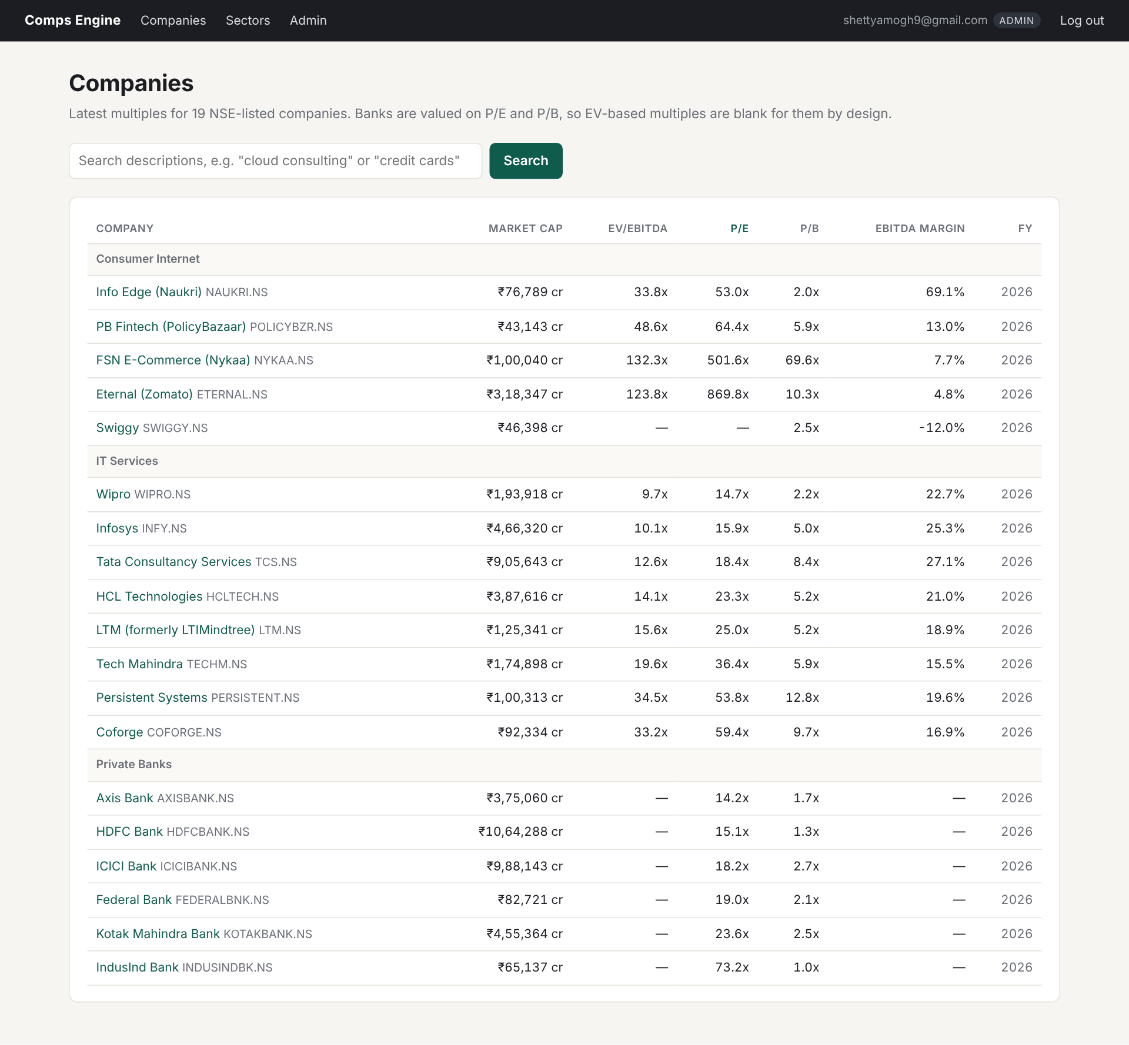
Figure 4. Companies page sorted by P/E (view latest_multiples, whitelisted ORDER BY).
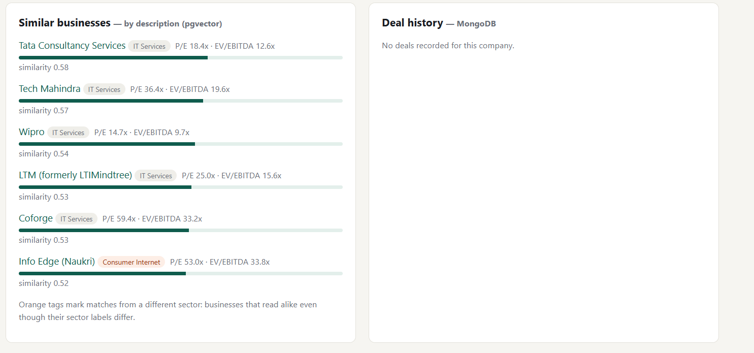
Figure 5. Infosys company page: similar businesses from pgvector (one cross-sector match, Info Edge) and the MongoDB deal panel; no deals are recorded for Infosys.
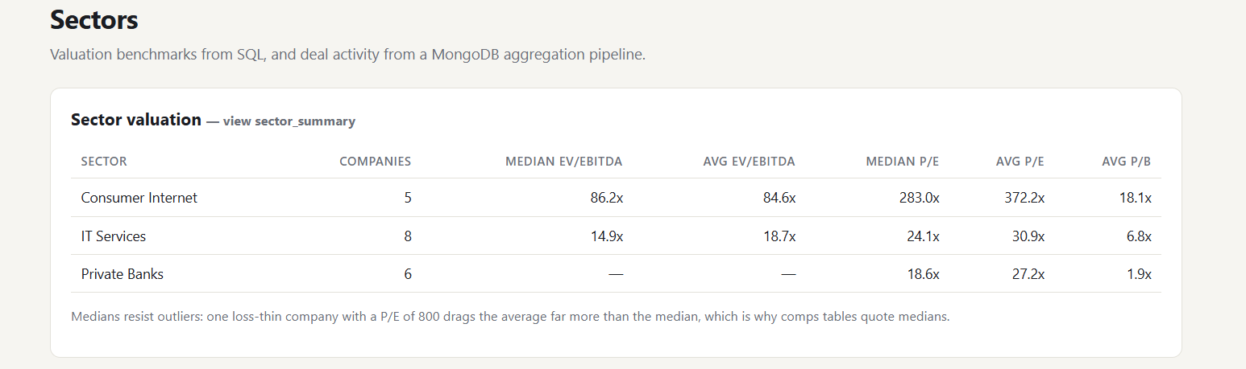
Figure 6. Sectors page: valuation benchmarks from the sector_summary view (medians and averages).

9. Next.js Project Tree Structure
Repository comps-engine (dependencies, build output, caches and secrets excluded):
comps-engine/
├── db/
│ ├── init/
│ │ └── 00_extensions.sql
│ ├── queries/
│ │ ├── demo_dml.sql
│ │ ├── demo_queries.sql
│ │ ├── mongo_commands.js
│ │ └── vector_commands.sql
│ ├── 01_schema.sql
│ ├── 02_views.sql
│ ├── 03_functions.sql
│ ├── 04_triggers.sql
│ ├── 05_alter_demo.sql
│ ├── 06_seed.sql
│ └── 07_roles.sql
├── docs/
│ └── schema.dbml
├── ingest/
│ ├── apply_sql.py
│ ├── check_connections.py
│ ├── deals.json
│ ├── embed.py
│ ├── load_deals.py
│ ├── load_financials.py
│ └── requirements.txt
├── web/
│ ├── app/
│ │ ├── admin/
│ │ │ └── page.js
│ │ ├── api/
│ │ │ ├── admin/
│ │ │ │ ├── audit/
│ │ │ │ │ └── route.js
│ │ │ │ └── financials/
│ │ │ │ └── route.js
│ │ │ ├── auth/
│ │ │ │ ├── login/
│ │ │ │ │ └── route.js
│ │ │ │ ├── logout/
│ │ │ │ │ └── route.js
│ │ │ │ └── register/
│ │ │ │ └── route.js
│ │ │ ├── companies/
│ │ │ │ └── route.js
│ │ │ ├── comps/
│ │ │ │ └── route.js
│ │ │ ├── deals/
│ │ │ │ └── route.js
│ │ │ ├── search/
│ │ │ │ └── route.js
│ │ │ ├── sectors/
│ │ │ │ └── route.js
│ │ │ └── similar/
│ │ │ └── route.js
│ │ ├── company/
│ │ │ └── [ticker]/
│ │ │ └── page.js
│ │ ├── login/
│ │ │ └── page.js
│ │ ├── register/
│ │ │ └── page.js
│ │ ├── search/
│ │ │ └── page.js
│ │ ├── sectors/
│ │ │ └── page.js
│ │ ├── globals.css
│ │ ├── layout.js
│ │ ├── not-found.js
│ │ └── page.js
│ ├── components/
│ │ ├── AuthForm.js
│ │ ├── FinancialsForm.js
│ │ └── LogoutButton.js
│ ├── lib/
│ │ ├── auth.js
│ │ ├── db.js
│ │ ├── format.js
│ │ ├── mongo.js
│ │ ├── queries.js
│ │ └── session.js
│ ├── scripts/
│ │ └── create-admin.mjs
│ ├── env.local.example
│ ├── jsconfig.json
│ ├── middleware.js
│ ├── next.config.mjs
│ ├── package-lock.json
│ └── package.json
├── .env.example
├── .gitignore
├── README.md
└── docker-compose.yml

10. Sample Application Code and Demo

10.1 Middleware: authentication and role check on every request (web/middleware.js)
import { NextResponse } from "next/server";
import { COOKIE, verifySession } from "./lib/auth";

const PUBLIC = ["/login", "/register", "/api/auth/login", "/api/auth/register"];

/** Runs before every page and API request: no valid session means no access,
* and anything under /admin or /api/admin needs the admin role. */
export async function middleware(req) {
const { pathname } = req.nextUrl;
if (PUBLIC.some((p) => pathname === p)) return NextResponse.next();

const isApi = pathname.startsWith("/api/");
const session = await verifySession(req.cookies.get(COOKIE)?.value);

if (!session) {
if (isApi) return NextResponse.json({ error: "Not logged in" }, { status: 401 });
const url = new URL("/login", req.url);
url.searchParams.set("next", pathname);
return NextResponse.redirect(url);
}

const adminArea = pathname.startsWith("/admin") || pathname.startsWith("/api/admin");
if (adminArea && session.role !== "admin") {
if (isApi) return NextResponse.json({ error: "Admins only" }, { status: 403 });
return NextResponse.redirect(new URL("/?denied=1", req.url));
}
return NextResponse.next();
}

export const config = {
matcher: ["/((?!_next/static|_next/image|favicon.ico).*)"],
};

10.2 Running each request as a database role (web/lib/db.js)
// Database roles created in db/07_roles.sql. A role name cannot be a $1
// parameter, so only these fixed names are ever put into SET ROLE.
const DB_ROLES = new Set(["app_analyst", "app_admin"]);

/** Run one parameterised query. Values are always passed separately ($1, $2 ...),
* never concatenated into the SQL string, which is what prevents SQL injection.
*
* With a role, the query runs inside a short transaction after
* SET LOCAL ROLE, so Postgres checks that role's privileges. Without one it
* runs as the connecting user (only the login/register routes do this,
* because no role is known before someone has logged in). */
export async function query(text, params = [], role = null) {
if (!role) return (await pool.query(text, params)).rows;
return transaction((client) => client.query(text, params).then((r) => r.rows), { role });
}

/** Run fn inside a transaction on one connection.
* - role: database role for the whole transaction (SET LOCAL ROLE)
* - userId: stored in app.user_id, which the audit trigger reads to record
* who made the change. */
export async function transaction(fn, { role = null, userId = null } = {}) {
if (role && !DB_ROLES.has(role)) throw new Error(`Unknown database role ${role}`);
const client = await pool.connect();
try {
await client.query("BEGIN");
if (role) await client.query(`SET LOCAL ROLE ${role}`);
if (userId != null) {
await client.query("SELECT set_config('app.user_id', $1, true)", [String(userId)]);
}
const result = await fn(client);
await client.query("COMMIT");
return result;
} catch (err) {
await client.query("ROLLBACK");
throw err;
} finally {
client.release();
}
}

10.3 Admin write through the stored procedure (web/app/api/admin/financials/route.js)
// POST /api/admin/financials -> record_financials() in ONE transaction,
// running as the app_admin database role. The admin's user id is put in
// app.user_id for that transaction, so the audit trigger records exactly
// who changed what.
export async function POST(req) {
const { session, error } = await requireRole("admin");
if (error) return error;

const parsed = Body.safeParse(await req.json().catch(() => ({})));
if (!parsed.success) {
const issue = parsed.error.issues[0];
return Response.json({ error: `${issue.path.join(".")}: ${issue.message}` }, { status: 400 });
}
const b = parsed.data;

try {
const result = await transaction(async (client) => {
const { rows } = await client.query(
"SELECT company_id FROM companies WHERE upper(ticker) = upper($1)", [b.ticker]);
if (!rows.length) return { status: 404, body: { error: `Unknown ticker ${b.ticker}` } };

await client.query(
`CALL record_financials($1::int, $2::int, $3::numeric, $4::numeric, $5::numeric,
$6::numeric, $7::numeric, $8::numeric, $9::numeric, $10::numeric)`,
[rows[0].company_id, b.fiscal_year, b.revenue, b.ebitda, b.net_income,
b.total_debt, b.cash, b.total_equity, b.price, b.market_cap]
);
return { status: 200, body: { ok: true, message: `Saved FY${b.fiscal_year} for ${b.ticker.toUpperCase()}` } };
}, { role: "app_admin", userId: session.userId });
return Response.json(result.body, { status: result.status });
} catch (err) {
// Constraint and trigger errors (codes 23xxx, or P0001 from RAISE) are
// the user's input being rejected; anything else is a real server error.
if (err.code?.startsWith("23") || err.code === "P0001") {
return Response.json({ error: `Rejected by the database: ${err.message}` }, { status: 400 });
}
// 42501 = insufficient_privilege: the database role itself said no.
if (err.code === "42501") {
return Response.json({ error: `Database permission denied: ${err.message}` }, { status: 403 });
}
throw err;
}
}

10.4 Demo screenshots
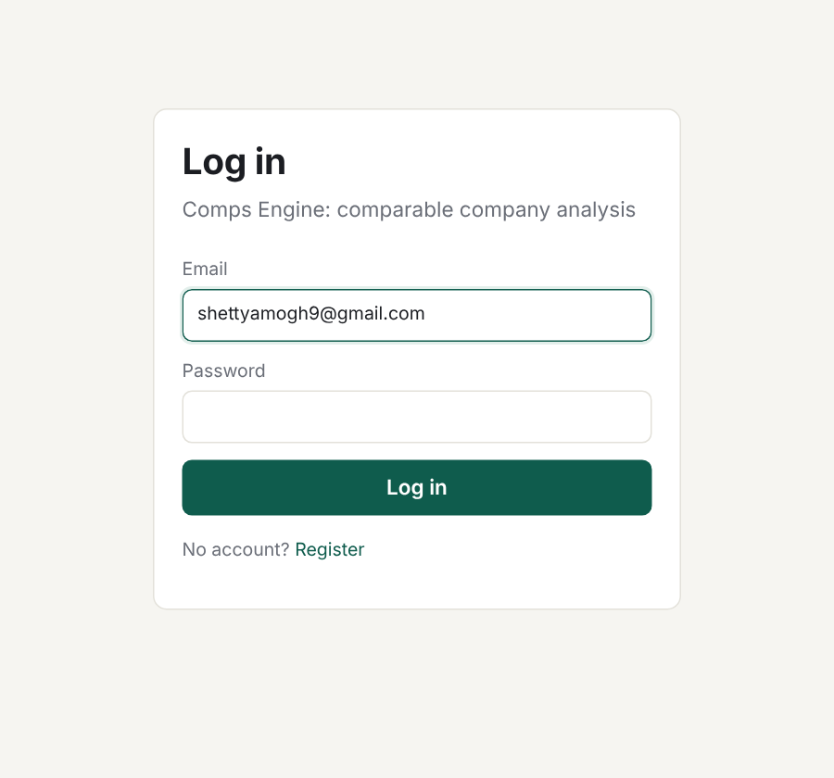
Figure 7. Login page.
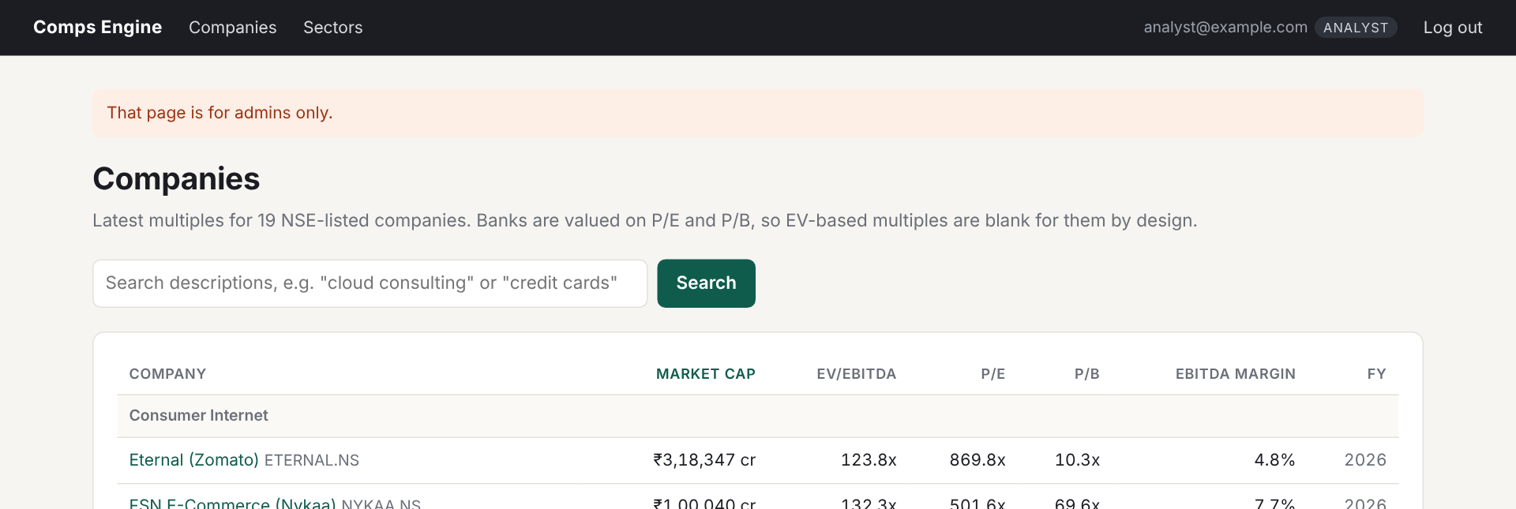
Figure 8. An analyst who opens /admin is sent back with a message; the Admin link is not shown to analysts.
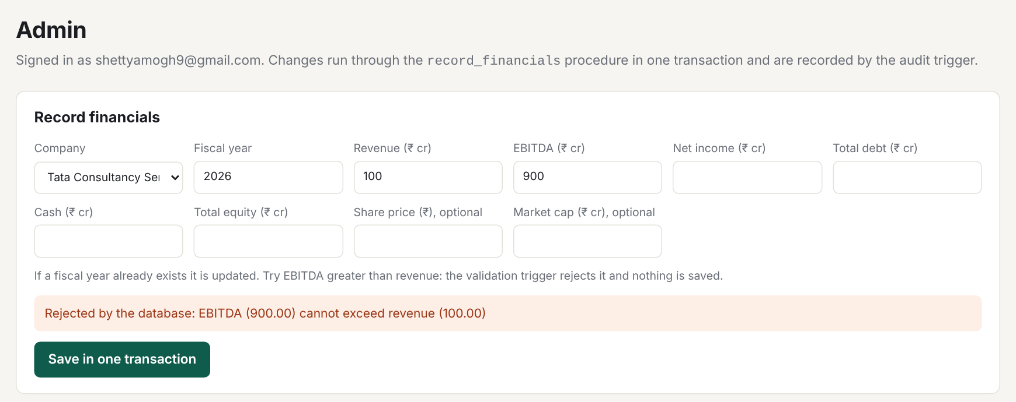
Figure 9. Admin entering EBITDA greater than revenue: the validation trigger rejects it and nothing is saved.
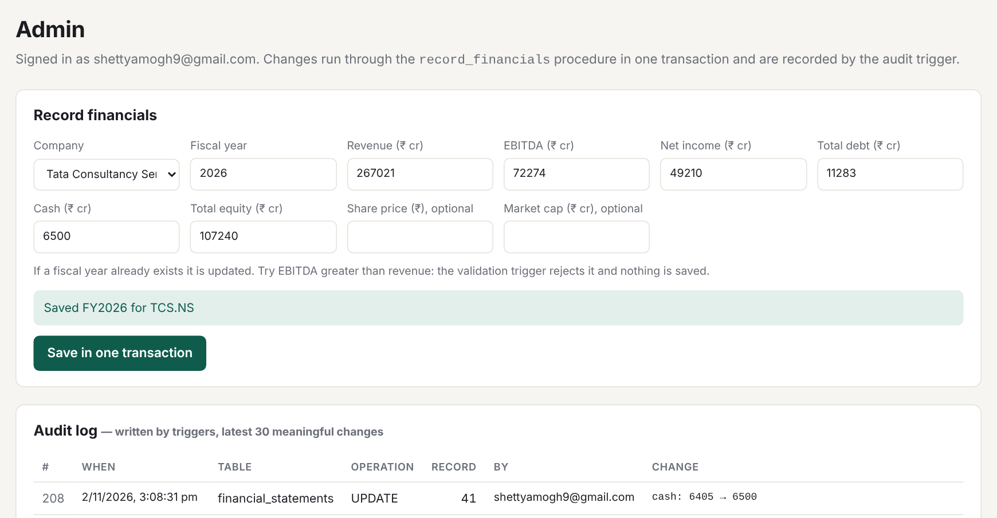
Figure 10. A valid save through record_financials, running as database role app_admin; the audit trigger records the change and who made it.
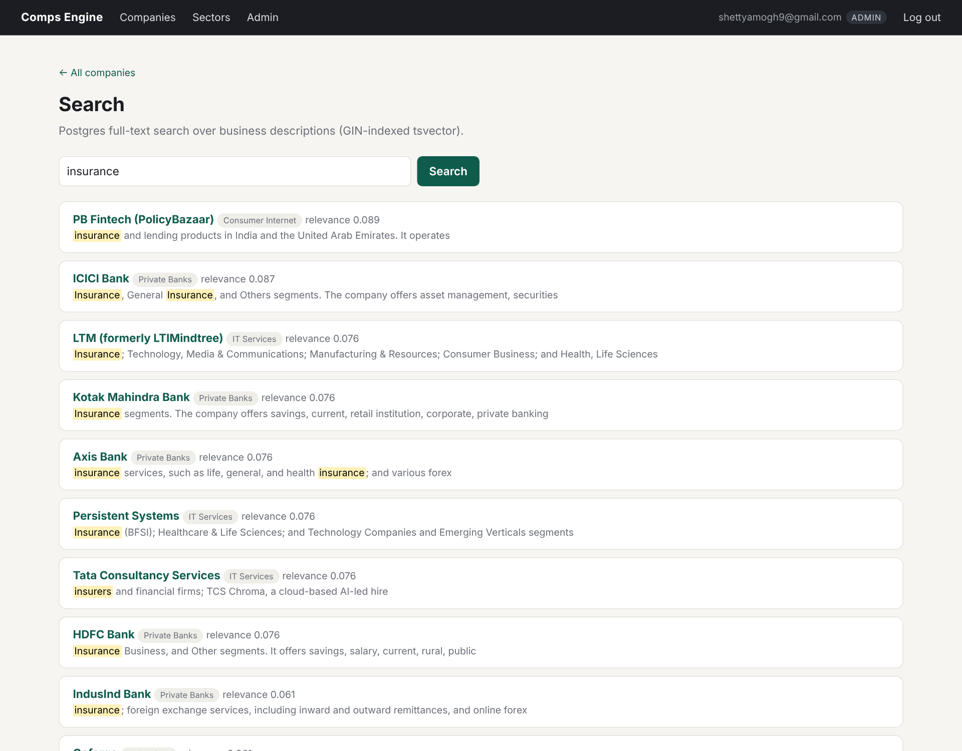
Figure 11. Full-text search for "insurance": ranked with ts_rank, matches highlighted with ts_headline.

11. Evaluation Rubrics: Completion Status
# | Criteria | Distribution | Status
1 | Database Design | ER diagram , relational schema with keys, relationships, and constraints | Completed. Chen ER diagram with weak entities (Fig. 1); relational schema with PK, FK, UNIQUE and CHECK constraints (Fig. 2, Sec. 4).
2 | Database Creation | SQL database implementation - DDL with constraints , NoSQL/Vector database creation , Technology justification | Completed. DDL in db/01–07 (Sec. 5); MongoDB collection with $jsonSchema validator and indexes; pgvector table with HNSW index; justification in Sec. 2.4–2.6.
3 | SQL Operations and Queries | DML operations , Nested/correlated/Recursive SQL queries, Join SQL queries | Completed. INSERT/UPDATE/DELETE and upsert (6.1); 4-table join, nested, correlated and EXISTS subqueries, recursive CTE, CTE with window functions, GROUP BY/HAVING (6.2).
4 | Advanced Database Concepts | Advanced database concepts (Procedure/function, trigger, CTE) , NoSQL/Vector feature RUD | Completed. Procedure record_financials, 4 functions, 3 triggers, recursive CTE and views; MongoDB read/update/delete/aggregate; pgvector read/update/delete (Sec. 7).
5 | Web Application and Database Integration | Next.js interface , Backend/API and database integration | Completed. Next.js pages and 11 API routes over PostgreSQL, pgvector and MongoDB (Sec. 9–10).
6 | Authentication and Authorization | Authentication implementation (front end and backend) and minimum two roles and role-based access control in database | Completed. Register/login/logout with bcrypt and httpOnly JWT; roles Analyst and Admin checked in middleware and routes, and enforced in PostgreSQL by roles app_analyst/app_admin (8b).
7 | Documentation, Git/GitHub, Demonstration, Testing, and Originality | Documentation, Git/GitHub , Originality and individual contribution | Completed. README with setup steps, phase-wise commits on GitHub, 25/25 test cases passing (8c). Team: Amogh Shetty and Allen Anish.

12. Conclusion and Future Enhancements
Comps Engine shows that one analyst question ("what is this company worth relative to its peers?") is best answered with three data models working together: relational tables for uniform financial data and its integrity rules, vectors for similarity of meaning, and documents for deal records whose shape varies. The relational core enforces correctness with constraints, triggers, an atomic procedure and an audit trail; access rules are enforced both by the application and by PostgreSQL itself.
Future enhancements:
• Free-text semantic search in the web app (embed the query in the browser or a small Python service).
• Saved comp sets in the user interface (the tables already exist) with export to Excel.
• Scheduled daily price refresh and quarterly financials.
• Larger universe (Nifty 500) with sector filters before vector search, where the HNSW index pays off.
• Precedent-transaction multiples from MongoDB deal values alongside trading comps.

