BUDT703: Database Management Systems

Submitted to : Professor Adam Lee

Submitted by : Project_0507_13

PeakPerformance Partners

Team members:

Amoghvarsh Kulkarni

Sai Thanmayi Karpurapu

Vedant Kamat

Devni Shah

**BRAND NAME:**

**PeakPerformance Partners:** Transforming Teams To Triumph

**MISSION STATEMENT**

As consultants, our mission is to serve as the catalyst for the University of Maryland's softball team's transformation, to equip the team with actionable recommendations, enabling them to elevate performance standards and establish a legacy of sporting achievement.

**MISSION OBJECTIVES:**

● OBJECTIVE 1: Analyze the top 10 teams where Maryland has lost against the maximum number of times

● OBJECTIVE 2: Analyze the top 10 away locations where Maryland has won the most number of times.

● OBJECTIVE 3: Analyze the top 10 matches where Maryland has won with a shutout.

● OBJECTIVE 4: Analyze the top 10 of teams against which Maryland has won the maximum number of times.

● OBJECTIVE 5: Analyze the top 10 teams against whom Maryland has won by the highest margin.

**Business tasks and processes:**

● Comparing year on year Maryland's performance.

● Storing information about opponents.

● Managing game locations: played in home ground or away, dates, and times.

● Determining no. of matches played at a particular location.

● Recording and tracking softball game results.

**RELATIONAL SCHEMAS**

Entities, Attributes and Primary Keys:

Match (**mchId** ,mchAt, mchScrUmd, mchScrOpp,locId)

Date (**datMch** , datDay)

Location (**locId** , locCty ,locState)

Opponent (**oppId** , oppName)

Play (***mchId*** , ***datMch*** , ***oppId***)

**Host: Binary Relationship**

1 location hosts 1 or more matches

1 match to 1 location

**Play: Ternary Relationship**

1 match and 1 opponent to 1 date

1 match and 1 date to 1 opponent

1 date and 1 opponent to 1 match

**ER DIAGRAM:**

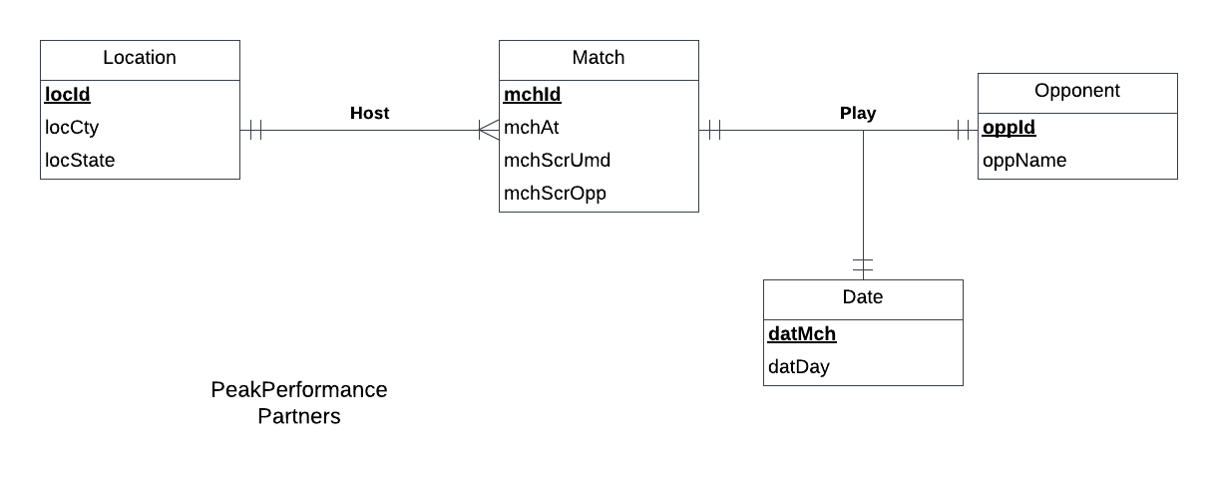

**BUSINESS RULES:**

1. If Location details are deleted from the database then matches which are to be held at that location gets deleted.
2. If Location details are updated in the database then matches which are to be held at that location gets updated.
3. If Match gets canceled or deleted from the database then the associated location will also be deleted.
4. If Match gets added or updated then the associated location will also be updated.
5. If Match gets canceled or deleted from the database then the date associated with that Match ID and the opponent should be deleted.
6. If Match gets added or updated then its date should also be updated and the opponent should also be updated.
7. If a Match Date is canceled then corresponding Match and opponent data has to be deleted.
8. If a Match date is updated then corresponding Match and Opponent data has to be updated as well.
9. If the opponent is deleted from the database, corresponding Match and Match date gets deleted from the database.
10. If opponent data is updated, corresponding Match data and date of match gets updated.

| Relation | Foreign Key | Base Relation | Primary Key | Business rule | Constraint:  ON DELETE | Business rule | Constraint:  ON UPDATE |
| --- | --- | --- | --- | --- | --- | --- | --- |
| Host | locId | Location | locId | R1 | CASCADE | R2 | CASCADE |
| Host | mchId | Match | mchId | R3 | CASCADE | R4 | CASCADE |
| Play | mchId | Match | mchId | R5 | CASCADE | R6 | CASCADE |
| Play | datMch | Date | datMch | R7 | CASCADE | R8 | CASCADE |
| Play | oppId | Opponent | oppId | R9 | CASCADE | R1 | CASCADE |

**SAMPLE DATA FOR EVERY RELATION:**

Date

(**datMch** , datDay)

('04/01/2000','Sat'),

('04/12/2000','Wed'),

('04/14/2000','Fri'),

('04/16/2000','Sun'),

('04/22/2000','Sat')

**Location**

(**locId** , locCty, locState)

('lo001','Marietta','GA'),

('lo002','Baltimore','MD'),

('lo003','College Park','MD'),

('lo004','State Ewing','NJ'),

('lo005','Tallahassee','FL')

Match

(**mchId** ,mchAt, mchScrUmd, mchScrUmd,locId)

('m200001', 'Home',5,0,'lo003'),

('m200002','Home',6,1,'lo003'),

('m200003','Home',4,2,'lo003'),

('m200004','Home',4,1,'lo003'),

('m200005','Home',2,3,'lo010')

Opponent

**(oppId** , oppName)

('op01','Robert Morris'),

('op02','Fiu'),

('op03','Binghamton'),

('op04','Mount St. Marys'),

('op05','South Carolina'),

('op06',’Drexel')

**Play**

**(mchId, datMch, oppId)**

('m200001','04/01/2000','op212'),

('m200002','04/01/2000','op212'),

('m200003','04/12/2000','op62'),

('m200004','04/12/2000','op62'),

('m200005','04/14/2000','op08')