ASG Airlines — End-to-End Data Engineering Case Study
Completed solution based on the supplied UseCase - Airlines.xlsx workbook.

1. What was built
A reproducible local data-engineering pipeline covering ingestion, profiling, cleaning, validation, quarantine, transformation, PII protection, dimensional modelling and KPI generation. The outputs are ready to be imported into Power BI.

2. Dataset inventory
Flights: 1,020 rows.
Bookings: 1,000 rows.
Payments: 1,000 rows.
Passengers: 1,039 rows.

3. Key findings from the supplied data
- 1,020 flight rows were supplied; 1,005 were retained for the analytical flight fact table.
- 15 flight records were quarantined because they were duplicates or failed quality rules.
- 1 analytical flights were identified as overnight/cross-day flights.
- Average recalculated flight duration is 164.62 minutes.
- The source contains a 6F flight prefix that consistently maps to IndiGo; it was standardized to 6E.
- The source contains missing and UNKNOWN airline values; these were inferred from flight prefixes when unambiguous.
- The source contains 30 invalid payment amounts and 30 invalid booking statuses; those records are quarantined.
- Passenger IDs contain duplicate records and some passenger last names are missing; passenger PII is not exposed to Power BI.

4. Architecture
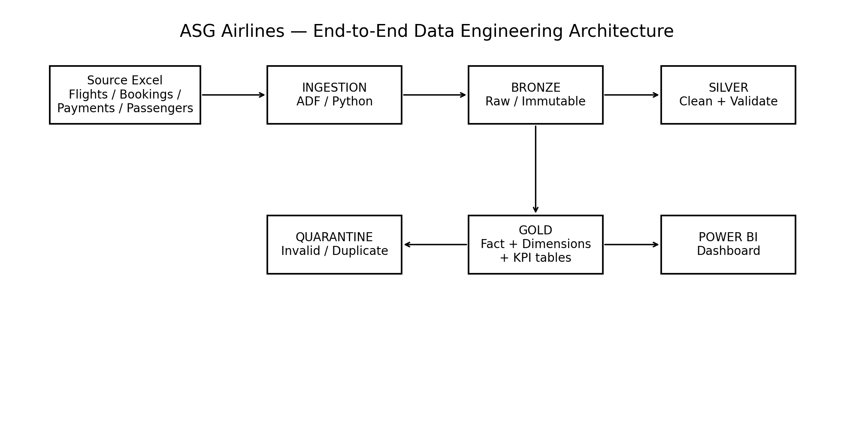
Cloud target architecture: Azure Data Factory → ADLS Gen2 Bronze → Databricks/Synapse Silver → Gold fact/dimension/KPI tables → Power BI. The submitted implementation is locally reproducible with Python/Pandas.

5. Flight cleaning logic
- Normalize flight IDs and preserve the original identifier for auditability.
- Standardize 6F to 6E for IndiGo.
- Infer missing/UNKNOWN airlines from the flight prefix when possible.
- Parse departure and arrival as timestamps.
- If arrival is earlier than departure, add one day to arrival.
- Calculate duration from normalized timestamps.
- Flag duration <= 0 or > 8 hours as anomalies.
- Quarantine duplicate business-key records.

6. Data model
Fact_Flight is the central fact table and connects to Dim_Airline, Dim_Route and Dim_Date. This supports airline, route and time slicing without duplicating descriptive attributes.

7. PII protection
Passenger names, email, phone, Aadhaar, passport and emergency-contact details are excluded from the Power BI dataset. A restricted SHA-256 masked dataset is included only to demonstrate governance. In a cloud deployment, RBAC/managed identities, Key Vault and restricted raw storage should be used.

8. Power BI pages
- Executive Overview — total flights, average duration, overnight %, anomalies, airline and route traffic.
- Duration Analysis — duration by airline/route, duration distribution, overnight comparison.
- Route Performance — route traffic, average duration, overnight %, anomaly %.
- Data Quality & Anomalies — quarantined records, missing values and anomaly reasons.

9. Assumptions
- The dataset is synthetic and flight-prefix-to-airline mapping is reliable.
- 6F is treated as a corrupted form of 6E because its records map to IndiGo.
- Arrival earlier than departure indicates a cross-midnight flight.
- Eight hours is used as a conservative anomaly threshold for this domestic-flight dataset.
- Passenger-level PII is not required for the operational dashboard.

