CityView360 – Project Proposal

Project Title: CityView360 – A Real-Time Urban Complaint and Resolution Platform

Team Members:

- Amogh Vijay

- Navdeep R

# 1. Project Overview

Urban areas face increasing difficulties in managing civic services such as water, sanitation, electricity, and infrastructure due to fragmented complaint channels and delayed action. Our project, CityView360, aims to streamline this process through a unified digital platform that integrates real-time reporting, AI-powered categorization, and intelligent analytics dashboards.  
  
CityView360 is a web-based complaint management platform that enables citizens to report public utility issues, upload evidence, track resolution status, and receive timely updates. Administrators and officials can monitor trends, prioritize interventions, and ensure accountability through comprehensive data visualizations. By combining ease of access for citizens with powerful backend intelligence for authorities, the platform is designed to improve transparency, efficiency, and public trust.

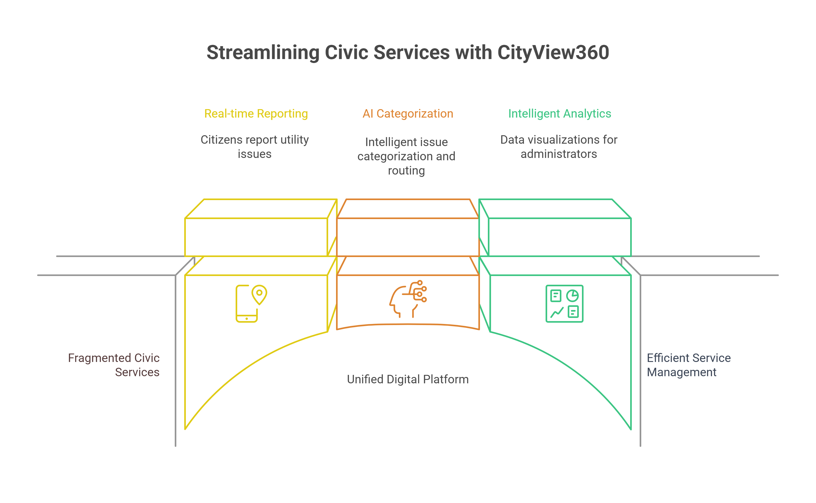

# 2. Problem Statement and Vision

Problem Statement  
Despite frequent complaints raised by citizens, civic issues often remain unresolved because existing reporting systems are fragmented, manual, and lack real-time data analysis. This leads to delayed responses, inefficient resource allocation, and public frustration.  
  
Vision  
CityView360 envisions a single, accessible platform where citizens can easily submit and track complaints while authorities leverage AI and analytics to monitor, prioritize, and resolve issues efficiently. The goal is to transform the complaint resolution process into a transparent, data-driven service that continuously adapts and improves over time.

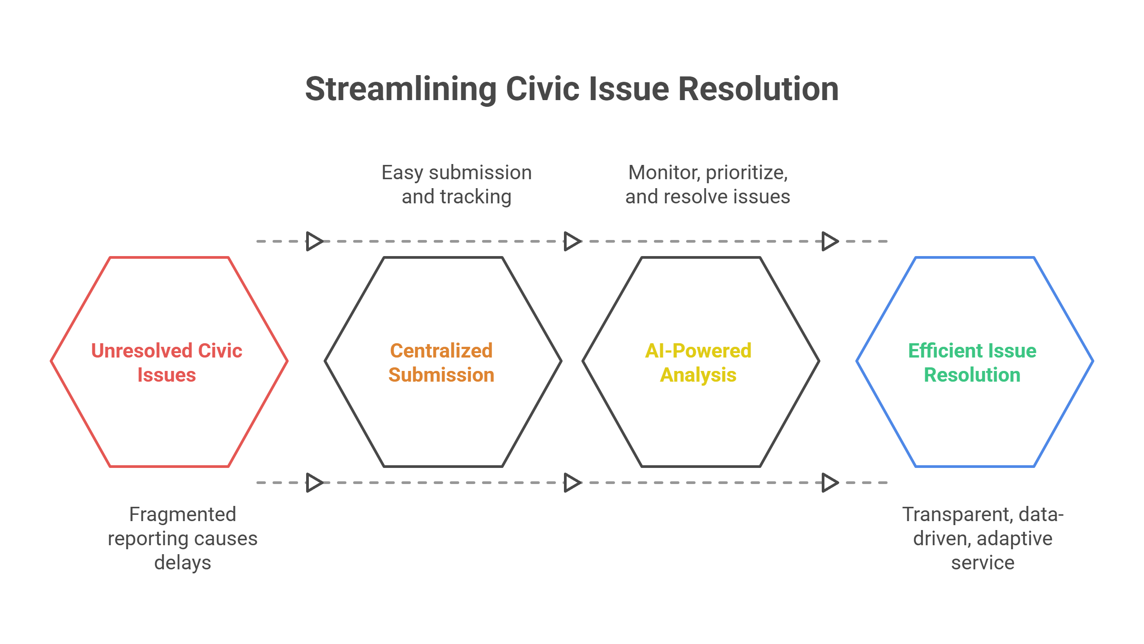

# 3. Scope and Functional Features

The scope of CityView360 includes the development of a full-stack web application that manages the entire complaint-to-resolution pipeline, from submission to closure. Citizens will be able to report issues using text descriptions, images, and geolocation tags, and then track the progress of their tickets through a clear, accessible interface.  
  
Complaints will be automatically categorized using natural language processing models that assign appropriate tags and severity levels. Administrators will be able to view and manage all complaints through an interactive dashboard that highlights patterns and emerging trends. The platform will include escalation workflows, ensuring overdue complaints are flagged and addressed appropriately. Over time, as more data is collected, the system’s predictive capabilities will evolve to proactively identify potential problem areas and recommend interventions.

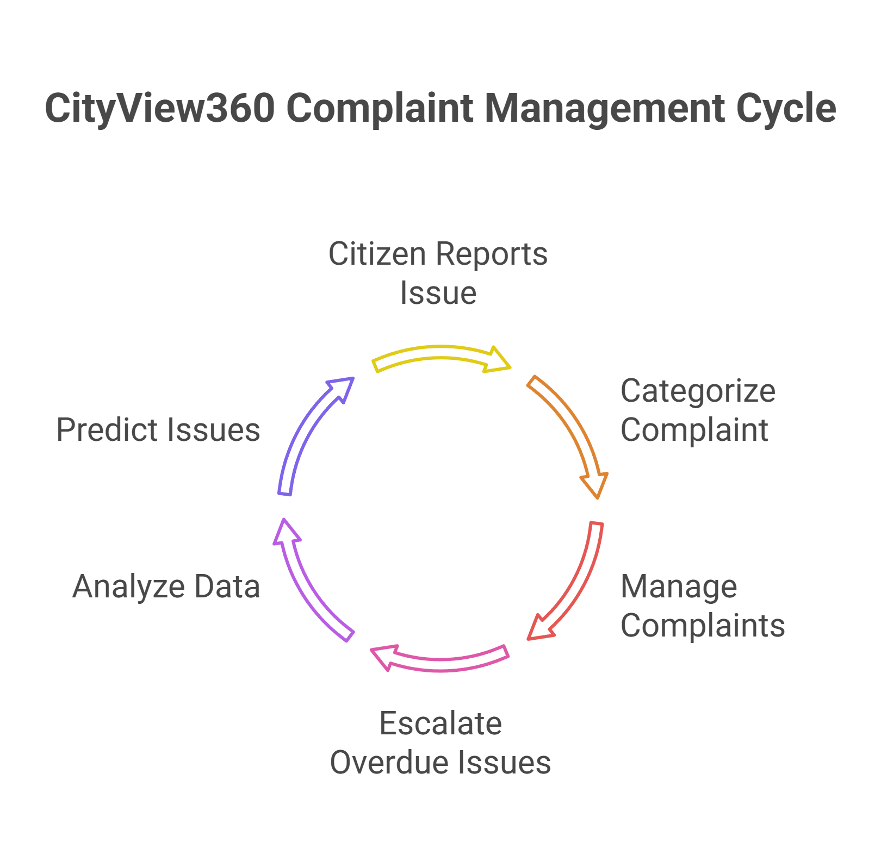

# 4. System Architecture and Escalation Process

CityView360 is designed as a modular platform comprising several key components. The Citizens Portal serves as the primary interface for users to register, submit complaints, upload supporting evidence, and receive notifications.  
  
The Chatbot Assistant will serve as a conversational interface that guides users step by step through the complaint submission process. It will offer simple prompts, auto-suggestions, and clarifying questions to ensure complaints are complete and accurately categorized. To protect user privacy, all conversations with the chatbot will be securely encrypted during transmission and stored only as necessary to process and classify complaints. Personal data will not be shared with any third party and will be accessible only to authorized system administrators and the relevant officials handling each case. The chatbot is designed for maximum ease of use, supporting clear language and optional pre-filled templates to help citizens of all backgrounds quickly and confidently report issues.  
  
The backend categorization engine uses AI models to classify each complaint by type and urgency, while the database stores all complaint records, user profiles, and resolution history. Officials access a dedicated dashboard that provides real-time tracking, filtering, and assignment capabilities. An analytics engine generates visual insights such as heatmaps, severity breakdowns, and time-based trends.  
  
CityView360 incorporates a flexible, AI-supported escalation process. When a complaint is first submitted, it is categorized and prioritized based on multiple factors, including the type of issue, severity rating, and the number of similar active complaints in the system. These attributes guide the urgency and assignment of each case. Regardless of severity or category, all complaints must be escalated if they remain unresolved beyond 45 days. At that point, the system automatically triggers a yellow flag and sends a notification to the responsible official. The escalation logic will be further refined over time as the AI model learns patterns from historical data, enabling more adaptive thresholds and prioritization rules.

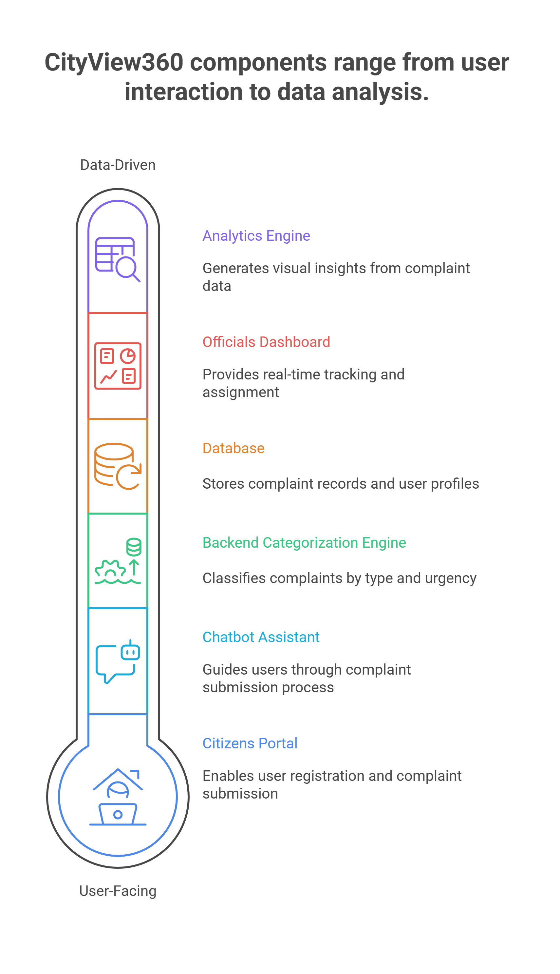

# 5. Implementation Plan

The technology stack for CityView360 has been selected to balance modern development practices and scalability. The frontend will be built using React, HTML, and CSS, while D3.js will be integrated for advanced heatmap visualizations. The backend will rely on Node.js and Express.js to handle data processing and routing. PostgreSQL and MySQL are proposed as robust database options, with APIs such as HuggingFace providing NLP capabilities for complaint categorization.  
  
The implementation will proceed in four phases. Phase 1 will focus on building the core system for complaint submission, storage, and basic admin access. Phase 2 will introduce chatbot support, automatic categorization, and real-time status tracking. Phase 3 will add the data intelligence layer, incorporating visualizations and escalation logic. Finally, Phase 4 will expand the platform with department-specific dashboards and predictive insights. The exact deployment and hosting strategy will be finalized after selecting the most suitable cloud environment, such as AWS, Firebase, or Heroku.

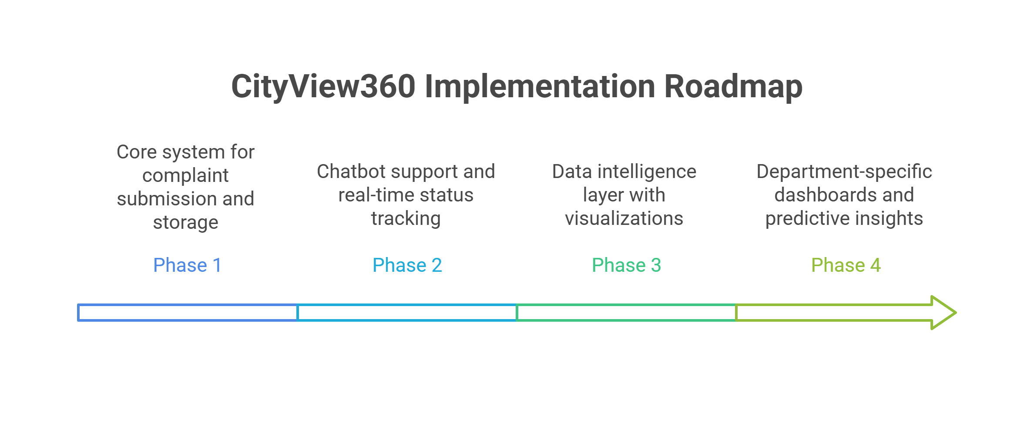

# 6. Analytics and Visualization

CityView360’s analytics capabilities are a central aspect of the platform. The system will combine D3.js with React-based chart libraries such as Recharts or Nivo to create a comprehensive set of visual tools. Heatmaps generated by D3.js will display complaint density and severity across geographic regions with full interactivity. Standard charts including pie, bar, and line graphs will track issue distribution, monthly trends, and resolution performance.  
  
A unified styling system will be implemented to maintain visual consistency across all components, ensuring that the platform feels cohesive and professional. As the AI models mature and begin to recognize new complaint categories and patterns, the analytics module will automatically expand to incorporate new scenarios, providing decision-makers with increasingly valuable insights.

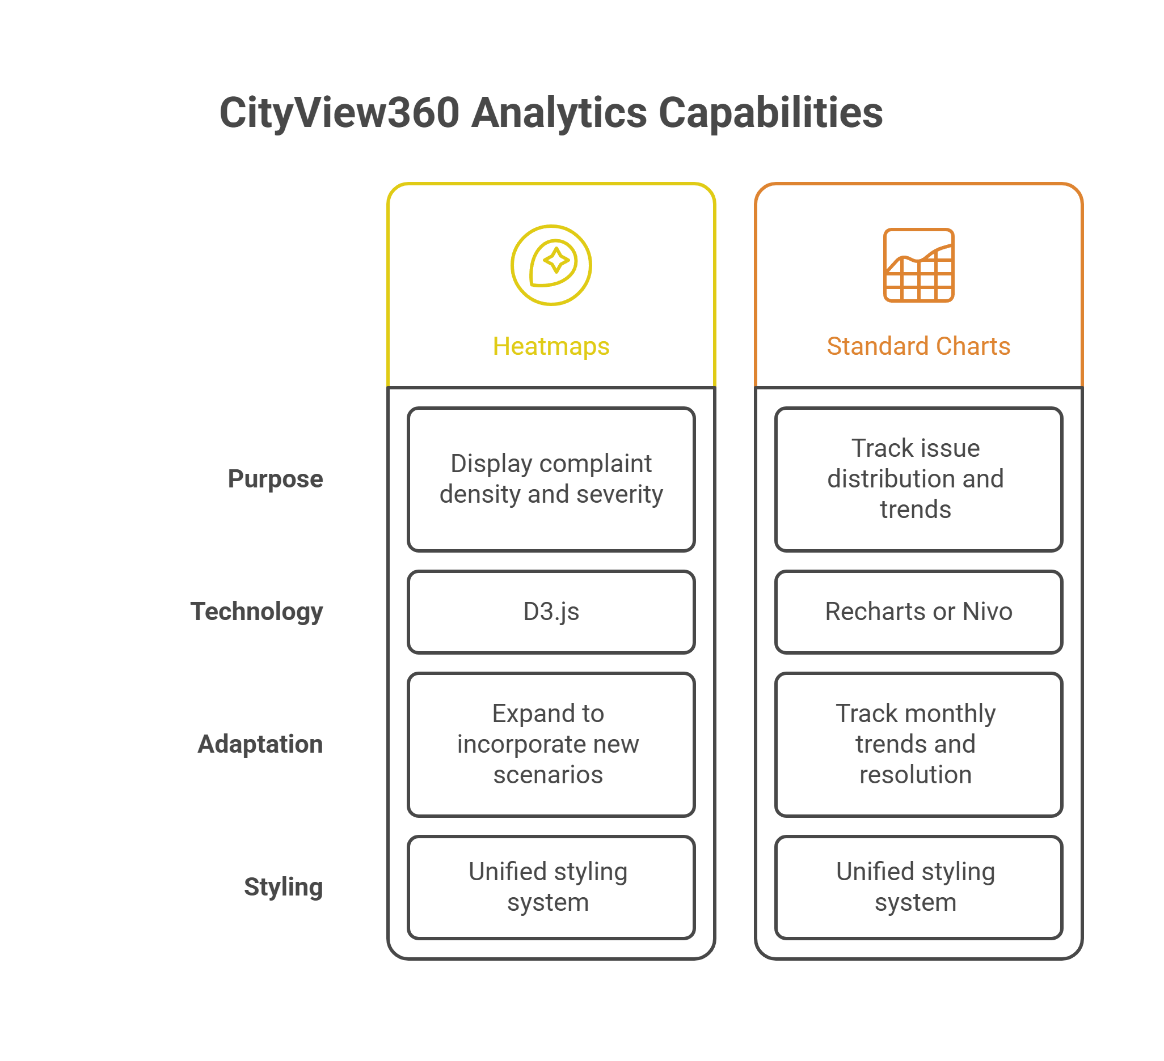

# 7. Evaluation and Future Work

The success of CityView360 will be measured by improvements in issue resolution times, the proportion of complaints resolved within service-level agreements, and citizen satisfaction levels. Planned metrics include the average time to resolution, the number of complaints escalated due to delays, and user feedback ratings collected after each case closure.  
  
Future enhancements will focus on developing a mobile application, improving the natural language processing models for more precise categorization, and adding predictive analytics to support proactive planning by civic authorities. Over time, the platform will become a continuously evolving tool that adapts to new challenges and enables smarter urban governance.