UMAP by sorting Measurement Timestamp, and Beach Name

data_sorted = data.sort_values(by=['Measurement Timestamp','Beach Name'])

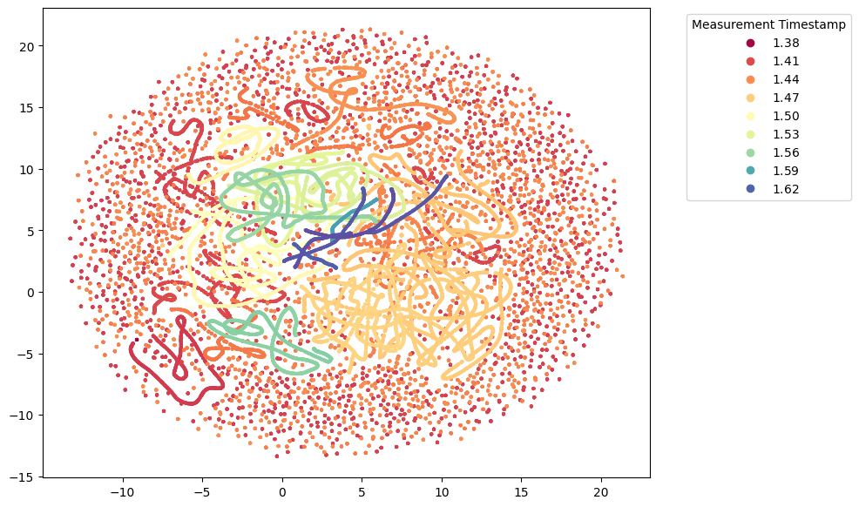

UMAP by sorting Beach Name and Measurement Timestamp

data_sorted = data.sort_values(by=['Beach Name','Measurement Timestamp'])

Using the

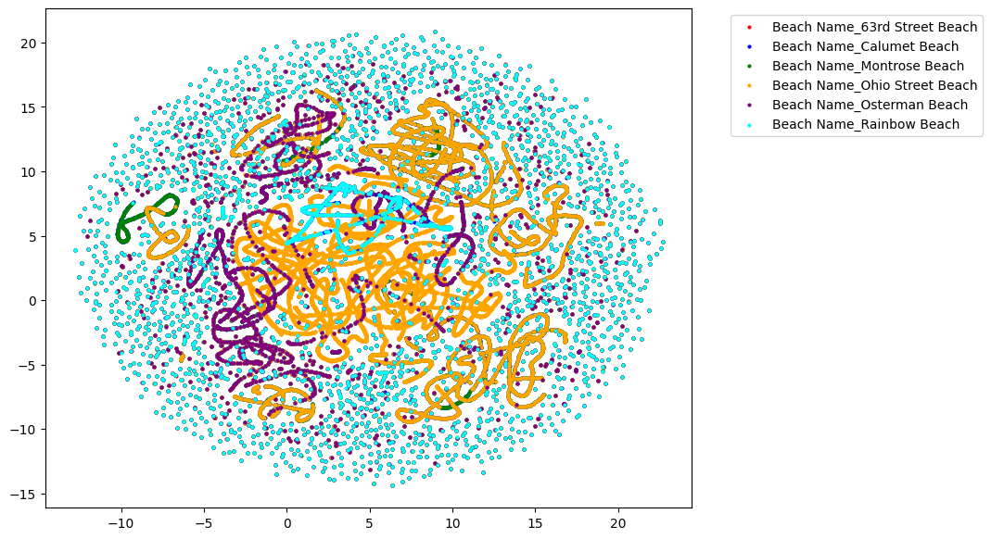The **apply()** method is used to apply the **timestamp()** function to each value in the 'timestamp' column. The **timestamp()** function converts each datetime object to a numeric representation.

encoded_data_pre['Measurement Timestamp'] = encoded_data_pre['Measurement Timestamp'].apply(lambda x: x.timestamp())

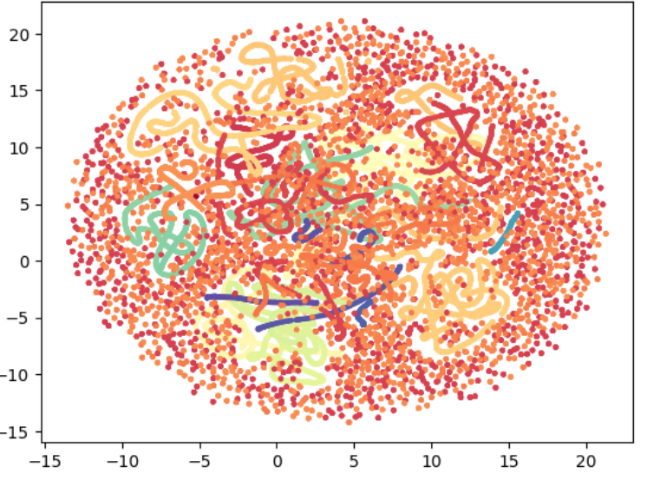

reducer = umap.UMAP(random_state=SEED,

n_neighbors = 5,

n_components = 2,

min_dist = 0.7)

