

Vanilla Management System (VMS) R16
VMSGPRHOSTR16_B0000 DB Analysis Document

Documentation Control
Ver. No. | Author/s | Reason of Change | Date of Change
1.0 | UBAIDUR RAHMAN.H | Initial Draft | 10-MAY-2019

Table of Contents
Table of Contents 2
Purpose of the Document 3
1 VMSGPRHOSTR16 (R16_B0000) Release changes 4

Purpose of the Document
This document contains the Execution plan information for the modified query and newly added column in R16 -B0000 release.

VMSGPRHOSTR16 (R16_B0000) Release changes
B0000
- JIRA – VMS -867.
- DDL CHANGEs – Yes
  - 0 Modified procedures in 0 Package Bodies
  - 1 Modified Procedure outside of package
  - 0 Table Changes with new column
  - 1 New Tables
- DML Changes – No
- TRIGGERS – No
- INDEXES- Yes
  - 1 index
- BULK LOAD – No
- BACKUP Tables – No

DB :- VMS -867.

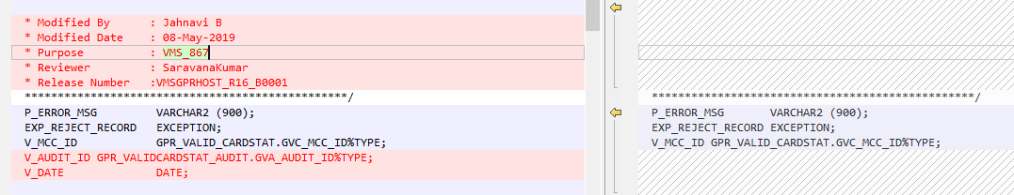

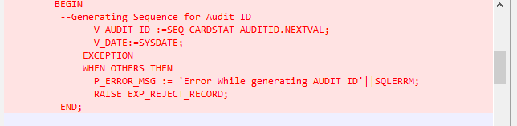

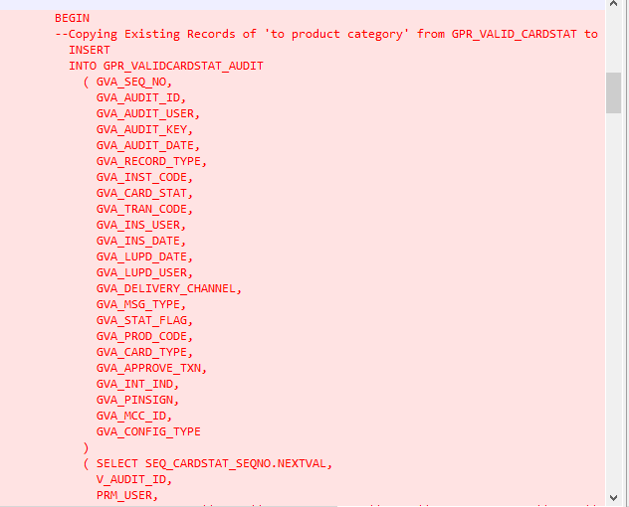

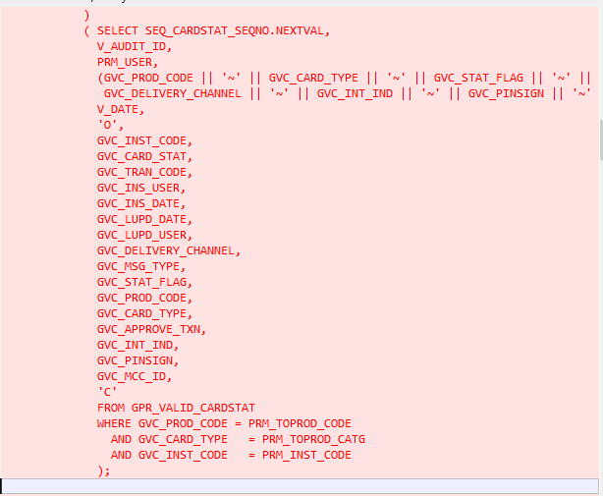

Plan for above query:-

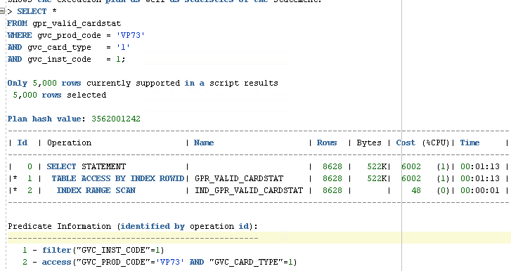

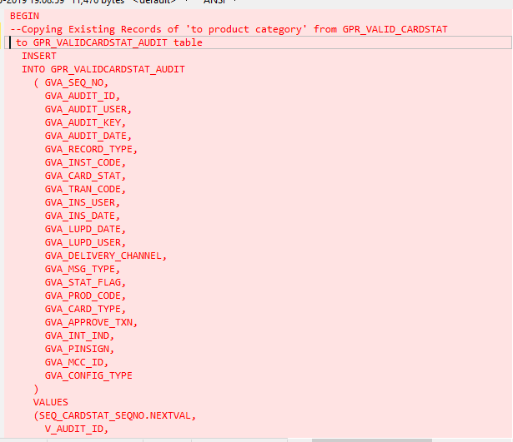

NEW TABLE : GPR_VALIDCARDSTAT_AUDIT

INDEX FOR GPR_VALIDCARDSTAT_AUDIT : INDX_GPRVALIDCARDSTAT_AUDITID

NEW SEQUENCES:-

SEQ_CARDSTAT_AUDITID
SEQ_CARDSTAT_SEQNO

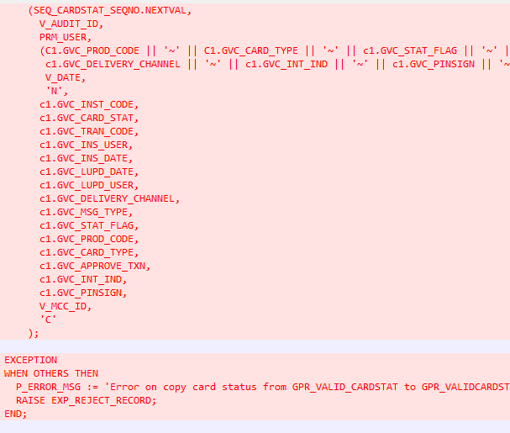

END OF DOCUMENTATION.

