

Vanilla Management System (VMS) R16
VMSGPRHOSTR16_B0004 DB Analysis Document

Documentation Control
Ver. No. | Author/s | Reason of Change | Date of Change
1.0 | UBAIDUR RAHMAN.H | Initial Draft | 24-MAY-2019

Table of Contents
Table of Contents 2
Purpose of the Document 3
1 VMSGPRHOSTR16 (R16_B0004) Release changes 4

Purpose of the Document
This document contains the Execution plan information for the modified query and newly added column in R16 -B0004 release.

VMSGPRHOSTR16 (R16_B0004) Release changes
B0004
- JIRA – VMS-934,VMS-876.
- DDL CHANGEs – Yes
  - 0 Modified procedures in 0 Package Bodies
  - 2 Modified Procedure outside of package
  - 2 Table Changes with new column
  - 0 New Tables
- DML Changes – Yes
- TRIGGERS – No
- INDEXES- Yes
  - 1 index
- BULK LOAD – No
- BACKUP Tables – No
DB :-

DML:-
INSERTS ON :-
CMS_INST_PARAM for VMS-934.

VMS – 876
> Analysis Done in QAB;
SQL> SELECT
2 audit_id,
3 audit_date,
4 action_by,
5 (
6 CASE
7 WHEN old_value IS NULL THEN 'Insert'
8 ELSE 'Update'
9 END
10 ) AS action_type,
11 old_value,
12 new_value
13 FROM
14 (
15 SELECT
16 audit_id,
17 (
18 SELECT
19 TO_CHAR(MAX(gva_audit_date),'mm/dd/yyyy hh:mm:ss')
20 FROM
21 gpr_validcardstat_audit
22 WHERE
23 gva_audit_id = audit_id
24 ) AS audit_date,
25 action_by,
26 LISTAGG(
27 CASE
28 WHEN gva_record_type = 'O' THEN tran_desc
29 END,
30 '<br/>') WITHIN GROUP(ORDER BY tran_desc) old_value,
31 LISTAGG(
32 CASE
33 WHEN gva_record_type = 'N' THEN tran_desc
34 END,
35 '<br/>') WITHIN GROUP(ORDER BY tran_desc) new_value
36 FROM
37 (
38 SELECT DISTINCT
39 gva_audit_id AS audit_id,
40 (
41 SELECT
42 cum_user_name
43 FROM
44 cms_user_mast
45 WHERE
46 cum_user_pin = gva_audit_user
47 ) AS action_by,
48 gva_record_type,
49 (
50 SELECT
51 ctm_tran_desc
52 FROM
53 cms_transaction_mast
54 WHERE
55 gva_tran_code = ctm_tran_code
56 AND
57 ctm_delivery_channel = gva_delivery_channel
58 ) AS tran_desc
59 FROM
60 gpr_validcardstat_audit
61 WHERE
62 gva_approve_txn = 'Y'
63 AND
64 gva_audit_key = 'XP13~1~C~14~07~NS~NS~'
65 AND
66 gva_audit_user = 9493
67 AND
68 gva_audit_date BETWEEN SYSDATE-20 AND SYSDATE
69 )
70 GROUP BY
71 audit_id,
72 action_by
73 )
74 ORDER BY audit_id DESC;

Explain Plan

Plan hash value: 1047120621

--------------------------------------------------------------------------------------------------------------
| Id | Operation | Name | Rows | Bytes | Cost (%CPU)| Time |
--------------------------------------------------------------------------------------------------------------
| 0 | SELECT STATEMENT | | 1 | 94 | 103 (1)| 00:00:02 |
| 1 | SORT AGGREGATE | | 1 | 11 | | |
| 2 | TABLE ACCESS BY INDEX ROWID| GPR_VALIDCARDSTAT_AUDIT | 1378 | 15158 | 26 (0)| 00:00:01 |
|* 3 | INDEX RANGE SCAN | INDX_GPRVALIDCARDSTAT_AUDITID | 1378 | | 4 (0)| 00:00:01 |
| 4 | TABLE ACCESS BY INDEX ROWID | CMS_USER_MAST | 1 | 19 | 2 (0)| 00:00:01 |
|* 5 | INDEX UNIQUE SCAN | UK_USER_MAST | 1 | | 1 (0)| 00:00:01 |
| 6 | TABLE ACCESS BY INDEX ROWID | CMS_TRANSACTION_MAST | 1 | 30 | 3 (0)| 00:00:01 |
|* 7 | INDEX SKIP SCAN | PK_TRANSACTION_MAST | 1 | | 2 (0)| 00:00:01 |
| 8 | SORT GROUP BY | | 1 | 94 | 103 (1)| 00:00:02 |
| 9 | VIEW | | 1 | 94 | 102 (0)| 00:00:02 |
|* 10 | FILTER | | | | | |
|* 11 | TABLE ACCESS FULL | GPR_VALIDCARDSTAT_AUDIT | 1 | 47 | 102 (0)| 00:00:02 |
--------------------------------------------------------------------------------------------------------------

Predicate Information (identified by operation id):
---------------------------------------------------
3 - access("GVA_AUDIT_ID"=:B1)
5 - access("CUM_USER_PIN"=:B1)
7 - access("CTM_TRAN_CODE"=:B1 AND "CTM_DELIVERY_CHANNEL"=:B2)
filter("CTM_TRAN_CODE"=:B1 AND "CTM_DELIVERY_CHANNEL"=:B2)
10 - filter(SYSDATE@!>=SYSDATE@!-20)
11 - filter("GVA_AUDIT_KEY"='XP13~1~C~14~07~NS~NS~' AND "GVA_AUDIT_USER"=9493 AND
"GVA_APPROVE_TXN"='Y' AND "GVA_AUDIT_DATE">=SYSDATE@!-20 AND "GVA_AUDIT_DATE"<=SYSDATE@!)

SQL> create index test_indx on gpr_validcardstat_audit (gva_audit_key);

Index TEST_INDX created.

SQL> set echo on;
SQL> set autotrace on;

SQL> SELECT
2 audit_id,
3 audit_date,
4 action_by,
5 (
6 CASE
7 WHEN old_value IS NULL THEN 'Insert'
8 ELSE 'Update'
9 END
10 ) AS action_type,
11 old_value,
12 new_value
13 FROM
14 (
15 SELECT
16 audit_id,
17 (
18 SELECT
19 TO_CHAR(MAX(gva_audit_date),'mm/dd/yyyy hh:mm:ss')
20 FROM
21 gpr_validcardstat_audit
22 WHERE
23 gva_audit_id = audit_id
24 ) AS audit_date,
25 action_by,
26 LISTAGG(
27 CASE
28 WHEN gva_record_type = 'O' THEN tran_desc
29 END,
30 '<br/>') WITHIN GROUP(ORDER BY tran_desc) old_value,
31 LISTAGG(
32 CASE
33 WHEN gva_record_type = 'N' THEN tran_desc
34 END,
35 '<br/>') WITHIN GROUP(ORDER BY tran_desc) new_value
36 FROM
37 (
38 SELECT DISTINCT
39 gva_audit_id AS audit_id,
40 (
41 SELECT
42 cum_user_name
43 FROM
44 cms_user_mast
45 WHERE
46 cum_user_pin = gva_audit_user
47 ) AS action_by,
48 gva_record_type,
49 (
50 SELECT
51 ctm_tran_desc
52 FROM
53 cms_transaction_mast
54 WHERE
55 gva_tran_code = ctm_tran_code
56 AND
57 ctm_delivery_channel = gva_delivery_channel
58 ) AS tran_desc
59 FROM
60 gpr_validcardstat_audit
61 WHERE
62 gva_approve_txn = 'Y'
63 AND
64 gva_audit_key = 'AP029~1~C~17~02~0~P~'
65 AND
66 gva_audit_user = 9467
67 AND
68 gva_audit_date BETWEEN SYSDATE-20 AND SYSDATE
69 )
70 GROUP BY
71 audit_id,
72 action_by )
73 ORDER BY audit_id DESC;

Explain Plan

Plan hash value: 2588789886
----------------------------------------------------------------------------------------------------------------
| Id | Operation | Name | Rows | Bytes | Cost (%CPU)| Time |
----------------------------------------------------------------------------------------------------------------
| 0 | SELECT STATEMENT | | 3 | 282 | 6 (17)| 00:00:01 |
| 1 | SORT AGGREGATE | | 1 | 11 | | |
| 2 | TABLE ACCESS BY INDEX ROWID | GPR_VALIDCARDSTAT_AUDIT | 3901 | 42911 | 68 (0)| 00:00:01 |
|* 3 | INDEX RANGE SCAN | INDX_GPRVALIDCARDSTAT_AUDITID | 3901 | | 9 (0)| 00:00:01 |
| 4 | TABLE ACCESS BY INDEX ROWID | CMS_USER_MAST | 1 | 19 | 2 (0)| 00:00:01 |
|* 5 | INDEX UNIQUE SCAN | UK_USER_MAST | 1 | | 1 (0)| 00:00:01 |
| 6 | TABLE ACCESS BY INDEX ROWID | CMS_TRANSACTION_MAST | 1 | 30 | 3 (0)| 00:00:01 |
|* 7 | INDEX SKIP SCAN | PK_TRANSACTION_MAST | 1 | | 2 (0)| 00:00:01 |
| 8 | SORT GROUP BY | | 3 | 282 | 6 (17)| 00:00:01 |
| 9 | VIEW | | 6 | 564 | 5 (0)| 00:00:01 |
|* 10 | FILTER | | | | | |
|* 11 | TABLE ACCESS BY INDEX ROWID| GPR_VALIDCARDSTAT_AUDIT | 6 | 276 | 5 (0)| 00:00:01 |
|* 12 | INDEX RANGE SCAN | TEST_INDX | 47 | | 1 (0)| 00:00:01 |
----------------------------------------------------------------------------------------------------------------

Predicate Information (identified by operation id):
---------------------------------------------------

3 - access("GVA_AUDIT_ID"=:B1)
5 - access("CUM_USER_PIN"=:B1)
7 - access("CTM_TRAN_CODE"=:B1 AND "CTM_DELIVERY_CHANNEL"=:B2)
filter("CTM_TRAN_CODE"=:B1 AND "CTM_DELIVERY_CHANNEL"=:B2)
10 - filter(SYSDATE@!>=SYSDATE@!-20)
11 - filter("GVA_AUDIT_USER"=9467 AND "GVA_APPROVE_TXN"='Y' AND "GVA_AUDIT_DATE">=SYSDATE@!-20 AND
"GVA_AUDIT_DATE"<=SYSDATE@!)
12 - access("GVA_AUDIT_KEY"='AP029~1~C~17~02~0~P~')

SP_COMMON_TXNLOG.prc

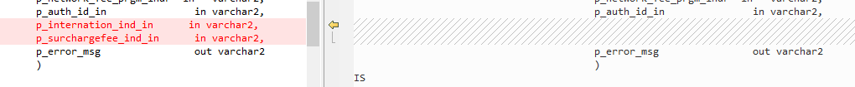
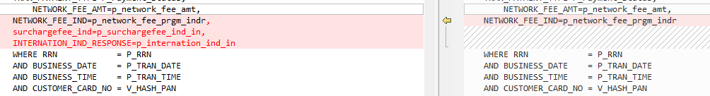
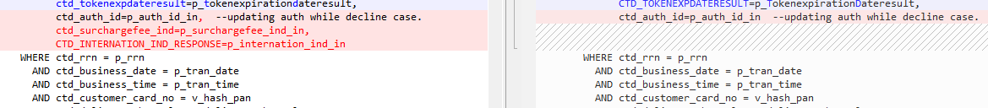
SP_CARDSTATUS_COPY.prc

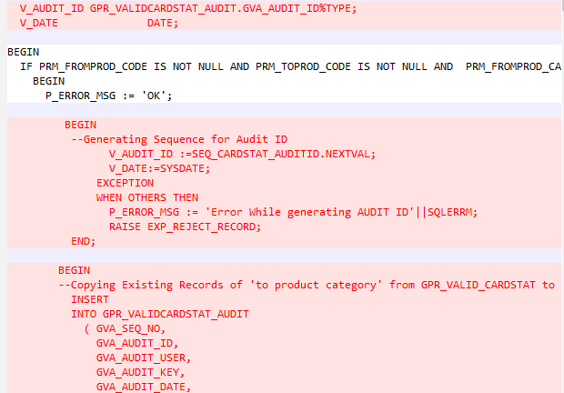

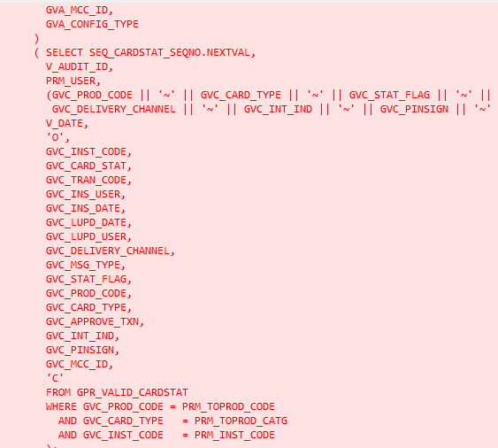

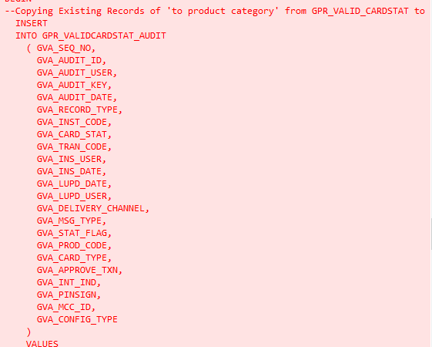

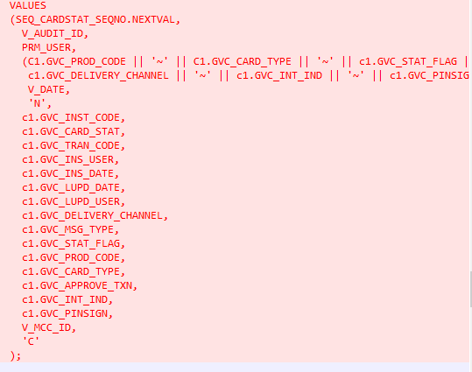

END OF DOCUMENTATION.

