

Vanilla Management System (VMS) R16
VMSGPRHOSTR16_B0006 DB Analysis Document

Documentation Control
Ver. No. | Author/s | Reason of Change | Date of Change
1.0 | UBAIDUR RAHMAN.H | Initial Draft | 31-MAY-2019

Table of Contents
Table of Contents 2
Purpose of the Document 3
1 VMSGPRHOSTR16 (R16_B0006) Release changes 4

Purpose of the Document
This document contains the Execution plan information for the modified query and newly added column in R16 -B0006 release.

VMSGPRHOSTR16 (R16_B0006) Release changes
B0006
- JIRA – VMS- 952 ,VMS-932 .
- DDL CHANGEs – Yes
  - 0 Modified procedures in 0 Package Bodies
  - 1 Modified Procedure outside of package
  - 0 Table Changes with new column
  - 0 New Tables
- DML Changes – Yes
- TRIGGERS – No
- INDEXES- No
  - 0 index
- BULK LOAD – No
- BACKUP Tables – No
DB :-
VMS- 952.
SP_TRAN_FEES_CMSAUTH.prc

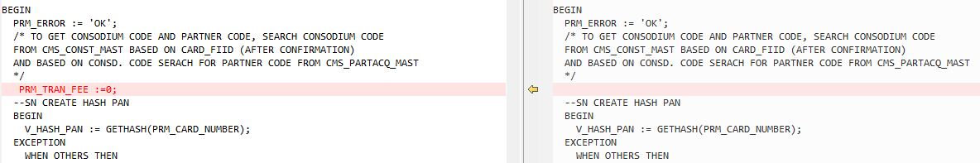

END OF DOCUMENTATION.

