

Vanilla Management System (VMS) R52
VMSGPRHOSTR52_B0001 DB Analysis Document

Documentation Control
Ver. No. | Author/s | Reason of Change | Date of Change
1.0 | UBAIDUR RAHMAN.H | Initial Draft | 23/09/21

Table of Contents
Table of Contents 2
Purpose of the Document 3
1 VMSGPRHOSTR52_B0001 Release changes 4

Purpose of the Document
This document contains the Execution plan information for the modified query and newly added column in R52_B0001 release.

VMSGPRHOSTR45 (R52_B0001) Release changes
B0003
- JIRA – VMS – 4297 /VMS-5020
- DDL CHANGEs – Yes
  - 2 Modified procedure in 1 Package Bodies
  - 0 Modified Procedure outside of package
  - 0 Table Changes with new column
  - 0 New Tables
- DML Changes – No
- TRIGGERS – No
- INDEXES- No
  - 0 index
- BULK LOAD – No
- BACKUP Tables – No

Procedure: GPP_CARDS.RESEND_EMAIL

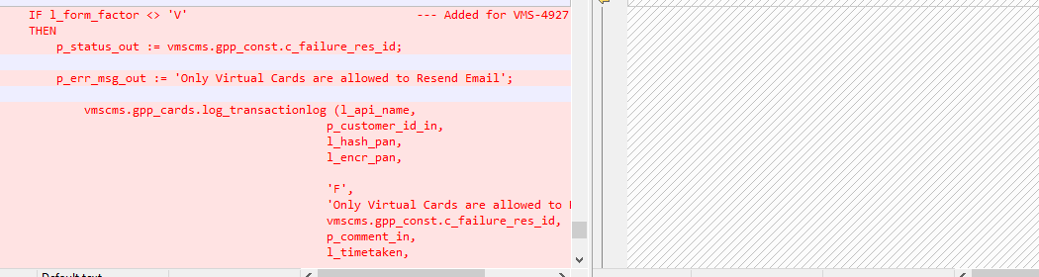
GPP_CARDS.REPLACE_CARD
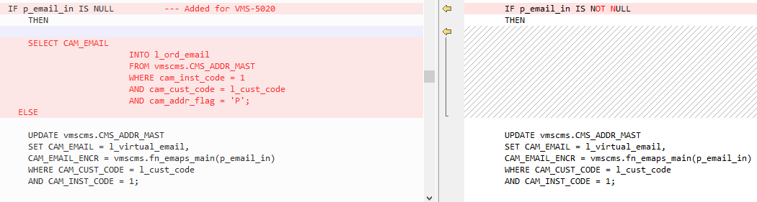
SELECT CAM_EMAIL
INTO l_ord_email
FROM vmscms.CMS_ADDR_MAST
WHERE cam_inst_code = 1
AND cam_cust_code = l_cust_code
AND cam_addr_flag = 'P';

Is already available in Package and uses index.

END OF DOCUMENTATION

