<Document Name>

Document Revision History
This section records the revision history of this document.
- Document Revision History
Date | Version | Author | Document Revision Description
January 1, 2009 | 0.01 | <Name> | <Description>

Table of Contents
1 Introduction 4
2 How to Use This Template 4
3 Heading Level 1 4
3.1 Heading Level 2 4
3.1.1 Heading Level 3 5
4 Review Minutes 7
5 Approvals 7

List of Tables
Table 1. Document Revision History 2
Table 2. Table Description 5
Table 3. Review Minutes for Rev 0.01 7
Table 4. Sign-Off Table 7

List of Figures
Figure 1. Figure Description 6

Introduction
<Begin each document with an introduction that is closely linked to the title of the document.>

How to Use This Template

NOTE: THIS TEMPLATE IS INTENDED FOR USE WITH TECHNICAL NOTES OF 10 PAGES OR MORE. FOR TECHNICAL NOTES OF LESS THAN 10 PAGES, RELEASE NOTES OR DATA SHEETS, REFER TO THE CORRESPONDING TEMPLATES.

The following two pages illustrate the main styles you’ll use. To access all the styles built in to this template, refer to the Styles and Formatting window, accessed as follows from the main Toolbar: Format / Styles and Formatting.
Note: Please use these styles as much as possible, rather than using the text formatting tools in the main toolbar. For example, if you want to bold a piece of Body Text, highlight the text and select the Body Text Bold style. Do not use the Bold icon from the toolbar, or Ctrl + B. Both of these actions will create and store excessive styles in your Styles and Formatting window. They may also cause MS Word to apply your change to all appearances of the style in which you made the change.
You are free to create your own styles as needed, using the New Style button near the top of the Styles and Formatting window. If you need help, feel free to contact Bill Burns at x232.

Heading Level 1
Body Text Body Text Body Text Body Text Body Text Body Text Body Text Body Text Body Text Body Text Body Text Body Text Body Text vv Body Text Body Text Body Text Body Text Body Text Body Text Body Text Body Text Body Text Body Text Body Text Body Text Body Text Body Text Body Text Body Text Body Text Body Text Body Text Body Text Body Text Body Text Body Text Body Text Body Text
Body Text Bold – Body Text Body Text Body Text Body Text
Body Text Bold – Body Text Body Text Body Text Body Text
Body Text tabbed
Body Text tabbed

Heading Level 2
Body Text Body Text Body Text Body Text Body Text Body Text Body Text Body Text Body Text Body Text Body Text Body Text Body Text vv Body Text Body Text Body Text Body Text Body Text Body Text Body Text Body Text Body Text Body Text Body Text Body Text Body Text Body Text Body Text Body Text Body Text Body Text Body Text Body Text Body Text Body Text Body Text Body Text Body Text
- Body Text Bullet
- Body Text Bullet
- Body Text Bullet Bold
- Body Text Bullet Bold

Heading Level 3
Body Text Body Text Body Text Body Text Body Text Body Text Body Text Body Text Body Text Body Text Body Text Body Text Body Text vv Body Text Body Text Body Text Body Text Body Text Body Text Body Text Body Text Body Text Body Text Body Text Body Text Body Text Body Text Body Text Body Text Body Text Body Text Body
Important: See the following page for more styles, including Table and Figure styles.
- Table Description
BodyTable Head Center | BodyTable Head Center
BodyTable Text BodyTable Text BodyTable Text BodyTable Text BodyTable Text  BodyTable Text Bold | ** BodyTable Text Center
- BodyTable Text Bullet  - BodyTable Text Bullet  - BodyTable Text Bullet Bold | ** BodyTable Text Center
BodyTable Head
BodyTable Text BodyTable Text BodyTable Text BodyTable Text BodyTable Text  BodyTable Text Bold | ** BodyTable Text Center
- BodyTable Text Bullet  - BodyTable Text Bullet  - BodyTable Text Bullet Bold | ** BodyTable Text Center
** Body Table Footnote Body Table Footnote Body Table Footnote Body Table Footnote Body Table Footnote

Heading Level 4
Body Text Body Text Body Text Body Text Body Text Body Text Body Text Body Text Body Text Body Text Body Text Body Text Body Text vv Body Text Body Text Body Text Body Text Body Text Body Text Body Text Body Text Body Text
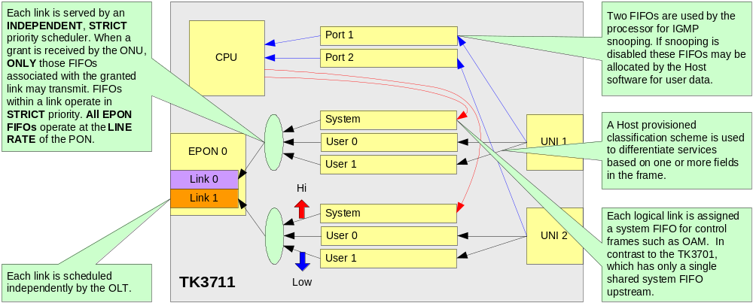
- Figure Description
Note: For graphics, choose the BodyTable Text Center style, and then add your graphic. This will center your graphic horizontally on the page.

Review Minutes
- Review Minutes for Rev 0.01
Review Minutes
Version Reviewed | 0.01
Date | 10.22.09
Attendees | [via email] Christopher Moezzi; Tim Crosta; Greg Caltabiano; Ed Boyd; Haley Recio; David Coakley; Drew Davis; Dave Malloy
Summary | Approved by all
Action Items | None
Approval | Approved by all

Approvals
- Sign-Off Table
Sign Off Table
Department | Approver | Approval* | Date
CEO | Greg Caltabiano | email | 10.22.09
CTO/Systems Group | Ed Boyd | email | 10.22.09
Engineering | Dave Malloy | email | 10.22.09
Marketing | Christopher Moezzi | email | 10.22.09
Operations | David Coakley | email | 10.22.09
Product Support | Tim Crosta | email | 10.22.09
* Please indicate approval “method.” For example, via email.

