PROJECT VIF
The Real-Time Student Food Bridge
TECHNICAL DOCUMENT
Database Schema &
Data Dictionary
The Vif Data Model — Entities, Fields,
Relationships and Integrity Rules
EPITECH — Capstone / Innovative Project
Lead Engineer: Rao Muhammad Mueez
Paris, France

Table of Contents

1. Introduction

1.1 Purpose
This document is the complete reference for the Vif database. It defines every entity, every field, the relationships between entities and the rules that keep the data consistent. It expands the single data model shown in the API Specification into the full schema, so that any developer can understand or extend the database without ambiguity.

1.2 Technology
- Database engine: PostgreSQL.
- Geospatial extension: PostGIS, used for location data and the 1 km radius queries.
- Access layer: SQLAlchemy ORM, used by the FastAPI backend.
- Identifiers: UUIDs are used as primary keys for all entities.

2. Entity-Relationship Overview
The Vif data model has six core entities. The diagram below shows them, their key fields and how they relate. Core entities are shown in navy, actor profiles in blue, and transaction entities in orange.

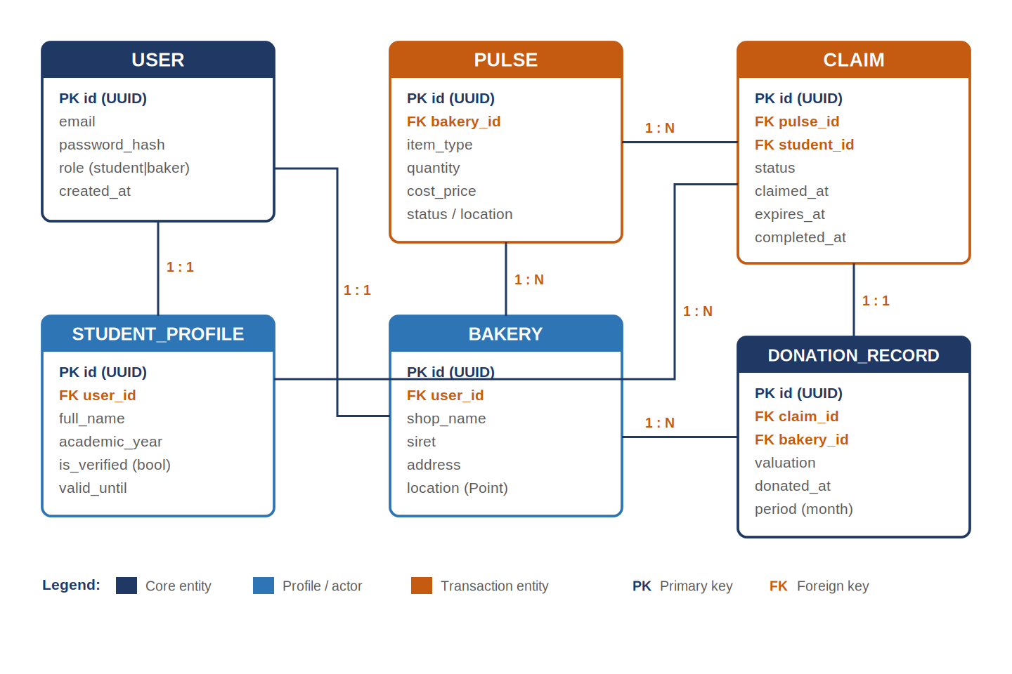
Figure 1 — Vif entity-relationship diagram.
The model is read as follows: each USER has exactly one role-specific profile (a STUDENT_PROFILE or a BAKERY). A BAKERY creates many PULSES. Each PULSE may receive many CLAIMS, and each CLAIM belongs to one student. A completed CLAIM produces exactly one DONATION_RECORD, and each BAKERY accumulates many donation records over time.

3. Schema Conventions
- Every table has a UUID primary key named id.
- Foreign keys are named <entity>_id (for example, bakery_id).
- Timestamps use a consistent created_at / updated_at pattern where relevant.
- Enumerated values (such as status) are constrained to a fixed set.
- Geographic points use the PostGIS Geography type for accurate distance queries.

4. Data Dictionary
Each table below lists its columns, types, constraints and purpose. Types are expressed in general terms; the exact PostgreSQL types are chosen at implementation.

4.1 Table: USER
The base account record. Every person on the platform — student or baker — has exactly one USER row.
Column | Type | Constraints | Description
id | UUID | Primary key | Unique account identifier.
email | String | Unique, not null | Login email address.
password_hash | String | Not null | Securely hashed password (never plain text).
role | Enum | student | baker | Determines which profile and permissions apply.
created_at | Timestamp | Not null | When the account was created.

4.2 Table: STUDENT_PROFILE
The student-specific data, including verification status. Holds no ID card image — only the extracted, minimal data, in line with the privacy requirements.
Column | Type | Constraints | Description
id | UUID | Primary key | Profile identifier.
user_id | UUID | Foreign key → USER | The account this profile belongs to.
full_name | String | Not null | Name extracted from the student ID via OCR.
academic_year | String | Not null | Academic year extracted from the ID (e.g. 2025/2026).
is_verified | Boolean | Default false | Whether the student passed verification.
valid_until | Date | Nullable | End of the verified period; triggers yearly re-verification.

4.3 Table: BAKERY
The boulangerie account, including the SIRET and location needed for the tax document and geofencing.
Column | Type | Constraints | Description
id | UUID | Primary key | Bakery identifier.
user_id | UUID | Foreign key → USER | The account this bakery belongs to.
shop_name | String | Not null | Display name of the bakery.
siret | String | Not null | French business identifier, required on the tax document.
address | String | Not null | Postal address, required on the tax document.
location | Geography(Point) | Not null | PostGIS coordinates for the 1 km geofence.

4.4 Table: PULSE
A single surplus-donation event posted by a baker. The central object of the platform.
Column | Type | Constraints | Description
id | UUID | Primary key | Pulse identifier.
bakery_id | UUID | Foreign key → BAKERY | The bakery that created the Pulse.
item_type | String | Not null | Type of surplus item (e.g. baguette).
quantity | Integer | Not null | Number of items offered.
cost_price | Decimal | Not null | Cost price per item, used for tax valuation.
status | Enum | active | claimed | expired | Current state of the Pulse.
location | Geography(Point) | Not null | Pickup location for the geofenced broadcast.
created_at | Timestamp | Not null | When the Pulse was posted.

4.5 Table: CLAIM
A student’s reservation of a Pulse, with the timer fields that drive the Karma Engine.
Column | Type | Constraints | Description
id | UUID | Primary key | Claim identifier.
pulse_id | UUID | Foreign key → PULSE | The Pulse being claimed.
student_id | UUID | Foreign key → STUDENT_PROFILE | The student making the claim.
status | Enum | active | completed | expired | Current state of the claim.
claimed_at | Timestamp | Not null | When the claim was made (timer start).
expires_at | Timestamp | Not null | When the 20-minute window ends.
completed_at | Timestamp | Nullable | When the QR handshake confirmed pickup.

4.6 Table: DONATION_RECORD
The Proof of Donation created on a completed claim; the source data for the monthly Cerfa document.
Column | Type | Constraints | Description
id | UUID | Primary key | Donation record identifier.
claim_id | UUID | Foreign key → CLAIM | The completed claim this record proves.
bakery_id | UUID | Foreign key → BAKERY | The donating bakery (for monthly aggregation).
valuation | Decimal | Not null | Donation value (quantity × cost price).
donated_at | Timestamp | Not null | When the donation was completed.
period | String | Not null | Month the donation belongs to, for tax aggregation.

5. Relationships & Integrity Rules
Relationship | Type | Rule
USER — STUDENT_PROFILE | 1 : 1 | A user with the student role has exactly one student profile.
USER — BAKERY | 1 : 1 | A user with the baker role has exactly one bakery.
BAKERY — PULSE | 1 : N | A bakery may create many Pulses; each Pulse belongs to one bakery.
PULSE — CLAIM | 1 : N | A Pulse may receive many claims; each claim refers to one Pulse.
STUDENT_PROFILE — CLAIM | 1 : N | A student may make many claims over time; each claim has one student.
CLAIM — DONATION_RECORD | 1 : 1 | A completed claim produces exactly one donation record.
BAKERY — DONATION_RECORD | 1 : N | A bakery accumulates many donation records, aggregated monthly.

5.1 Integrity Rules
- A claim can only be created for a Pulse whose status is active.
- A student can hold only one claim with status active at any time.
- A donation record is created only when a claim reaches status completed.
- Deleting a user account scrubs the linked profile’s personal identifiers (right to erasure) while preserving anonymised donation records for the tax audit trail.

6. Indexing & Performance
Index | Purpose
Spatial index on PULSE.location and BAKERY.location | Fast 1 km radius queries using PostGIS ST_DWithin.
Index on PULSE.status | Quickly find active Pulses for the map.
Index on CLAIM.status and CLAIM.expires_at | Efficiently find claims to expire via the Karma Engine.
Index on DONATION_RECORD.bakery_id and period | Fast monthly aggregation for the tax document.

7. Data Retention
Retention rules align the schema with the project’s privacy and legal requirements:
- Student ID card images are never stored — only the extracted name and academic year.
- Inactive student accounts are anonymised or deleted to avoid indefinite retention.
- Donation records are retained for the legally relevant period to support a possible tax audit, in anonymised form where personal data is not required.

8. Summary
This document defines the full Vif data model: six entities, their complete data dictionary, the relationships and integrity rules that keep the data consistent, the indexes that keep it fast, and the retention rules that keep it compliant. It is the authoritative reference for the database and a companion to the Functional Specification and API Specification.

