PROJECT VIF
The Real-Time Student Food Bridge
SUPPORTING DOCUMENT
Communication &
Awareness Plan
Telling People About Vif, Changing Minds and Building the Movement
EPITECH — Capstone / Innovative Project
Lead Engineer: Rao Muhammad Mueez
Paris, France

Table of Contents
Table of Contents 2
1. Purpose of this Document 3
2. Communication Strategy 3
2.1 Strategic Principles 3
2.2 Visual Identity 3
3. Audiences & Messages 3
3.1 Message to Bakeries 4
3.2 Message to Students 4
3.3 Message to Institutions (Universities, CROUS, Cities) 4
4. Poster Concepts (Designed Mockups) 4
4.1 Poster A — Bakery Window 4
4.2 Poster B — Campus 5
4.3 Poster C — The Cause Poster 6
5. Launch Events 7
5.1 Event Playbook — The Campus Stand (Detailed Example) 8
6. Channels & Cadence 8
7. Communication Timeline 9
8. Measuring Communication Success 9
9. Sensitive-Communication Guidelines 10
10. Summary 10

1. Purpose of this Document
A great platform that no one knows about changes nothing. This document is the full communication and awareness plan for Project Vif. It expands the communication section of Milestone 1 into a complete, actionable campaign: the strategy, the audiences, the messages, the designed poster mockups, the events, the channels, the timeline and the measurement.
Its goal is the “Unfreeze” stage of the change effort — making bakers and students aware that the current situation (waste and hunger) is not acceptable, and that an easy alternative now exists.

2. Communication Strategy

2.1 Strategic Principles
- One brand, two messages. Bakers and students are very different audiences; the visual identity stays constant while the message adapts.
- Frame, don’t pity. Vif is always communicated as “saving good food”, never as charity. This protects student dignity and widens appeal.
- Show, don’t tell. Live demos, real testimonials and visible impact convince far better than claims.
- Be honest about the model. Openly explaining that bakeries get a tax reduction is what makes “free food” believable rather than suspicious.
- Local first. Communication is concentrated in the pilot zone — a neighbourhood and its campus — not spread thin.

2.2 Visual Identity
Element | Specification
Name | Vif — short, energetic; in French “vif” means lively / quick, matching the real-time promise.
Primary colour | Deep navy (#1F3864) — trust, seriousness, reliability.
Accent colour | Warm orange (#C55A11) — freshness, warmth, the “pulse”, baked goods.
Tone of voice | Warm, clear, modern, optimistic. Never pitying, never corporate, never complicated.
Tagline | “The Real-Time Student Food Bridge.”

3. Audiences & Messages
Vif communicates to two primary audiences with distinct messages, plus a supporting message to institutions.

3.1 Message to Bakeries
Element | Content
Headline idea | “Don’t bin it — turn your surplus into a tax reduction.”
Core benefit | Recover value via the 238 bis CGI tax reduction; cut waste; improve local image.
Tone | Practical, reassuring, business-like; respects that the baker is busy.
Proof points | One click to give. Automatic monthly paperwork. A real partner association.
Objection handled | “No time” → 10-second Pulse. “Complicated” → automated Cerfa. “Risk” → clear Terms of Use.

3.2 Message to Students
Element | Content
Headline idea | “Fresh bakery food, free, right now, near you.”
Core benefit | Eat well at zero cost; quick, discreet, dignified.
Tone | Friendly, modern, anti-waste; never pitying.
Proof points | Verified students only. Real-time map. Food saved, not charity.
Objection handled | “Stigma” → anti-waste framing. “Privacy” → ID image discarded. “Nothing nearby” → live map.

3.3 Message to Institutions (Universities, CROUS, Cities)
A supporting message aimed at partners who can amplify Vif: “A concrete, low-cost tool that visibly supports your students’ welfare and reduces local food waste — with no operational burden for you.”

4. Poster Concepts (Designed Mockups)
Three posters support the launch. Each is presented below as a designed mockup ready to hand to a printer or designer for finalisation. All share the Vif identity and a single QR code; placeholders in [brackets] are completed once the partner association and event details are confirmed.

4.1 Poster A — Bakery Window
Audience: bakery owners and passers-by. Purpose: recruit bakeries and build neighbourhood awareness. The visual — a baguette becoming coins — communicates the core baker benefit in one glance.

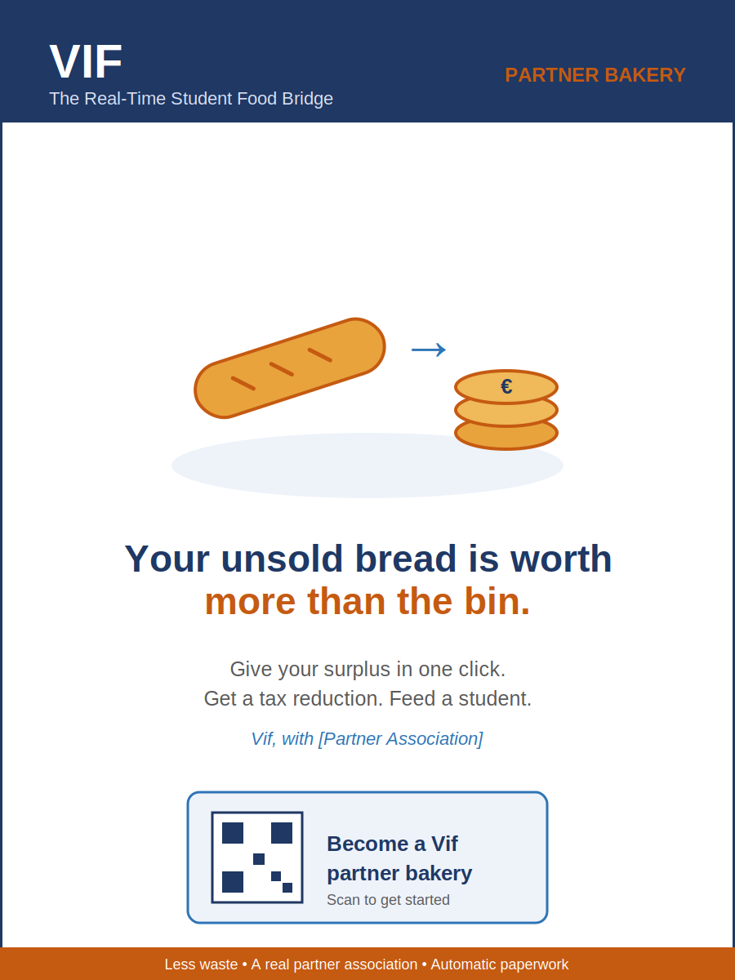
Poster A — displayed in bakery windows and at baker briefings.

4.2 Poster B — Campus
Audience: students. Purpose: drive app downloads. The phone-with-map visual shows the real-time, local promise; the dark background and modern layout deliberately avoid any “aid” aesthetic.

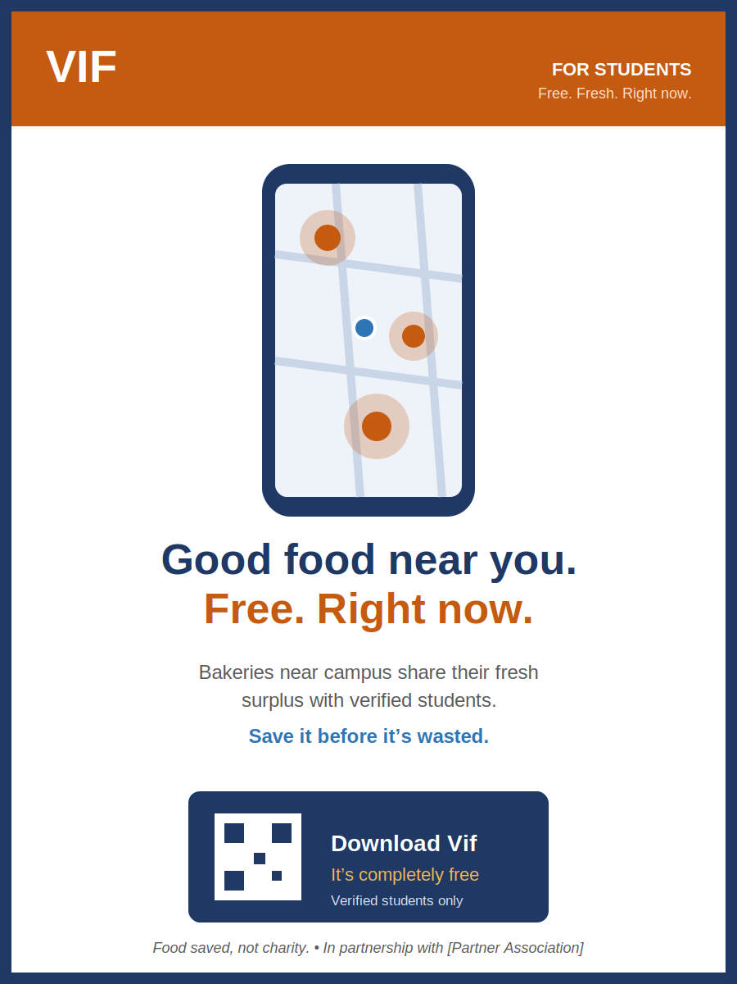
Poster B — displayed on campuses, in student residences and common areas.

4.3 Poster C — The Cause Poster
Audience: the general public, used at events. Purpose: explain the whole idea and the three-step flow. The split visual (waste vs. meal) states the problem and the solution together.

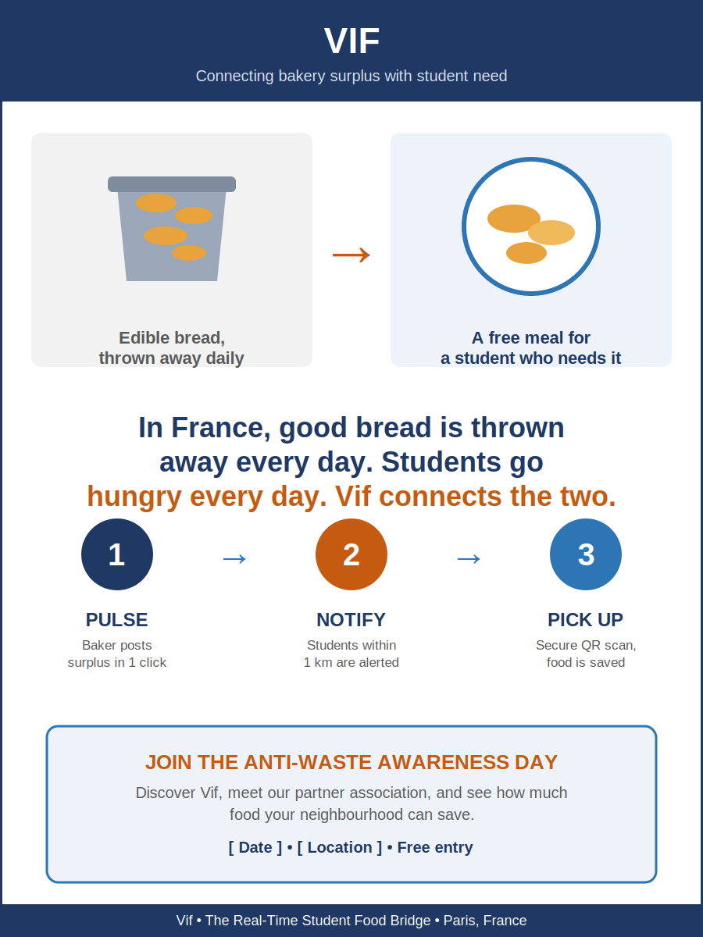
Poster C — used at awareness events and for press and public display.

5. Launch Events
Events turn a digital project into a real, local, human one and create moments for press coverage. Four event types support the launch.
Event | Audience | Format | Goal
“Vif Discovery” campus stand | Students | A stand at university entrances with live demo, on-the-spot sign-up and ID verification, and a free sample from a pilot bakery. | Convert footfall into verified users.
Baker breakfast briefing | Boulangeries | An early-morning meeting in a partner bakery: explain the tax mechanism, demo the app, answer objections. | Recruit pioneer bakeries.
Anti-waste awareness day | Public + press | A neighbourhood event with the partner association visualising daily waste and demoing Vif. | Build legitimacy and earn press coverage.
Jury / EPITECH demo day | School & jury | A formal presentation of the project, the change strategy and early results. | Academic validation of the capstone.

5.1 Event Playbook — The Campus Stand (Detailed Example)
A repeatable checklist so any team member can run the most frequent event:
- Before: choose a high-traffic spot and time (between classes); confirm a pilot bakery for samples; print Poster B and flyers.
- Setup: table, Vif banner, two phones for live demos, the bakery samples, a QR sign-up sheet.
- Pitch (15 seconds): “Bakeries near campus give away their fresh surplus — free, for verified students. Want to see?”
- Action: help the student download the app and verify on the spot; show them a live nearby Pulse.
- After: record sign-ups, collect quick feedback, note objections to refine the pitch.

6. Channels & Cadence
Channel | Audience | Used for | Frequency
Posters & flyers | Bakers, students, public | Local awareness and recruitment | Continuous during launch
Instagram / TikTok | Students | Short “food saved” videos, behind-the-scenes | 2–3 posts / week
Direct bakery visits | Bakers | Recruiting and reassuring | Ongoing in pilot zone
University / CROUS channels | Students | Credible mass reach | At launch + per milestone
Student unions / ambassadors | Students | Peer-to-peer endorsement | Ongoing
In-app notifications | All users | Activation and retention | Real-time + monthly recap
Local press | Public | Legitimacy and reach | Around events

7. Communication Timeline
The campaign is phased to mirror the project’s three sprints and the Lewin change stages.
Phase | Weeks | Communication focus
Pre-launch (Unfreeze) | Weeks 1–4 | Design and print posters; identify bakeries; set up social accounts; quietly line up pioneer bakeries and the partner association.
Launch (Change) | Weeks 5–8 | Baker breakfast briefings; first campus stands; begin social posting; first student sign-ups.
Activation (Change) | Weeks 9–12 | Anti-waste awareness day; ramp up campus presence; collect testimonials; press outreach.
Consolidation (Refreeze) | Post-pilot | Share results and impact figures; recognise partner bakeries; turn early users into advocates; prepare the jury demo.

8. Measuring Communication Success
Communication succeeds only when it changes behaviour. The following indicators are tracked from day one.
Indicator | What it tells us
Briefing attendance → baker sign-ups | Whether the baker message converts awareness into action.
App downloads after each event / campaign | Reach and pull of the student message.
Activation rate (first claim / first Pulse) | Whether messaging set correct expectations.
Social engagement (reach, saves, shares) | Resonance of the anti-waste framing.
Press mentions | External legitimacy generated by events.
Qualitative feedback at stands | Objections to address and messages to refine.

9. Sensitive-Communication Guidelines
Vif touches student precarity and food safety — sensitive topics. A few rules protect the project’s credibility:
- Never identify or photograph beneficiaries in a way that exposes their situation. Dignity comes before promotion.
- Never overstate impact. Use real, measured figures only; honesty is more persuasive and protects against backlash.
- If a food-safety concern arises, communicate quickly, factually and responsibly; do not minimise. Trust is the project’s most valuable asset.
- Always credit the partner association accurately and within the agreed terms of the convention.

10. Summary
This plan turns the Vif idea into a movement people can see, understand and join. It uses one consistent identity, two tailored messages, three designed posters, four event types and a phased timeline — all measured against real behaviour change. Executed well, it delivers the awareness and desire that the rest of the change strategy depends on.
Document links
This plan operationalises the communication section of Milestone 1 and draws its messages directly from the Personas & User Journeys document. Event timing aligns with the sprint roadmap in Milestone 2.

