Vibe Service and Protocol

Revision control
Rev. | Date | Initials | Change
0.1 | 2014-12-25 | RGR | Document created.
0.2 | 2015-01-10 | RGR | Added first version of the Vibe Service
0.3 | 2015-01-12 | RGR | Added Vibe Usage Description
0.4 | 2015-02-01 | RGR | Added Main Intensity Control (MIC)
0.5 | 2015-02-10 | RGR | Added more sequence diagram examples for Motor Control
0.6 | 2016-12-13 | JRR | Added sine and Gauss transitions
0.7 | 2016-12-29 | RGR | Added Timbre Id, rearranged chapters and added description of message identifier
0.8 | 2025-07-26 | JRR | Adding multidevice control and queries.Changed name to EMW-APP
0.9 | 2026-02-16 | JRR | Changed to lowercase UUIDs

Contents
1 Objective 4
1.1 Roles 4
1.2 Open items 4
2 Vibe Service Characteristics 5
2.1 Terminology 5
2.2 Service Characteristics 5
2.3 Service and Characteristic UUIDs 7
2.4 Product Differentiation 8
3 Vibe Protocol 9
3.1 Vibe Datagram v1.0 9
3.2 Vibe Protocol Modules 9
3.2.1 Control Module 9
3.2.2 Motor Module 10
3.3 Pattern Rules 18
4 Usage 20
4.1 Vibe Transport 20
4.1.1 Using the Write FIFO 20
4.1.2 Using the Read FIFO 20
4.2 Authentication 20
4.2.1 Introduction 20
4.2.2 Sequence Diagrams 21
4.2.3 Authentication Requirements 22
4.3 Motor Control 22
5 Vibe Protocol Implementation Requirement 25
6 Assumptions 26
7 Appendix 27
7.1 Defines 27
8 References 31

Objective
This document describes the proprietary Vibe Service and Protocol.
Among other devices it is provided by the Europe Magic Wand (EMW) GATT server.

Roles
The Server provides the Vibe Service towards a number of clients.

An example of a Server could be the Europe Magic Wand.
An example of a Client could be an App running on a Smartphone.

Open items

Vibe Service Characteristics

Terminology
The service contains the characteristics shown in the table below. The characteristic properties are shown as a string of characters with the following meaning:

- B: Broadcast procedure supported
  - Clients can ask the server to advertise the value (if there is room in the advertisement packets).
  - The characteristic must have the “Server Characteristic Configuration” descriptor, so clients can write to this to make the request.
- R: Read procedure supported
  - Clients can read the value.
- C: Write without response (write command) procedure supported
  - Clients can modify the value without getting a write response from the server.
- W: Write (with response) procedure supported
  - Clients can modify the value and get a write response from the server.
- N: Notify procedure supported
  - Clients can ask the server to send notifications whenever the value changes. Notifications don’t require confirmation from the client.
  - The characteristic must have the “Client Characteristic Configuration” descriptor, so clients can write to this to make the request.
- I: Indicate procedure supported
  - Clients can ask the server to send indications whenever the value changes. Indications require confirmation from the client.
  - The characteristic must have the “Client Characteristic Configuration” descriptor, so clients can write to this to make the request.

Service Characteristics

Characteristic | Req. | Properties | Value byte index | Description
Version | M | R | ----- | Version of Vibe Service.
Version | M | R | 0-1 | Two byte version number (xx.xx). E.g. version 1.0 would be 0x0100
Client Challenge or Response (CC/CR) | O | C | ----- | Client Challenge or Client Response as indicated by the first byte.
Client Challenge or Response (CC/CR) | O | C | 0 | 0: Client Challenge (CC) is in the following bytes.  1: Client Response (CR) is in the following bytes.  2: Error
Client Challenge or Response (CC/CR) | O | C | 1-16 | Contains either:  Client Challenge: 128-bit random number  Client Response: Hash(CC || SC || SECKEY)
Server Response or Challenge (SR/SC) | O | N | ----- | Server Response of Server Challenge as indicated by the first byte.
Server Response or Challenge (SR/SC) | O | N | 0 | 0: Server Response (SR) is in the following bytes.  1: Server Challenge (SC) is in the following bytes.  2: Error
Server Response or Challenge (SR/SC) | O | N | 1-16 | Contains either:  Server Response = Hash(SC || CC || SECKEY)  Server Challenge = 128-bit random number
Write Buffer Segment | M | C | ----- | Combined command register and payload write buffer. To transfer data to the Vibe Transport Write FIFO, the client shall write zero or more times to “Write Buffer Segment” and once to “Write Buffer Last”, depending on the length of the payload.  It is allowed to use fewer than VIBE_MAX_DATAGRAM_SIZE payload bytes and transfer the payload bytes using several subsequent writes to “Write Buffer Segment”, finishing off with a single write to “Write Buffer Last”.  This is advantageous if ATT_MTU is 23 (ATT_PAYLOAD payload bytes), since this avoids using inefficient GATT commands.
Write Buffer Segment | M | C | 0-19 | 20 byte payload segments
Write Buffer Last | M | C | ----- | Used to transfer the last payload segment. Preceded by N writes to “Write Buffer Segment” where N≥0.  Write to this characteristic also signals to the Server that the last segment has been received (it can start to process the FIFO).
Write Buffer Last | M | C | 0-19 | Last payload segment of package.
Read Buffer Segment | O | N | ----- | Similar to “Write Buffer Segment”, except the direction of the data is inverted, i.e. “N” (Notification) instead of “C” (Write Command).
Read Buffer Segment | O | N | 0-19 | See Write Buffer Segment
Read Buffer Last | O | N | ----- | Similar to “Write Buffer Last”, except the direction of the data is inverted, i.e. “N” (Notification) instead of “C” (Write Command).
Read Buffer Last | O | N | 0-19 | See “Write Buffer Last”.
Client Control | M | C | ----- | Client Control
Client Control | M | C | 0-19 | Payload bytes 0-19
Server State and Status | M | N | ----- | Server State and Status reporting
Server State and Status | M | N | 0-19 | Payload bytes 0-19
Note: GATT payload is max 20 bytes in BLE 4.1 if sent in a single LL packet.
M: Mandatory Characteristic, O: Optional Characteristic

All characteristics are control point characteristics (The services use the value written immediately, and the server does not have any need to store that value after it has been consumed).

This protocol (0.8 onwards) supports control via mobile app and LLM through an MCP interface, with extensions for multi-device connectivity.

Interoperability: Ensure backward compatibility (0.8 onwards) —new commands should default to "unsupported" error if not implemented.

The payload transported by the characteristics are Vibe Datagrams detailed in Section 3.1.

Service and Characteristic UUIDs
The UUIDs for this service and its characteristics are listed below. They are 128-bit version-4 (random) UUIDs according to [1].
Vibe Service Common Base UUID: 0000xxxx-1313-71be-1221-785dfeabc321

Service | UUID
Vibe Service | 00001221-1313-71be-1221-785dfeabc321

Characteristic | UUID
Version | 00001222-1313-71be-1221-785dfeabc321
Client Challenge or Response (CC/CR) | 00001223-1313-71be-1221-785dfeabc321
Server Response or Challenge (SR/SC) | 00001224-1313-71be-1221-785dfeabc321
Write Buffer Segment | 00001225-1313-71be-1221-785dfeabc321
Write Buffer Last | 00001226-1313-71be-1221-785dfeabc321
Read Buffer Segment | 00001227-1313-71be-1221-785dfeabc321
Read Buffer Last | 00001228-1313-71be-1221-785dfeabc321
Client Command | 00001229-1313-71be-1221-785dfeabc321
Server State and Status | 00001230-1313-71be-1221-785dfeabc321

Product Differentiation
Table 1 lists which characteristics are supported by products utilizing the Vibe Service and Protocol.

 | EMW-APP |  | …
Service
Vibe Service | 0.7
Characteristic
Version |  | 0.7
Client Challenge or Response (CC/CR)
Server Response or Challenge (SR/SC)
Write Buffer Segment |  | 0.7
Write Buffer Last |  | 0.7
Read Buffer Segment
Read Buffer Last
Client Command |  | 0.7
Server State and Status |  | 0.7
Multi-Device Synchronization |  | 0.8
Battery/Sensor Query |  | 0.8
OTA Firmware Update |  | 0.8
MCP Interface Integration |  | 0.8
Table 1: Supported services and characteristics by products utilizing the Vibe Service and Protocol

Vibe Protocol

Vibe Datagram v1.0
A Vibe Datagram v1.0 consists of a version and a size field. The payload holds the various Vibe Protocol Modules detailed in Section 3.2.

VER | SIZE | PAYLOAD
1 byte | 1byte | 0 – 118 bytes

The VER field indicates the version of the Vibe Datagram as 0bxxxx.0bxxxx which for version 1.0 would be 0b0001.0b0000 = 0x10

The SIZE field contains the number of bytes in the datagram excluding VER and SIZE. The SIZE value must be in the range [0; 118].

Vibe Protocol Modules
Vibe Protocol Modules are transported in the payload part of a Vibe Datagram.
Each module has a “Module id” that numbers the module.
Each module will then contain a set of messages, each numbered by a “Message id”

Control Module

Control.Reset
This command is used from the Client to reset the Server to idle state.

Byte Pos | Data | Type | Byte Length | Description
0 | 0x00 | uint8_t | 1 | Module id
1 | 0x00 | uint8_t | 1 | Message id

Motor Module
This module contain a set of messages that set how a Motor connected to a Vibe Server should be controlled.

Motor.RepeatingPattern
These commands are used from the Client to send repeating patterns controlling a motor at the Server side.
It holds Motor Control Segment(s) (MCS) which define patterns.
This pattern shall be repeated continuously by the Server until interrupted, see Section 3.3.
In addition to the Message identifier, these messages also holds a “Timbre id” which identify the timbre of the pattern being applied.

Linear transition pattern
Byte Pos | Data | Type | Byte Length | Description
0 | 0x01 | uint8_t | 1 | Module id
1 | 0x00 | uint8_t | 1 | Message id
2 | 0x00 | uint8_t | 1 | Timbre id – Linear
3 | Pattern Id | uint8_t | 1 | Pattern Identifier – This value is supplied by the Client, and then stored by the Server, to identify this Pattern.  This is used by the Client to acknowledge which pattern is run via e.g. Motor.State Notifications (see Section 3.2.2.3)
4 | Main Intensity Control (MIC) | uint8_t | 1 | The overall intensity, in percentage 0-100 %, at which the current pattern should begin execution. See Section 3.2.2.5.
5 | Intensity Begin | uint8_t | 1 | The intensity, in percentage 0-100 %, at which the Motor should begin this segment.
6 | Intensity End | uint8_t | 1 | The intensity, in percentage 0-100 %, at which the Motor should end this segment.
7 | Transition Period | uint16_t | 2 | Indicates the transition time for the Motor to transition from Intensity Begin to Intensity End. [ms]
8… | Additional Motor Control Segment(s)  .  .  .

Example:
Module Id | Msg Id | Timbre Id | Pattern Id | MIC | Int.Beg. | Int.End | Tra.Per. | Int.Beg. | Int.End | Tra.Per.
0x01 | 0x00 | 0x00 | 0x01 | 0x64 | 0 | 100 | 2000 | 100 | 100 | 1000

 | Int.Beg. | Int.End | Tra.Per. | Int.Beg. | Int.End | Tra.Per.
 | 100 | 0 | 2000 | 0 | 0 | 1000

Raw Characteristic Data:
Write Buffer Segment =
{ [VER, SIZE], [Module Id, Msg Id, Timb. Id, Pattern Id, MIC], [MCS1], [MCS2], [MCS3], [MCS4.0-1] } =
{ [0x10, 0x15], [0x01, 0x00, 0x00, 0x01, 0x64], [0x00, 0x64, 0x07, 0xD0], [0x64, 0x64, 0x03, 0xE8], [0x64, 0x00, 0x07, 0xD0], [0x00, 0x00] }
Write Buffer Last = { [MCS4.2-3] } = { [0x03, 0xE8] }

In this example, the pattern in Figure 1 is produced. As this is a repeating pattern the Motor connected to the Server will repeat this pattern until the Server is instructed to do otherwise, see Figure 2 and Section 3.3.
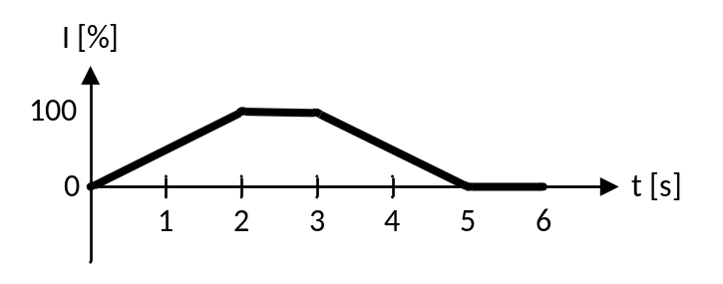
Figure 1: Repeating Pattern
(MIC = 100%, see Section 3.2.2.5)
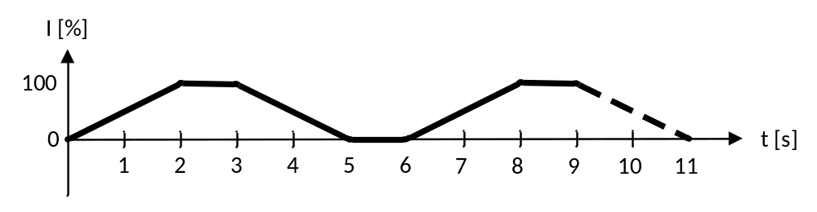
Figure 2: Continous execution of repeating pattern
(MIC = 100%, see Section 3.2.2.5)

Sine pattern
Byte Pos | Data | Type | Byte Length | Description
0 | 0x01 | uint8_t | 1 | Module id
1 | 0x00 | uint8_t | 1 | Message id
2 | 0x01 | uint8_t | 1 | Timbre id – Sine
3 | Pattern Id | uint8_t | 1 | Pattern Identifier – This value is supplied by the Client, and then stored by the Server, to identify this Pattern.  This is used by the Client to acknowledge which pattern is run via e.g. Motor.State Notifications (see Section 3.2.2.3)
4 | Main Intensity Control (MIC) | uint8_t | 1 | The overall intensity, in percentage 0-100 %, at which the current pattern should begin execution. See Section 3.2.2.5.
5 | Sine amplitude | uint8_t | 1 | The intensity, in percentage 0-100 %, describing the amplitude of the sine. 100% equals maximum when sine center value is 50%
6 | Sine center | uint8_t | 1 | The sine center intensity value, in percentage 0-100 %.
7 | Sine Period | uint16_t | 2 | The period of the sine wave [ms].

Formula describing the Sine pattern:
$$SineAmplitude∙\sin\left(2π\left(\frac{t}{SinePeriod}\right)\right)+SineCenter$$

Gauss transition pattern
Byte Pos | Data | Type | Byte Length | Description
0 | 0x01 | uint8_t | 1 | Module id
1 | 0x00 | uint8_t | 1 | Message id
2 | 0x02 | uint8_t | 1 | Timbre id - Gaussian
3 | Pattern Id | uint8_t | 1 | Pattern Identifier – This value is supplied by the Client, and then stored by the Server, to identify this Pattern.  This is used by the Client to acknowledge which pattern is run via e.g. Motor.State Notifications (see Section 3.2.2.3)
4 | Main Intensity Control (MIC) | uint8_t | 1 | The overall intensity, in percentage 0-100 %, at which the current pattern should begin execution. See Section 3.2.2.5.
5 | Gauss StartPoint | uint8_t | 1 | Start point intensity value, in percentage 0-100 %
6 | Gauss EndPoint | uint8_t | 1 | End point Gauss intensity value, in percentage 0-100 %.
7 | Gauss Duration | uint16_t | 2 | Duration until next Gauss transition begins (repeating Gauss pattern)
9 | Gauss Steep | uint8_t | 1 | Gauss steepness *20 ms
10 | Additional Motor Control Segment(s)  .  .  .

Formula describing the Gauss transition:

$$\left(StartPoint-EndPoint\right)∙e^{({-t^{2}}/{(2∙{Steep}^{2}}))}+EndPoint$$

Motor.NonRepeatingPattern
This command is used from the Client to send a non-repeating pattern controlling a motor at the Server side.
It holds Motor Control Segment(s) (MCS) which define a pattern.
This pattern shall be executed once by the Server (one-shot), see Section 3.3.

Byte Pos | Data | Type | Byte Length | Description
0 | 0x01 | uint8_t | 1 | Module id
1 | 0x01 | uint8_t | 1 | Message id
2 | 0x00 | uint8_t | 1 | Timbre id – Linear
3 | Pattern Id | uint8_t | 1 | Pattern Identifier – This value is supplied by the Client, and then stored by the Server, to identify this Pattern.  This is used by the Client to acknowledge which pattern is run via e.g. Motor.State Notifications (see Section 3.2.2.3)
4 | Main Intensity Control (MIC) | uint8_t | 1 | The overall intensity, in percentage 0-100 %, at which the current pattern should begin execution. See Section 3.2.2.5.
5 | Intensity Begin | uint8_t | 1 | The intensity, in percentage 0-100 %, at which the Motor should begin this segment.
6 | Intensity End | uint8_t | 1 | The intensity, in percentage 0-100 %, at which the Motor should end this segment.
7 | Transition Period | uint16_t | 2 | Indicates the transition time for the Motor to transition from Intensity Begin to Intensity End.
9 | Additional Motor Control Segment(s)  .  .  .

Example:
Module Id | Msg Id | Timbre Id | Pattern Id | MIC | Int.Beg. | Int.End | Tra.Per. | Int.Beg. | Int.End | Tra.Per.
0x01 | 0x01 | 0x00 | 0x02 | 0x64 | 0 | 50 | 500 | 50 | 50 | 1000

 | Int.Beg. | Int.End | Tra.Per. | Int.Beg. | Int.End | Tra.Per. | Int.Beg. | Int.End | Tra.Per.
 | 50 | 100 | 500 | 100 | 100 | 1000 | 100 | 0 | 500

Raw Characteristic Data:
Write Buffer Segment =
{ [VER, SIZE], [Module Id, Msg Id, Timb. Id, Pattern Id, MIC], [MCS1], [MCS2], [MCS3], [MCS4.0-1] } =
{ [0x10, 0x19], [0x01, 0x01, 0x00, 0x02, 0x64], [0x00, 0x32, 0x01, 0xF4], [0x32, 0x32, 0x03, 0xE8], [0x32, 0x64, 0x01, 0xF4], [0x64, 0x64] }
Write Buffer Last = { [MCS4.2-3], [MCS5] } = { [0xE8], [0x03, 0x64, 0x00, 0x01, 0xF4] }
In this example, the pattern in Figure 3 is produced. As this is a non-repeating pattern the Motor connected to the Server will execute this pattern and return to either a repeating pattern or idle, see Section 3.3.
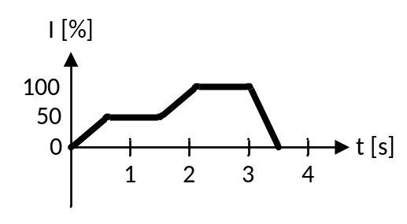
Figure 3: Non-Repeating Pattern
(MIC = 100%, see Section 3.2.2.5)

Gauss transition pattern
Byte Pos | Data | Type | Byte Length | Description
0 | 0x01 | uint8_t | 1 | Module id
1 | 0x01 | uint8_t | 1 | Message id
2 | 0x01 | uint8_t | 1 | Timbre id – Gaussian
3 | Pattern Id | uint8_t | 1 | Pattern Identifier – This value is supplied by the Client, and then stored by the Server, to identify this Pattern.  This is used by the Client to acknowledge which pattern is run via e.g. Motor.State Notifications (see Section 3.2.2.3)
4 | Main Intensity Control (MIC) | uint8_t | 1 | The overall intensity, in percentage 0-100 %, at which the current pattern should begin execution. See Section 3.2.2.5.
5 | Gauss StartPoint | uint8_t | 1 | Start point intensity value, in percentage 0-100 %
6 | Gauss EndPoint | uint8_t | 1 | End point Gauss intensity value, in percentage 0-100 %.
7 | Gauss Duration | uint16_t | 2 | Duration until next Gauss transition begins (repeating Gauss pattern)
9 | Gauss Steep | uint8_t | 1 | Gauss steepness *20 ms
10 | Additional Motor Control Segment(s)  .  .  .

Formula describing the Gauss transition:

$$\left(StartPoint-EndPoint\right)∙e^{({-t^{2}}/{(2∙{Steep}^{2}}))}+EndPoint$$

Motor.State
This notification is send from the Server to the Client to indicate the Motor State.

Byte Pos | Data | Type | Byte Length | Description
0 | 0x01 | uint8_t | 1 | Module id
1 | 0x02 | uint8_t | 1 | Message id
2 | State | uint8_t | 1 | 0: Motor Idle  1: Motor running repeating pattern  2: Motor running non-repeating pattern  3: Motor Error
3 | Pattern Id | uint8_t | 1 | Pattern Identifier of the pattern currently being executed.  The value 0x00 indicates that Motor is idle or in error state.  The value 0xFF indicates that Motor is running a Pattern dictated by the Server itself (e.g. set via push-buttons on an EMW).
4 | Main Intensity Control (MIC) | uint8_t | 1 | The overall intensity, in percentage 0-100 %, at which the current pattern is being executed. See Section 3.2.2.5.

Motor.ErrorEvent
This notification is send from the Server to the Client to indicate that an error has occurred.

Byte Pos | Data | Type | Byte Length | Description
0 | 0x01 | uint8_t | 1 | Module id
1 | 0x03 | uint8_t | 1 | Message id
2 | Errorcode | uint8_t | 1 | 1: Motor Error  2: Communication Error  3: …  .  .  This list can be expanded

Motor.MainIntensityControl
This notification is send from the Client to the Server to adjust the Main Intensity Control (MIC).

Byte Pos | Data | Type | Byte Length | Description
0 | 0x01 | uint8_t | 1 | Module id
1 | 0x04 | uint8_t | 1 | Message id
2 | Main Intensity Control (MIC) | uint8_t | 1 | The overall intensity, in percentage 0-100 %, at which the current pattern should be executed. A sort of “pre-gain” to the actual pattern.

When processing a Motor Control Segment (MCS) the actual intensity at which the motor should run is a multiplication of the MIC and MCS such that:
 | $$Motor Intensity(x)=MIC∙MCS(x),$$ | (1)
where x is the motor segment number.

As detailed in Section 3.2.2.1 and 3.2.2.2, a pattern can also request to set the MIC as part of the request to execute a pattern.
The valid values for the MIC is listed in
Main Intensity Control (MIC) Value |  | Description
Decimal | Hexadecimal
0-100 | 0x00 - 0x64 | Set the Motor Output Intensity to a percentage between 0 and 100 %
238 | 0xEE | Set the Motor Output Intensity to 100 %, and the MIC cannot be changed during the execution of this pattern. This means that e.g. pressing a button on the Server to decrease the Intensity will not have any effect.  The pattern execution will need to be stopped either via the Client (App) or on the Server (EMW) itself to stop this pattern.
255 | 0xFF | Leave the Motor Output Intensity unchanged (if it was currently 50 % it should still be 50% after receiving a MIC request of 0xFF.

Example:
Figure 4 shows the Non-Repeating Pattern displayed in Figure 3 with MIC = 50%. Notice that the actual motor output intensity is halved (MIC changed from 100% down to 50%).
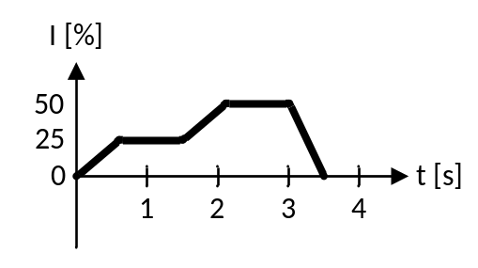
Figure 4: Non-Repeating Pattern
(MIC = 50%, see Section 3.2.2.5)

Backward Compatibility and Error Handling
To ensure interoperability across protocol versions, the Vibe Service must maintain backward compatibility. New commands (introduced in future versions, e.g., opcodes 0x0A and above) shall not affect the behavior of existing implementations.
**Handling Unknown Opcodes**: If the Server (device) receives a Write FIFO command with an unrecognized opcode, it shall respond via the Read FIFO with an "unsupported" error notification. This prevents connection failures and allows the Client (app or MCP interface) to fallback to supported features.
Error Structure (Notification via Read FIFO):
- Opcode: 0xFF (reserved for errors).
- Error Code: 1 byte (0x01 = Unsupported Opcode).
- Original Opcode: 1 byte (echo the unrecognized opcode for debugging).
- Additional Data: Variable (optional, e.g., device version string).
Example: If a v0.7 device receives OPCODE_SYNC_PATTERN (0x0A from v0.8), it responds with: [0xFF, 0x01, 0x0A].

**Client Behavior**: The app or LLM (via MCP) should check for error responses and gracefully degrade (e.g., use basic RepeatingPattern instead of advanced waveforms). For multi-device control, query device version. LLM via MCP should retry with fallback commands.

**Version Query**: To probe compatibility.
Command Structure (Client to Server, via Write FIFO):
- Opcode: 0x0F (OPCODE_QUERY_VERSION).
- No parameters.
Response (Server to Client, via Read FIFO):
- Protocol Version: 2 bytes (e.g., 0x0008 for v0.8).
- Device Firmware Version: 4 bytes (semantic version as uint32).
This ensures the protocol remains extensible for features like Bluetooth app control or LLM integration without requiring firmware updates on all devices.

This complements the datagram VER field by providing detailed firmware/capabilities info.

Pattern Rules
The effect of sending a pattern from Client to Server depends on the whether a pattern is already running, the type of pattern running and the type of the new pattern called:
1. When a repeating pattern is already running:
- If the new pattern is a repeating pattern, the new pattern will replace the original pattern.
- If the new pattern is a non-repeating the original pattern is interrupted, the new pattern is played then the original pattern is resumed.
2. When a non-repeating pattern is playing:
- If the new pattern is a repeating pattern, the new pattern will play when the original pattern completes.
- If the new pattern is a non-repeating pattern, the new pattern will not be running.
Note:
It is up to the Client to queue non-repeating patterns if required.

Usage

Vibe Transport
The Vibe Transport layer consists of a Write FIFO and a Read FIFO, where the client can transfer data to and from the server. The Vibe data consists of Vibe Datagrams of up to VIBE_MAX_DATAGRAM_SIZE bytes in length.
Legend:
- client.write_cmd(…): “Write Command” ATT protocol opcode sent from client.
- server.notify(…): “Handle Value Notification” ATT protocol opcode sent from the server.

Using the Write FIFO
This is an example of sending 85 bytes from the client to the server via the Write FIFO. The full payload size of the Write Buffer Segment/Last characteristics is not used, since ATT_MTU is only 20 (BLE 4.1).
client.write_cmd(“Write Buffer Segment”, payload[0:19]) | Send the first 20 bytes segment as  ATT_MTU equals 20.
client.write_cmd(“Write Buffer Segment”, payload[20:39]) | Send the next 20 bytes segment
client.write_cmd(“Write Buffer Segment”, payload[40:59]) | Send the next 20 bytes segment
client.write_cmd(“Write Buffer Segment”, payload[60:79]) | Send the next 20 bytes segment
client.write_cmd(“Write Buffer Last”, payload[79:84]) | Send the final 5 bytes segment

Using the Read FIFO
This is an example of sending 19 bytes from the server to the client via the Read FIFO. The transaction is complete after just one Notification from the server to the client, since the payload fits in the “Read Buffer Last” characteristic.
server.notify(“Read Buffer Last”, payload[0:18])
No notifications on the “Read Buffer Segment” characteristic.

Authentication

Introduction
The current solution in the Vibe Service uses the MD5 hash.

From http://en.wikipedia.org/wiki/Challenge%E2%80%93response_authentication:
Simple example mutual authentication sequence
- Server sends a unique challenge value sc to the client
- Client generates unique challenge value cc
- Client computes cr = hash(cc || sc || secret)
- Client sends cr and cc to the server
- Server calculates the expected value of cr and ensures the client responded correctly
- Server computes sr = hash(sc || cc || secret)
- Server sends sr
- Client calculates the expected value of sr and ensures the server responded correctly
where
- sc is the server generated challenge
- cc is the client generated challenge
- cr is the client response
- sr is the server response

This could be used for authentication in several scenarios:
- EMW(Server) <-> EMW App(Client)

Sequence Diagrams
The sequence diagram for mutual authentication in text form:

client.write_cmd(“Client Challenge or Response (CC/CR)”, type=CC, data=CC) | Send Client Challenge (CC) to server.
Server.notify(“Server Response or Challenge (SR/SC)”,  type=SR, data=Hash(SC || CC || SECKEY)) | Send Server Response (SR) to client.
Server.notify(“Server Response or Challenge (SR/SC)”,  Type=SC, data=SC) | Send Server Challenge (SC) to client.
client.write_cmd(“Client Challenge or Response (CC/CR)”,  type=CR, data=Hash(CC || SC || SECKEY)) | Send Client Response (CR) to server.

Note that compared to the Wikipedia example above, the client initiates the authentication sequence – not the server.

Authentication Requirements
When a Client has connected to a Server (not during pairing), the Server loads a timer with AUTH_EXECUTION_TIMEOUT.
The Client then has to initiate and complete a successful authentication with the Server, as described in Section 4.2.2, within AUTH_EXECUTION_TIMEOUT.
If the Client fails to complete the authentication, the Server shall return to idle and ignore further commands from that Client in AUTH_FAILURE_LOCKOUT_PERIOD.
Furthermore, after the AUTH_FAILURE_LOCKOUT_PERIOD the Short-term Key (STK) and Long-Term Key (LTK) for the failed Client shall be cleared from the Server Paired Device List.

Motor Control
This Section provides examples on how to use the Motor Module (see Section 3.2.2) of the Vibe Service and Protocol.
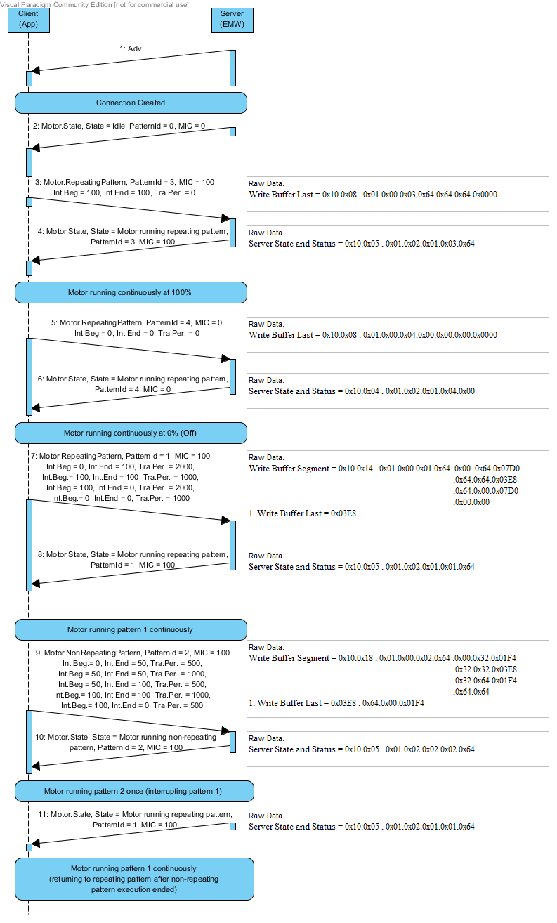
Figure 5: Example of repeating and non-repeating pattern execution. Non-repeating pattern interrupts repeating pattern - non-repeating executes and the control returns to the repeating pattern.
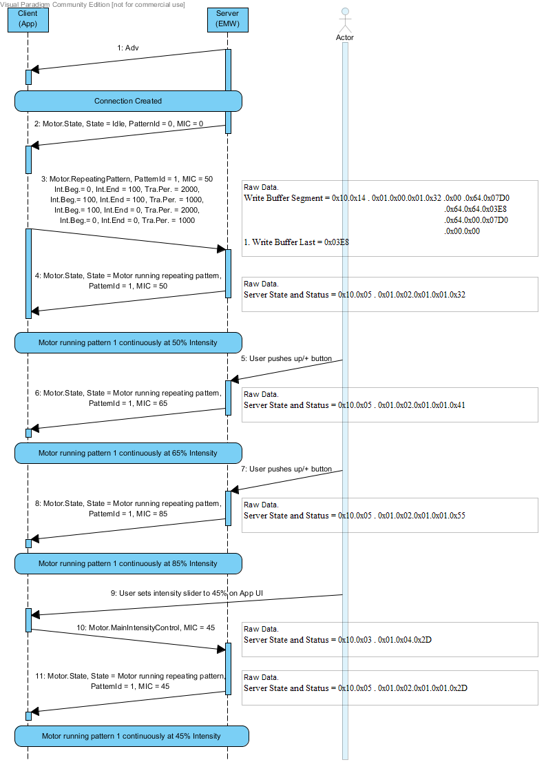
Figure 6: Example of repeating pattern execution, where User presses intensity up/+ on the EMW and App

Vibe Protocol Implementation Requirement
- The Server shall be able to have two buffers of size VIBE_MAX_DATAGRAM_SIZE to hold a repeating and a non-repeating pattern.
- If a disconnection or link loss occurs the Server shall reset the buffering/flush the FIFO. Such that if the Client sends a Write Buffer Segment after a new connection has been created that segment will be regarded as the first segment of a Vibe Datagram being received.

Assumptions
- Link Layer Payload size (L2CAP_MTU)
  - BLE 4.0/4.1: 27 bytes
  - BLE 4.2: 251 bytes
- ATT_MTU = L2CAP_MTU – 4 (max), due to overhead in L2CAP
- ATT payload = ATT_MTU – 3 (max), due to overhead in ATT protocol (Write Command and Value Notification).
- It is assumed that the Client/Server shall limit Link Layer payload size to 128, since large packets are more likely to be lost. It also reduces the memory usage considerably (a scarce resource).
  - L2CAP_MTU=128 ATT_MTU=124 ATT payload=121
    - This means that the size of Write/Read Buffer Segment/Last is reduced to 121.

Appendix

Defines
Table 2 lists the constants utilized in the Vibe Service
Name | Value |  | Description
ATT_PAYLOAD | 20 bytes |  | The number of bytes which can be send/received via one characteristic at a time (per write).
VIBE_MAX_DATAGRAM_SIZE | 121 bytes |  | The maximum length of a datagram, which will be received via the ATT layer in segments of ATT_PAYLOAD bytes.
AUTH_PROCEDURE_PERIOD | 7 seconds |  | A Client must have completed a successful authorization procedure after being connected to the Server within AUTH_EXECUTION_TIMEOUT seconds (not during pairing).
AUTH_FAILURE_LOCKOUT_PERIOD | 5 seconds |  | A Server shall return to idle and ignore further commands from a Client in AUTH_FAILURE_LOCKOUT_PERIOD if that Client failed to complete a successful authorization procedure within AUTH_EXECUTION_TIMEOUT seconds of connection creation (not during pairing).  Furthermore, after the AUTH_FAILURE_LOCKOUT_PERIOD the faulty Client Short-term Key (STK) and Long-Term Key (LTK) should be cleared from the Server Paired Device List.
MAIN_INTENSITY_CONTROL_DEFAULT | 50 [%] |  | When the Server processes a Motor Control Segment, the actual motor output intensity will depends on the MCS Intensity and the Main Intensity Control Intensity as defined in (1).  The default value is 50, which denotes 50%.
OPCODE_SYNC_PATTERN | 0x0A |  | For multidevice control (Advanced Motor Control)
OPCODE_QUERY_STATUS | 0x0B |  | Retrieve real-time device status for app display
OPCODE_QUERY_VERSION | 0x0F |  | Version Query for Firmware for backward compability
OPCODE_ERROR | 0xFF |  | Error
Table 2: Defined constants in the Vibe Service

Illustration of setup:
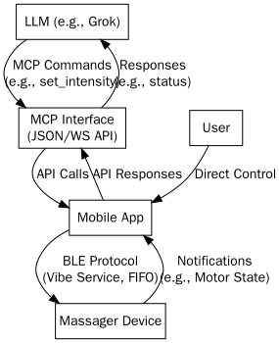
Diagram 1: Setting a Speed (Intensity) on the EMW
This flowchart shows how the app (or LLM via MCP) sets the motor speed/intensity on the EMW using the Vibe Protocol. It involves writing to the FIFO characteristic with a Motor Control Segment (MCS) for intensity, followed by a state notification—useful for dynamic LLM-generated vibrations in the improved EMW.

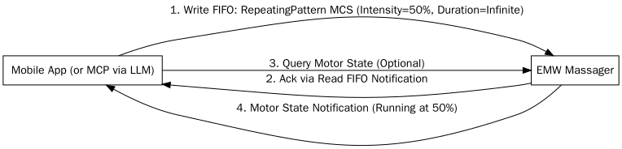
Diagram 2: Using an OPCODE Command (e.g., QUERY_VERSION)
This sequence diagram demonstrates sending an OPCODE-based command (e.g., OPCODE_QUERY_VERSION) from the app to the EMW, with a response via notification. This ensures backward compatibility and is essential for LLM control via MCP to check firmware before advanced features in the improved EMW.

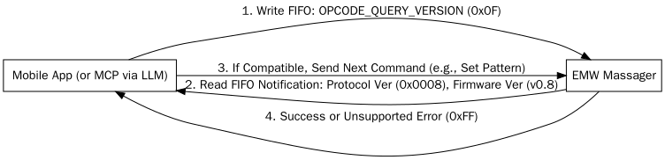
Diagram 3: Connecting EMW (Server) and APP (Client) via Bluetooth
This diagram depicts the EMW as the BLE server advertising its Vibe Service, with the app as the client initiating the connection, discovering services, and optionally authenticating.

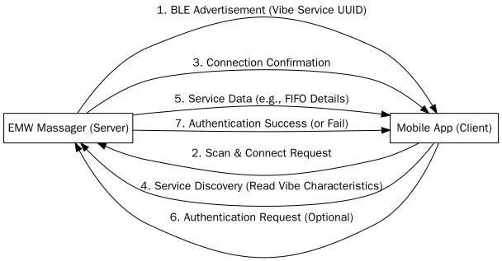

Diagram 4: APP Connecting to Two EMWs (Server) via Bluetooth
This diagram illustrates the flow for the mobile app (acting as the BLE client) to connect to two Europe Magic Wand (EMW) massagers (acting as BLE servers). It shows the app scanning for multiple devices, establishing connections sequentially or simultaneously (depending on BLE hardware limits), discovering their Vibe Services, and optionally authenticating with each. This supports the improved EMW's multi-device control capability, enabling synchronized patterns via the app or MCP interface.

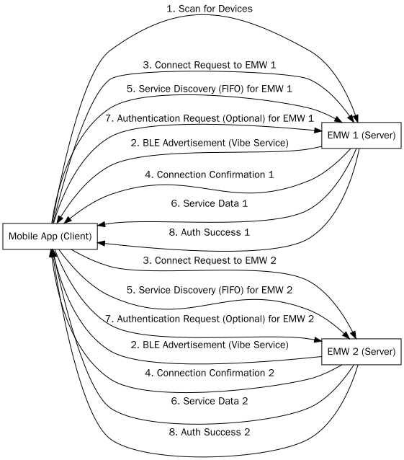

References
- IETF UUID standard RFC 4122,
https://datatracker.ietf.org/doc/rfc4122/?include_text=1

