SRM INSTITUTE OF SCIENCE AND TECHNOLOGY
COLLEGE OF ENGINEERING AND TECHNOLOGY | SCHOOL OF COMPUTING
DEPARTMENT OF DATA SCIENCE AND BUSINESS SYSTEMS
UNIT 2 - TASK 1a: CREDIT RISK SCORECARD MODELING REPORT
Application Scorecard & Expected Loss (PD, LGD, EAD) Quantification
Methodological Reference: Naeem Siddiqi (*Credit Risk Scorecards*, Wiley)
————————————————————————————————————————————————————————————

1. Executive Summary & Regulatory Context
Credit scoring serves as the foundation of retail banking credit underwriting and capital adequacy under Basel III. This project develops and validates an industrial-grade logistic regression credit scorecard using the German Credit Risk dataset, adhering to Naeem Siddiqi's scorecard scaling framework (PDO=20, Target Score=600 at 50:1 odds). In addition to predicting binary default, the project models regulatory risk parameters: Probability of Default (PD), Loss Given Default (LGD), Exposure at Default (EAD), and portfolio Expected Loss (EL = PD * LGD * EAD).

2. Model Discrimination & Validation Metrics
Metric | Train Set (N=750) | Test Set (N=250) | Industry Benchmark
ROC-AUC | 0.8262 | 0.7765 | >= 0.75
Gini Coefficient (2*AUC - 1) | 0.6523 | 0.5529 | >= 0.50
Kolmogorov-Smirnov (KS) | 53.78% | 44.00% | >= 40.0%

3. Performance Diagnostic Visualizations
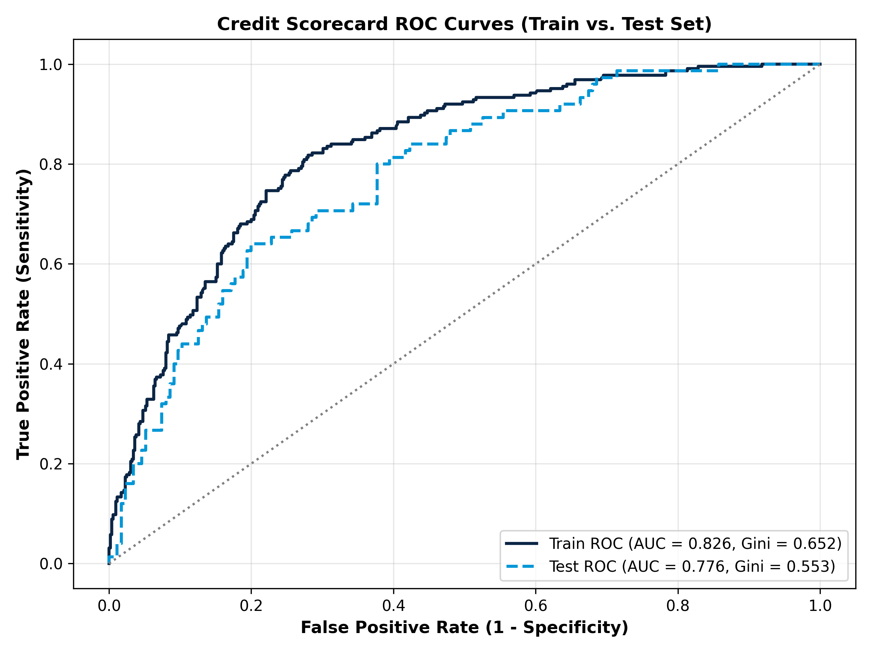
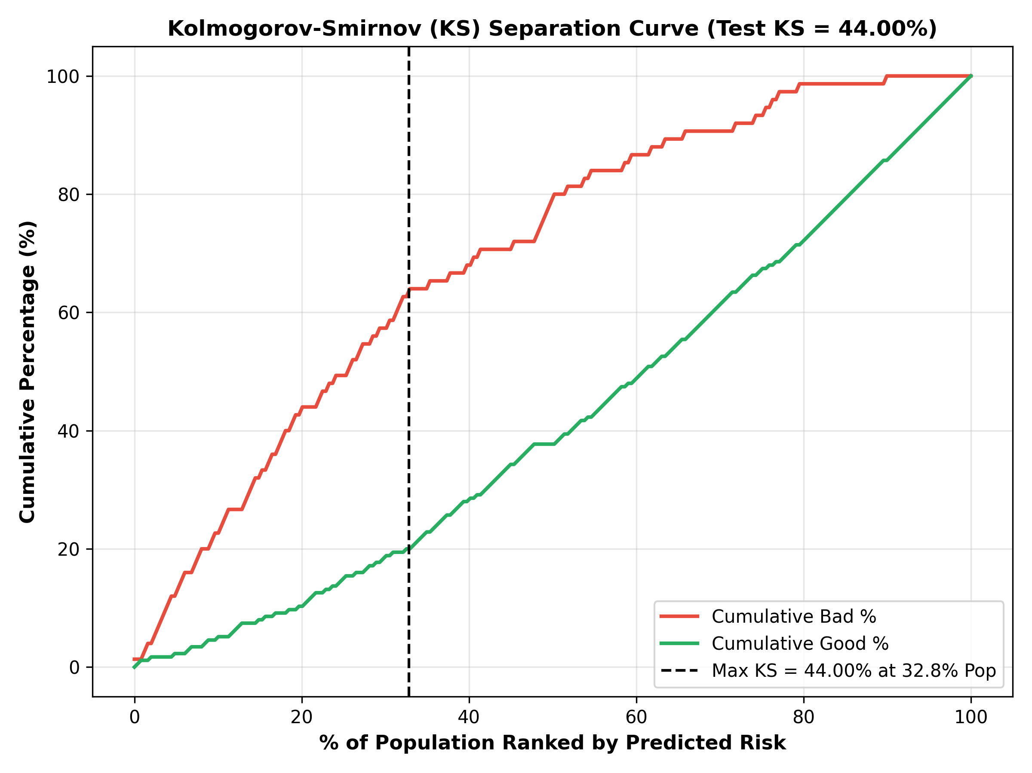
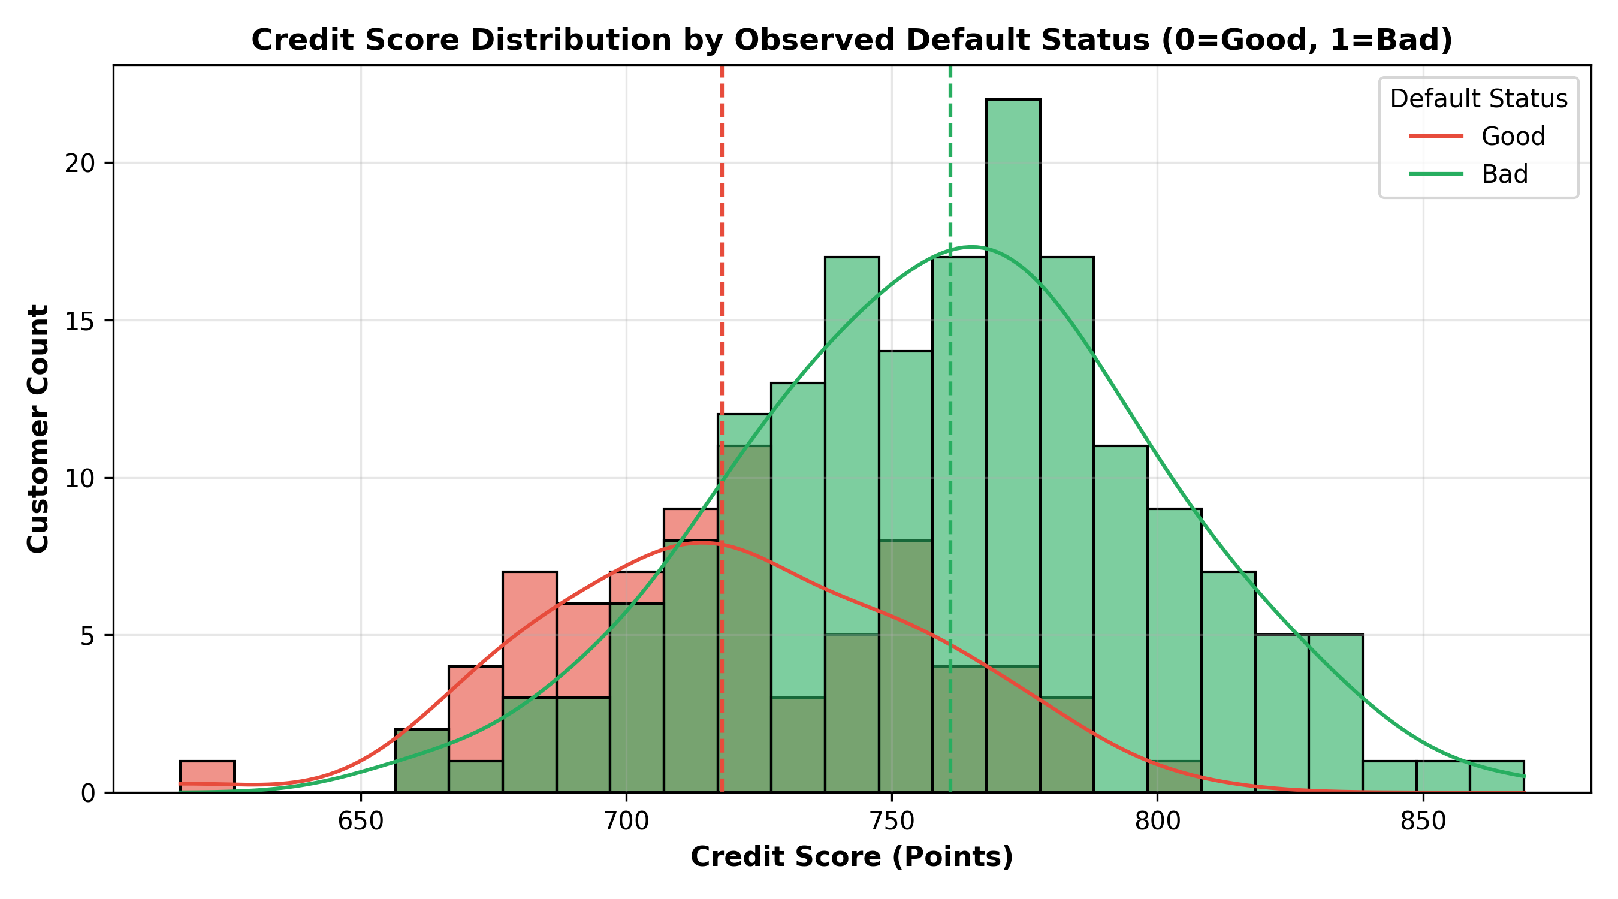

4. Portfolio Expected Loss Summary by Rating Tier
Rating Grade | Count | Observed Default % | Avg Score | Avg PD % | Total EAD (€) | Total Expected Loss (€)
Grade F (High Risk / Subprime) | 147 | 68.03% | 681.8 | 72.43% | €766,077.00 | €233,612.58
Grade D (Vulnerable / Speculative) | 229 | 50.66% | 716.2 | 45.77% | €832,236.00 | €142,185.16
Grade C (Moderate Risk) | 159 | 25.79% | 740.7 | 26.59% | €476,081.00 | €47,822.75
Grade B (Acceptable / Investment Grade) | 166 | 14.46% | 760.7 | 15.41% | €462,474.00 | €25,005.46
Grade A (Prime / Low Risk) | 162 | 9.26% | 782.5 | 7.92% | €404,513.00 | €11,348.49
Grade AAA (Super Prime / Pristine) | 137 | 2.92% | 814.2 | 2.99% | €329,877.00 | €3,072.59

