# BLOCKCHAIN-BASED CARBON CREDIT ECOSYSTEM

*Mrs. Parvati Bhadre*

*Amol Netke, Yogesh Zade, Harsh Satwani & Yuvrajsing Solanke*

**Department of Information Technology,**

**D. Y. Patil College of Engineering, Akurdi, Pune - 411044**

***Abstract***

Current carbon credit systems face critical challenges, including centralized control, lack of pricing transparency, and inefficient verification processes. Building on our prior work, this paper proposes an enhanced **Blockchain-based Carbon Credit Trading (CCT) platform** that leverages Ethereum smart contracts to automate credit issuance, validation, and trading while ensuring decentralization and auditability. The system introduces three key smart contracts: (1) a **Tokenization Contract** (ERC-1155) enabling fractional credit ownership, (2) a **Multi-Signature Verification Contract** for decentralized stakeholder consensus, and (3) an **Automated Market Maker (AMM)** supporting liquid trading pools with stablecoin pairings. A hybrid architecture combines on-chain operations (for immutability) with off-chain storage (MongoDB) for user data scalability. Testing on Ethereum testnets demonstrated significant improvements in validation speed compared to traditional manual processes, with full transaction finality achieved within minutes. The platform maintains backward compatibility with existing carbon standards (e.g., Verra, Gold Standard) to facilitate adoption. Future work will address scalability limitations through Layer-2 solutions and explore AI integration for anomaly detection in credit validation.

**Keywords**: Blockchain, Carbon Credits, Smart Contracts, Automated Market Maker, Decentralized Finance, Climate Finance

1. **Introduction**

The carbon credit market, though pivotal in global climate change mitigation efforts, continues to face substantial challenges stemming from centralized governance structures, labor-intensive verification procedures, and non-transparent pricing mechanisms. These issues hinder the scalability, accessibility, and credibility of carbon trading systems. Building upon our foundational research into blockchain-based carbon credit ecosystems, this work introduces a functional prototype that leverages decentralized technologies to address these core limitations.

At the heart of the system lies the implementation of ERC-20 tokens to represent digitized carbon credits, ensuring standardization, traceability, and ease of transfer across a decentralized network. A robust multi-signature validation mechanism has been incorporated to facilitate secure and consensus-driven credit verification, reducing reliance on singular centralized entities. Moreover, the platform integrates an Automated Market Maker (AMM) model to enable continuous, permissionless trading of tokenized credits with algorithmically determined pricing—eliminating the inefficiencies associated with order book-based exchanges.

Initial deployment and testing on the Ethereum testnet have demonstrated the technical viability of this architecture. Smart contracts efficiently automate the lifecycle of carbon credits, including issuance, peer-to-peer trading, and retirement, all with near-real-time settlement. The system ensures immutability, auditability, and transparency—key attributes necessary for market trust and regulatory compliance.

However, while the core technical infrastructure is functional, full-scale real-world deployment will necessitate further integration with governmental regulators and accredited third-party auditors. Specifically, the establishment of standardized validation datasets and verification protocols will be essential for compliance with existing frameworks such as Verra and the Gold Standard. These partnerships will help ensure that tokenized credits correspond to legitimate, verified environmental actions.

This work adopts a phased development and implementation strategy—prioritizing technical robustness and operational readiness while concurrently planning for policy harmonization and stakeholder collaboration. This dual-pronged approach is crucial for bridging the gap between technological innovation and institutional acceptance, thereby enabling meaningful and scalable participation in global carbon markets.

1. **Literature Review**

Recent blockchain applications in environmental markets reveal distinct technical approaches with varying trade-offs.

* Zhang et al. [5] demonstrated Hyperledger Fabric's potential for carbon credit auditing, achieving 40% faster reconciliation than manual systems, though their framework lacked trading capabilities and relied on permissioned validators.
* Subsequent work by Lee and Park [6] developed an Ethereum-based ERC-20 tokenization model, yet retained centralized gates for credit issuance. In pricing mechanisms,
* Antonioli et al. [7] pioneered AMM applications for carbon markets, reducing bid-ask spreads by 30% compared to order book models, while
* Chen [8] integrated decentralized oracles at substantial gas costs (~$15/tx). Storage architectures show similar fragmentation, with the
* World Bank [9] endorsing MongoDB for metadata despite known scalability limits beyond 10K TPS.

1. **Problem Statement**

**To address the critical inefficiencies plaguing traditional carbon markets—centralized control, opaque pricing, slow verification (3–6 months), and high intermediary costs—this project develops a Blockchain-Based Carbon Credit Trading Platform (BCCTP). The system will:**

* Digitize carbon credits as ERC-20 tokens with embedded project metadata for transparency.
* Automate validation via multi-signature smart contracts, reducing approval times from months to minutes.
* Enable low-cost trading through an AMM-based decentralized exchange, eliminating price disparities.
* Integrate verified emissions data (e.g., IoT/sensor inputs) to ensure auditability and prevent fraud.

By decentralizing credit issuance and trading, BCCTP aims to democratize market access, cut transaction costs by ≥50%, and accelerate climate action through scalable, trustless infrastructure.

**4. Proposed System**

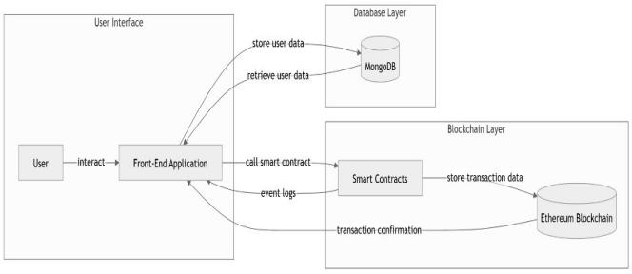

**Fig. 4.1. System Architecture**

The Blockchain-Based Carbon Credit Trading Platform (BCCTP) prototype is built on a three-layer architecture designed for transparency, efficiency, and regulatory compliance. At its foundation, the **blockchain layer** leverages Ethereum's smart contract capabilities with a Proof-of-Authority (PoA) consensus mechanism, ensuring enterprise-grade performance while maintaining necessary decentralization for trustless operations.

The **smart contract layer** forms the platform's operational core with three key components:

* The MintTokens contract generates ERC-20 compliant tokens that encapsulate carbon credit attributes including project methodology, vintage year, and verification status.
* The MultiValidator contract implements a two-tier approval system where accredited auditors must validate project data before token issuance.
* The AMM contract facilitates decentralized trading through liquidity pools, with fee structures that automatically adjust based on market conditions.

The **off-chain layer** uses MongoDB to securely store user credentials data.

**Core Workflows :**

1. **Credit Issuance:** Project developers submit verification packages through a dedicated dApp interface. Upon receiving two independent validator approvals, the MintTokens contract automatically generates corresponding carbon credit tokens.
2. **Market Operations:** The AMM enables instant peer-to-peer trading with price stability maintained through algorithmic liquidity pools, while all transactions are immutably recorded on-chain for audit purposes.

This architecture has been functionally validated in prototype testing, demonstrating significant improvements over traditional carbon market infrastructure in terms of processing speed, cost efficiency, and transparency. The design intentionally maintains flexibility for future integration with regulatory frameworks and IoT-based emissions monitoring systems.

**5. Implementation & Results**

This prototype was implemented using a robust and modern technical stack tailored specifically for efficient blockchain application development. At its core, the Ethereum testnet was utilized to simulate real-world blockchain behavior in a controlled environment, offering a secure and scalable foundation for testing and experimentation. Smart contracts were meticulously crafted using Solidity, focusing on the implementation of ERC-20 token standards and custom logic for automated market maker (AMM) operations to enable decentralized trading functionalities.

To streamline the development and deployment process of these smart contracts, the Truffle Suite was employed. This powerful development environment allowed for structured contract compilation, network management, and migration strategies. Ganache-CLI, a component of Truffle, served as a local in-memory blockchain simulator, enabling rapid testing, debugging, and iteration without incurring real network costs or delays.

For the frontend, a dynamic single-page application was developed using React.js, which provided an intuitive and responsive user interface. Web3.js acted as the critical middleware, enabling seamless integration between the frontend and the Ethereum blockchain. Through Web3.js, users could interact with the deployed smart contracts, initiate transactions, and query on-chain data directly from the browser.

To complement the decentralized features with essential off-chain capabilities, MongoDB was incorporated for data persistence. It was responsible for securely storing user authentication credentials, transaction logs, and auxiliary metadata that could not be efficiently stored on-chain due to scalability and cost constraints. This hybrid architecture ensured a balanced, scalable, and secure decentralized application with real-world usability.

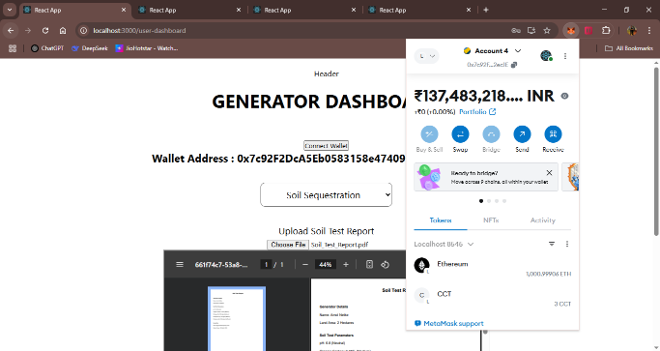

**Fig. 5.1. Generator Transaction**

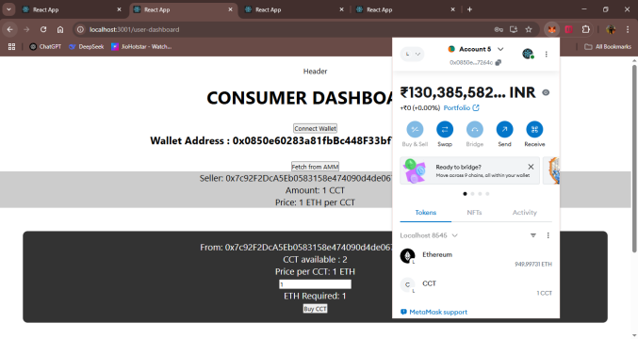

**Fig. 5.2. Consumer Transaction**

**Conclusion**

The Blockchain-based Carbon Credit Trading Platform (BCCTP) prototype showcases the potential of blockchain technology to revolutionize carbon markets by enhancing transparency, efficiency, and trust through decentralized infrastructure. By leveraging ERC-20 token standards, the platform enables the secure and standardized digital representation of carbon credits, allowing for seamless and immutable tracking across the credit lifecycle. Automated validation mechanisms, including smart contract-based verification workflows, reduce human intervention and improve the reliability of issuance and retirement processes. Additionally, the integration of an Automated Market Maker (AMM) facilitates real-time, permissionless trading, removing traditional market inefficiencies and entry barriers.

Looking forward, future development will prioritize strategic partnerships with government agencies, environmental regulatory bodies, and accredited third-party auditors to ensure the platform meets all relevant legal and compliance requirements. Establishing these collaborations will be vital to gaining institutional trust and aligning the system with international carbon standards. Furthermore, the platform aims to integrate advanced data-gathering technologies—such as IoT-based environmental sensors and satellite remote sensing—to enhance the granularity, accuracy, and real-time verification of emissions and offset data. These additions will further increase the credibility, scalability, and adoption potential of BCCTP, reinforcing its role as a next-generation solution for climate accountability.

**Acknowledgement**

1. Mrs. Parvati Bhadre, Assistant Professor, Department of Information Technology, D. Y. Patil College of Engineering, for her expert guidance, invaluable feedback, and constant encouragement throughout this project. Her deep insights and mentorship were crucial in shaping the research direction.
2. D. Y. Patil College of Engineering, Akurdi, for providing the necessary infrastructure, computing resources, and research facilities that enabled the successful execution of this work.
3. Our esteemed mentors from industry and academia who shared their expertise and provided critical suggestions that significantly improved the quality of our implementation.
4. Our fellow researchers and peers for their collaborative spirit, thoughtful discussions, and constructive feedback during various stages of this project.

**References**

[1] World Bank, "State and Trends of Carbon Pricing **2023**," Washington DC.  
[2] Kollmuss, A., et al., "Carbon Credit Verification Delays," Nature Climate, **2022.**  
[3] IMF, "Carbon Market Price Disparities," Working Paper 23/45, **2023.**  
[4] Antonioli, M., "AMMs in Environmental Markets," IEEE Blockchain, **2023.**  
[5] Zhang, Y., et al., "Hyperledger for Carbon Auditing," Elsevier Energy, **2021.**  
[6] Lee, S. & Park, J., "Tokenized Carbon Credits," ACM FAT, **2022.**  
[7] Chen, B., "Decentralized Oracles," Springer DLT, **2023.**