Contents

SIH26170 · ISRO / Department of Space · Theme: Smart Automation
AETHER
Adaptive ESS Thermal Health and Early Reject
AI-Driven Anomaly Detection in Component Burn-In and Screening
Briefing pack for the idea presentation (PPT). Copy these facts onto slides. Do not invent extra numbers.
Use this file as the single source of truth while you build the deck. Each section maps to a slide. Speaker notes sit under the facts.

1. How to use this document
- Build 8 to 10 slides. SIH idea decks that try to dump the whole report lose the jury.
- Every number in this file is from the held-out test lots in models/metrics.json and the README. Do not round them into something prettier.
- The live demo is a CSV score on Screen my data. It is not a chamber plugged into the laptop. Do not say that it is.
- Figures live in docs/figures/. Drop them onto the matching slides.
- GitHub: https://github.com/amol16112005/AETHER-SIH26170

2. Suggested slide map
Slide | Title | What belongs on it | Time
1 | Title | AETHER, SIH26170, ISRO / DoS, Smart Automation, one-line claim | 15 s
2 | The gap | Static datasheet vs lot-relative maverick. 45 µA vs 10 µA vs 50 µA | 45 s
3 | What AETHER does | Module A + Module B → PASS / HOLD / REJECT at 24 h | 45 s
4 | Pipeline | 0 h + 24 h in. 168 h never an input. Figure: pipeline.png | 40 s
5 | Module A — PAT | Median + 6×1.4826×MAD. Isolation Forest + Mahalanobis on lot z-scores | 40 s
6 | Module B — drift | Ridge + HGB forecast of 168 h. Safety slope. MAE vs linear baseline | 40 s
7 | Decision policy | PASS finish 168 h. HOLD extra 96 h. REJECT pull now. Hours only from REJECT | 30 s
8 | Held-out results | 0 escapes. 75 REJECT / 27 HOLD. 12.7% healthy HOLD. 10,944 h saved | 50 s
9 | Live demo | Screen my data. Upload LOTSIH 24 h CSV. LOTSIH-0045 REJECT | 60–90 s
10 | Close | Same pipeline on a new lot. Retrain only on a new historical corpus | 20 s

3. Slide 1 — Title

On-slide text
- AETHER — Adaptive ESS Thermal Health and Early Reject
- Problem: SIH26170 — AI-Driven Anomaly Detection in Component Burn-In and Screening
- Organization: ISRO / Department of Space
- Theme: Smart Automation
- One-line claim: Models train offline on historical lots. At the 24 h gate a new lot CSV is scored with the frozen bundle: lot-relative PAT plus a 168 h drift forecast. No 168 h reading is used at inference.

Speaker note
Open with the claim, not the stack. The jury already knows burn-in exists. They need to hear that you score at 24 hours without waiting for 168 hours.

4. Slide 2 — The gap static limits cannot close

Problem in one paragraph
Traditional burn-in at 125 °C uses static datasheet limits. That misses latent defects: parts that stay inside the data-book box but sit far from their lot, or that drift on a slope no healthy part in the lot would take. Those parts escape into payloads.

Pinned SIH example — put this on the slide as three numbers
Quantity | Value | What a static screen does
Lot leakage (median) | ~10 µA | Looks healthy
Part LOTSIH-0045 leakage | 45.3 µA at 24 h | Still under the cap
Datasheet max | 50 µA | Static PASS
Lot-relative PAT | z ≈ 35 vs the lot | Dynamic REJECT

Three defect modes the generator injects
Mode | What it looks like at 24 h | Why static limits fail
Maverick | In-spec, far from lot median | The part is still under the datasheet cap
Latent drift | Normal 0 h, bad slope 0→24 h | 168 h failure is still in the future
Runaway | Quadratic aging | Static limits catch it only late
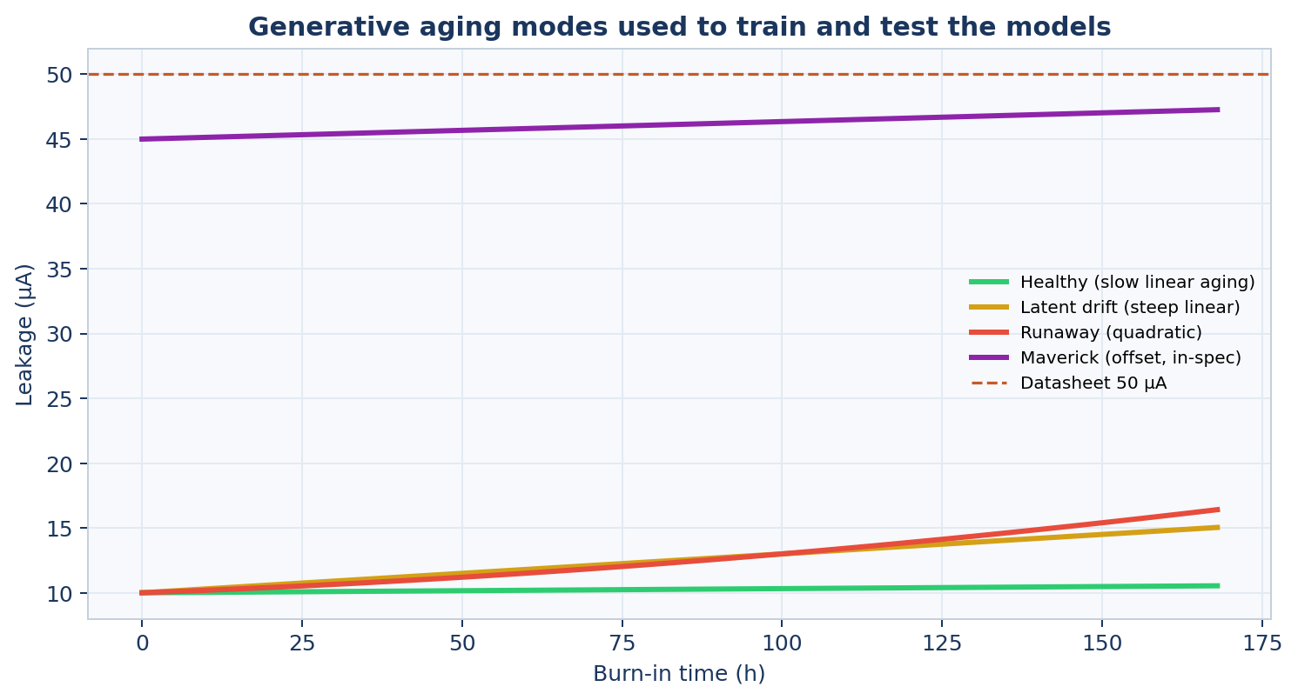
Figure: three aging modes the synthetic lots inject.

Speaker note
Say the 45 versus 10 versus 50 example out loud. It is the problem statement’s own example. Then say: that is why PAT is lot-relative, and why one row by itself cannot show a maverick.

5. Slide 3 — What AETHER does

On-slide text
- Module A: dynamic outlier detection (PAT / DPAT) — robust median and MAD, Isolation Forest, robust Mahalanobis, all lot-normalized.
- Module B: 24 h → 168 h drift forecast for IDDQ, leakage, and propagation delay. 168 h is the target during training and is never an input at inference.
- Fused QA decision a human can read: PASS, HOLD, or REJECT, plus an inspector brief in engineering English.

Parameters
Parameter | Unit | Datasheet max
Standby current (IDDQ) — required | µA | 50
Leakage current — required | µA | 50
Propagation delay (tpd) — required | ns | 10
VTH — optional extra | V | 0.90 (min 0.28)
IDSAT — optional extra | mA | 25 (min 4)
Reverse leakage — optional extra | µA | 12

Readout times
Burn-in hours in the dataset: 0, 24, 96, 168. The 24 h gate uses only 0 h and 24 h. 96 h and 168 h can be empty on a live file. If they are present they can be plotted against the forecast. They do not change PASS / HOLD / REJECT.

6. Slide 4 — Pipeline
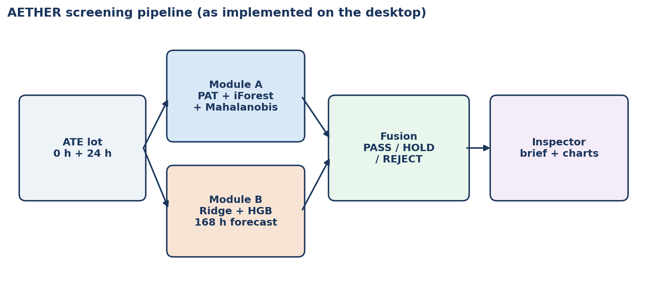
Figure: AETHER screening pipeline. Drop this on slide 4.

Flow to draw if you redraw it
- Input: a whole lot, part_id, lot_id, IDDQ / leakage / tpd at 0 h and 24 h.
- Module A: lot median and MAD → robust z. Isolation Forest and Mahalanobis on those lot-relative features.
- Module B: predict 168 h from 0 h + 24 h (value, slope, relative change, log, linear extrapolation).
- Fuse: cost-sensitive thresholds. FN cost 1000, FP cost 12.
- Output: PASS / HOLD / REJECT + inspector brief. Chamber hours claimed only from 24 h REJECT (144 h per pulled part).

Judge line (use this wording)
Models are trained offline on historical lots. At the 24 h gate a new lot CSV is scored with the frozen bundle: lot-relative PAT + 168 h drift forecast. No 168 h reading is used at inference.

7. Slide 5 — Module A (dynamic outliers)

PAT formula
AEC-Q001 style robust PAT: median ± 6 × 1.4826 × MAD. Isolation Forest contamination 0.06. Features are lot-normalized so a fast process corner does not scrap the whole lot.
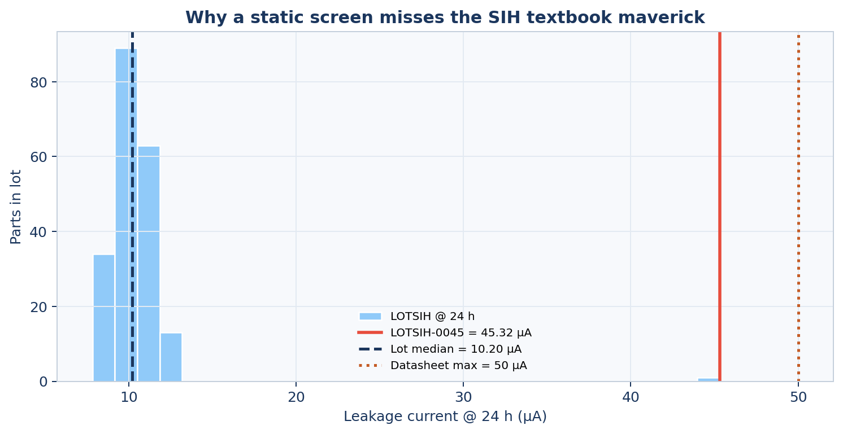
Figure: lot-relative PAT histogram.

Speaker note
PAT is computed inside the uploaded lot. Upload tens to hundreds of parts. A single part is its own median, so z ≈ 0 and Module A cannot see a maverick. One-part mode in Screen my data compares against a canned reference lot — that is a demo trick, not PAT on a new process corner.

8. Slide 6 — Module B (drift forecast)

On-slide text
- Inputs: value at 0 h, value at 24 h, 24 h slope, relative change, log, linear extrapolation to 168 h.
- Target at training time: hidden 168 h IDDQ, leakage, tpd, and optional VTH / IDSAT / reverse leakage.
- Models: Ridge (explainable) blended with Histogram Gradient Boosting. Blend weight 0.7 on the booster.
- Unsafe if predicted slope exceeds the healthy 95th-percentile safety slope, or the forecast crosses 90% of the datasheet cap.

Held-out MAE versus linear extrapolation
Parameter | AETHER MAE | Linear-extrap MAE
IDDQ 168 h | 0.51 µA | 1.26 µA
Leakage 168 h | 0.30 µA | 0.72 µA
tpd 168 h | 0.07 ns | 0.19 ns
VTH 168 h | 0.007 V | 0.019 V
IDSAT 168 h | 0.20 mA | 0.46 mA
Reverse leakage 168 h | 0.10 µA | 0.29 µA

Speaker note
If they ask why Ridge is still there: the inspector waterfall shows which feature pushed the 168 h forecast. The booster improves MAE. Ridge stays for the explanation.

9. Slide 7 — Three decisions, not two
Decision | Meaning | Chamber
PASS | Lot-relative and predicted drift inside the envelope | Finish remaining 168 h burn-in
HOLD | Not a clean pass, do not scrap yet | Extra readout at 96 h
REJECT | Maverick and/or unsafe predicted drift | Pull at 24 h; 144 h recovered
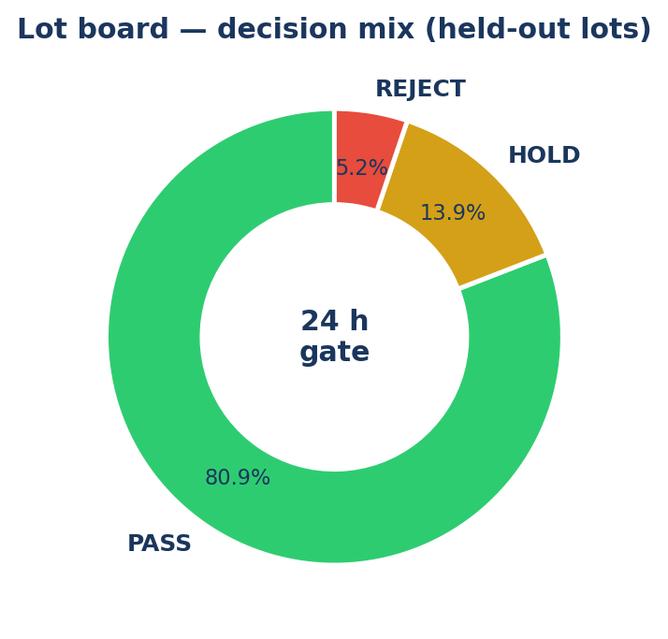
Figure: decision mix. Use only if it matches the test-lot counts below.
Flight parts that look healthy still complete burn-in. Hours claimed back are only slots freed by early REJECT. HOLD exists because space-grade silicon is expensive. A two-class scrap/release policy is the wrong shape.

Cost weights used to set thresholds
Event | Relative cost
False negative (missed defective) | 1000
False positive (healthy REJECT) | 12
HOLD on a defective | 40
HOLD on a healthy part | 2

10. Slide 8 — Held-out results (the rubric)
25 lots, 5,145 parts. Train / val / test are split by lot, not by part. Every defective in the test lots still passes the datasheet at 24 h — a static screen would miss all of them.

Test lots (never seen in training)
Metric | Value
Parts | 1,449
Defectives / latent escapes | 102 / 102
Detection recall (FN is the ISRO penalty) | 100% (0 miss / 102)
Latent-escape catch rate | 100%
24 h REJECT precision | 98.7%
Catch rate (HOLD or REJECT) | 100% — 0 escapes
REJECT-only recall | 73.5% (75 / 102)
Healthy HOLD rate | 12.7% (171 / 1,347)
By defect type REJECT / HOLD / PASS | Maverick 42/0/0 · Latent 18/15/0 · Runaway 15/12/0
Decisions | 1,175 PASS · 198 HOLD · 76 REJECT
Chamber hours recovered (REJECT × 144 h) | 10,944 h
LOTSIH-0045 | Static PASS (45.3 < 50) · Dynamic REJECT (z ≈ 35 vs lot 10.1 µA)

Speaker note
Lead with recall and the zero false negatives, then REJECT precision, then hours. Precision of the fused score itself is lower because HOLD is not a reject — do not quote the 0.37 fused precision as if it were REJECT precision. The rubric number is 98.7% REJECT precision.

11. Slide 9 — Live demo script

What the jury should see
- Open the Streamlit app. First tab is the canned lot board.
- Go to Screen my data.
- Caption on the tab: Inference only. 168 h is never an input.
- Upload a lot CSV, or Load example lot (25 parts, one maverick). Backup file: data/demo_lotsih_24h.csv (200 parts, includes LOTSIH-0045).
- Show decision counts PASS / HOLD / REJECT, then the 0 h vs 24 h scatter, then pick LOTSIH-0045 or LIVE-0010 in the part picker.
- Open Inspect this part: static PASS, dynamic REJECT, inspector brief.

Expected backup run (demo_lotsih_24h.csv)
200 parts. 174 PASS, 25 HOLD, 1 REJECT. The reject is LOTSIH-0045.

What they upload (minimum columns)
Column | Meaning
part_id | Part name
lot_id | Lot that part belongs to
iddq_0h, iddq_24h | Quiescent current, µA
ileak_0h, ileak_24h | Leakage current, µA
tpd_0h, tpd_24h | Propagation delay, ns
A lot file, not a single part. 96 h and 168 h can be empty. Labels (is_defective, defect_type) are not required to decide. Datasheet caps default to 50 / 50 / 10 if omitted.

Same pipeline, other door
POST /screen-lot (python -m uvicorn src.api:app --port 8000) calls the same enrich then apply_models path. Do not demo the API unless they ask. The CSV tab is the live story.

Do not say
- That a burn-in chamber is plugged into the laptop.
- That the model retrains on the upload. It does not. screening_bundle.joblib stays frozen. Retrain only with python scripts/train.py on a new historical corpus.
- That 168 h is used at inference. It is not.

12. Slide 10 — Close and Q&A bank

Close line
A new lot at the 24 h gate is scored with the saved model. PAT is that lot’s median and MAD. Drift is a 168 h forecast from 0 h and 24 h. The inspector gets PASS, HOLD, or REJECT in English.

If they ask: is the data real ISRO flight data?
No. ISRO flight data is not public. The generator builds lot-structured burn-in with the three defect modes above. Replace data/burnin_parts.csv with a real ATE export of the same columns and re-run scripts/train.py. No other code changes.

If they ask: why not binary classification?
Space-grade parts are expensive. HOLD keeps a borderline part in the chamber to 96 h instead of killing it or releasing it.

If they ask: why Isolation Forest range is frozen for one part?
A one-part query would otherwise renormalize the IF score to itself. Live one-part mode uses the training-lot min/max so the calibrated HOLD/REJECT thresholds still mean the same thing.

If they ask: software stack
Layer | What we use
Language | Python 3.12
Models | scikit-learn 1.8 (Ridge, HGB, Isolation Forest, MinCovDet)
QA UI | Streamlit + Plotly
Optional API | FastAPI POST /screen-lot
Repo | github.com/amol16112005/AETHER-SIH26170

13. Copy-paste speaker script (about 5 minutes)
Burn-in today still uses a datasheet box. A part at 45 microamps in a 10 microamp lot still passes a 50 microamp cap. That is the maverick the problem statement names. AETHER scores the lot at 24 hours. Module A is lot-relative PAT. Module B forecasts 168 hour drift from 0 and 24 hour readings only. The inspector gets PASS, HOLD, or REJECT. On lots the model never trained on we catch all 102 latent defectives with zero PASS escapes: 75 rejected at 24 h, 27 sent to 96 h, 12.7 percent of healthy parts held. REJECT precision is 98.7 percent. 76 early rejects free 10,944 chamber hours. I will score the LOTSIH demo file. LOTSIH-0045 is the only reject. That is a CSV score with a frozen model. It is not a chamber on this laptop.

14. File checklist before the pitch
Item | Path
This briefing | docs/AETHER_SIH26170_PPT_Briefing.docx
Existing idea PPT | docs/SIH2026_AETHER_Idea_Presentation.pptx
Figures | docs/figures/
Example lot (25 rows) | data/live_lot_template.csv
LOTSIH 24 h demo (200 parts) | data/demo_lotsih_24h.csv
Frozen bundle | models/screening_bundle.joblib
Held-out metrics | models/metrics.json
Technical report | docs/AETHER_SIH26170_Technical_Report.docx
Local app | python -m streamlit run app.py

