Week – 5

Introduction to JavaScript

***Aim –***

To understand the basics of Java Script and learn how to navigate to a particular element using DOM and modify it.

***Case Study 1:* Updating a Product Price on an E-Commerce Website**

You are developing an e-commerce website where product details are displayed dynamically. One of the products listed has a price that needs to be updated due to a discount. Your task is to navigate to the price element using the DOM and modify its value when the "Apply Discount" button is clicked.

**Code –**

<!DOCTYPE html>

<html lang="en">

  <head>

    <meta charset="UTF-8">

    <meta name="viewport" content="width=device-width, initial-scale=1.0">

    <title>DOM Navigation - Modify Element</title>

    <style>

      .product {

        border: 2px solid black;

        padding: 20px;

        width: 300px;

        text-align: center;

        margin: 20px auto;

      }

      #price {

        font-size: 20px;

        font-weight: bold;

        color: red;

      }

    </style>

  </head>

  <body>

    <div class="product">

      <h2>Wireless Headphones</h2>

      <p id="price">$100</p>

      <button onclick="applyDiscount()">Apply Discount</button>

    </div>

    <script>

      function applyDiscount() {

        // Navigate to the price element

        let priceElement = document.getElementById("price");

        // Modify the price content

        priceElement.innerHTML = "$80"; // New discounted price

        // Change style to indicate discount applied

        priceElement.style.color = "green";

        priceElement.style.fontSize = "24px";

      }

    </script>

  </body>

</html>

**Output -**

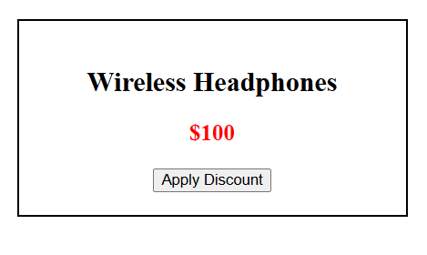 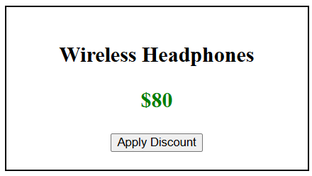

***Case Study 2 :* Real-Time Stock Price Update in a Finance Website**

You are developing a finance website that displays real-time stock prices for multiple companies. The stock prices change dynamically, and when the "Update Prices" button is clicked, the values for all stocks are updated using document.getElementsByClassName().

**Challenge 1:** Auto-Update Prices Every 5 Seconds

**Challenge 2:** Add a "Stop Auto-Update" Button

**Code –**

<!DOCTYPE html>

<html lang="en">

  <head>

    <meta charset="UTF-8">

    <meta name="viewport" content="width=device-width, initial-scale=1.0">

    <title>Live Stock Price Update</title>

    <style>

      body {

        text-align: center;

        font-family: Arial, sans-serif;

      }

      .stock-container {

        width: 60%;

        margin: 20px auto;

        padding: 20px;

        border: 2px solid black;

        background-color: *#f4f4f4*;

      }

      .stock {

        font-size: 24px;

        margin: 10px 0;

      }

      .price {

        color: red;

        font-weight: bold;

      }

      button {

        margin-top: 20px;

        padding: 10px 20px;

        font-size: 18px;

        cursor: pointer;

      }

    </style>

  </head>

  <body>

    <h1>Live Stock Price Update</h1>

    <div class="stock-container">

      <p class="stock">Apple (AAPL): <span class="price">$150</span></p>

      <p class="stock">Google (GOOGL): <span class="price">$2800</span></p>

      <p class="stock">Amazon (AMZN): <span class="price">$3300</span></p>

      <p class="stock">Tesla (TSLA): <span class="price">$900</span></p>

    </div>

    <button onclick="updatePrices()">Update Prices</button>

    <button onclick="stopAutoUpdate()">Stop Auto Update</button>

    <script>

      let autoUpdateInterval;

      function updatePrices() {

        let priceElements = document.getElementsByClassName("price");

        for (let i = 0; i < priceElements.length; i++) {

          let randomPrice = (Math.random() * (5000 - 500) + 500).toFixed(2);

          priceElements[i].innerHTML = "$" + randomPrice;

          priceElements[i].style.color = "green";

          setTimeout(() => {

            priceElements[i].style.color = "red";

          }, 1000);

        }

      }

      function autoUpdate(){

        autoUpdateInterval = setInterval(updatePrices, 5000);

      } function stopAutoUpdate() {

        clearInterval(autoUpdateInterval);

      }

      autoUpdate();

    </script>

  </body>

</html>

**Output -**

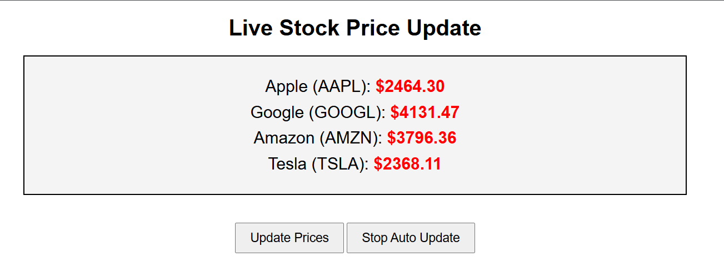

***Case Study 3 :* Live Score Update in a Sports Website**

You are developing a sports website that displays the live score of a football match. Every time a team scores a goal, the score updates dynamically using the DOM.

**Challenge 1:** Add a Reset Button

**Challenge 2:** Add a Match Timer

**Challenge 3**: Add a Foul Counter

**Code –**

<!DOCTYPE html>

<html lang="en">

  <head>

    <meta charset="UTF-8">

    <meta name="viewport" content="width=device-width, initial-scale=1.0">

    <title>Live Football Score</title>

    <style>

      body {

        font-family: Arial, sans-serif;

        text-align: center;

      }

      .scoreboard {

        width: 50%;

        margin: auto;

        padding: 20px;

        border: 2px solid black;

        background-color: *#f4f4f4*;

      }

      .team {

        font-size: 24px;

        font-weight: bold;

        margin: 10px;

      }

      .score {

        font-size: 40px;

        color: blue;

      }

      .highlight {

        color: red;

        font-weight: bold;

      }

      button {

        margin: 10px;

        padding: 10px 20px;

        font-size: 18px;

        cursor: pointer;

      }

    </style>

  </head>

  <body>

    <h1>Live Football Score</h1>

    <div class="scoreboard">

      <p class="team">Team A: <span id="scoreA" class="score">0</span></p>

      <p class="team">Team B: <span id="scoreB" class="score">0</span></p>

    </div>

    <button onclick="goalScored('A')">Goal Scored by Team A</button>

    <button onclick="goalScored('B')">Goal Scored by Team B</button>

    <button onclick="reset()">Reset Score</button>

    <div class="timeContainer">Match Time: <span class="timer" id="matchTimer">0:00</span></div>

    <button onclick="startTimer()">Start Match</button>

    <p class="foul">Fouls Committed by Team A: <span id="foulA" class="foul">0</span></p>

    <p class="foul">Fouls Committed by Team B: <span id="foulB" class="foul">0</span></p>

    <button onclick="foulCommited('A')">Foul by Team A</button>

    <button onclick="foulCommited('B')">Foul by Team B</button>

    <script>

      let matchTime = 0;

      function goalScored(team) {

        let scoreElement = document.querySelector("#score" + team);

        let allScores = document.querySelectorAll(".score");

        let currentScore = parseInt(scoreElement.innerHTML);

        scoreElement.innerHTML = currentScore + 1;

        allScores.forEach(score => score.classList.remove("highlight"));

        scoreElement.classList.add("highlight");

        setTimeout(() => {

          scoreElement.classList.remove("highlight");

        }, 1000);

      }

      function reset(){

        let scores = document.querySelectorAll(".score");

        scores.forEach(score => {score.innerHTML=0;});

      }

      function startTimer() {

        timerInterval = setInterval(function() {

          matchTime++;

          let minutes = Math.floor(matchTime / 60);

          let seconds = matchTime % 60;

          document.getElementById('matchTimer').innerHTML = `${minutes}:${seconds < 10 ? '0' : ''}${seconds}`;

        }, 1000);

      }

      function foulCommited(team) {

        // Select the correct score element

        let foul = document.querySelector("#foul" + team);

        let allFouls = document.querySelectorAll(".foul");

        // Increase the score by 1

        let foulCount = parseInt(foul.innerHTML);

        foul.innerHTML = foulCount + 1;

      }

    </script>

  </body>

</html>

**Output -**

