**ES5/ES6 Features**

***Aim -***

To understand various ES5/ES6 features and use them to design basic application like a dynamic table, calculator, validating IPv4 address etc.

***Problem 1 - Multiplication Table***

Display multiplication table for the given number.

**Code –**

<!DOCTYPE html>

<html lang="en">

<head>

    <meta charset="UTF-8">

    <meta name="viewport" content="width=device-width, initial-scale=1.0">

    <title>Tables</title>

</head>

<body>

    <form>

        <label for="num">Enter Number: </label>

        <input type="number" id="num" name="num" required>

        <button type="submit" onclick="getTable()">Get Table</button>

    </form>

    <p id = "demo"></p>

    <script>

        function getTable(){

            event.preventDefault();

            var ans="";

            var n=document.getElementById("num").value;

            if (n===""){

                ans="Enter a number";

            } else{

                for (let i=1; i<=10; i++){

                    ans = ans + n + " * " + i + " = " + (n*i) + "<br>";

                    console.log(ans);

                }

            }

            document.getElementById("demo").innerHTML = ans;

        }

    </script>

</body>

</html>

**Output –**

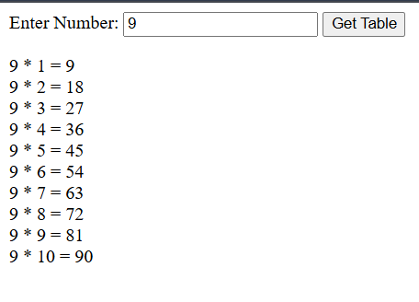

***Problem 2 – Table of Tables***

Create a Java script code to generate a multiplication table asking the

user to enter number of rows and columns. If user enters nothing or 0 then

display multiplication table with 10 rows and 10 columns.

**Code –**

<!DOCTYPE html>

<html lang="en">

<head>

    <meta charset="UTF-8">

    <meta name="viewport" content="width=device-width, initial-scale=1.0">

    <title>Table of tables</title>

</head>

<body>

    <form>

        <label for="rows">Enter Rows: </label>

        <input type="number" id="rows" name="rows" required>

        <label for="cols">Enter Columns: </label>

        <input type="number" id="cols" name="cols" required>

        <button type="submit" onclick="getTable()">Get Table</button>

    </form>

    <table id="multiplication-table" border="1"></table>

    <script>

        function getTable() {

            event.preventDefault();

            let rows = document.getElementById('rows').value;

            let col = document.getElementById('cols').value;

            rows = (rows && rows > 0) ? parseInt(rows) : 10;

            col = (col && col > 0) ? parseInt(col) : 10;

            let table = document.getElementById('multiplication-table');

            table.innerHTML = '';

            for (let i = 1; i <= rows; i++) {

                let row = table.insertRow();

                for (let j = 1; j <= col; j++) {

                    let cell = row.insertCell();

                    cell.textContent = i * j;

                }

            }

        }

    </script>

</body>

</html>

**Output –**

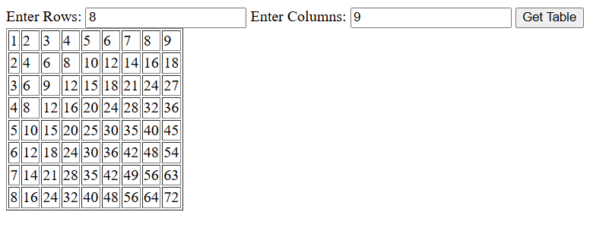

***Problem 3 – Temperature Conversion***

Write a java script function which converts Fahrenheit to Celsius.

**Code –**

<!DOCTYPE html>

<html lang="en">

<head>

    <meta charset="UTF-8">

    <meta name="viewport" content="width=device-width, initial-scale=1.0">

    <title>Temperature Conversion</title>

</head>

<body>

    <form>

        <label for="fah">Enter temperature in Fahrenheit: </label>

        <input type="number" id="fah" name="fah" required>

        <button type="submit" onclick="toCelsius()">Convert to Celsius</button>

    </form>

    <p id="ans"></p>

    <script>

        function toCelsius(){

            event.preventDefault();

            let f = document.getElementById("fah").value;

            document.getElementById("ans").innerHTML = "Equivalent temperature in degree Celsius is: "+ ((f-32)*(5/9));

        }

    </script>

</body>

</html>

**Output –**

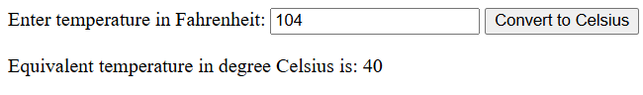

***Problem 4 – Add Hyphens***

Write a JavaScript program which accept a number as input and insert

dashes (-) between each two even numbers. For example if you accept

025468 the output should be 0-254-6-8.

**Code –**

<!DOCTYPE html>

<html lang="en">

<head>

    <meta charset="UTF-8">

    <meta name="viewport" content="width=device-width, initial-scale=1.0">

    <title>Format even</title>

</head>

<body>

    <form>

        <label for="string">Enter string: </label>

        <input type="number" id="string" name="string" required>

        <button type="submit" onclick="addHyp()">Convert to Dashed</button>

    </form>

    <p id="answer"></p>

    <script>

        addHyp = () => {

            event.preventDefault();

            var ans = "";

            let str = document.getElementById("string").value;

            for (let i=0; i<str.length-1; i++){

                ans+=str[i];

                if ((Number(str[i])%2==0) && (Number(str[i+1])%2==0)){

                    ans+="-";

                }

            }

            ans+=str[str.length-1];

            document.getElementById("answer").innerHTML = ans;

        }

    </script>

</body>

</html>

**Output –**

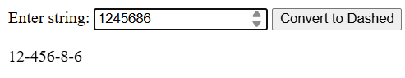

***Problem 5 – Most frequent element***

Write a JavaScript program to find the most frequent item of an array.

Sample array : var arr1=[3, “a”, “a”, “a”, 2, 3, “a”, 3, “a”, 2, 4, 9, 3];

Sample Output : a ( 5 times )

**Code –**

function findMostFrequentItem(arr) {

    let frequency = {};

    for (let i = 0; i < arr.length; i++) {

        let item = arr[i];

        frequency[item] = (frequency[item] || 0) + 1;

    }

    let mostFrequentItem = null;

    let maxFrequency = 0;

    for (let item in frequency) {

        if (frequency[item] > maxFrequency) {

            mostFrequentItem = item;

            maxFrequency = frequency[item];

        }

    }

    console.log(`${mostFrequentItem} (${maxFrequency} times)`);

}

var arr1 = [3, 'a', 'a', 'a', 2, 3, 'a', 3, 'a', 2, 4, 9, 3];

findMostFrequentItem(arr1);

**Output –**

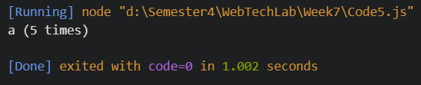

***Problem 6 – Pizza Order***

Write a Javascript code to display the following table to order pizza

**Code –**

<!DOCTYPE html>

<html lang="en">

<head>

    <meta charset="UTF-8">

    <meta name="viewport" content="width=device-width, initial-scale=1.0">

    <title>Pizza Order Form</title>

</head>

<body>

    <h2>Pizza Order Form</h2>

    <table border="1">

        <tr>

            <th>Item Name</th>

            <th>Price</th>

            <th>Quantity</th>

        </tr>

        <tr>

            <td>Chicken Pizza</td>

            <td>100</td>

            <td><input type="number" id="chickenQty" min="0" oninput="calculateTotal()"></td>

        </tr>

        <tr>

            <td>Paneer Pizza</td>

            <td>80</td>

            <td><input type="number" id="paneerQty" min="0" oninput="calculateTotal()"></td>

        </tr>

        <tr>

            <td>Veg Pizza</td>

            <td>70</td>

            <td><input type="number" id="vegQty" min="0" oninput="calculateTotal()"></td>

        </tr>

    </table>

    <br>

    <label>Total Cost: </label>

    <input type="text" id="totalCost" readonly>

    <br><br>

    <button onclick="confirmOrder()">Confirm Order</button>

    <button onclick="cancelOrder()">Cancel Order</button>

    <script>

        function calculateTotal() {

            let chickenPizzaPrice = 100;

            let paneerPizzaPrice = 80;

            let vegPizzaPrice = 70;

            let chickenQty = document.getElementById("chickenQty").value || 0;

            let paneerQty = document.getElementById("paneerQty").value || 0;

            let vegQty = document.getElementById("vegQty").value || 0;

            let totalCost = (chickenPizzaPrice * chickenQty) +

                            (paneerPizzaPrice * paneerQty) +

                            (vegPizzaPrice * vegQty);

            document.getElementById("totalCost").value = totalCost;

        }

        function confirmOrder() {

            alert("Your order is confirmed. It will reach you in 10 minutes.");

        }

        function cancelOrder() {

            document.getElementById("chickenQty").value = "";

            document.getElementById("paneerQty").value = "";

            document.getElementById("vegQty").value = "";

            document.getElementById("totalCost").value = "";

        }

    </script>

</body>

</html>

**Output –**

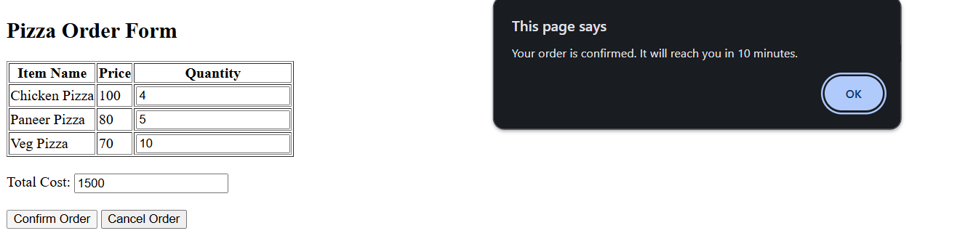

***Problem 7 – Calculator***

Write a Javascript code to design a basic calculator.

**Code –**

<!DOCTYPE html>

<html lang="en">

<head>

    <meta charset="UTF-8">

    <meta name="viewport" content="width=device-width, initial-scale=1.0">

    <title>Basic Calculator</title>

    <style>

        body {

            font-family: Arial, sans-serif;

            text-align: center;

        }

        .calculator {

            width: 220px;

            margin: auto;

            padding: 20px;

            border: 2px solid black;

            border-radius: 5px;

            background-color: lightgray;

            display: inline-block;

        }

        input {

            width: 100%;

            height: 50px;

            text-align: right;

            font-size: 20px;

            margin-bottom: 10px;

        }

        .buttons {

            display: grid;

            grid-template-columns: repeat(4, 1fr);

            gap: 5px;

        }

        button {

            width: 50px;

            height: 50px;

            font-size: 18px;

        }

    </style>

</head>

<body>

    <h2>Basic Calculator</h2>

    <div class="calculator">

        <input type="text" id="result" readonly>

        <div class="buttons">

            <button onclick="display('1')">1</button>

            <button onclick="display('2')">2</button>

            <button onclick="display('3')">3</button>

            <button onclick="display('+')">+</button>

            <button onclick="display('4')">4</button>

            <button onclick="display('5')">5</button>

            <button onclick="display('6')">6</button>

            <button onclick="display('-')">-</button>

            <button onclick="display('7')">7</button>

            <button onclick="display('8')">8</button>

            <button onclick="display('9')">9</button>

            <button onclick="display('*')">*</button>

            <button onclick="clearScreen()">C</button>

            <button onclick="display('0')">0</button>

            <button onclick="calculate()">=</button>

            <button onclick="display('/')">/</button>

        </div>

    </div>

    <script>

        function clearScreen() {

            document.getElementById("result").value = "";

        }

        function display(value) {

            document.getElementById("result").value += value;

        }

        function calculate() {

            try {

                document.getElementById("result").value = eval(document.getElementById("result").value);

            } catch (e) {

                alert("Invalid Expression");

            }

        }

    </script>

</body>

</html>

**Output –**

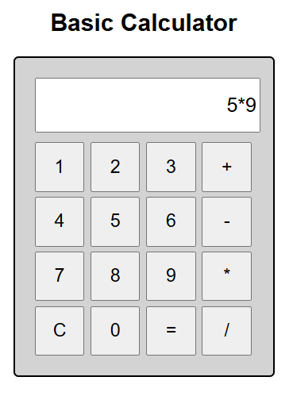 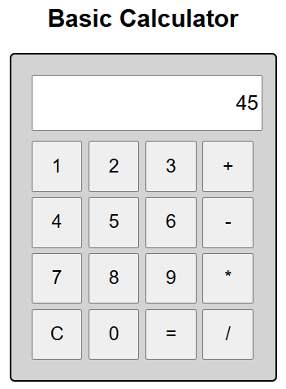

***Problem 8 – Validate IPv4 Address***

IPv4 addresses are canonically represented in dot-decimal notation, which consists of four decimal numbers, each ranging from 0 to 255, separated by dots, e.g., “172.16.254.1”. Frame a regular expression to check the given string is a IPv4 address or not.

**Code –**

<!DOCTYPE html>

<html lang="en">

<head>

    <meta charset="UTF-8">

    <meta name="viewport" content="width=device-width, initial-scale=1.0">

    <title>IPv4 Address Validation</title>

</head>

<body>

    <h2>IPv4 Address Validation</h2>

    <form onsubmit="event.preventDefault(); validateIPv4();">

        <label for="ipAddress">Enter an IPv4 Address:</label>

        <input type="text" id="ipAddress" name="ipAddress" required>

        <button type="submit">Submit</button>

    </form>

    <script>

        function validateIPv4() {

            var ipAddress = document.getElementById("ipAddress").value;

      var ipv4Pattern = /^(25*[0-5]*|2*[0-4][0-9]*|*[01]*?*[0-9][0-9]*?)\.(25*[0-5]*|2*[0-4][0-9]*|*[01]*?*[0-9][0-9]*?)\.(25*[0-5]*|2*[0-4][0-9]*|*[01]*?*[0-9][0-9]*?)\.(25*[0-5]*|2*[0-4][0-9]*|*[01]*?*[0-9][0-9]*?)$/;

            if (ipv4Pattern.test(ipAddress)) {

                alert("Valid IPv4 Address");

            } else {

                alert("Invalid IPv4 Address");

            }

        }

    </script>

</body>

</html>

**Output –**

