**Introduction to ReactJS**

***Aim -***

To understand the creation of React App and understand its basic workflow using Components.

***Task 1 – Real DOM vs Virtual DOM***

Write a program to understand the difference between a real DOM and Virtual DOM.

**Code –**

**DOMExample.js –**

import React, { useState } from 'react';

function DOMExample() {

   const [count, setCount] = useState(0);

   const increment= () => {

       setCount(count + 1);

   };

   return (

       <div>

       <h1>Virtual DOM</h1>

       <p>Count: {count}</p>

       <button onClick={increment}>Increment</button>

       <p>Open the Elements to observe the difference when clicked.</p>

    </div>);}

export default DOMExample;

**Output –**

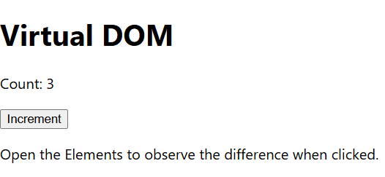

**RealDOM.html -**

<!DOCTYPE html>

<html lang="en">

<head>

<meta charset="UTF-8">

<meta name="viewport" content="width=device-width, initial-scale=1.0">

<title>Actual DOM</title>

</head>

<body>

<h1>Actual DOM Example</h1>

<p id="count">0</p>

<button onclick="increment()">Increment</button>

<p>Open the Elements to observe the difference when clicked.</p>

<script>

let count = 0;

function increment() {

count++;

document.getElementById("count").innerHTML = count;

}

</script>

</body>

</html>

**Output –**

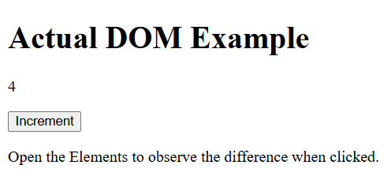

***Task 2 – Component Calling Component***

Write a program to demonstrate calling a component from another component.

**Code –**

**Inner.js -**

function Inner() {

    return (

      <div>

        <p>This is the Inner component which is called in Outer Component</p>

      </div>

    )

   }

export default Inner;

**Outer.js –**

import React from 'react';

import Inner from './Inner';

function Outer() {

 return (

   <div>

     <h1>Outer component</h1>

     <h3>Now a component will be called</h3>

     <Inner />

     <h3>Back in the outer component</h3>

   </div>

 )

}

export default Outer;

**Output –**

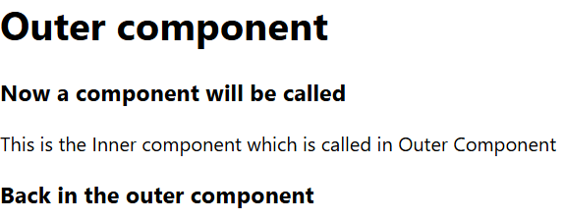

***Task 3 – React Class Component***

Write a program to demonstrate React Class Components.

**Code –**

**ClassComponent.js –**

import React, { Component } from 'react'

export default class ClassComponent extends Component {

 render() {

   return (

     <div>

       <h1>Class Component</h1>

       <p>Class Component is a type of component in React that is defined using a class.</p>

     </div>

   )

 }

}

**Output –**

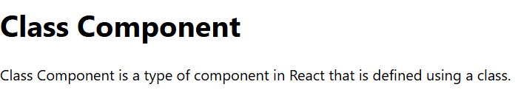

***Task 4 – React Props***

Write a program to demonstrate React props.

**Code –**

**Props.js –**

import React from 'react'

function Props(props) {

 return (

   <div>

     <h1>Player details</h1>

     <p>Name: {props.name}</p>

     <p>Nationality: {props.nation}</p>

   </div>

 )

}

export default Props

**Output –**

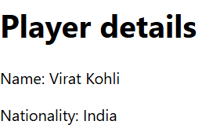

***Task 4 – React Lifecycle***

Write code to illustrate the lifecycle of React JS.

**Code –**

**Lifescycle.js –**

import React, { Component } from "react";

class FullLifecycleDemo extends Component {

  constructor(props) {

    super(props);

    this.state = { color: "Red", prevColor: "", status: "Mounting Component..." };

    console.log("Mounting: Constructor");

  }

  static getDerivedStateFromProps(props, state) {

    console.log("Mounting/Updating: getDerivedStateFromProps");

    return { color: props.favColor || state.color };

  }

  componentDidMount() {

    console.log("Mounting: componentDidMount");

    this.setState({ status: "Component Mounted Successfully!" });

  }

  shouldComponentUpdate(nextProps, nextState) {

    console.log("Updating: shouldComponentUpdate");

    return true;

  }

  getSnapshotBeforeUpdate(prevProps, prevState) {

    console.log("Updating: getSnapshotBeforeUpdate");

    return prevState.color;

  }

  componentDidUpdate(prevProps, prevState, snapshot) {

    if (snapshot && snapshot !== this.state.prevColor) {

      console.log(`Updating: componentDidUpdate  (Prev Color: ${snapshot})`);

      this.setState({ prevColor: snapshot });

    }}

  componentWillUnmount() {

    console.log("Unmounting: componentWillUnmount");

    alert("Component is about to be unmounted!");

  }

  changeColor = () => {

    const newColor = this.state.color === "Red" ? "Blue" : "Red";

    this.setState({ color: newColor });

  };

  render() {

    console.log("🔹 Updating: render()");

    return (

      <div style={styles.container}>

        <h2>Full Lifecycle</h2>

        <p><b>Status:</b> {this.state.status}</p>

        <p><b>Current Color:</b> {this.state.color}</p>

        {this.state.prevColor && <p><b>Previous Color:</b> {this.state.prevColor}</p>}

        <button onClick={this.changeColor} style={styles.button}>

          Change Color

        </button>

        <button onClick={this.props.unmount} style={styles.button}>

          Unmount Component

        </button>

      </div>

    );

  }}

class Parent extends Component {

  state = { showChild: true };

  toggleChild = () => this.setState({ showChild: !this.state.showChild });

  render() {

    return (

      <div>

        {this.state.showChild ? (

          <FullLifecycleDemo unmount={this.toggleChild} />

        ) : (

          <h2 style={{ textAlign: "center" }}>Component Unmounted!</h2>

        )}

      </div>

    );

  }

}

const styles = {

  container: { padding: "20px", textAlign: "center", border: "2px solid black", width: "300px", margin: "auto" },button: { margin: "10px", padding: "10px" }};

export default Parent;

**Output –**

 

