**Hooks, Routers and MongoDB CRUD**

***Aim -***

To understand about React Hooks and React Router, perform basic CRUD operations in MongoDB.

***Task 1 – React Hooks***

Write code to understand different hooks in React JS.

**Code –**

**useStateDemo.js –**

import React, { useState } from 'react';

function Counter() {

  const [count, setCount] = useState(0);

  return (

    <div>

      <p>You clicked {count} times</p>

      <button onClick={() => setCount(count + 1)}>Click me</button>

    </div>

  );

}

export default Counter;

**Output –**

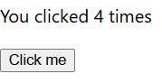

**useEffectDemo.js –**

import React, { useState, useEffect } from 'react';

function Timer() {

  const [seconds, setSeconds] = useState(0);

  useEffect(() => {

    const interval = setInterval(() => {

      setSeconds(s => s + 1);

    }, 1000);

    return () => clearInterval(interval);

  }, []);

  return <p>Timer: {seconds}s</p>;

}

export default Timer;

**Output -**



**useRefDemo.js –**

import React, { useRef } from 'react';

function FocusInput() {

  const inputRef = useRef(null);

  const handleClick = () => {

    inputRef.current.focus();

  };

  return (

    <div>

      <input ref={inputRef} type="text" />

      <button onClick={handleClick}>Focus the input</button>

    </div>

  );

}

export default FocusInput;

**Output –**



**ThemeContext.js –**

import React, { createContext } from 'react';

export const ThemeContext = createContext('grey');

**useContext.js –**

import React, { useContext } from 'react';

import { ThemeContext } from './ThemeContext';

function UseContextDemo() {

 const theme = useContext(ThemeContext);

 return (

 <div style={{ backgroundColor: theme, padding: '10px' }}> <h3>useContext Hook</h3>

 <p>Theme: {theme}</p>

 </div>

 );

}

export default UseContextDemo;

**Output –**

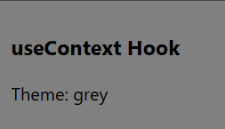

***Task 2 – React Routing***

Write a program to demonstrate routing in React.

**Code –**

**Blogs.js -**

const Blogs = () => {

    return <h1>Blog Articles</h1>;

  };

export default Blogs;

**Contact.js –**

const Contact = () => {

    return <h1>Contact Me</h1>;

  };

export default Contact;

**HomePage.js –**

const Home = () => {

    return <h1>Home</h1>;

  };

export default Home;

**NoPage.js –**

const NoPage = () => {

    return <h1>404</h1>;

  };

export default NoPage;

**index.js –**

import ReactDOM from "react-dom/client";

import { BrowserRouter, Routes, Route } from "react-router-dom";

import Layout from "./pages/Layout_link";

import Home from "./pages/HomePage";

import Blogs from "./pages/Blogs";

import Contact from "./pages/Contact";

import NoPage from "./pages/NoPage";

export default function App() {

  return (

    <BrowserRouter>

      <Routes>

        <Route path="/" element={<Layout />}>

          <Route index element={<Home />} />

          <Route path="blogs" element={<Blogs />} />

          <Route path="contact" element={<Contact />} />

          <Route path="*" element={<NoPage />} />

        </Route>

      </Routes>

    </BrowserRouter>

  );

}

**Output –**

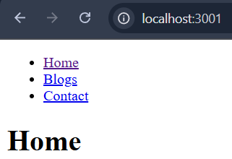 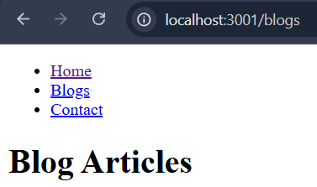

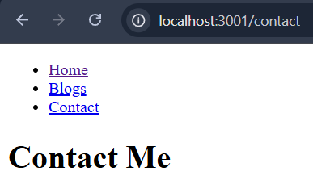 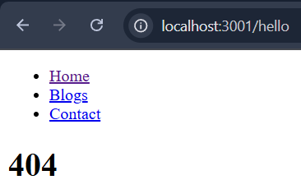

***Task 3 – MongoDB CRUD***

Write a program to demonstrate React Class Components.

**Create database and Collection –**





**Inserting records (Create) –**

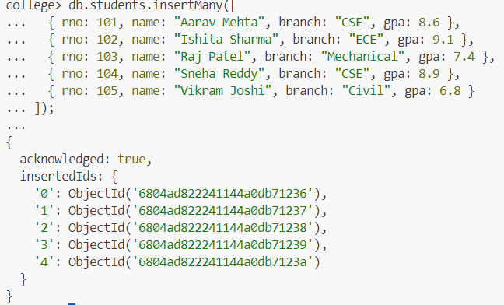

**Finding records (Read) –**

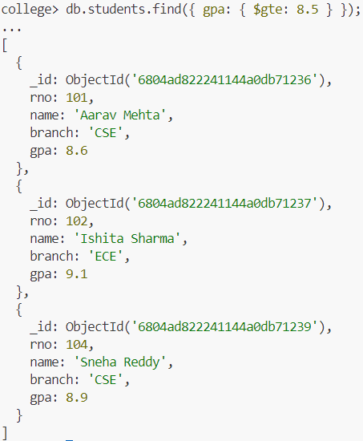

**Updating records (Update) –**

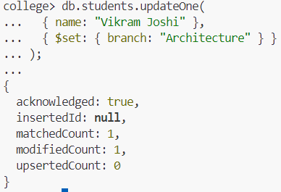

**Deleting records(Delete) –**

