Modern College of Arts, Science and Commerce, Pune-05
Department of Statistics,
M.Sc. II (Statistics) Semester IV
Date : / / Submission Date : / /
Practical No. 4
Title : ANOCOVA in one way or two way mode

Q1)
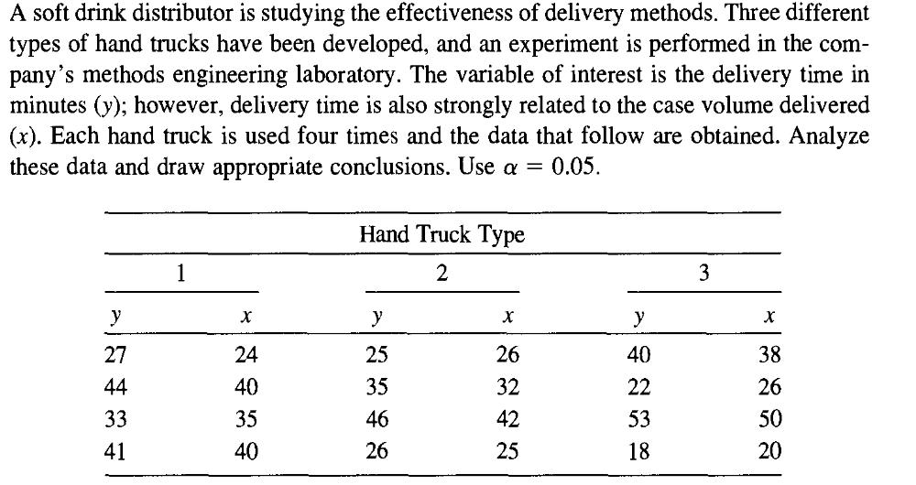
Q2)

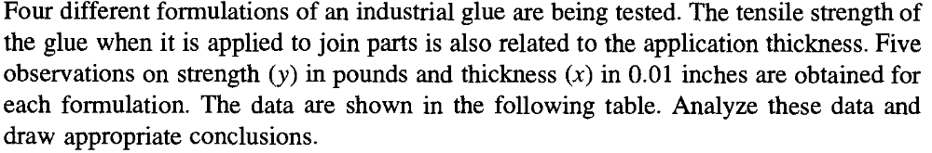
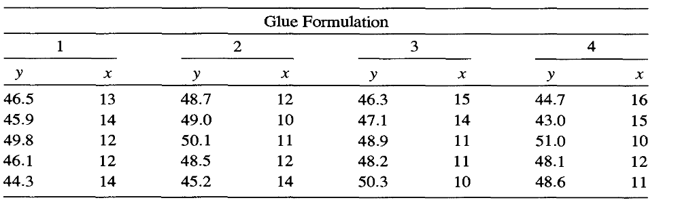

Q1)
y x htt
27 24 1
44 40 1
33 35 1
41 40 1
25 26 2
35 32 2
46 42 2
26 25 2
40 38 3
22 26 3
53 50 3
18 20 3

Results for: Worksheet 2

Scatterplot of y vs x

General Linear Model: y versus x, htt

Method

Factor coding (-1, 0, +1)

Factor Information

Factor Type Levels Values
htt Fixed 3 1, 2, 3

Analysis of Variance

Source DF Adj SS Adj MS F-Value P-Value
x 1 1217.55 1217.55 232.20 0.000
htt 2 11.65 5.82 1.11 0.375
Error 8 41.95 5.24
Lack-of-Fit 7 37.45 5.35 1.19 0.610
Pure Error 1 4.50 4.50
Total 11 1285.67

Model Summary

S R-sq R-sq(adj) R-sq(pred)
2.28986 96.74% 95.51% 93.10%

Coefficients

Term Coef SE Coef T-Value P-Value VIF
Constant -4.75 2.64 -1.80 0.110
x 1.1733 0.0770 15.24 0.000 1.03
htt
1 0.226 0.943 0.24 0.817 1.36
2 1.082 0.946 1.14 0.286 1.37

Regression Equation

htt
1 y = -4.52 + 1.1733 x

2 y = -3.66 + 1.1733 x

3 y = -6.05 + 1.1733 x

To test:
H₀₁: Treatment means are do not differs significantly v/s
H₁₁: Treatment means are differ significantly

Decision:

1) Here P value corresponding to treatment i.e. Hand truck is 0.375>0.005 .Therefore we accept H₀₁.
2) Here P value corresponding to X i.e. Volume delivered is 0 < 0.005 .Therefore we Reject H₀₂.

Conclusion:

1) Three types of hand truck have same delivery time.
2) There is a linear relationship between delivery time of hand truck and volume delivered.i.e.as volume to be delivered changes delivery time also changes.

Q2)
y x gf
46.5 13 1
45.9 14 1
49.8 12 1
46.1 12 1
44.3 14 1
48.7 12 2
49.0 10 2
50.1 11 2
48.5 12 2
45.2 14 2
46.3 15 3
47.1 14 3
48.9 11 3
48.2 11 3
50.3 10 3
44.7 16 4
43.0 15 4
51.0 10 4
48.1 12 4
48.6 11 4

Results for: Worksheet 3

General Linear Model: y versus x, gf

Method

Factor coding (-1, 0, +1)

Factor Information

Factor Type Levels Values
gf Fixed 4 1, 2, 3, 4

Analysis of Variance

Source DF Adj SS Adj MS F-Value P-Value
x 1 59.566 59.5658 42.62 0.000
gf 3 1.771 0.5903 0.42 0.740
Error 15 20.962 1.3975
Lack-of-Fit 11 12.572 1.1429 0.54 0.808
Pure Error 4 8.390 2.0975
Total 19 91.585

Model Summary

S R-sq R-sq(adj) R-sq(pred)
1.18215 77.11% 71.01% 58.67%

Coefficients

Term Coef SE Coef T-Value P-Value VIF
Constant 60.09 1.94 30.91 0.000
x -1.010 0.155 -6.53 0.000 1.08
gf
1 -0.440 0.466 -0.94 0.360 1.55
2 0.129 0.469 0.27 0.788 1.57
3 0.393 0.459 0.85 0.406 1.51

Regression Equation

gf
1 y = 59.65 - 1.010 x

2 y = 60.22 - 1.010 x

3 y = 60.48 - 1.010 x

4 y = 60.01 - 1.010 x

To test:
H₀₁: Treatment means are do not differs significantly. VS
H₁₁: Treatment means are differ significantly

Decision:

1) Here p-value corresponding to treatment i.e. glue is 0.740 > 0.005 .Therefore we accept H₀₁.

2) Here p-value corresponding to X i.e. Volume delivered is 0< 0.005 .Therefore we Reject H₀₂.

Conclusion:

1) The tensile strength of glue do not differs significantly.

2) There is a linear relationship between tensile strength of glue and thickness.i.e. as tensile strength of glue changes its thickness also changes.

