Mirror a BST
Given a binary tree, convert it into its mirror form. A binary tree is said to be mirrored when left and right children of all non-leaf nodes are interchanged.
Input Format
In the function pointer to the root of the binary tree is passed.
Output Format
Return the pointer to the root of the mirrored tree.

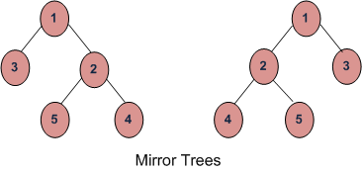
Sample Testcase

Solution: mirrorBST.cpp

IsBST?

Given a Binary Tree, Check if the tree is a BST or not!
Example-I
1
/ \
2 3
/ \ \
4 5 6
false

Example-II
4
/ \
2 5
/ \ \
1 3 6
true
Solution: isBST.cpp

Delete in BST

Given a root node reference of a BST and a key, delete the node with the given key in the BST. Return the root node reference (possibly updated) of the BST.
Basically, the deletion can be divided into two stages:
- Search for a node to remove.
- If the node is found, delete the node.
Example:

7
/ \
5 9
/ \ / \
3 6 8 10

Delete node 9
Return:
7
/ \
5 8
/ \ \
3 6 10

Solution: deleteNode.cpp

