K-th Level
Given a binary tree with N nodes. Your task is to print its Kth level.
Input Format
In the function a pointer to the root node of the binary tree is passed.
Output Format
Return a vector containing nodes at Kth level

Input: 60 --- Level 0 / \ 50 30 --- Level 1 / \ / 80 10 40 --- Level 2 K = 1Output: 30 50
Solution: kthLevel.cpp

Sum of Nodes

Given a binary tree with N nodes. Your task is to return the sum of all N nodes.
Input Format
In the function a pointer to the root node of the binary tree is passed.
Output Format
Return a integer representing sum of all nodes

Sample Input
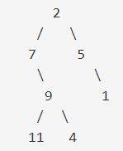

Sample Output
39
Solution: nodeSum.cpp

Min Depth

Given a binary tree with N nodes. Your task is to find the minimum depth.
Input Format
In the function a pointer to the root node of the binary tree is passed.
Output Format
Return an integer representing minimum depth

Sample Input

Sample Output
3
Explanation
Minimum depth is between nodes 2 and 1 since minimum depth is defined as the
number of nodes along the shortest path from the root node down to the nearest leaf node.
Solution: minDepth.cpp

Symmetric Tree

Given a binary tree with N nodes. Your task is to check whether it is a mirror of itself (i.e., symmetric around its center).
Input Format
In the function a pointer to the root node of the binary tree is passed.
Output Format
Return true if symmetric otherwise return false.

Sample Input
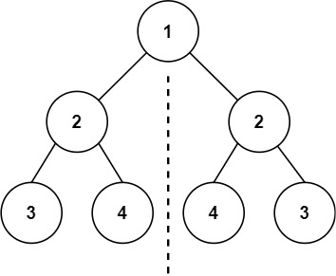

Sample Output
True
Solution: symmetricTree.cpp

Expression Tree

Given a full binary expression tree consisting of basic binary operators (+ , – ,*, /) and some integers in the form of string, Your task is to evaluate the expression tree.
Note: All the nodes' data are in the form of string.
Input Format
In the function a pointer to the root node of the binary tree is passed.
Output Format
Return an integer representing the final value of the expression.

Sample Input
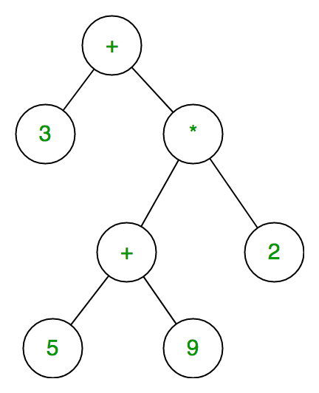

Sample Output
31

Explanation
( ((5 + 9) * 2 ) + 3) = 31
Solution: expressionTree.cpp

Remove Half Nodes

Given A binary Tree. Your task is to remove all the half nodes (which has only one child) and return the INORDER traversal of the updated binary tree.
Input Format
In the function a pointer to the root node of the binary tree is passed.
Output Format
Return an integer vector containing INORDER traversal of the updated binary tree.

Sample Input
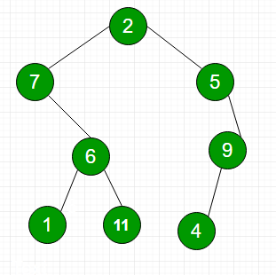

Sample Output
INORDER traversal of the new tree : 1 6 11 2 4

Explanation
Nodes 7, 5 and 9 are half nodes as one of their child is Null.

Solution: removeHalfNode.cpp

