N-Queen Ways
You are given an empty chess board of size N*N. Find the number of ways to place N queens on the board, such that no two queens can kill each other in one move. A queen can move vertically, horizontally and diagonally.
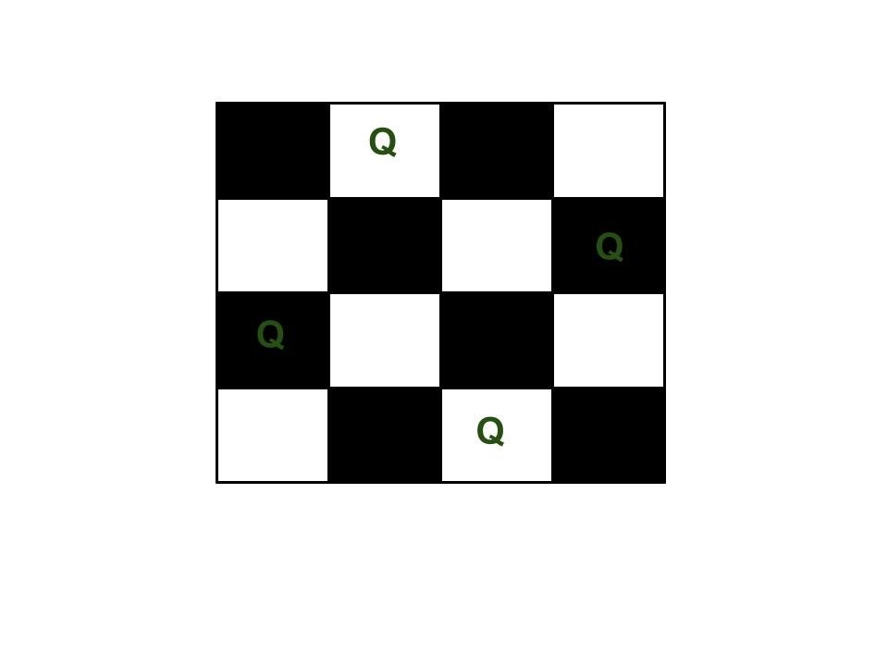
Input Format:
In the function you are given an integer N as a parameter.
Output Format:
Return the number of possible solutions.
Constraints:
1<=N<=10
Sample Testcase 1:
Input:
4
Output:
2
Sample Testcase 2:
Input:
1
Output:
1
Solution: nQueenProblem.cpp

Rat and Mice

You are given an N*M grid. Each cell (i,j) in the grid is either blocked, or empty. The rat can move from a position towards left, right, up or down on the grid.
Initially rat is on the position (1,1). It wants to reach position (N,M) where its mice is waiting for. There exits a unique path in the grid . Find that path and help the rat reach its mice.

Input Format
Given vector of strings representing a grid with N rows and M columns.
'X' in position (i,j) denotes that the cell is blocked and 'O' denotes that the cell is empty.

Output Format
Print N lines, containing M integers each. A 1 at a position (i,j) denotes that the (i,j)th cell is covered in the path and a 0 denotes that the cell is not covered in the path.

Sample Input
5 4OXOOOOOXXOXOXOOXXXOO
Sample Output
1 0 0 0 1 1 0 0 0 1 0 0 0 1 1 0 0 0 1 1
Solution: ratMaze.cpp

Word Break Problem

Given a str which is a valid sentence without any spaces between the words and a dictionary of valid English words, find all possible number of ways to break the sentence in individual dictionary words.
Input Format
In the function a string str and a vector of strings representing dictionary is passed
Output Format
Return an integer representing the total no. of ways

Sample Input
dictionary = { i, like, sam, sung, samsung, mobile}str = "ilikesamsungmobile"
Sample Output
2
Explanation
Following are the 2 possible ways to break the string
i like sam sung mobile i like samsung mobile
Solution: wordBreak.cpp

Unique Subset

Given an integer array nums that may contain duplicates, return all possible subsets (the power set).
The solution set must not contain duplicate subsets. Return the solution in ascending order.
Input Format
In the function an integer vector is passed.
Output Format
Return a vector of vectors containing unique subsets.

Sample Input
[1,2,2]
Sample Output
[[],[1],[1,2],[1,2,2],[2],[2,2]]
Solution: uniqueSubsets.cpp

Word Search

Given an m x n grid of characters board and a string word, return true if word exists in the grid.
The word can be constructed from letters of sequentially adjacent cells, where adjacent cells are horizontally or vertically neighboring. The same letter cell may not be used more than once.
Input Format
In the function 2-d vector of character is passed.
Output Format
Return true if the word is present otherwise false.

Sample Input
board = [["A","B","C","E"],["S","F","C","S"],["A","D","E","E"]] word = "ABCCED"

Sample Output
true
Explanation
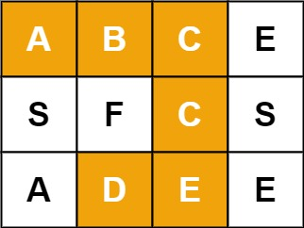
Solution: wordSearch.cpp

